COUNTRY (USA)

Report on Groundfish Activities by the International Pacific Halibut Commission (IPHC) in 2024

April 2025

Prepared for the
Canada-United States Groundfish Technical Committee

Edited by Josep Planas

With contributions by:
Josep Planas, Barbara Hutniczak

International Pacific Halibut Commission
2320 West Commodore Way, Suite 300
Seattle, Washington 98199-1287

Executive Summary
Management of the Pacific halibut resource and fishery has been the responsibility of the International Pacific Halibut Commission (IPHC) since its creation in 1923 (Figure 1). Assessing, forecasting, and managing the resource and fishery requires accurate assessments, continuous monitoring, and research responsive to the needs of managers and stakeholders. The fishery for Pacific halibut (Hippoglossus stenolepis) is one of the most valuable and geographically largest in the northeast Pacific Ocean. Industry participants from Canada and the United States of America have prosecuted the modern fishery and have depended upon the resource since the 1880s. Annual removals have been as high as 100 million pounds, and the long-term average of removals is 64 million pounds.

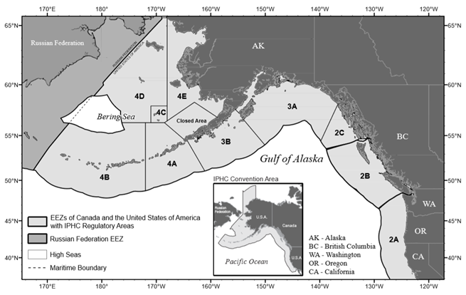

Figure 1. Map of the IPHC Convention Area and IPHC Regulatory Areas.

Surveys and Monitoring
The IPHC’s Fishery-Independent Setline Survey (FISS) provides catch information and biological data on Pacific halibut (Hippoglossus stenolepis) that are collected independently of the commercial fishery. These data, which are collected using standardized methods, bait and gear during the summer of each calendar year, provide an important comparison with data collected from the commercial fishery. The directed commercial fishery is variable in its gear composition and distribution of fishing effort over time, and presents a broad spatial and temporal sampling of the stock. Pacific halibut biological data collected on the FISS (e.g. the size, age, and sex composition) are used to monitor changes in biomass, growth, and mortality in adult and sub-adult components of the Pacific halibut population. In addition, records of non-target species caught during FISS operations provide insight into bait competition, rate of bait attacks, and serve as an index of abundance over time, making them valuable to the assessment, management, and avoidance of non-target species. For details on FISS work conducted in 2024, please refer to the following paper IPHC Fishery-Independent Setline Survey (FISS) design and implementation in 2024.

Furthermore, the IPHC collects data each year through ongoing data collection projects that are funded separately, either as part of the FISS or as part of the directed commercial fishery data collection program. Ongoing data collections projects include the following:

IPHC Secretariat aboard National Marine Fisheries Service groundfish trawl surveys in the Gulf of Alaska, Bering Sea and Aleutian Islands
The National Oceanic and Atmospheric Administration (NOAA) Fisheries has conducted annual bottom trawl surveys on the eastern Bering Sea continental shelf since 1979 and the IPHC has participated in the survey on an annual basis since 1998 by directly sampling Pacific halibut from trawl survey catches. The IPHC has participated in the NOAA Fisheries Aleutian Islands trawl survey, which takes place every two years, since 2012. Alternating year by year with the Aleutian Islands trawl survey is the NOAA Fisheries Gulf of Alaska trawl survey, which IPHC has participated in since 1996. The IPHC uses the NOAA Fisheries trawl surveys to collect information on Pacific halibut that are not yet vulnerable to the gear used for the IPHC FISS or directed commercial fishery, and as an additional data source and verification tool for stock analysis. In addition, trawl survey information is useful as a forecasting tool for cohorts approaching recruitment into the FISS or directed commercial fishery.

Sampling of directed commercial landings
The IPHC positions Secretariat to sample the directed commercial landings for Pacific halibut in Alaska, British Columbia, Washington, and Oregon. Sampling of commercial landings involves collecting Pacific halibut otoliths, tissue samples (fin clips) for genetic sexing, fork lengths, weights, logbook information, and final landing weights. The collected data are used in the stock assessment and other research. The collected otoliths provide age composition data and the tissue samples provide sex composition. Lengths and weight data, in combination with age data and sex data, provide size-at-age analyses by sex. Mean weights are combined with final landing weights to estimate catch in numbers. Logbook information provides weight per unit effort data, fishing location for the landed weight, and data for research projects. Finally, tags are collected to provide information on migration, exploitation rates, and natural mortality. In addition to sampling the catch, other objectives include collecting recovered tags, and copying information from fishing logs along with the respective landed weights, for as many Pacific halibut trips as possible throughout the entire season.

Environmental data collection in the IPHC FISS
Since 2009, the IPHC has been collecting environmental data as water column profiles in each station sampled as part of the IPHC FISS. The data collected includes surface to depth profiles of pressure (depth), temperature, conductivity (salinity), dissolved oxygen, pH, and chlorophyl a concentration. From 2009 until 2023, collected environmental data, related metadata and maps of profiled FISS stations are publicly available on the IPHC website (https://www.iphc.int/datatest/data/water-column-profiler-data).

Research
Population genomics
Understanding population structure is imperative for sound management and conservation of natural resources. Pacific halibut in US and Canadian waters are managed as a single, panmictic population on the basis of tagging studies and historical (pre-2010) analyses of genetic population structure that failed to demonstrate significant differentiation in the eastern Pacific Ocean. The IPHC Secretariat is currently revising Pacific halibut population structure in IPHC Convention waters using state-of-the-art low-coverage whole genome resequencing (lcWGR) methods. For this purpose, the IPHC Secretariat used genetic samples from male and female adult Pacific halibut collected during the spawning (winter) season from known spawning grounds in five geographic areas: Western and Central Aleutian Islands, Bering Sea, Central Gulf of Alaska and British Columbia (Figure 2). Furthermore, temporal replicates at many of these locations are available and have enabled the IPHC Secretariat to evaluate the stability of genetic structure over time, ensuring confidence in the results. As a requisite for the lcWGR approach used, the IPHC Secretariat first produced a high-quality reference genome (Jasonowicz et al., 2022) that has been used to generate genomic sequences from 570 individual Pacific halibut collected from the five above-mentioned geographic areas (Figure 2).
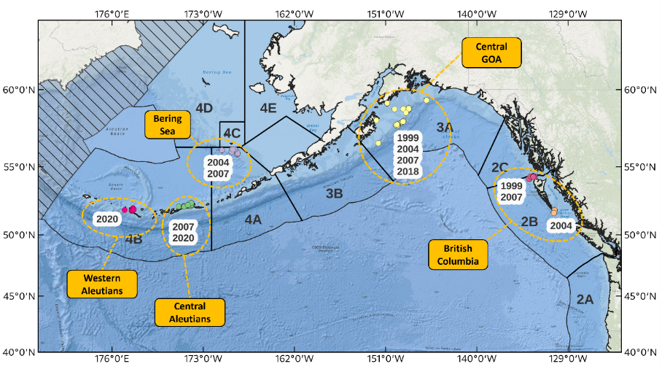
Figure 2. Map of sample collections made during the spawning season used for genomic analysis of population structure in Pacific halibut in the northeast Pacific Ocean.
Using the lcWGR approach, the IPHC Secretariat has identified approximately 10.2 million single nucleotide polymorphisms (SNPs) that have been used to evaluate population structure at the highest resolution possible. Despite the use of a very high-resolution genomic approach, preliminary analyses of population structure using a genome-wide subset of 4.7 million SNPs, indicated that distinct genetic groups were not apparent in the dataset. Multiple methods were used to characterize population structure: principal component analysis revealed a considerable degree of genetic similarity between samples collected in different geographic areas (Figure 3), and unsupervised clustering methods (K-means clustering and the estimation of admixture proportions) also failed to detect discrete genetic groups. These results suggest that there is very little spatial structure among the five spawning groups sampled in different geographic areas within IPHC Convention Waters. Furthermore, assignment testing was carried out to assess our ability to accurately assign samples back to their location in which they were collected. Cross-validation was used to evaluate assignment accuracy and indicated a limited ability (34.7%) to accurately assign samples back to the geographic location in which they were collected from. We hypothesize that the absence of distinct genetic groups among our sample collections is due to a considerable degree of geneflow among the geographic areas sampled in this study and, consequently, to the genetically panmictic nature of the Pacific halibut population sampled for this study.

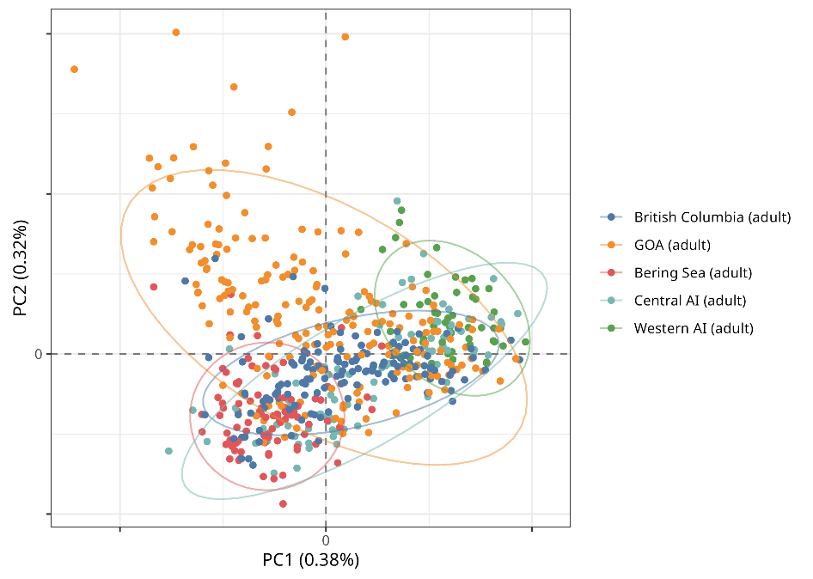
Figure 3. Principal Component Analysis (PCA) biplot of the first two PC axes for 570 Pacific halibut. Samples are colored by geographic area. Circles represent 95% confidence ellipses.

Despite using very high-resolution genomic methods to characterize genomic variation in spawning groups of Pacific halibut collected over large spatial and temporal scales, the results presented here are consistent with genetic panmixia. However, while it is important to note that we cannot simply prove that panmixia exists by failing to reject it, the results presented here are consistent with the current assessment practices of the IPHC which considers Pacific halibut in IPHC Convention Waters as a single coastwide stock (Stewart and Hicks, 2025).

Revised female maturity schedules based on histological data
The coastwide maturity schedule (i.e. the proportion of mature females by age) that is currently used in SA is based on visual (i.e. macroscopic) maturity data collected in IPHC’s Fishery-Independent Setline Survey (FISS). However, the coastwide maturity schedule has not been revised in recent years and it may have an undetermined degree of uncertainty. For this reason, the IPHC Secretariat is undertaking studies to revise the female maturity schedule coastwide and in all four IPHC Biological Regions through histological (i.e. microscopic) characterization of maturity. To accomplish this objective, the IPHC Secretariat started collecting ovarian samples for histology during the 2022 and 2023 FISS seasons. The 2022 FISS sampling resulted in a total of 1,023 ovarian samples collected in Biological Regions 2, 3, 4 and 4B. Due to a reduced FISS design, in 2023 sampling only occurred in Biological Regions 2 and 3 and 1,111 ovarian samples were collected (Figure 4). Ovarian samples from 2022 and 2023 were processed for histology and scored for maturity using histological maturity classifications, as previously described in Fish et al. (2020, 2022). Following this maturity classification criteria, all sampled Pacific halibut females were assigned to either the mature or immature categories. Mature female Pacific halibut are deemed to have at least reached the early vitellogenic (Vtg1) female developmental stage (Fish et al., 2020).
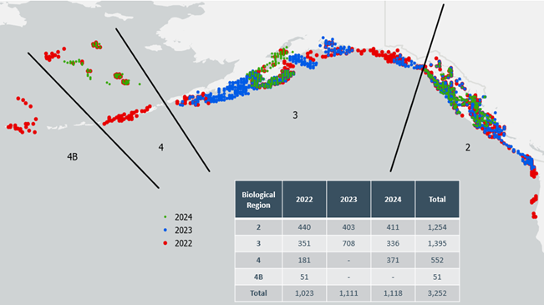

Figure 4. Map of 2022, 2023 and 2024 maturity samples for histology collected on FISS. Red dots (2022), blue dots (2023) and green dots (2024) indicate a distinct FISS station in which a sample was collected.

Maturity ogives (i.e., the relationships between the probability of maturity determined by histological assessments and variables including IPHC Biological Region, age, and year) were estimated by fitting generalized additive models (GAM) with logit link (i.e., logistic regression) to the 2022 and 2023 data using year as a factor (Figure 5). When comparing Biological Regions 2 and 3 (the only two Biological Regions with two consecutive years of data) spatial and temporal differences in maturity ogives become apparent. First, the maturity ogive for Biological Region 2 shows lower steepness than that for Biological Region 3 in both years, indicating that Biological Region 2 has a lower proportion of mature females from ages 7 to 25 than Biological Region 3 over the period of ovarian sample collection during the FISS. Second, the maturity ogive in Biological Region 2 increased markedly in steepness between 2022 and 2023, indicating an increase in the proportion of mature females at younger ages, whereas the maturity ogive in Biological Region 3 was very similar across the two years. Future collection of ovarian samples in additional years will be required to establish any potential temporal and/or spatial differences in maturity ogives. For this reason, the IPHC Secretariat continued to collect ovarian samples in the 2024 FISS. A total of 1,118 ovarian samples were collected during 2024, with 411 samples in Biological Region 2, 336 samples in Biological Region 3, and 371 samples in Biological Region 4. These samples have been processed, and data analyses are underway.

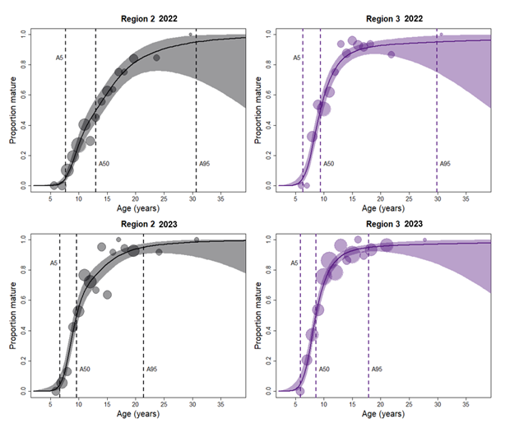
Figure 5. Female Pacific halibut age-at-maturity by IPHC Biological Region (BR2, left; BR3, right) and year (2022, top; 2023, bottom) using best-fit GAM. Color shading indicates 95% confidence intervals for each IPHC Biological Region. Vertical dash lines indicate age at 5% (A5), 50% (A50), and 95% (A95) maturity.

Stock Assessments and Management by Species/Group (1 – 3 paragraphs for each species/group)

N. Pacific Halibut & IPHC Activities

Stock assessment
The 2024 stock assessment produced the following scientific advice regarding the Pacific halibut stock:

Sources of mortality: In 2024, total Pacific mortality due to fishing decreased to 32.70 million pounds (14,832 t), below the 5-year average of 35.66 million pounds (16,174 t) and representing the lowest value in over 100 years, due to a TCEY reduction of 4.6% from 2023 to 2024. Of that total mortality, 83% was retained and utilized in one of the fishery; this was below to the percent utilized in 2023 (84%) and equal to that observed in 2022.

Fishing intensity: The 2024 fishing mortality corresponded to a point estimate of SPR = 49%; there is a 33% chance that fishing intensity exceeded the IPHC’s current reference level of F_{43%}. The Commission does not currently have a coastwide fishing intensity limit reference point.

Stock status (spawning biomass): Current (beginning of 2025) female spawning biomass is estimated to be 149 million pounds (67,500 t), which corresponds to a 30% chance of being below the IPHC trigger reference point of SB_{30%}, and an 11% chance of being below the IPHC limit reference point of SB_{20%}. The stock is estimated to have declined 32% from 2016 to 2024, then increased by 3% to the beginning of 2025. The relative spawning biomass (compared to the biomass projected to be present at the beginning of 2025 in the absence of any fishing) is currently estimated to be 38%, after reaching the lowest point in the recent time series (28%) in 2011. Therefore, the stock is considered to be ‘not overfished’.

Stock distribution: After increases in 2020-2021, the proportion of the coastwide stock represented by Biological Region 3 has decreased in 2022-24 to the lowest estimate in the time-series. This trend occurs in tandem with increases in Biological Region 2. The lack of FISS sampling in Biological Region 4B in 2023-24 has resulted in increased uncertainty in both the trend and scale of the stock distribution in this Region.

Outlook: Projections indicate that the spawning biomass would increase in the absence of any fishing mortality, with risks of stock decline over one and three years both less than 1/100. At the status quo coastwide TCEY (35.28 million pounds), risks of stock decrease over one and three years are 43/100 and 45/100. For all harvest levels that exceed the three-year surplus (37.4 million pounds) risks of stock decline are larger than 50/100, and reaching 88/100 for the coastwide TCEY that is projected to correspond to the F_{35%} MSY proxy harvest level in 2025. Alternative harvest levels around the status quo (+/- 5 and 10%) are projected to result in levels of fishing intensity ranging from F_{50%} to F_{44%}, similar to those estimated in recent years. At the reference level of fishing mortality (F_{43%}) the 2025 coastwide TCEY is projected to be 39.8 million pounds (41.7 million pounds of total mortality including U26 non-directed discard mortality). Stock decline over the next three years is projected to be likely (57/100 to 58/100) at this level of fishing intensity. The probability of a reduction in the coastwide TCEY in order to maintain a fishing intensity no greater than F_{43%} over the next three years is projected to be 49/100.

For more information on the 2024 stock assessment and the fishery status, please refer to paper IPHC-2025-AM101-11 at the IPHC website.

Management
The IPHC completed the 101th Session of the IPHC Annual Meeting (AM101) on 31 January 2025 with decisions on total mortality limits, fishery limits, fishing period dates, and other fishery regulation changes. A total of 165 members of the public (104 in-person and 61 remote) attended the meeting.

Meeting documents, presentations, recordings of the sessions, and the report of the meeting are available on the AM100 meeting page at the IPHC website: 101th Session of the IPHC Annual Meeting (AM101). Decisions arising from this meeting, including management decisions, are documented in the following report: Report of the 101th Session of the IPHC Annual Meeting (AM101).

Mortality limits
Mortality limits adopted for 2025 represent a 15.8% decrease from 2024.

Table 1: Mortality limits for 2024 and 2025.

IPHC Regulatory Area | 2024 TCEY (Mlbs) | 2025 TCEY (Mlbs) | Change
2A | 1.65 | 1.65 | 0
2B | 6.47 | 5.45 | -15.8%
2C | 5.79 | 5.22 | -9.85%
3A | 11.36 | 9.08 | -20.1%
3B | 3.45 | 2.86 | -17.1%
4A | 1.61 | 1.34 | -16.8%
4B | 1.25 | 1.04 | -16.8%
4CDE | 3.70 | 3.08 | -16.8%
IPHC Convention Area | 35.28 | 29.72 | -15.8%

Other Actions
Management Strategy Evaluation: https://www.iphc.int/the-commission/harvest-strategy-policy
The MSE analysis was first completed in 2020 with an evaluation and comparison of many candidate management procedures that were presented to the Commission for potential adoption and implementation. These management procedures were made up of many different elements to determine the coastwide Total Constant Exploitation Yield (TCEY) and distribute it to IPHC Regulatory Areas.

Current MSE work consists of analyses to support the development of a harvest strategy policy. This includes further defining management objectives, evaluating management procedures without an annual stock assessment, evaluating the effect of changes in the Fishery-independent setline survey (FISS) design, identifying exceptional circumstances that would warrant additional evaluations of management procedures, and incorporating these outcomes in the harvest strategy policy.

Overall, the clear communication of MSE results is important so that stakeholders and Commissioners can make informed decisions and implement a harvest strategy policy. For more information on the 2024 MSE work, please refer to paper IPHC-2025-AM101-12 at the IPHC website.

Reserves (1 – 3 paragraphs)
N/A

Data Management (1- 3 paragraphs)
N/A

Upcoming Work, Emerging Needs, and Challenges (3 paragraphs)
The approved fishery-independent setline survey (FISS) design for 2025 involves sampling 517 stations in four biological regions, seven IPHC Regulatory Areas (2A, 2B, 2C, 3A, 3B, 4A and 4B), and 10 charter regions (Figure 6).

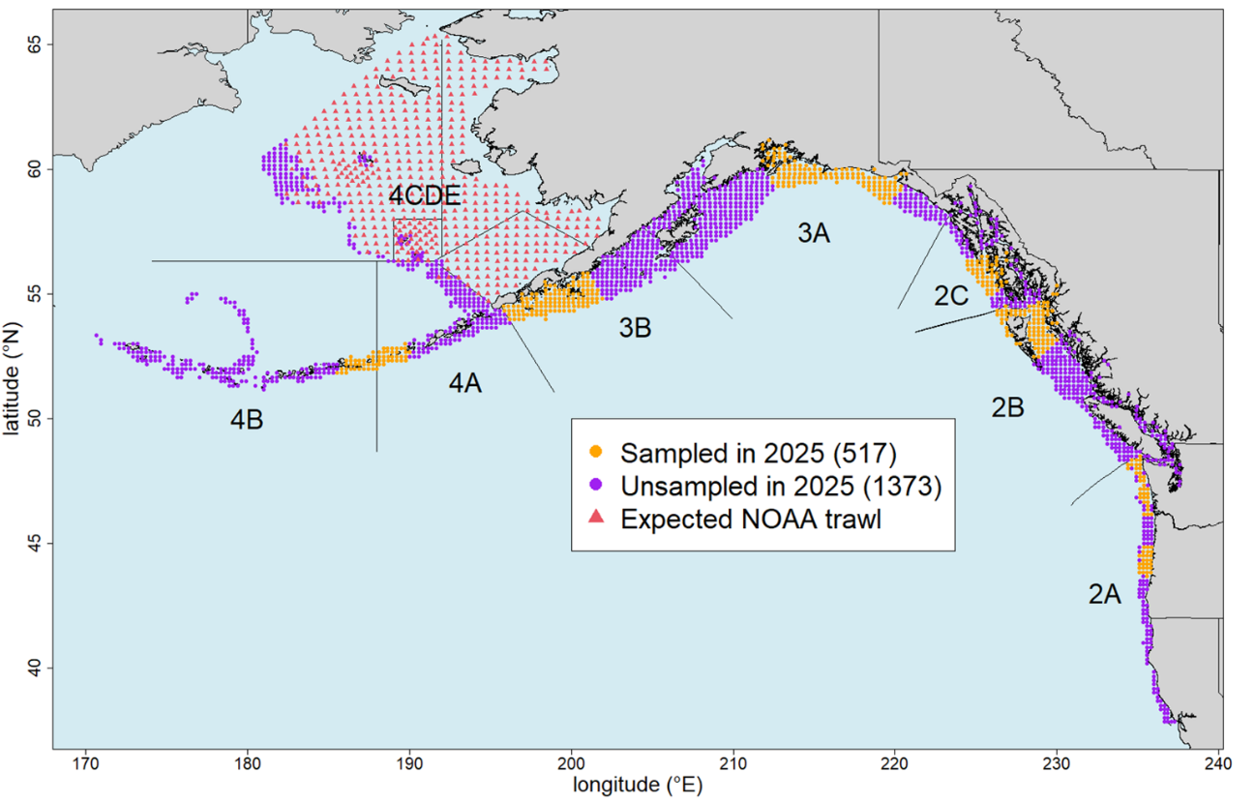

Figure 6. Approved 2025 FISS design.

Other Publications (list)
Dykstra, C., Wolf, N., Harris, B.P., Stewart, I.J., Hicks, A., Restrepo. F., Planas, J.V. 2024. Relating capture and physiological conditions to viability and survival of Pacific halibut discarded from commercial longline gear. Ocean & Coastal Management. 249: 107018. https://doi. org/10.1016/j.ocecoaman.2024.107018
Sadorus, L. L., Webster, R. A. and Sullivan, M. 2024. Environmental conditions on the Pacific halibut fishing grounds obtained from a decade of coastwide oceanographic monitoring, and the potential application of these data in stock analyses. Marine and Freshwater Research. 75: MF23175. https://doi.org/10.1071/MF23175.
Simchick, C., Simeon, A., Bolstad, K., Planas, J.V. 2024. Endocrine patterns associated with ovarian development in female Pacific halibut (Hippoglossus stenolepis). General and Comparative Endocrinology. 347: 114425. https://doi.org/10.1016/j.ygcen.2023.114425
Thomas, R.E., Gauthier, S., Grandin, C., Hicks, A., Parker-Stetter, S. 2024 To trawl or not to trawl: Questioning core assumptions of trawl placement choice in fisheries acoustic surveys. Fisheries Research. 270: 106897. https://doi.org/10.1016/j.fishres.2023.106897
Hutniczak, B., Wilson, D., Stewart, I., Hicks, A. 2024. A hundred years of Pacific halibut management in the context of global events. Frontiers in Marine Science. 11:1424002. https:// doi.org/10.3389/fmars.2024.1424002

Agency Contact List (1-2 pages)

- Dr David T. Wilson. Executive Director. david.wilson@iphc.int

- Dr Barbara Hutniczak. Fisheries Regulations & Data Services Branch Manager. barbara.hutniczak@iphc.int

- Dr Josep Planas. Biological and Ecosystem Sciences Branch Manager. josep.planas@iphc.int

- Dr Allan Hicks. Quantitative Scientist (MSE). allan.hicks@iphc.int

- Dr Ian Stewart. Quantitative Scientist (Stock Assessment). ian.stewart@iphc.int

