CANADA

**Report on Groundfish Activities in British Columbia, Canada, by Fisheries and Oceans Canada in 2024**

**April 2025**

Prepared for the

Canada-United States Groundfish Technical Committee

Edited by Dana Haggarty

With contributions by :

Jillian Dunic, Philina English, Andy Edwards, Nick Fisch, Chris Grandin, Rowan Haigh, Kendra Holt, Norm Olsen, Matthew Siegle, Malcolm Wyeth.

Fisheries and Oceans Canada

Science Branch, Pacific Biological Station,

Nanaimo, British Columbia, Canada, V9T 6N7

Contents

1. Executive Summary 4

2. Surveys and Monitoring 4

Fishing Surveys 4

Multispecies Synoptic Bottom Trawl Surveys 6

Hard Bottom Longline Hook Surveys 8

Sablefish Research and Assessment Survey 10

Strait of Georgia Dogfish Longline Hook Survey 10

Small Mesh Multispecies Bottom Trawl Survey 10

Hydroacoustic Surveys 11

International Pacific Halibut Commission Survey 12

3. Research and Publications 12

Groundfish Synopsis Report 12

Collection of Commercial Biological Samples 13

Small Mesh Multispecies Survey Report 13

Passive Acoustic Monitoring (PAM) of Rocky Reef Fishes 14

Evaluating the Utility of Integrating Close-Kin Mark Recapture-Data within Stock Assessments 14

Body condition as a shared response to environmental conditions 15

State of the Pacific Ocean: Trends in Pacific Canadian Groundfish Stock Status and Surveys 15

Lingcod Egg Conversion 16

Enhanced Salmon Sampling Program 16

Explaining empirical dynamic modelling using verbal, graphical and mathematical approaches 17

pacea: An R package of Pacific ecosystem information to help facilitate an ecosystem approach to fisheries management 17

Using highest density intervals can reduce perceived uncertainty in stock assessments. 17

4. Stock Assessments and Management by Species/Group (1 – 3 paragraphs for each species/group) 18

Stocks Assessed in 2024 18

Pacific Spiny Dogfish (Outside) 18

Offshore Hake 19

Bocaccio 19

Yellowtail Rockfish 20

Sablefish 21

Petrale Sole 21

Arrowtooth Flounder 22

Summary of Assessment Advice by Stock 22

5. Reserves 27

6. Data Management 29

7. Upcoming Work, Emerging Needs, and Challenges 29

8. Agency Contact List 30

# Executive Summary

In 2024, the Groundfish Section in the Pacific Region of DFO Science had a productive year. The Multispecies Synoptic Bottom Trawl surveys took place on the West Coast of Vancouver Island and the West Coast of Haida Gwaii. Hard Bottom Longline (HBLL) surveys in waters Inside and Outside of Vancouver Island both surveyed their southern regions (Inside HBLL: Strait of Georgia; Outside HBLL: north and west coasts of Vancouver Island and Central Coast), and the Sablefish survey took place throughout offshore outside waters. Offshore Pacific Hake Acoustic-Trawl Survey was on a research year and Hake were only found south of the Canada-US border. The Strait of Georgia Hake survey took place in Winter of 2024 and 2025.

Several research and monitoring publications were completed in 2024 and are described in the Research Section, including updated GF Synopsis reports, updated groundfish species trends presented at the annual “State of the Pacific Ocean” meeting, and work on the R package “pacea” developed in order to support DFO science to the include environmental considerations in stock assessments.

During 2024/25, DFO Science provided coastwide harvest advice in full stock assessments for Petrale Sole, Yellowtail Rockfish and Pacific Spiny Dogfish and stock assessment updates for Bocaccio and Arrowtooth Flounder. Advice was provided for Sablefish in the form of a management procedure (MP) update.

# Surveys and Monitoring

## Fishing Surveys

The Fisheries and Oceans Canada (DFO) Groundfish section of the Stock Assessment and Research Division conducts a suite of fishing surveys using bottom trawl, longline hook, and longline trap gear that, in aggregate, provide comprehensive coverage for all offshore waters of Canada’s Pacific Coast. The core surveys include the Multispecies Synoptic Bottom Trawl, Hard Bottom Longline Hook (HBLL), and Sablefish Longline Trap surveys (Figure 1).

Data from the synoptic bottom trawl surveys and hard bottom longline hook surveys are published annually to the Government of Canada Open Government Portal and to OBIS:

* Open Government Portal
  + [Synoptic Bottom Trawl Surveys](https://open.canada.ca/data/en/dataset/a278d1af-d567-4964-a109-ae1e84cbd24a)
  + [Hard Bottom Longline Surveys](https://open.canada.ca/data/en/dataset/945e0f13-119b-451b-9038-50c6eb641aef)
  + [Sablefish Offshore Longline Trap Survey](https://open.canada.ca/data/en/dataset/813ff561-b38d-4241-b370-0a17c60976af)
  + [Sablefish Inlet Longline Trap Survey](https://open.canada.ca/data/en/dataset/016035c7-dbcd-4559-bf54-d2658d00f4c2)
* OBIS
  + [Queen Charlotte Sound Bottom Synoptic Trawl Survey](http://ipt.iobis.org/obiscanada/resource?r=qcs)
  + [West Coast Vancouver Island Synoptic Trawl Survey](http://ipt.iobis.org/obiscanada/resource?r=westcoast)
  + [Hecate Strait Synoptic Trawl Survey](http://ipt.iobis.org/obiscanada/resource?r=hecate)
  + [West Coast Haida Gwaii Synoptic Trawl Survey](http://ipt.iobis.org/obiscanada/resource?r=wchg)
  + [Strait of Georgia Synoptic Trawl Survey](http://ipt.iobis.org/obiscanada/resource?r=sog)
  + [Inside North Hard Bottom Longline Survey](http://ipt.iobis.org/obiscanada/resource?r=hbll-in-n)
  + [Inside South Hard Bottom Longline Survey](http://ipt.iobis.org/obiscanada/resource?r=hbll-in-s)
  + [Outside North Hard Bottom Longline Survey](http://ipt.iobis.org/obiscanada/resource?r=hbll-out-n)
  + [Outside South Hard Bottom Longline Survey](http://ipt.iobis.org/obiscanada/resource?r=hbll-out_s)

All the core surveys follow similar random depth-stratified designs and have in common full enumeration of the catches (all catch sorted to the lowest taxon possible), size composition sampling for most species, and more detailed biological sampling of selected species. Most of the surveys are conducted in collaboration with the commercial fishing industry under the authorities of various Collaborative Agreements. In addition to these randomized surveys, a fixed-station longline hook survey targeting North Pacific Spiny Dogfish in the Strait of Georgia has been completed every three to five years (Figure 2). The Groundfish Section also routinely participates in two hydroacoustic surveys and collects groundfish data from a Small Mesh Multispecies Bottom Trawl Survey (Figure 2).

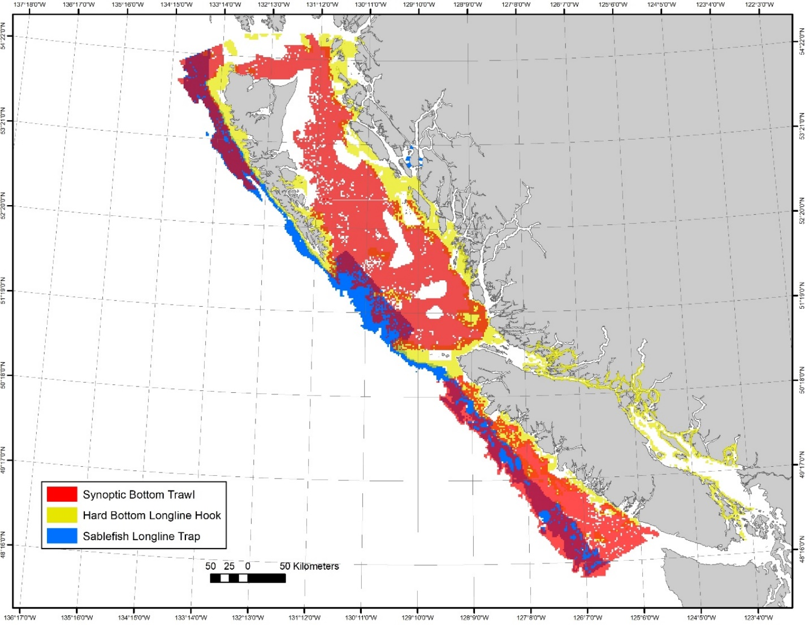

Figure 1. Random depth-stratified survey coverage.

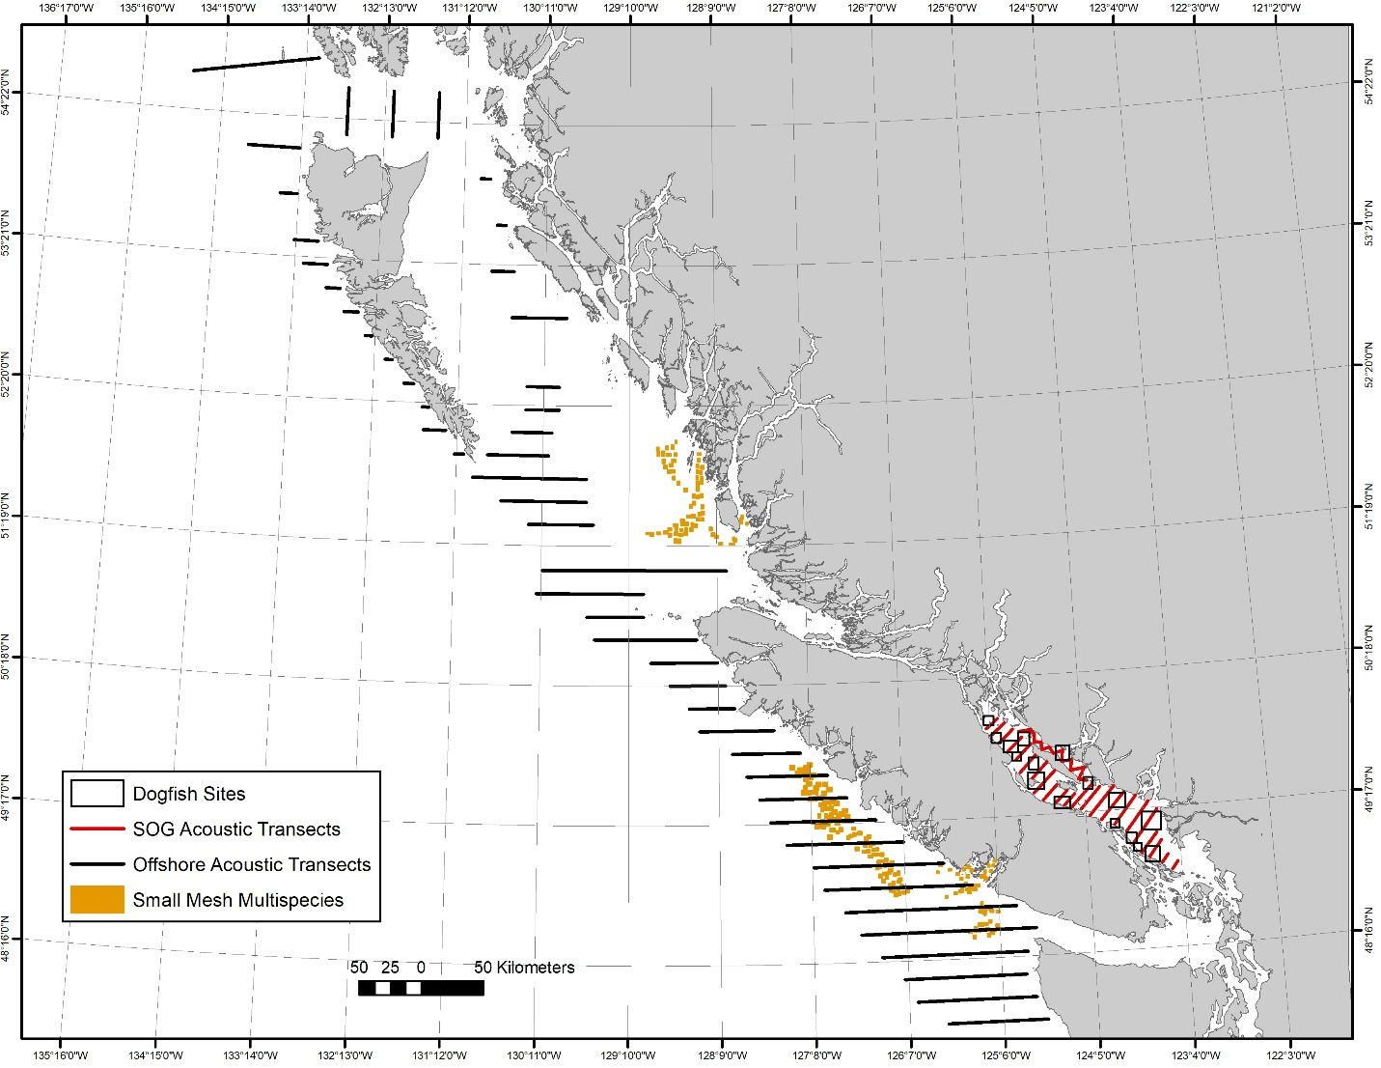

Figure 2. Coverage of surveys other than the random depth-stratified surveys shown in Figure 1. Surveys shown include the Strait of Georgia Dogfish Longline Hook Survey sites, the Offshore Pacific Hake Acoustic-Trawl Survey transects, the Strait of Georgia (SOG) Acoustic-Trawl Survey transects, and the Small Mesh Multispecies Bottom Trawl Survey tow locations.

### Multispecies Synoptic Bottom Trawl Surveys

The Multispecies Synoptic Bottom Trawl Surveys are conducted in four areas of the BC coast with two areas surveyed each year such that the whole coast is covered over a two-year period. Typically, the West Coast of Vancouver Island (WCVI) and West Coast of Haida Gwaii (WCHG) are surveyed in even-numbered years while Hecate Strait (HS) and Queen Charlotte Sound (QCS) are surveyed in odd-numbered years (Figure 3). An additional synoptic bottom trawl survey has been conducted twice in the Strait of Georgia (SOG), but vessel availability and staffing constraints have precluded establishing a regular schedule.

These surveys are conducted under a collaborative agreement with the Canadian Groundfish Research and Conservation Society (CGRCS) and, in typical years, one survey occurs on a Canadian Coast Guard Vessel with DFO staff while one survey occurs on a chartered commercial fishing vessel with a mix of DFO staff and contracted technicians. In aggregate, the surveys provide coast-wide coverage of most of the trawlable habitat between 50 and 500 meters depth.

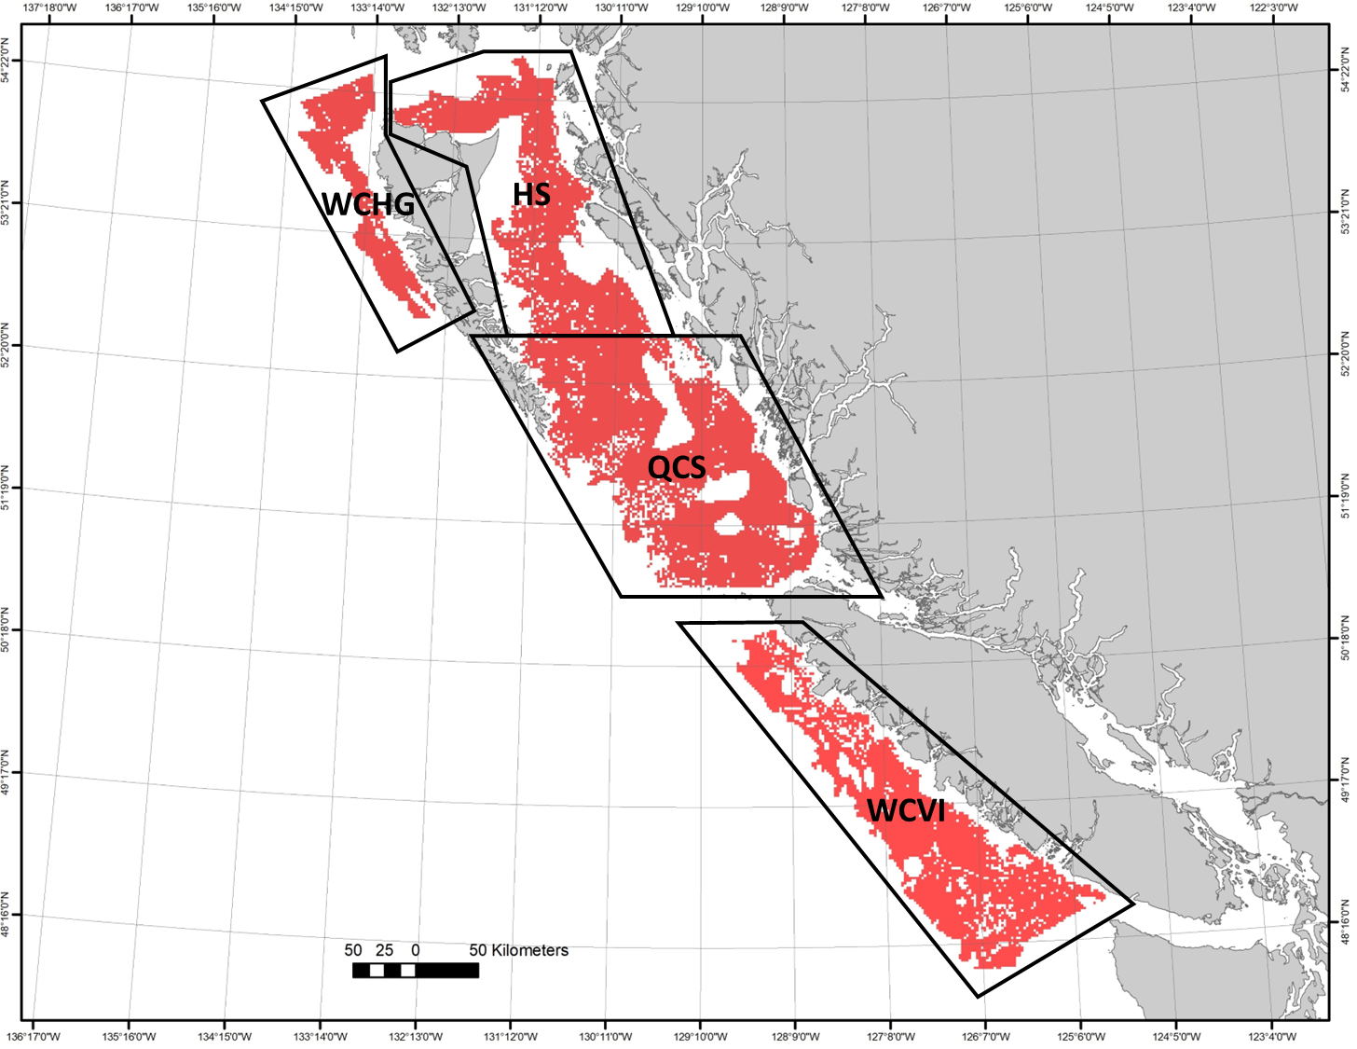

Figure 3. Multispecies Synoptic Bottom Trawl Survey coverage showing the extents of the West Coast of Haida Gwaii (WCHG), Hecate Strait (HS), Queen Charlotte Sound (QCS) and West Coast of Vancouver Island (WCVI) survey areas.

The West Coast Vancouver Island (WCVI) and West Coast Haida Gwaii Queen Charlotte Sound (WCHG) Multispecies Synoptic Bottom Trawl surveys were conducted in 2024. The WCVI survey was completed on the research vessel *Sir John Franklin* from mid-May to mid-June while the WCHG survey was completed on the chartered commercial trawl vessel *Nordic Pearl* from late-August to late-September. A total of 261 successful tows were completed over the two surveys with 148 in WCVI and 113 in WCHG (Figure 4). The dominant species in the WCVI survey catches were Sablefish (*Anoplopoma fimbria*), Arrowtooth Flounder (*Atheresthes stomias*), North Pacific Spiny Dogfish (*Squalus suckleyi*), Rex Sole (*Glyptocephalus zachirus*), and Dover Sole (*Microstomus pacificus*). The dominant species in the WCHG survey catches were Pacific Ocean Perch (*Sebastes alutus*), Rougheye/Blackspotted Rockfish Complex (*Sebastes aleutianus/melanostictus* complex), Sharpchin Rockfish (*Sebastes zacentrus*), Silvergray Rockfish (*Sebastes brevispinis*), and Yellowmouth Rockfish (*Sebastes reedi*).

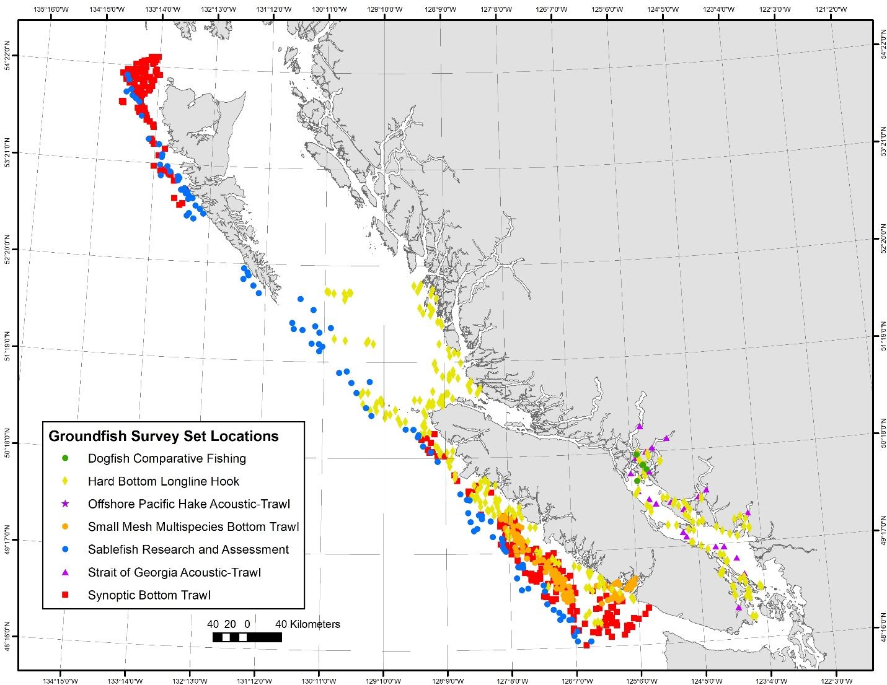

Figure 4. Fishing locations of 2024 Groundfish surveys. Fishing locations of the Offshore Pacific Hake Acoustic-Trawl Survey are not shown in this figure because they are all significantly south of British Columbia.

### Hard Bottom Longline Hook Surveys

The Hard Bottom Longline Hook (HBLL) Surveys are conducted annually in “outside” waters (not between Vancouver Island and the mainland) and “inside” waters (between Vancouver Island and the mainland). Both the “outside” and “inside” areas are divided into northern and southern regions and surveys annually alternate between the regions such that the whole coast is covered over a two-year period (Figure 5). The outside surveys are conducted under a collaborative agreement with the Pacific Halibut Management Association (PHMA) and occur on chartered commercial fishing vessels with contracted technicians. The inside surveys are conducted by DFO and occur on a Canadian Coast Guard vessel with DFO staff. In aggregate, the HBLL surveys provide coast-wide coverage of most of the untrawlable habitat between 20 and 220 meters depth.

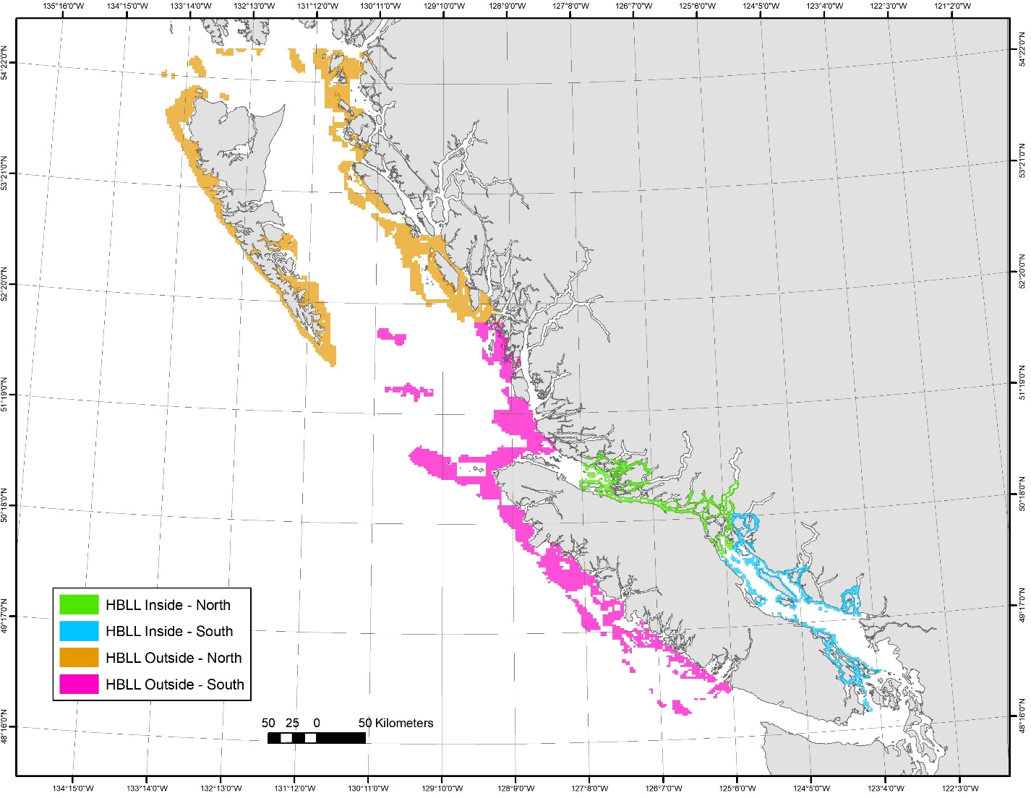

Figure 5. Hard Bottom Longline Hook Survey coverage.

In 2024 the southern regions of both the outside and inside areas were surveyed (Figure 4). The outside HBLL survey was conducted on the chartered commercial longline vessels *Banker II* and *Free to Wander* from mid-July to late-August. A total of 174 sets were completed and the most abundant species were Yelloweye Rockfish (*Sebastes ruberrimus*), Pacific Halibut (*Hippoglossus stenolepis*), Sablefish (*Anoplopoma fimbria*), Quillback Rockfish (*Sebastes maliger*), and Lingcod (*Ophiodon elongatus*). The inside survey was conducted on the research vessel Neocaligus from late-July to late- August. A total of 74 successful random sets were completed and the most abundant species were North Pacific Spiny Dogfish (*Squalus suckleyi*), Yelloweye Rockfish (*Sebastes ruberrimus*), Longnose Skate (*Raja rhina*), and Quillback Rockfish (*Sebastes maliger*).

In addition to the standard randomized sets, the 2024 HBLL survey in the inside area included a comparative fishing experiment. This work was a continuation of the work completed in 2022 and 2023. The primary goal of this work is to help assess the option of replacing the North Pacific Spiny Dogfish abundance index from the quasi-triennial Strait of Georgia Dogfish (DOG) survey with one from the annual HBLL Inside survey. The ultimate goal is to stop conducting the October DOG survey but the two surveys differ not only in timing, locations and depth range, but also in the hook size, spacing, and bait. The secondary goal of this work is to help assess how the DOG survey change in gear type from J to circle hooks in 2004 impacts inshore rockfish abundance indices over the survey time series. The 2022 and 2023 comparative sets were deployed in the standard DOG sites and depths. Each comparative set was half DOG gear and bait and half HBLL gear and bait. A total of 24 and 26 sets were completed in 2022 and 2023, respectively. The 2024 comparative sets were deployed in selected locations that were expected to yield catches of inshore rockfish species. This work is hindered by the lack of commercially available J hooks so only 4 comparative sets were completed in 2024. Each set was half historic DOG J-hook gear and half modern DOG circle hook gear.

### Sablefish Research and Assessment Survey

The Sablefish Research and Assessment Survey is an annual longline trap survey targeting Sablefish. This survey fishes at randomly selected locations in offshore waters as well as at fixed stations in mainland inlets. The survey provides catch rates and biological data for use in stock assessments and, historically, Sablefish have been tagged and released from each set. The survey is conducted under a collaborative agreement with Wild Canadian Sablefish Ltd. and occurs on a chartered commercial fishing vessel by a mix of DFO staff and contracted technicians. This survey covers the depth range of 150 m to 1250 m for the entire outer BC coast as well as several central coast inlets (Figure 1).

Parts of the 2024 Sablefish survey were reduced in scope compared to recent years. First, tagging operations have moved to a biennial rotation: there was no tagging in 2023 but tagging did occur for 2024. Second, the inlets component was reduced from four inlets to one. In addition, the bottom contact work previously conducted has been replaced with a gear selectivity study designed to examine the effects of different escape ring configurations.

In 2024, the survey was conducted on the commercial fishing vessel *Pacific Viking* from early October to mid-November. Poor weather prevented completion of the planned work: 86 of the planned 91 random offshore survey sets and 14 of the 15 planned gear selectivity study sets were completed. The 5 inlets survey and 2 inlet gear selectivity sets were not completed. A further 16 gear selectivity study sets were completed in offshore locations (Figure 4). The most abundant species were Sablefish (*Anoplopoma fimbria*), North Pacific Spiny Dogfish (*Squalus suckleyi*), Lingcod (*Ophiodon elongatus*), Pacific Halibut (*Hippoglossus stenolepis*), and Arrowtooth Flounder (*Atheresthes stomias*).

### Strait of Georgia Dogfish Longline Hook Survey

The Strait of Georgia Dogfish Longline Hook (DOG) Survey is conducted every two to five years and follows a fixed-station design that fishes at 10 to 12 locations in the Strait of Georgia (Figure 2). The survey was not conducted in 2024.

### Small Mesh Multispecies Bottom Trawl Survey

The Small Mesh Multispecies Bottom Trawl (MSSM) Survey is an annual fixed-station survey of commercially important shrimp grounds off the West Coast of Vancouver Island (Figure 2) that was initiated in 1973, and occurs on a Canadian Coast Guard Vessel with DFO staff. Catch rate indices generated by the survey have been used to track the abundances of several groundfish stocks. Groundfish staff assist in catch sorting and species identification and also collect biological samples from selected fish species. The 2024 survey was conducted onboard the research vessel *Sir John Franklin* from late April to mid-May and a total of 82 usable tows were completed (Figure 4). The most abundant species were Spotted Ratfish (*Hydrolagus colliei*), Rex Sole (Gly*ptocephalus zachirus*), Slender Sole (*Lyopsetta exilis*), Eulachon (*Thaleichthys pacificus*), and Dover Sole (*Microstomus pacificus*).

### Hydroacoustic Surveys

Groundfish participates in two acoustic-trawl surveys that focus on Pacific Hake (*Merluccius productus*). One survey is conducted in offshore waters while the second is conducted in east of Vancouver Island in the Strait of Georgia and larger mainland inlets (Figure 2).

The Offshore Pacific Hake Acoustic-Trawl Survey is part of the Joint Canada/US Hake Acoustic Survey. The survey goals alternate annually between survey and research. The 2024 trip was a research year and the work included fishing using a midwater trawl equipped with six pocket nets spread throughout the main trawl net. The survey was conducted onboard the research vessel *Sir John Franklin* in mid-August. The survey only found Hake well south of the Canada/US border and then the trip was cut short by mechanical breakdown. Processing the pocket net tows is very time consuming and a total of only 13 tows were completed (Figure 5). The most abundant species were Pacific Hake (*Merluccius productus*) and Pacific Ocean Perch (*Sebastes alutus*) with minor catches of other species.

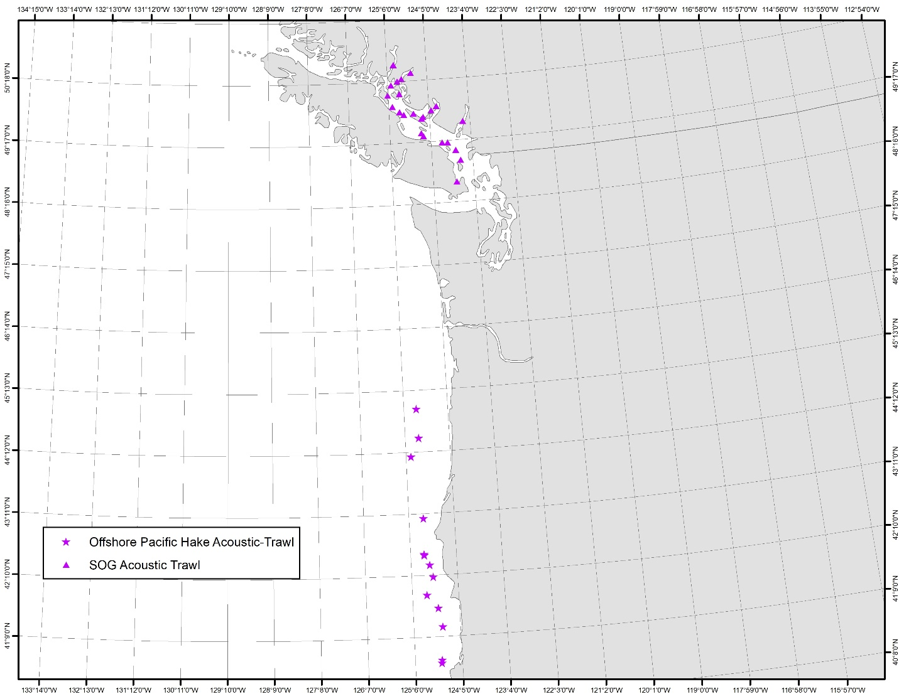

Figure 6. Tow locations completed during the 2024 Offshore Pacific Hake Acoustic-Trawl and Strait of Georgia (SOG) Acoustic-Trawl surveys.

The Strait of Georgia Acoustic-Trawl Survey is a scaled-down version of the Offshore Pacific Hake “survey” year where the vessel collects acoustic backscatter data along predefined transects. Acoustic data is collected during daylight hours with opportunistic pelagic trawl fishing to characterize the species and size composition. The 2024 survey was conducted onboard the research vessel *Sir John Franklin* from late-February to early March and a total of 24 tows were completed (Figure 6). The most abundant species were Walleye Pollock (*Gadus chalcogrammus*) and Pacific Hake (*Merluccius productus*) with minor catches of other species.

### International Pacific Halibut Commission Survey

The International Pacific Halibut Commission(IPHC) conducts an annual stock assessment longline survey in waters from California to Alaska, including British Columbia (BC) waters. The survey's main goal is to provide data on Pacific Halibut (*Hippoglosus stenolepis*) for stock assessment purposes. However, data are also recorded on other species caught, making it the longest ongoing groundfish survey in BC waters and hence a valuable source of data for many species. The gfiphc R package (<https://github.com/pbs-assess/gfiphc>), developed at PBS and updated annually, contains much of the relevant data (and enables extraction from **GFBio** for the rest). It also includes code for deriving relative biomass index trends for non-halibut groundfish species within BC, based on methods that take into account the changing survey methodologies (see Anderson et al., 2019). Results for 113 species are directly viewable at <http://htmlpreview.github.io/?https://github.com/pbs-assess/gfiphc/blob/master/vignettes/data_for_all_species.html>, and are incorporated into the groundfish synopsis report (DFO 2022).

# Research and Publications

### Groundfish Synopsis Report

In 2024, two updates to the groundfish synopsis report were released as technical reports. These contain data up to 2022 and up to 2023. Starting with the 2022 data update, data from the Small-Mesh Multi-species bottom trawl are now included in the biomass indices and length composition data; three species were added: Eulachon (*Thaleichthys pacificus*), Popeye (*Coryphaenoides cinereus*), and Shortbelly Rockfish (*Sebastes jordani*); and spatiotemporal model-based biomass indices are also now included for the IPHC, coastwide Synoptic surveys, coastwide Outside HBLL surveys, and the combined Inside HBLL surveys.  
In the 2023 data update: the data for the IPHC spatiotemporal model index is now derived directly from the IPHC website; recreational and unknown sectors have been removed from the commercial biological samples; and we have updated the species name “North Pacific Spiny Dogfish” to “Pacific Spiny Dogfish” in accordance with the latest American Fisheries Society recommendation. Lastly, the CPUE index standardization is now done using a spatiotemporal model. This report is generated using the gfsynopsis package (<https://github.com/pbs-assess/gfsynopsis>).

Anderson, S.C., Dunic, J.C., Keppel, E.A., and Edwards, A.M. 2024. A data synopsis for British Columbia groundfish: 2022 data update. Can. Tech. Rep. Fish. Aquat. Sci. 3624: viii + 267 p. <https://waves-vagues.dfo-mpo.gc.ca/library-bibliotheque/41252068.pdf>

Anderson, S.C., Dunic, J.C., Keppel, E.A., and Edwards, A.M. 2024. A data synopsis for British Columbia groundfish: 2023 data update. Can. Tech. Rep. Fish. Aquat. Sci. 3641: viii +262 p. <https://doi.org/10.60825/aevx-nb49>

Collection of Commercial Biological Samples

Historically, the collection of commercial biological samples from groundfish species was conducted by at-sea fisheries observers from Archipelago Marine Research (AMR). However, in 2020, due to the COVID pandemic, the observer program was shut down and never re-started. It was replaced instead by electronic monitoring (EM) systems, also provided by AMR.

To address the lack of commercial biological samples, several programs were initiated starting in 2022. These programs are intended to provide comprehensive biological samples of selected groundfish species, including length, weight, sex, maturity, and age structures. The first program was targeted at Pacific Hake offloads, primarily from the west coast of Vancouver Island. In 2023, sampling of selected rockfish species from trawl landings was initiated at the ports of Ucluelet, Port Hardy, Prince Rupert, and Lax-Kwʼalaams (formerly Port Simpson). Also in 2023, shoreside sampling of Arrowtooth Flounder from freezer trawlers began. These samples are collected by crews during commercial fishing, frozen, then delivered to AMR staff at offload for processing. In 2024 shoreside sampling of Pacific Cod was added, and a program to have fishing crews measure Pacific Halibut lengths at sea was initiated. Finally, in 2025 shoreside sampling of Dover Sole, Southern Rock Sole, English Sole, and Petrale Sole was added. All of these programs are actively monitored by a working group that includes representatives from industry and DFO, and it is anticipated that additional species or species groups, will be added to the existing programs going forward. A technical report describing this program will be prepared in 2025-26.

### Small Mesh Multispecies Survey Report

Since 1973, Fisheries and Oceans Canada (DFO) has conducted the Small-mesh Multi-species Bottom Trawl Survey (SMMS), the longest continuous fisheries-independent monitoring time series for groundfish off the west coast of Vancouver Island (WCVI). Initially designed to collect data to assess Pink shrimp (*Pandalus jordani*) populations, the survey also samples groundfish. The SMMS provides a valuable historical baseline for groundfish species as current synoptic trawl surveys for Pacific groundfish began in 2003 and are biennial across regions. However, changes to the SMMS, including changes to the sampling area, fishing gear, and catch recording procedures, may affect the quality of groundfish population indices. Dr. Jillian Dunic and Dr. Sean Anderson summarised these changes and assessed how they affect the interpretation of relative biomass indices for groundfish. They compared spatiotemporal model-based population indices from the SMMS with other regional indices and examined the distribution of lengths and ages in comparison to the synoptic West Coast Vancouver Island trawl survey (SYN WCVI). The comparison of indices and review of changes suggest that the modelled SMMS index is a suitable measure of relative biomass for species identified at the species level throughout the survey. However, changes to the survey, such as the switch to comprehensive species sorting and identification in 2003, coupled with a lack of calibration data, mean that there are some uncertainties in the pre-2003 data. Importantly, for some species, the SMMS detected signs of rockfish recruitment earlier than the SYN WCVI.

Dunic, J.C. and Anderson, S.C. 2025. [Assessing the quality of groundfish population indices  
derived from the Small-mesh Multi-species Bottom Trawl Survey](https://doi.org/10.60825/rjyz-8w29). Can. Tech. Rep. Fish. Aquat.  
Sci. 3667: v + 40 p. (<https://doi.org/10.60825/rjyz-8w29>)

### Passive Acoustic Monitoring (PAM) of Rocky Reef Fishes

Dr. Dana Haggarty and collaborators continue to work on developing methods to use Passive Acoustics (i.e. recordings of fish sounds) to monitor fishes. However, the significant time required for human analysts to manually label fish sounds in acoustic recordings does not yet allow passive acoustics to be used as a viable tool for monitoring fishes. They developed an automatic fish sound detector using a deep learning approach Convolutional Neural Network (CNN). Algorithms were trained using 21,950 manually annotated fish and non-fish sounds collected from 2014 to 2019 at five different locations in the Strait of Georgia, British Columbia, Canada and tested on data from those sites that was withheld from the training phase, data from Barkley Sound, British Columbia, and data collected in the Port of Miami, Florida, USA. The approach can efficiently monitor (unidentified) fish sounds in a variety of environments and can also facilitate the development of species-specific detectors, as new fish sounds are being identified. They provide the software [FishSound Finder](https://github.com/xaviermouy/FishSound_Finder), an easy-to-use open-source implementation of the CNN detector with detailed documentation.

Mouy, X., Archer, S.K., Dosso, S., Dudas, S., English, P., Foord, C., Halliday, W., Juanes, F., Lancaster, D., Van Parijs, S., and Haggarty, D. 2024. Automatic detection of unidentified fish sounds: A comparison of traditional machine learning with deep learning [Original Research]. Frontiers in Remote Sensing 5. [doi:10.3389/frsen.2024.1439995](https://www.frontiersin.org/journals/remote-sensing/articles/10.3389/frsen.2024.1439995/full).

### Evaluating the Utility of Integrating Close-Kin Mark Recapture-Data within Stock Assessments

Close-Kin Mark-Recapture (CKMR) sampling, by providing information on abundance and survival rates (and potentially other quantities), offers a promising new data source for fisheries stock assessments. Sample design in order to achieve a desired precision is somewhat straightforward in simple CKMR models; however when integrated within a full stock assessment model with many other data sources, the value of the data (in terms of a reduction in uncertainty of model estimates) is less clear. In this research, Dr. Fisch demonstrates the expected improvements in precision and accuracy of derived quantities and estimated parameters within statistical catch-at-age models when opportunistic CKMR sampling is conducted and the data integrated within the assessment. By opportunistic CKMR sampling he means to describe the genetic sampling of individuals that comprise the age composition data, such that increases in CKMR sampling would also increase the age composition samples (and vice versa). Expected improvements were examined across three life history types (cod-like, flatfish-like, and sardine-like) and different amounts of data available to the assessment, including the uncertainty and inclusion of an abundance index and the sample size and time series length of CKMR and age composition samples. Results suggest CKMR data can provide considerable improvements in accuracy and precision of spawning stock biomass at the end of the time series and parameters defining natural mortality and scale of the population, provided an adequate annual sample size is collected relative to the spawning abundance of the stock during the period of CKMR inference. The time-series length of CKMR data and uncertainty or inclusion of an abundance index played a much more moderate role in how much improvement CKMR data provided over models fit without CKMR. This result was likely a function of the model being privy to an effectively known catch time series and known steepness, allowing it to estimate stock scale and trend reasonably well without CKMR data given informative composition data. Dr Fisch recommends simulation analyses including stock assessments as estimation models be carried out for those considering routinely collecting and integrating CKMR data into fisheries stock assessments.

Fisch, N., 2025. Expected improvements in precision when integrating opportunistic close-kin mark-recapture data into fisheries stock assessments. *Fisheries Research*, *281*, p.107222.

<https://doi.org/10.1016/j.fishres.2024.107222>

### Body condition as a shared response to environmental conditions

Drs. Philina English, Sean Anderson, and Robyn Forrest are investigating how environmental changes in Canadian Pacific waters are influencing average body condition for 35 groundfish species. Because the condition of mature male, mature female, and immature individuals have different implications for population dynamics, measurement issues, and potentially different ecological drivers, they first separated individual fish and overall catches into these components and generated a density-weighted annual index of average condition for each component of the population. Then they identified common trends across species and correlations with environmental conditions. Regardless of sex or maturity, they found that spring sea surface temperature (SST) and two-year-lagged North Pacific Gyre Oscillation (NPGO, an indicator of productivity on our coast) were most related to body condition. For most species, warmer SST was either neutrally or positively correlated with body condition, while the impact of NPGO was more variable. Immature body condition was also strongly correlated with primary production, but among species this effect was equally likely to be negative (e.g., Pacific Spiny Dogfish, Lingcod, Sablefish) as positive (e.g., Quillback Rockfish, Southern Rock Sole, Spotted Ratfish). This approach has the benefit of both providing an ecosystem perspective of shared responses across an assemblage of species, while also providing species-specific inference. Components of these analysis are forming the basis for a couple R packages currently in development to aid in identifying environmental relationships for consideration in stock assessments (github.com/pbs-assess/[gfcondition](https://github.com/pbs-assess/gfcondition), and github.com/pbs-assess/[gfenvriocor](https://github.com/pbs-assess/gfenvirocor)).

### State of the Pacific Ocean: Trends in Pacific Canadian Groundfish Stock Status and Surveys

Since 1999 an annual State of the Pacific Ocean meeting has been convened by DFO to bring together the marine science community in the Pacific Region and present the results of the most recent year’s monitoring in the context of previous observations and expected future conditions. The workshop to review ecosystem conditions in each year is a hybrid meeting which alternates between Nanaimo and Sidney, BC. A technical report includes submissions based on presentations given at the meeting and poster summaries. Groundfish trends are presented at this meeting annually and a summary is published in the report. Trends for 2024 were presented at the meeting on March

Average groundfish stock status declined from 1950 to around 2000, and following management changes, has remained relatively stable since then. In 2024, assessments were updated for four stocks (Petrale Sole, Bocaccio, Pacific Spiny Dogfish (outside), and Arrowtooth Flounder). Over the last two decades, survey indices increased for ~66% of stocks, remained neutral for ~14%, and declined for ~20% stocks. All assessed shelf rockfish (Bocaccio, Canary, Redstripe, Silvergray, Widow, Yellowtail) and several slope rockfish increased in surveyed biomass over the last 5–7 years; surveyed biomass also increased for several flatfish (Petrale, English, Rex, and Dover Sole) but declined for Arrowtooth Flounder over the last 5–10 years. Survey indices for Pacific Spiny Dogfish stocks had the steepest declines across all stocks—particularly for the outside stock, which excludes inside Vancouver Island waters—despite low fishing pressure compared to historical levels.

Sean C. Anderson, Jillian C. Dunic, Philina A. English, Trends in Pacific Canadian Groundfish Stock Status and Surveys. *In* Boldt, J.L., Joyce, E., Tucker, S., Gauthier, S., and Dosser, H. (Eds.). 2024. [State of the physical, biological and selected fishery resources of Pacific Canadian marine ecosystems in 2023](https://waves-vagues.dfo-mpo.gc.ca/library-bibliotheque/41260879.pdf). Can. Tech. Rep. Fish. Aquat. Sci. 3598: viii + 315 p.

### Lingcod Egg Conversion

Lingcod eggs are a culturally important food source to some First Nations of coastal British Columbia. Leah Walker and Dana Haggarty developed a conversion factor to translate Lingcod egg harvest quantity to adult Lingcod management equivalents under a fishing allocation. A dive survey was conducted in the Strait of Georgia at Snake Island reef on January 24, 2022, to collect samples from three Lingcod egg masses. From these three samples, the mean weight per egg was 17.1 ± 0.2 mg (mean ± SE), the mean diameter per egg was 3.49 ± 0.03 mm, and the mean number of eggs per 100 ml was 2612 ± 268 eggs. Published data from previous Lingcod egg mass density surveys in 2001-2005 and 2010-2012 were also used in the conversion analysis. Previous surveys determined a mean nest density across all locations and years of 0.40 ± 0.03 nests per 100 m2 and a mean nest volume of 4432 ± 218 ml. We estimated the conversion factor between Lingcod eggs and adult equivalents as 2.82 ± 0.36 kg of adult Lingcod per kg of Lingcod eggs. This conversion factor could be applied in determining future harvest allocations.

Walker, L.C. and Haggarty, D.R. 2024. [Lingcod (Ophiodon elongatus) eggs to adult mass conversion factor for harvest allocation in the Strait of Georgia.](https://waves-vagues.dfo-mpo.gc.ca/library-bibliotheque/41242798.pdf) Can. Tech. Rep. Fish. Aquat. Sci. 3604: v + 15 p.

### Enhanced Salmon Sampling Program

The Pacific Region Groundfish Trawl Fishery is one of the largest fisheries in British Columbia by catch volume and value. Beginning fall 2022, new monitoring and retention requirements for salmon bycatch were introduced in the fishery to improve the accuracy of catch estimates and collect information on Chinook salmon stock composition and coded wire tags (CWT). This report describes results for the 2023/24 groundfish fishery, the first full year of the enhanced monitoring program. There was an estimated total of 28,145 salmon caught in the 2023/24 groundfish fishery including 21,696 Chinook salmon. CWT and genetic stock composition estimates indicate that most bycatch of Canadian origin Chinook salmon was from the Fraser Fall 4(1) stock management unit, which includes CWT exploitation rate indicator stocks from the Chilliwack and Harrison River. A new salmon bycatch management plan has been implemented for the 2024/25 fishery, including a fleet-wide bycatch cap of 9,500 Chinook salmon, therefore, future catches will be reduced compared to information reported here for 2023/24.

Lagasse, C.R., Fraser, K.A., Braithwaite, E., Komick, N. 2025. [Salmon Bycatch Monitoring and Sampling Results for the Pacific Region 2023/24 Groundfish Trawl Fishery](https://doi.org/10.60825/d0e4-pp46). Can. Manuscr. Rep. Fish. Aquat. Sci. 3298: vi + 41 p.

### Explaining empirical dynamic modelling using verbal, graphical and mathematical approaches

Drs. Andy Edwards, Luke Rogers and Carrie Holt published on models that are used to help manage natural populations usually consist of mathematical equations. Empirical dynamic modelling is an approach that makes population projections based only on the data, and not on equations that make fundamental assumptions. This approach is becoming widely used in ecology, and fisheries in particular. However, the methods behind it have not been fully documented, and so Edwards et al. (2024) fill in some of the existing gaps and explain the approach using different styles (including a narrated video). In particular, this reveals that current implementation may give incorrect results.

Edwards, A.M, L.A. Rogers, and C.A. Holt (2024). Explaining empirical dynamic modelling using verbal, graphical and mathematical approaches. Ecology and Evolution, 14:e10903, 1-12. [https://doi.org/10.1002/ece3.10903](https://can01.safelinks.protection.outlook.com/?url=https%3A%2F%2Fdoi.org%2F10.1002%2Fece3.10903&data=05%7C02%7CDana.Haggarty%40dfo-mpo.gc.ca%7Cd753ef5f388543acabb308dd716b185a%7C1594fdaea1d94405915d011467234338%7C0%7C0%7C638791426977474690%7CUnknown%7CTWFpbGZsb3d8eyJFbXB0eU1hcGkiOnRydWUsIlYiOiIwLjAuMDAwMCIsIlAiOiJXaW4zMiIsIkFOIjoiTWFpbCIsIldUIjoyfQ%3D%3D%7C0%7C%7C%7C&sdata=uOsb2AQCARmoPTws7iH8JdZiL0olHQzWjEpBNJC%2Ft7k%3D&reserved=0)

### pacea: An R package of Pacific ecosystem information to help facilitate an ecosystem approach to fisheries management

Dr. Andy Edwards and collaborators continue to develop the pacea R package in order to support DFO science the include environmental considerations in stock assessments. The revised Fisheries Act from DFO says that “. . . the Minister shall take into account the environmental conditions affecting a fish stock.” Yet <50% of DFO’s stock assessments use environmental data (as of 2022), and only 28% of assessments in DFO’s Pacific Region. The leading cause of not using environmental data is availability of the data. To help rectify this and facilitate an ecosystem approach to fisheries management, Edwards et al. (2024) developed the R package pacea, which contains ecosystem information from a variety of sources, all in an fully-documented R package (complete with plotting functions and analytical tools). Information includes temperature, climatic and oceanographic indices, outputs from a physical biogeochemical oceanographic model and a physical oceanographic model, and biological estimates of biomass or abundances of Pacific Herring, Pacific Hake, Harbour Seals and zooplankton. The package is open source and freely available, continues to be updated, and is already being used in assessments (e.g. Appendix H of Johnson et al., 2025).

Edwards A.M., Tai T.C., Watson J., Peña M.A., Hilborn A., Hannah C.G., Rooper C.N., Flynn K.L., and Oldford, G.L. (2024). pacea: An R package of Pacific ecosystem information to help facilitate an ecosystem approach to fisheries management. [https://github.com/pbs-assess/pacea](https://can01.safelinks.protection.outlook.com/?url=https%3A%2F%2Fgithub.com%2Fpbs-assess%2Fpacea&data=05%7C02%7CDana.Haggarty%40dfo-mpo.gc.ca%7Cd753ef5f388543acabb308dd716b185a%7C1594fdaea1d94405915d011467234338%7C0%7C0%7C638791426977512832%7CUnknown%7CTWFpbGZsb3d8eyJFbXB0eU1hcGkiOnRydWUsIlYiOiIwLjAuMDAwMCIsIlAiOiJXaW4zMiIsIkFOIjoiTWFpbCIsIldUIjoyfQ%3D%3D%7C0%7C%7C%7C&sdata=Byj4cYJhPXM9Z6RZkshdWo766%2B7sDYoYRNWQnl7vz7E%3D&reserved=0), [https://zenodo.org/doi/10.5281/zenodo.13840804](https://can01.safelinks.protection.outlook.com/?url=https%3A%2F%2Fzenodo.org%2Fdoi%2F10.5281%2Fzenodo.13840804&data=05%7C02%7CDana.Haggarty%40dfo-mpo.gc.ca%7Cd753ef5f388543acabb308dd716b185a%7C1594fdaea1d94405915d011467234338%7C0%7C0%7C638791426977534996%7CUnknown%7CTWFpbGZsb3d8eyJFbXB0eU1hcGkiOnRydWUsIlYiOiIwLjAuMDAwMCIsIlAiOiJXaW4zMiIsIkFOIjoiTWFpbCIsIldUIjoyfQ%3D%3D%7C0%7C%7C%7C&sdata=4GyBoJmLNy2BXO%2FVMUdh9wqRcFoTqYhy57%2F3n3tXFjk%3D&reserved=0)

### Using highest density intervals can reduce perceived uncertainty in stock assessments.

Stock assessments need to communicate uncertainty of estimated quantities, which is often done through figures and tables depicting credible or confidence intervals. Edwards and Auger-Méthé (2025) show that computing such intervals with the usual equal-tailed approach has undesirable consequences, such as excluding highly probable values yet including relatively improbable values. This can give an overly optimistic impression of the health of fish stocks, with potential unexpected management implications. Instead, using highest density intervals can resolve these problems, resulting in narrower intervals that reduce perceived uncertainty (by >3 billion fish for a recent cohort of Pacific Hake, for example). Therefore, Edwards and Auger-Méthé (2025) recommend consideration of highest density intervals in fisheries applications and other fields to better characterize uncertainty and improve conservation advice.

Edwards A.M. and M. Auger-Méthé (2025). Using highest density intervals can reduce perceived uncertainty in stock assessments.

Fisheries Research, 285:107326. [https://doi.org/10.1016/j.fishres.2025.107326](https://can01.safelinks.protection.outlook.com/?url=https%3A%2F%2Fdoi.org%2F10.1016%2Fj.fishres.2025.107326&data=05%7C02%7CDana.Haggarty%40dfo-mpo.gc.ca%7Cd753ef5f388543acabb308dd716b185a%7C1594fdaea1d94405915d011467234338%7C0%7C0%7C638791426977570164%7CUnknown%7CTWFpbGZsb3d8eyJFbXB0eU1hcGkiOnRydWUsIlYiOiIwLjAuMDAwMCIsIlAiOiJXaW4zMiIsIkFOIjoiTWFpbCIsIldUIjoyfQ%3D%3D%7C0%7C%7C%7C&sdata=kEFOwkHI6cTHIPZygPzKToN8SaL4cGHIlDtE1atSyUI%3D&reserved=0)

# Stock Assessments and Management by Species/Group

During 2024/25, DFO Science provided coastwide harvest advice in full stock assessments for Petrale Sole, Yellowtail Rockfish and Pacific Spiny Dogfish and stock assessment updates for Bocaccio and Arrowtooth Flounder. Advice was provided for Sablefish in the form of a management procedure (MP) update. Updated advice for Pacific Halibut and offshore Pacific Hake continue to be provided annually by the International Pacific Halibut Commission (IPHC) and Pacific Hake Joint Technical Committee (JTC), respectively. In 2025/26 DFO Science anticipates assessments for Outside Lingcod, Gulf Hake, Silvergray Rockfish, Dover Sole, the outside stock of Yelloweye Rockfish, and an MP update for Sablefish.

## Stocks Assessed in 2024

### Pacific Spiny Dogfish (Outside)

Pacific Spiny Dogfish (*Squalus suckleyi*) are assessed in BC as two stocks associated with “inside” waters between Vancouver Island and the mainland, and an “outside” stock in the remaining coastal areas. The outside dogfish stock was assessed in 2024 and reviewed at CSAS in October 2024. The assessment reconstructed the historical abundance of outside Dogfish through two-sex, age-structured population models fit to fishery and survey catch, indices of abundance or biomass from standardized commercial trawl catch per unit effort (CPUE) and scientific surveys, and length composition data from both fisheries and scientific surveys. The models were constructed using Stock Synthesis SS3. The base model estimated unfished recruitment and selectivity parameters for the fisheries and surveys. Biological parameters related to growth, maturity, and fecundity were estimated outside of the population dynamics model, but uncertainty was captured through several alternative sets of parameters. No recruitment deviations were estimated as no information about cohort strength was evident in the size composition data. The assessment explored uncertainties related to natural mortality (M), discard mortality, the representativeness of various indices of abundance, the shape of the stock-recruit curve, and the possibility of time-varying changes to M. In total, the assessment considered one base model, 15 sensitivity models without time-varying M, and five sensitivity models with time-varying M. The Science Advisory Report and Research Document are both in preparation and have not yet been published. Results will be provided in next year’s GTC report.

### Offshore Hake

Management of Pacific Hake has been under a treaty (The Agreement) between Canada and the United States since 2011. The stock is managed by the Joint Management Committee (JMC) which is made up of fisheries managers and industry representatives from both the U.S. and Canada. These managers receive advice from the JTC and the Scientific Review Group (SRG), which is a committee responsible for the scientific review of the assessment.

The final assessment document and other treaty-related documents are posted at: Johnson, K.F., A.M. Edwards, A.M. Berger, C.J. Grandin, and C.R. Wetzel (2025). Status of the Pacific Hake (whiting) stock in U.S. and Canadian waters in 2025. Prepared by the Joint Technical Committee of the U.S. and Canada Pacific Hake/Whiting Agreement, National Marine Fisheries Service and Fisheries and Oceans Canada. 286 p. <https://s3.amazonaws.com/media.fisheries.noaa.gov/2025-02/Status-Pacific-Hake-whiting-US-and-Canadian-waters-2025.pdf>

### Bocaccio

Bocaccio (*Sebastes paucispinis*) was assessed in 2019 (Research Document 2022/001, Science Advisory Report 2020/025, Proceedings 2021/014), and a very large 2016 cohort was predicted to elevate the stock from the DFO Critical Zone to the Healthy Zone by 2023. An update of the stock assessment model using new survey and commercial CPUE indices was performed in 2021 (Science Response 2022/001), which verified the recovery of this species: B2022 /BMSY = 1.499 (0.625, 3.416). This stock has been followed closely because prior to the large recruitment event in 2016, Bocaccio was under a rebuilding plan, so another update to the 2019 assessment was completed in 2024.

Given the 2021 and 2024 updated stock assessments, the 2019 stock assessment appeared to have underestimated the actual rate of recovery. This was because both updates estimated a larger 2016 cohort than the 2019 stock assessment (indicated by millions of age-1 fish in 2017): 2024 R2017 = 44 (25, 92), 2021 R2017 = 47 (25, 96), and 2019 R2017 = 25 (12, 59) million age-1 fish. In 2019, the stock assessment projected that the 2022 and 2024 spawning biomass would be in the Healthy zone (>0.8BMSY) with 48% and 85% probabilities, respectively, at a constant projected catch of 200 t/y from 2020 to 2023. The 2021 update estimated the 2022 spawning biomass to have a probability of 87% to be the Healthy zone, and projected the 2024 biomass (at catch = 500 t/y) to have a probability of >99% to be the Healthy zone, even though the actual 2022 and 2023 catches were much higher than the 500 t/y used in that projection. Nevertheless, in spite of the higher catches observed in 2022 and 2023, the 2024 update estimated that the 2024 spawning biomass had a probability of 99% to be above the upper stock reference point (0.8MSY) and in the Healthy zone.

DFO. 2024. [Update of the 2019 Bocaccio (Sebastes paucispinis) Stock Assessment for British Columbia in 2024](https://waves-vagues.dfo-mpo.gc.ca/library-bibliotheque/41260284.pdf). DFO Can. Sci. Advis. Sec. Sci. Resp. 2024/033.

### Yellowtail Rockfish

The BC coastwide stock of Yellowtail Rockfish (*Sebastes flavidus*) was assessed in 2024 using a two-sex, catch-at-age model. Inputs included catch (reconstructed back to 1935) from one commercial trawl fishery (non-trawl catch was negligible but added into the catch series), six fishery-independent trawl survey series, and age composition data from three survey series (24 years of data) and the commercial fishery (38 years of data). The model started from an assumed equilibrium state in 1935.

Bayesian models, run on the Stock Synthesis 3 platform, were fit to the MPD level (most likely parameter estimates), and a Markov Chain Monte Carlo (MCMC) ‘No U-Turn Sampling’ (NUTS) procedure was used to sample parameter space. Primary estimated parameters included natural mortality *M* for each sex, the stock-recruitment steepness parameter *h*, and recruitment of age-0 fish (as log *R*0) in an unfished equilibrium system. Additional estimated parameters included recruitment deviations over the period 1935–2024, average recruitment over the period 1935-2015, and selectivity for the commercial trawl fleet and for the three surveys with age frequency (AF) data. The survey scaling coefficients (*q*) were determined analytically. Fourteen sensitivity analyses, evaluated with MCMC, were conducted relative to the base run to test the effect of alternative model assumptions.

The base run (adopted as the best model run for the species given the data) estimated the Yellowtail Rockfish female spawning population biomass at the start of 2025 (median with 0.05 and 0.95 quantiles) to be 0.56 (0.33, 0.91) relative to *B*0 and 2.3 (1.2, 4.6) relative to *B*MSY. This latter result suggested that the 2025 spawning population was positioned well in the Healthy zone. The maximum sustainable yield was estimated to be 4,556 tonnes (2,840 t, 7,416 t), and *B*MSY was estimated to be 9,807 t (5,225 t, 16,099 t).

The median MCMC estimates by the 14 sensitivity runs for *B*2025/*B*0 ranged from 0.47 to 0.81 and for *B*2025/*B*MSY ranged from 2.02 to 3.16, indicating that all 14 sensitivity runs lay well in the Healthy zone. These sensitivity runs included: estimating senescence for YTR older than age 9, estimating dome-shaped selectivity for females, parameterising the weighting of AFs, increasing and decreasing pre-1996 catch histories, using higher and lower recruitment standard deviation (*σR*) assumptions, as well as estimating *σR*, omitting ageing error, using two alternative ageing error vectors, adding the Hard Bottom longline survey series, using an alternative geostatistical approach to estimating the synoptic survey indices, and splitting the single trawl fleet into bottom and midwater trawl fleets.

Correlations for six environmental index series were explored by using them as covariates with the base run’s posterior distribution of estimated recruitment deviations. None of the these environmental series showed much predictive power because of the considerable associated uncertainty and the relatively small amount of observed contrast across the range of available observations. However, these relationships suggested that there could be some potential predictive power once more detailed analyses were undertaken.

Starr, P.J. and Haigh, R. 2024. Yellowtail Rockfish (*Sebastes flavidus*) stock assessment for British Columbia in 2024. (in prep). DFO Can. Sci. Advis . Sec. Res. Doc. 2025/nnn. v + xxx p.

### Sablefish

Sablefish (*Anoplopoma fimbria*) stock status is regularly evaluated as part of a management strategy evaluation (MSE) process. An operating model (OM) is used to both estimate stock status and simulate data for prospective testing of management procedure (MP) performance relative to stock and fishery objectives. The intention is to select an MP that can be repeatedly applied to produce a catch limit each year using updated monitoring data. Once an MP is selected, it is applied annually until the next round of OM update and MP evaluation. The last update to the BC Sablefish OM was done in 2022 (DFO 2023), with simulation testing used to inform selection of the current Sablefish MP.

In 2024, the Sablefish MP was applied to updated stock and fishery monitoring data to set the TAC for the 2024-25 fishing year (DFO 2024). MP biomass was estimated to be well above the upper control point below which harvest rates are reduced, which meant that the target harvest rate for 2024-25 was set at the maximum target harvest rate of 6.4%. The MP recommended catch limit for 2024-25 was 3,029 tonnes, which was the same level as the previous year.

DFO. 2023. [A Revised Operating Model for Sablefish in British Columbia in 2022](https://waves-vagues.dfo-mpo.gc.ca/library-bibliotheque/41102587.pdf). DFO Can. Sci. Advis. Sec. Sci. Advis. Rep. 2023/010.

DFO. 2024. [Application of the British Columbia Sablefish (*Anoplopoma fimbria*) Management Procedure for the 2024-25 Fishing Year](https://waves-vagues.dfo-mpo.gc.ca/library-bibliotheque/41244072.pdf). DFO Can. Sci. Advis. Sec. Sci. Resp. 2024/013.

### Petrale Sole

The BC Coastwide stock of Petrale Sole (*Eopsetta jordani*) was assessed in a two-sex catch-at-age model using catch data (from 1938 to 2023), and was fit to three fishery-independent survey indices (from 2003 to 2023) and age data from the fishery and fishery-independent surveys (from 2004 to 2019). Petrale Sole is primarily harvested by the multi-species groundfish trawl fishery. Natural mortality (M), which had to be fixed, was identified as a key uncertainty in this stock assessment, leading to the development of an ensemble model based on three separate models with low, medium, and high M fixed estimates. This approach allowed some uncertainty in M to be incorporated into estimated stock status and harvest advice.

Maximum sustainable yield (MSY)-based reference points were recommended for characterizing stock status and informing harvest decisions. A limit reference point (LRP) at 0.4 female spawning biomass at maximum sustainable yield (BMSY), a candidate upper stock reference (USR) at 0.8BMSY, and a candidate removal reference (RR) at fishing mortality at maximum sustainable yield (FMSY) were used, consistent with the provisional recommendations in the Precautionary Approach (PA) policy. Stock status relative to the unfished female spawning biomass (B0) was also presented in the assessment document. The stock at the beginning of 2024 was estimated to be in the Healthy zone, with female spawning biomass at the beginning of 2024 (B2024) estimated to be 3.01 (95% credible interval: 1.62,5.60) times the female spawning biomass at maximum sustainable yield, BMSY. Also, B2024 was estimated to be 0.96 (0.55,1.63) times B0. B2024 is above the LRP and candidate USR with a greater than 99% probability. Additionally, fishing mortality in 2023 was below the candidate RR with a greater than 99% probability.

DFO. 2025. [Assessment of Petrale Sole in British Columbia in 2024](https://waves-vagues.dfo-mpo.gc.ca/library-bibliotheque/4127961x.pdf). DFO Can. Sci. Advis. Sec. Sci. Advis. Rep. 2025/002.

### Arrowtooth Flounder

Arrowtooth Flounder (*Atheresthes stomias*) stock status on the West Coast of British Columbia  
was last assessed using data from 1996–2021. In the last assessment (reviewed in 2022; the ‘2022 stock assessment’), the stock was estimated slightly below the Upper Stock Reference (USR) in the base model and close to the Limit Reference Point (LRP) under one sensitivity model with higher recruitment variation. The model also showed declining estimated spawning stock biomass, declining survey indices, and declining estimated recruitment. Due to these issues, a two-year update on the stock was requested by the Groundfish Management Unit (GMU) in 2023 including data. This two-year span was chosen since the biennial survey indexes included in the model would each have one new year of data.

In 2024 a stock assessment update was done, in which the catch and survey indices were updated for the 2022 model. The update model estimated a median stock size at the beginning of 2024 at 67.01 kilotonnes (kt) with a credible interval (CI) of 50.20–90.65 kt. When divided by the estimated unfished biomass (*B*0), the median relative biomass for 2022 was estimated to be 0.37 with a CI of 0.26–0.55. The estimated median relative biomass for 2011, was estimated to be 0.80 with a CI of 0.56–1.13. The estimated biomass declined each year from 2011–2023.

DFO. In press. Stock Status update for Arrowtooth Flounder (*Atheresthes stomias*) for the West

Coast of British Columbia in 2024. DFO Can. Sci. Advis. Sec. Sci. Resp. 2024/999.

### Summary of Assessment Advice by Stock

Table 1. List of Groundfish Stocks Assessed in British Columbia with references.

|  |  |  |  |
| --- | --- | --- | --- |
| **Species and Stock** | **Last Year Assessed** | **References** | **Next Planned Assessment** |
| Hagfish |  |  |  |
| Elasmobranchs |  |  |  |
| Big Skate | 2011 | King, J., Surry, A., Garcia, S. and Starr, P. 2015. Big Skate (*Raja binoculata*) and Longnose Skate (*R. rhina*) stock assessments for British Columbia. DFO Can. Sci. Advis. Sec. Res. Doc. 2015/070. <https://publications.gc.ca/collections/collection_2016/mpo-dfo/Fs70-5-2015-070-eng.pdf>  DFO. 2014. Big Skate (*Raja binoculata*) and Longnose Skate (*R. rhina*) stock assessments for British Columbia. DFO Can. Sci. Advis. Sec. Sci. Advis. Rep. 2014/027. <https://publications.gc.ca/collections/collection_2014/mpo-dfo/Fs70-6-2014-027-eng.pdf> |  |
| Dogfish (Outside) | 2025 | Anderson, S., Huynh, Q., Davidson, L. and King, J. 2025. Pacific Spiny Dogfish (*Squalus suckleyi*) Population Modelling for Outside Waters of British Columbia in 2024. DFO Can. Sci. Advis. Sec. Res. Doc. Accepted at CSAP review. |  |
| Longnose Skate | 2011 | King, J., Surry, A., Garcia, S. and Starr, P. 2015. Big Skate (*Raja binoculata*) and Longnose Skate (*R. rhina*) stock assessments for British Columbia. DFO Can. Sci. Advis. Sec. Res. Doc. 2015/070. <https://publications.gc.ca/collections/collection_2016/mpo-dfo/Fs70-5-2015-070-eng.pdf>  DFO. 2014. Big Skate (*Raja binoculata*) and Longnose Skate (*R. rhina*) stock assessments for British Columbia. DFO Can. Sci. Advis. Sec. Sci. Advis. Rep. 2014/027. <https://publications.gc.ca/collections/collection_2014/mpo-dfo/Fs70-6-2014-027-eng.pdf> |  |
| Other Sharks |  |  |  |
| Spotted Ratfish |  |  |  |
| Gadids |  |  |  |
| Grenadiers |  |  |  |
| Pacific Cod (WCHG/HS/QCS) | 2020 | Forrest, R., Anderson, S., Grandin, C. and J., S. 2020. Assessment of Pacific Cod (*Gadus macrocephalus*) for Hecate Strait and Queen Charlotte Sound (Area 5ABCD), and West Coast Vancouver Island (Area 3CD) in 2018. DFO Can. Sci. Advis. Sec. Res. Doc. 2020/070. <https://waves-vagues.dfo-mpo.gc.ca/library-bibliotheque/40952290.pdf> |  |
| Pacific Cod (WCVI) | 2022 | DFO. 2024. Status update of Pacific Cod (*Gadus macrocephalus*) off the West Coast of Vancouver Island in 2023. DFO Can. Sci. Advis. Sec. Sci. Resp. 2024/003. <https://publications.gc.ca/collections/collection_2024/mpo-dfo/fs70-7/Fs70-7-2024-003-eng.pdf> |  |
| Pacific Hake (Inside) |  |  | 2025-26 |
| Pacific Hake/Whiting | 2024 | Grandin, C., Johnson, K., Edwards, A. and Berger, A. 2024. Status of the Pacific Hake (whiting) stock in U.S. and Canadian waters in 2024. Prepared by the Joint Technical Committee of the U.S. and Canada Pacific Hake/Whiting Agreement, National Marine Fishery Service and Fisheries and Oceans Canada. 246~p. <https://s3.amazonaws.com/media.fisheries.noaa.gov/2024-02/hake-assessment-2024.pdf> | Annual |
| Walleye Pollock | 2017 | Starr, P. and Haigh, R. 2021. Walleye Pollock (*Theragra chalcogramma*) stock assessment for British Columbia in 2017. DFO Can. Sci. Advis. Sec. Res. Doc. 2021/004. <https://publications.gc.ca/collections/collection_2021/mpo-dfo/fs70-5/Fs70-5-2021-004-eng.pdf> |  |
| Rockfishes and Thornyheads |  |  |  |
| Bocaccio | 2024 | DFO. 2024. Update of the 2019 Bocaccio (*Sebastes paucispinis*) Stock Assessment for British Columbia in 2024. DFO Can. Sci. Advis. Sec. Sci. Resp. 2024/033. |  |
| Canary Rockfish |  | Stanley, R., Starr, P. and Olsen, N. 2009. Stock assessment for Canary Rockfish (*Sebastes pinniger*) in British Columbia waters. DFO Can. Sci. Advis. Sec. Res. Doc. 2009/013. |  |
| China Rockfish |  |  |  |
| Copper Rockfish |  |  |  |
| Pacific Ocean Perch (QCS) | 2023 | DFO. 2024. Pacific Ocean Perch (*Sebastes alutus*) Stock Assessment for British Columbia in 2023. DFO Can. Sci. Advis. Sec. Sci. Rep. 2024/012. <https://www.dfo-mpo.gc.ca/csas-sccs/Publications/ResDocs-DocRech/2025/2025_004-eng.pdf> |  |
| Pacific Ocean Perch (WCHG) | 2023 | DFO. 2024. Pacific Ocean Perch (*Sebastes alutus*) Stock Assessment for British Columbia in 2023. DFO Can. Sci. Advis. Sec. Sci. Rep. 2024/012. <https://www.dfo-mpo.gc.ca/csas-sccs/Publications/ResDocs-DocRech/2025/2025_004-eng.pdf> |  |
| Pacific Ocean Perch (WCVI) | 2023 | DFO. 2024. Pacific Ocean Perch (*Sebastes alutus*) Stock Assessment for British Columbia in 2023. DFO Can. Sci. Advis. Sec. Sci. Rep. 2024/012. <https://www.dfo-mpo.gc.ca/csas-sccs/Publications/ResDocs-DocRech/2025/2025_004-eng.pdf> |  |
| Quillback (Inside) | 2021 | DFO. 2023. Application of the Management Procedure Framework for Inside Quillback Rockfish (*Sebastes maliger*) in British Columbia in 2022. DFO Can. Sci. Advis. Sec. Sci. Advis. Rep. 2023/033. <https://www.dfo-mpo.gc.ca/csas-sccs/Publications/SAR-AS/2023/2023_033-eng.pdf> |  |
| Quillback (Outside) | 2021 | Huynh, Q., Siegle, M. and Haggarty, D. 2025. Application of the Management Procedure Framework for Outside Quillback Rockfish (*Sebastes maliger*) in British Columbia in 2021. DFO Can. Sci. Advis. Sec. Res. Doc. 2024/028. <https://publications.gc.ca/collections/collection_2025/mpo-dfo/fs70-5/Fs70-5-2024-028-eng.pdf> |  |
| Redbanded Rockfish |  |  |  |
| Redstripe Rockfish | 2018 | Starr, P. and Haigh, R. 2021. Redstripe Rockfish (*Sebastes proriger*) stock assessment for British Columbia in 2018. DFO Can. Sci. Advis. Sec. Res. Doc. 2021/014. <https://waves-vagues.dfo-mpo.gc.ca/library-bibliotheque/40738644.pdf> |  |
| Rougheye/Blackspotted | 2021 | Starr, P. and Haigh, R. 2020. Rougheye/Blackspotted Rockfish (*Sebastes aleutianus/melanostictus*) stock assessment for British Columbia in 2020. DFO Can. Sci. Advis. Sec. Res. Doc. 2020/020. <https://waves-vagues.dfo-mpo.gc.ca/library-bibliotheque/41072091.pdf> |  |
| Shortraker Rockfish | 1998 | Schnute, J., Olsen, N. and Haigh, R. 1999. Slope rockfish assessment for the west coast of Canada in 1998. DFO Can. Stock Assess. Sec. Res. Doc. 99/16. <https://publications.gc.ca/collections/collection_2015/mpo-dfo/Fs70-1-1999-16-eng.pdf> |  |
| Silvergray Rockfish | 2014 | Starr, P., Haigh, R. and Grandin, C. 2016. Stock assessment for Silvergray Rockfish (*Sebastes brevispinis*) along the Pacific coast of Canada. DFO Can. Sci. Advis. Sec. Res. Doc. 2016/042. <https://waves-vagues.dfo-mpo.gc.ca/library-bibliotheque/365822.pdf> | 2025-26 |
| Tiger Rockfish |  |  |  |
| Widow Rockfish | 2019 | DFO. 2019. Widow Rockfish (*Sebastes entomelas*) stock assessment for British Columbia in 2019. DFO Can. Sci. Advis. Sec. Sci. Advis. Rep. 2019/044. <https://publications.gc.ca/collections/collection_2019/mpo-dfo/fs70-6/Fs70-6-2019-044-eng.pdf> |  |
| Yelloweye Rockfish (Inside) | 2019 | DFO. 2020. Evaluation of Management Procedures for the Inside Population of Yelloweye Rockfish Rebuilding Plan in British Columbia. DFO Can. Sci. Advis. Sec. Sci. Advis. Rep. 2020/056. <https://waves-vagues.dfo-mpo.gc.ca/library-bibliotheque/40953890.pdf> |  |
| Yelloweye Rockfish (Outside) | 2019 | DFO. 2020. Evaluation of Potential Rebuilding Strategies for Outside Yelloweye Rockfish in British Columbia. DFO Can. Sci. Advis. Sec. Sci. Advis. Rep. 2020/024. <https://waves-vagues.dfo-mpo.gc.ca/library-bibliotheque/40951704.pdf> | 2025-26 |
| Yellowmouth Rockfish | 2022 | DFO. 2022. Yellowmouth Rockfish (*Sebastes reedi*) Stock Assessment for British Columbia in 2021. DFO Can. Sci. Advis. Sec. Sci. Advis. Rep. 2022/001. <https://waves-vagues.dfo-mpo.gc.ca/library-bibliotheque/4103336x.pdf> |  |
| Yellowtail Rockfish | 2015 | DFO. 2015. Yellowtail Rockfish (*Sebastes flavidus*) stock assessment for the coast of British Columbia, Canada. DFO Can. Sci. Advis. Sec. Sci. Advis. Rep. 2015/010. <https://publications.gc.ca/collections/collection_2015/mpo-dfo/Fs70-6-2015-010-eng.pdf> |  |
| Longspine Thornyhead |  |  |  |
| Shortspine Thornyhead | 2016 | Starr, P. and Haigh, R. 2017. Stock assessment of the coastwide population of Shortspine Thornyhead (*Sebastolobus alascanus*) in 2015 off the British Columbia coast. DFO Can. Sci. Advis. Sec. Res. Doc. 2017/015. <https://waves-vagues.dfo-mpo.gc.ca/library-bibliotheque/40603039.pdf>  DFO. 2016. Stock assessment of the coastwide population of Shortspine Thornyhead (*Sebastolobus alascanus*) for British Columbia, Canada in 2015. DFO Can. Sci. Advis. Sec. Sci. Advis. Rep. 2016/016. <https://publications.gc.ca/collections/collection_2016/mpo-dfo/Fs70-6-2016-016-eng.pdf> |  |
| Sablefish, Greenlings and Sculpins |  |  |  |
| Sablefish | 2022 | Cox, S., Kronlund, A., Lacko, L. and Jones, M. 2023. A Revised Operating Model for Sablefish in British Columbia, Canada in 2016. DFO Can. Sci. Advis. Sec. Res. Doc. 2023/023. <https://waves-vagues.dfo-mpo.gc.ca/library-bibliotheque/41110961.pdf> |  |
| Kelp Greenling |  |  |  |
| Lingcod (Inside) | 2014 | Holt, K., King, J. and Krishka, B. 2016. Stock assessment for Lingcod (*Ophiodon elongatus*) in the Strait of Georgia, British Columbia in 2014. DFO Can. Sci. Advis. Sec. Res. Doc. 2016/013. <https://waves-vagues.dfo-mpo.gc.ca/Library/363960.pdf>  DFO. 2015. Stock assessment for Lingcod (*Ophiodon elongatus*) in the Strait of Georgia, British Columbia in 2014. DFO Can. Sci. Advis. Sec. Sci. Advis. Rep. 2015/014. <https://publications.gc.ca/collections/collection_2015/mpo-dfo/Fs70-6-2015-014-eng.pdf> |  |
| Lingcod (Outside) | 2011 | King, J., McAllister, M., Holt, K. and Starr, P. 2012. Lingcod (*Ophiodon elongatus*) stock assessment and yield advice for outside stocks in British Columbia. DFO Can. Sci. Advis. Sec. Res. Doc. 2011/124. <https://publications.gc.ca/collections/collection_2013/mpo-dfo/Fs70-5-2011-124-eng.pdf>  DFO. 2011. Lingcod (*Ophiodon elongatus*) stock assessment and yield advice for outside stocks in British Columbia. DFO Can. Sci. Advis. Sec. Sci. Advis. Rep. 2011/051. <https://waves-vagues.dfo-mpo.gc.ca/library-bibliotheque/344977.pdf> | 2025-26 |
| Cabezon |  |  |  |
| Flatfishes |  |  |  |
| Arrowtooth Flounder | 2023 | DFO. 2025. Stock Status Update for Arrowtooth Flounder (*Atheresthes stomias*) for the West Coast of British Columbia in 2024. DFO Can. Sci. Advis. Sec. Sci. Resp. Accepted at CSAP review. |  |
| Dover Sole |  |  | 2025-26 |
| English Sole | 2006 | Starr, P. 2009. English Sole (*Parophrys vetulus*) in British Columbia, Canada: Stock assessment for 2006-07 and advice to managers for 2007/08. DFO Can. Sci. Advis. Sec. Res. Doc. 2009/069. <https://waves-vagues.dfo-mpo.gc.ca/library-bibliotheque/338923.pdf> |  |
| Pacific Halibut |  | Assessed by IPHC | Annual |
| Petrale Sole | 2024 | DFO. 2025. Assessment of Petrale Sole in British Columbia in 2024. DFO Can. Sci. Advis. Sec. Sci. Advis. Rep. 2025/002. <https://waves-vagues.dfo-mpo.gc.ca/library-bibliotheque/4127961x.pdf>. |  |
| Rex Sole |  |  |  |
| Southern Rock Sole | 2014 | DFO. 2014. Stock assessment and harvest advice for Rock Sole (*Lepidopsetta* spp.) in British Columbia. DFO Can. Sci. Advis. Sec. Sci. Advis. Rep. 2014/039. <https://waves-vagues.dfo-mpo.gc.ca/Library/363948.pdf>  Holt, K., Starr, P., Haigh, R. and Krishka, B. 2016. Stock assessment and harvest advice for Rock Sole (*Lepidopsetta* spp.) in British Columbia. DFO Can. Sci. Advis. Sec. Res. Doc. 2016/009. <https://waves-vagues.dfo-mpo.gc.ca/Library/364200.pdf> |  |

# Reserves

The Government of Canada continue to work with First Nations, the Provinces and partners to conserve 25 per cent of Canada’s oceans by 2025 and 30 per cent by 2030 and several marine conservation areas currently exist in BC (Figure 7). One new area was closed with a fishery notice on [February 14, 2024; Lophelia Reef](https://www.canada.ca/en/fisheries-oceans/news/2024/03/fisheries-and-oceans-canada-closes-the-first-and-only-known-live-coral-reef-in-pacific-canada-to-all-commercial-and-recreational-bottom-contact-fis.html)—also known by its Wakashan name q̓áuc̓íwísuxv—was closed to all commercial and recreational bottom-contact fisheries, including midwater trawl. Currently protected as a fishery closure, it is identified within the Northern Shelf Bioregion Marine Protected Area’s Network Action Plan, and is a proposed Parks Canada National Marine Conservation Area Reserve (NMCAR), which is currently in the feasibility assessment stage. This Lophelia coral reef is the most northern coral reef known in the Pacific Ocean and was first discovered in 2021 and mapped in 2022, on joint surveys between DFO, the Kitasoo Xai’xais Nation and the Central Coast Indigenous Resource Alliance (CCIRA) on board the Canadian Coast Guard Ship (CCGS) Vector.

A map showing marine conservation initiatives in British Columbia, Canada in 2024. 



Figure 7. A map of federal marine conservation initiatives in British Columbia, Canada in 2024.

# Data Management

No major changes have been done to GFBio**,** the oracle database developed in-house by DFO staff in the 1990s, which houses groundfish research survey and commercial biological data collected in British Columbia from the 1940s to the present. Minor updates have been made to data acquisition software applications, GFBioField, and the Sclerochronology Lab Direct Data Entry Application (SCLDDE). GFFOS is a SQL database developed by DFO Science staff and maintained by the Groundfish Data Unit. GFFOS contains reformatted and manipulated data from commercial groundfish fishery data held in the Fishery Operations System (FOS) oracle database. The groundfish modules of FOS are maintained by the Fisheries Management Branch of DFO and hold data such as hail out / hail in information, fisher logs, observer logs, and offload information from the dockside monitoring program. GFFOS imports key information from FOS tables, reformatted to facilitate querying by DFO Science staff, and uses the available sources of catch information to produce “best estimates” of catch.

The research vessel Sir John Franklin upgraded the trawl net mensuration system to Scanmar ScanBas 365. The new system does not output data using a traditional NMEA format which required the development of additional software to log the data output into the GFBioField database.

# Upcoming Work, Emerging Needs, and Challenges

Dr. Matt Siegle and Kendra Holt, along with some other collaborators, have just been awarded with a Canadian Science Research Fellowship (CSRF) to fund a 3 year project titled “Histological identification of skipped spawning in Sablefish, Yelloweye Rockfish, and Haddock, and subsequent influence on reference points.” The objective of this project is to validate the macroscopic maturity estimates obtained in the field for three case study groundfish stocks (Sablefish, Outside Yelloweye Rockfish, and Eastern Georges Bank Haddock) using microscopic evaluations of histological preparations of ovary samples. They will be hiring a post-doctoral fellow to lead this work. The Groundfish section has ship time on the CCGS Franklin in February of 2026 to conduct winter biological sampling of groundfish. Currently, all stock assessment surveys in BC are conducted in the summer, so maturity data of groundfish is limited to this season. The upcoming survey in the winter will focus on collecting data on selected groundfish species during the spawning season, including Yelloweye Rockfish and Sablefish which are the Pacific focus of the CSRF, as well as Pacific Cod, Arrowtooth and other flatfish species.

An ongoing challenge exists at DFO with respect to uncertainty in Science funding over the long term and bureaucratic hurdles associated with hiring, procurement, contracting and travel. Economic uncertainty created by tariffs on Canadian goods by the United States and Chinese governments may impact the Canadian fishing industry, which may, in turn, put collaborative research surveys in jeopardy.

Another challenge we face is potential changes and a lack of support for extractive surveys in Marine Protected Areas as well as in some First Nations territories. The Haida First Nation openly opposes trawling in Haida [territory](https://www.haidanation.ca/stewardship/marine/trawl-monitoring/).

# Agency Contact List

Government of Canada employees contacts information can be found in the “[Government Employee Directory](https://gcdirectory-gcannuaire.ssc-spc.gc.ca/en/GCD/?rd=1&pgid=002).”

|  |  |  |
| --- | --- | --- |
| Fisheries and Oceans Canada Minister | | The Honourable Joanne Thompson |
| Deputy Minister | | Annet Gibbons |
| Regional Director General (Pacific) | | Anna Classen |
| Fisheries Management Branch | |  |
| Regional Director of Fisheries Management | | Neil Davis |
| Director of Resource Management | | Danielle Scriven (Acting) |
| Regional Manager of Groundfish | | Maureen Finn (Acting) |
| Science Branch | |  |
| Regional Director of Science | | Andrew Thomson |
| Strategic Science Initiatives Division | | March Klaver (Acting) |
| Centre for Science Advice – Pacific | | Miriam O |
| Stock Assessment and Research Division | | Ken Fong (Acting) |
| Groundfish Section | | Dana Haggarty |
|  | Inshore Rockfish | Matthew Siegle |
|  | Offshore Rockfish | Rowan Haigh |
|  | Sablefish | Kendra Holt |
|  | Hake | Chris Grandin |
|  | Dogfish and Lingcod | Lindsay Davidson (Acting) |
|  | Surveys Program | Malcolm Wyeth |
|  | Surveys Support | Norm Olsen |
|  | Quantitative Methods | Sean Anderson |
| Quantitative Assessment Methods Section | | Steve Schut |
| Fisheries and Assessment Data Section | | Shelee Hamilton |
| Marine Invertebrates Section | | Mary Thiess (Acting) |
| Salmon Assessment | | Antonio Velez-Espino |
| Salmon Coordinator | | Dawn Lewis |
| Aquatic Diagnostics, Genomics & Technology Division | | Jon Chamberlain |
| Applied Technology | | Jackie Detering (Acting) |
| Genetics | | Geoff Lowe (Acting) |
| Aquatic Animal Health | | Kristen Westfall (Acting) |
| Ecosystem Science Division | | Eddy Kennedy |
| Marine Spatial Ecology & Analysis | | Tammy Norgard |
| Aquatic Ecosystem & Marine Mammals | | Sean MacConnachie |
| Regional Ecosystem Effects on Fish & Fisheries | | Michelle Charbonneau |
| Freshwater Ecosystems | | Jeffery Lemieux |
| Nearshore Ecosystems | | Cher LaCoste |
| Ocean Science Division | | Kim Houston |
| Canadian Hydrographic Service (CHS) | | Mariah McCooey |