CANADA

**Report on Groundfish Activities by DFO Pacific Region in 2022**

**April 2023**

Prepared for the

Technical Sub-Committee of the Canada-United States Groundfish Committee

Edited by Dana Haggarty and Jillian Dunic

With contributions by

Sean Anderson, Maria Cornthwaite, Lindsay Davidson, Andrew Edwards, Deirdre Finn,

Robyn Forest, Chris Grandin, Lorri Granum, Rowan Haigh,

Kendra Holt, Chris Rooper, Matthew Siegle and Malcolm Wyeth

Fisheries and Oceans Canada

Science Branch, Pacific Biological Station,

Nanaimo, British Columbia V9T 6N7

Table of Contents

I. Agency Overview 1

II. Surveys 3

A. Databases and Data Acquisition Software 3

B. Commercial Fishery Monitoring and Biological Sampling 4

C. Research Surveys 5

III. Reserves 11

IV. Review of Agency Groundfish Research, Assessment and Management 15

A. Hagfish 15

B. Dogfish and other sharks 16

C. Skates and Chimeras 18

D. Pacific Cod 19

E. Walleye Pollock 20

F. Pacific Whiting (Hake) 20

G. Grenadiers 22

H. Rockfish 23

I. Thornyheads 30

J. Sablefish 31

K. Lingcod 33

L. Atka Mackerel 34

M. Flatfish 34

N. Pacific Halibut & IPHC Activities 35

O. Other Groundfish Species 36

V. Ecosystem Studies 36

VI. Other related studies 38

VII. Publications 38

A. Primary Publications 40

B. Other Publications 42

Appendix 1: British Columbia commercial groundfish TACs, landings, and research allocations for 2022. 44

# Agency Overview

Fisheries and Oceans Canada (DFO) has its regional headquarters office (RHQ) for the Pacific Region (British Columbia and Yukon) in Vancouver, British Columbia, with area offices and science facilities at various locations throughout the Region. Groundfish fishery management is conducted by the Groundfish Management Unit within the Fisheries Management Branch at RHQ, while Groundfish stock assessment and research is conducted by Science Branch at the Pacific Biological Station (PBS) in Nanaimo, and at the Institute of Ocean Sciences (IOS) in Sidney. Within Science Branch, a variety of programs are responsible for delivering groundfish stock assessments and research and for providing science advice to fishery managers, species at risk coordinators, marine spatial planners, etc. Directors, division managers, and section heads are as follows:

Fisheries and Oceans Canada Minister: The Honourable Joyce Murray

Regional Headquarters Office (RHQ)

Regional Director General: Rebecca Reid

Fisheries and Aquaculture Management Branch

Regional Director of Fisheries Management: Neil Davis

Regional Director of Resource Management and Sustainability: Jennifer Nener (Acting)

Regional Manager of Groundfish: Danielle Scriven

Science Branch

Regional Director of Science: Andrew Thomson

Strategic Science Initiatives Division (SSID): Shelby Reesor (Acting)

* Centre for Science Advice – Pacific: Miriam O
* Strategic Partnerships and Programs: March Klaver

Stock Assessment and Research Division (StAR): John Holmes

* Groundfish Section: Dana Haggarty
* Quantitative Assessment Methods Section: Steve Schut
* Fisheries and Assessment Data Section: Shelee Hamilton
* Marine Invertebrates Section: Ken Fong
* Salmon Assessment: Antonio Velez-Espino
* Salmon Coordinator: Dawn Lewis

Aquatic Diagnostics, Genomics & Technology Division (ADGT): Jon Chamberlain (Acting)

* Applied Technology: Kathryn Berry
* Genetics: John Candy
* Aquatic Animal Health: Mark Higgins

Ocean Science Division (OSD): Kim Houston

* Ecology and Biogeochemistry: Neil Dangerfield
* Modelling & Prediction: Di Wan (Acting)
* State of the Ocean: Gwyn Lintern

Ecosystem Science Division (ESD): Eddy Kennedy

* Marine Spatial Ecology & Analysis: Tammy Norgard
* Aquatic Ecosystem & Marine Mammals: Sean MacConnachie
* Freshwater Ecosystems: Jeffery Lemieux
* Nearshore Ecosystems: Cher LaCoste
* Regional Ecosystem Effects on Fish & Fisheries: Jason Ladell (Acting)

Canadian Hydrographic Service (CHS): Mark LeBlanc

Groundfish research and stock assessment work is conducted amongst the Groundfish, Fisheries and Assessment Data, and Quantitative Methods Sections within the Stock Assessment and Research (StAR) division. Groundfish specimen ageing and genetics are conducted in the Applied Technologies and Genetics Sections in Aquatic Diagnostics, Genomics & Technology Division (ADGT). Acoustic fisheries research and surveys are led by the Ecology and Biogeochemistry Section in Ocean Science Division (OSD). Ecosystem studies, marine protected areas research and planning, and habitat research is undertaken in collaboration with staff in the Ecosystems Science Division (ESD). The Canadian Hydrographic Service (CHS) is responsible for hydrographic surveys and navigational products and services in Canada.

Fishery Managers and other clients receive science advice from StAR through the Canadian Centre for Scientific Advice Pacific (CSAP) review committee. Groundfish subject matter experts (SMEs) meet periodically throughout the year to provide scientific peer review of stock assessment working papers and develop scientific advice. Every peer review process involves both internal (DFO) and external reviewers. The resulting Science Advisory Report summarizes the advice to Fishery Managers, with the full stock assessment becoming a Research Document. A proceedings document summarizing the meeting is also available. Updates to accepted stock assessments as well as management procedure updates can be published as Science Response documents. All four types of documents can be downloaded from the Canadian Stock Assessment Secretariat website: <http://www.dfo-mpo.gc.ca/csas-sccs/index-eng.htm>. The frequency of review meetings and production of stock assessment advice for fisheries managers varies depending on departmental, branch and regional priorities.

The Canadian Coast Guard operates DFO research vessels. These research vessels include the J.P. Tully, Vector, Neocaligus, and the Sir John Franklin. In 2022, Groundfish surveys were completed on the Neocaligus and Sir John Franklin.

The Groundfish Trawl, Sablefish, Rockfish, Lingcod, North Pacific Spiny Dogfish, and Halibut fishery sectors continue to be managed as an integrated fishery with Individual Vessel Quotas (IVQs). IVQs can be for specific areas or coastwide. Within the general IVQ context, managers also use a suite of management tactics including time and area specific closures and bycatch limits. The 2022 Groundfish Integrated Fisheries Management Plan v.3.0 (IFMP) is available from the Federal Science Library: https://waves-vagues.dfo-mpo.gc.ca/library-bibliotheque/41034971.pdf.

Allocations of fish for financing scientific and management activities are identified in the Groundfish IFMP. Use of Fish Collaborative Agreements were developed for 2022-23 between Fisheries and Oceans Canada and Wild Canadian Sablefish (multi-year agreement to the end of 2023), Pacific Halibut Management Association of BC (multi-year agreement to the end of 2026), and the Canadian Groundfish Research and Conservation Society to support groundfish science activities through the allocation of fish to finance the activities (updated annually).

*Fish stock provisions*

Following amendments made to Canada’s *Fisheries Act*, new regulations amending the Fishery (General) Regulations, ss. 69-70, were published in *Canada Gazette Part II*, including required contents of rebuilding plans. The Fish Stocks provisions have come into force for 30 prescribed major fish stocks. The date of coming into force was **April 4, 2021** the date in which the regulations were registered. Rebuilding requirements under the Fish Stock Provisions will apply to Inside Yelloweye Rockfish and Bocaccio. Domestic Fisheries Policy is currently finalizing approvals for revised Rebuilding Plan Guidelines to support the development of rebuilding plans to meet these requirements. Other Pacific groundfish stocks listed as “major stocks” but that don’t require rebuilding plans include Outside Yelloweye Rockfish, Pacific Hake, and Sablefish. Other Pacific groundfish stocks will be gazetted in following batches in subsequent years. For more information: https://www.gazette.gc.ca/rp-pr/p2/2022/2022-04-13/html/sor-dors73-eng.html.

The second batch of major stocks to be gazetted is expected soon.

# Surveys

## Databases and Data Acquisition Software

**GFBioField** is a data acquisition software application created in-house by DFO staff in the Groundfish Surveys Program at the Pacific Biological Station in Nanaimo British Columbia. GFBioField was designed for real-time data capture and data entry during at-sea surveys but can also be used for dockside sampling and office-based data entry. Modified versions have been developed by Groundfish Surveys staff for use by other programs such as the Marine Invertebrates Section within the StAR Division, and the Aquatic Ecosystems and Marine Mammals Section and Regional Ecosystem Effects on Fish and Fisheries Section in the Ecosystem Science Division. GFBioField uses a client-server architecture employing Microsoft SQL Server 2016 for the back-end data storage and business logic along with a Microsoft Access 2016 front-end.

**GFBio** is an oracle database developed in-house by DFO staff in the 1990s, which houses groundfish research survey and commercial biological data collected in British Columbia from the 1940s to the present. GFBio now includes 29,412 trips and 11,981,382 individual fish specimens. In 2022, data entry activities concentrated on input of current-year groundfish research cruises, hake & sablefish dockside commercial samples, and fish ages.

The **Sclerochronology Lab Direct Data Entry Application**, or **SCLDDE** for short, is a new software application for direct entry of fish ages and related data by Sclerochronology Lab (SCL) staff into GFBio. The application is similar to GFBioField, and was developed in-house in 2021 by Norm Olsen from the Groundfish Surveys Program. The application incorporates the age request process (where a researcher selects available samples from GFBio and requests ages), provides a means for SCL staff to view and prioritize requests, and then provides data entry forms for real-time entry of ages and other associated information. The application has been online for production aging since November 2021, and underwent testing and further development throughout 2022. In 2022, the SCLDDE was used for Hake, Quillback Rockfish, and Canary Rockfish ages, with additional species to be added over time. Fish ages not entered directly through the SCLDDE continue to be entered manually from paper data sheets by Groundfish Data Unit staff.

**GFFOS** is a SQL database developed by DFO Science staff and maintained by the Groundfish Data Unit. GFFOS contains reformatted and manipulated data from commercial groundfish fishery data held in the Fishery Operations System (FOS) oracle database. The groundfish modules of FOS are maintained by the Fisheries and Aquaculture Management Branch of DFO and hold data such as hail out / hail in information, fisher logs, observer logs, and offload information from the dockside monitoring program. GFFOS imports key information from FOS tables, reformatted to facilitate querying by DFO Science staff, and uses the available sources of catch information to produce “best estimates” of catch.

## Commercial Fishery Monitoring and Biological Sampling

*Fishery Monitoring*

Groundfish commercial fisheries in British Columbia are subject to 100% catch monitoring. This requirement is met using an electronic monitoring (EM) system on each trip. In addition, a dockside monitoring program (DMP) validates all commercial landings. EM systems must meet standards specified by DFO, must be functional for the duration of any fishing trip, and are subject to an audit following every trip. The combination of fisher logbooks with EM and DMP are intended to provide an accurate and complete record of all fishing that takes place under a commercial groundfish fishing licence. The Groundfish Trawl fishery currently uses an EM program to fulfil the 100% at-sea monitoring requirement previously fulfilled by the at-sea observer program (ASOP). The EM program includes equipment (cameras, hydraulic and rotational sensors, GPS) which must meet certain standards, video-monitored fixed measuring grids for all releases of lingcod and sablefish which are subject to size limits, and an audit program to ensure the accuracy of fishing logs. Consequences for non-compliance with EM audit standards may include partial or 100 per cent replacement of fisher logbook data with EM estimates when audits do not meet standards.

Commercial fishery data from fisher logs and DMP are captured electronically in the groundfish modules of the Fishery Operations System (FOS) database, maintained by the Fisheries and Aquaculture Management Branch of DFO. EM data are held separately but may be used to replace fisher logbook data in FOS per audit requirements. Groundfish Science maintains the SQL database GFFOS, which contains the post-audit groundfish FOS data, reformatted to be useful for scientific purposes.

*Biological Sampling*

Biological samples have previously been collected from the commercial groundfish fishery by at-sea observers in the trawl fishery and through dockside sampling of the trawl fishery and sablefish trap/longline fishery. Since the suspension of ASOP in April 2020 there have been no at-sea biological samples from the groundfish trawl fishery. DMP sampling by the service provider was reduced but continued for the hake trawl fishery, and sablefish vessels have continued setting aside samples for subsequent dockside sampling by DFO staff.

In 2022, DFO Science & Fisheries Management staff worked with Archipelago Marine Research and the Canadian Groundfish Research and Conservation Society to develop a program to resume collection biological samples from the portion of the groundfish trawl fishery that would have been subject to ASOP. The first pilot of the new sampling program will begin in spring 2023 with the collection of shore-side samples from rockfish “wet boats” landing at the port of Ucluelet on the West Coast of Vancouver Island, with plans to expand to other ports and other components of the fishery. The 2022 DMP hake samples included both typical dockside samples from trips which previously would not have had an at-sea observer, as well as samples from freezer trawlers which were set aside at sea by vessel crew for subsequent sampling at the dockside – these samples would have previously been collected and sampled at sea by an observer. DFO Science continues to work on a review of the numbers and types of biological samples needed to support groundfish stock assessment and research on an ongoing basis. Results are expected soon and will guide the implementation of future biosampling programs.

Commercial biological samples are uploaded to GFBio on an annual basis, or more frequently as required.

## Research Surveys

The Fisheries and Oceans, Canada (DFO) Groundfish section of the Stock Assessment and Research Division conducts a suite of fishing surveys using bottom trawl, longline hook, and longline trap gear that, in aggregate, provide comprehensive coverage for all offshore waters of Canada’s Pacific Coast. The core surveys include the Multispecies Synoptic Bottom Trawl, Hard Bottom Longline Hook, and Sablefish Longline Trap surveys (Figure 1).

Data from the synoptic bottom trawl surveys and hard bottom longline hook surveys are published annually to the Government of Canada Open Government Portal and to OBIS:

* Open Government Portal
  + [Synoptic Bottom Trawl Surveys](https://open.canada.ca/data/en/dataset/a278d1af-d567-4964-a109-ae1e84cbd24a)
  + [Hard Bottom Longline Surveys](https://open.canada.ca/data/en/dataset/945e0f13-119b-451b-9038-50c6eb641aef)
* OBIS
  + [Queen Charlotte Sound Bottom Synoptic Trawl Survey](http://ipt.iobis.org/obiscanada/resource?r=qcs)
  + [West Coast Vancouver Island Synoptic Trawl Survey](http://ipt.iobis.org/obiscanada/resource?r=westcoast)
  + [Hecate Strait Synoptic Trawl Survey](http://ipt.iobis.org/obiscanada/resource?r=hecate)
  + [West Coast Haida Gwaii Synoptic Trawl Survey](http://ipt.iobis.org/obiscanada/resource?r=wchg)
  + [Strait of Georgia Synoptic Trawl Survey](http://ipt.iobis.org/obiscanada/resource?r=sog)
  + [Inside North Hard Bottom Longline Survey](http://ipt.iobis.org/obiscanada/resource?r=hbll-in-n)
  + [Inside South Hard Bottom Longline Survey](http://ipt.iobis.org/obiscanada/resource?r=hbll-in-s)
  + [Outside North Hard Bottom Longline Survey](http://ipt.iobis.org/obiscanada/resource?r=hbll-out-n)
  + [Outside South Hard Bottom Longline Survey](http://ipt.iobis.org/obiscanada/resource?r=hbll-out_s)

All the core surveys follow similar random depth-stratified designs and have in common full enumeration of the catches (all catch sorted to the lowest taxon possible), size composition sampling for most species, and more detailed biological sampling of selected species. Most of the surveys are conducted in collaboration with the commercial fishing industry under the authorities of various Collaborative Agreements. In addition to these randomized surveys, a fixed-station longline hook survey targeting North Pacific Spiny Dogfish in the Strait of Georgia is completed every two to three years. The Groundfish section also routinely participates in the Canadian portion of the Joint Canada US Hake Acoustic Survey and collects groundfish information from a DFO Small-Mesh Bottom Trawl Survey (Figure 2).

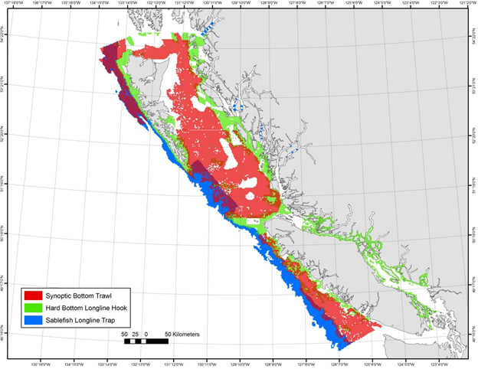

Figure 1. Random depth-stratified survey coverage.

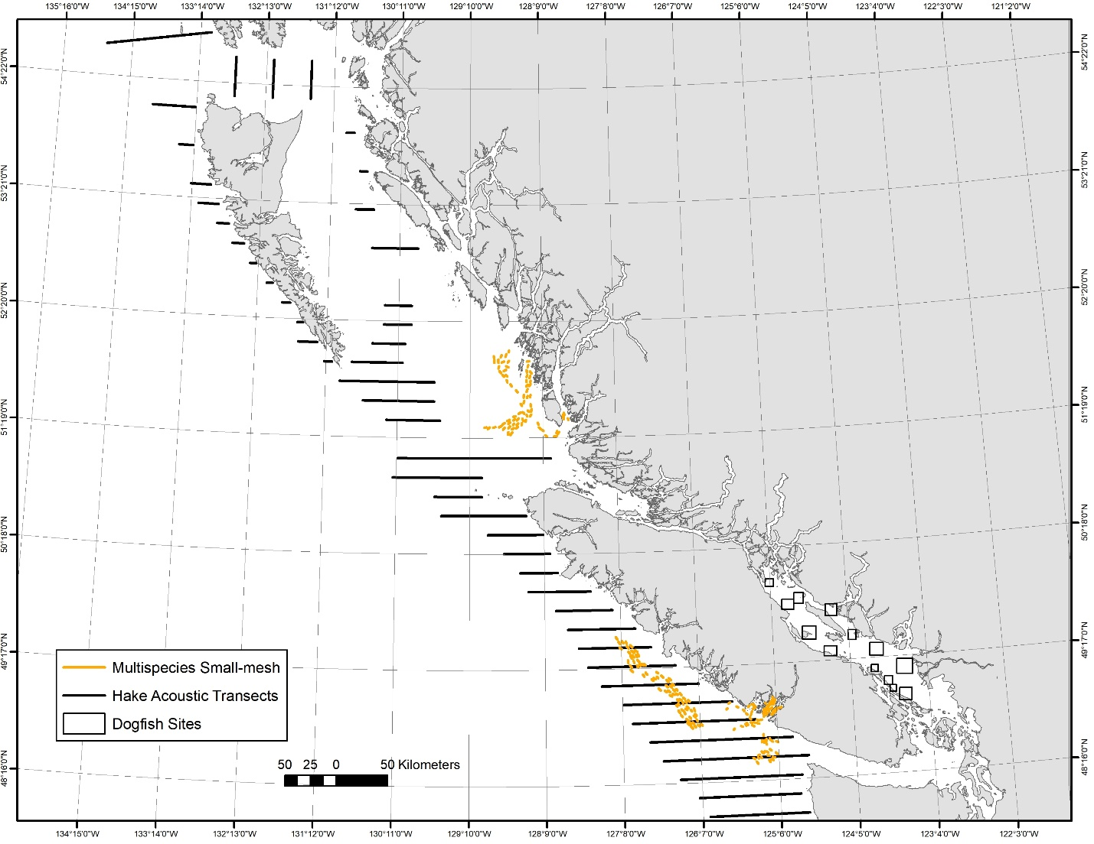

Figure 2. Non-random depth-stratified surveys that form part of the Groundfish fishing surveys program including the Multispecies Small-mesh Bottom Trawl Survey, the Pacific Hake Acoustic Survey, and the Strait of Georgia Dogfish Longline Hook Survey.

The **Multispecies Synoptic Bottom Trawl Surveys** are conducted in four areas of the BC coast with two areas surveyed each year such that the whole coast is covered over a two-year period. Typically, the West Coast of Vancouver Island (WCVI) and West Coast of Haida Gwaii (WCHG) are surveyed in even-numbered years while Hecate Strait (HS) and Queen Charlotte Sound (QCS) are surveyed in odd-numbered years (Figure 3). An additional synoptic bottom trawl survey has been conducted twice in the Strait of Georgia (SOG), but vessel availability and staffing constraints have precluded establishing a regular schedule.

These surveys are conducted under a collaborative agreement with the Canadian Groundfish Research and Conservation Society (CGRCS) and, in typical years, one survey occurs on a Canadian Coast Guard Vessel with DFO staff while one survey occurs on a chartered commercial fishing vessel with a mix of DFO staff and contracted technicians. In aggregate, the surveys provide coast-wide coverage of most of the trawlable habitat between 50 and 500 meters depth.

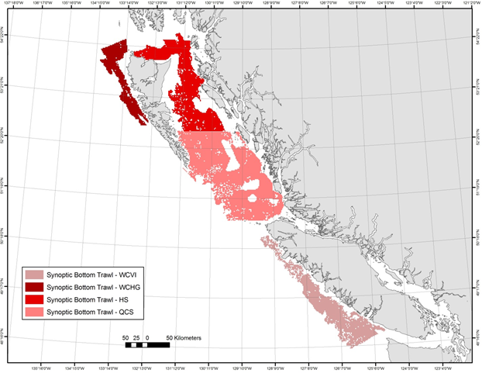

Figure 3. Multispecies Synoptic Bottom Trawl Survey coverage.

The WCVI and WCHG Synoptic Bottom Trawl surveys were all conducted in 2022. The WCVI survey was completed on the research vessel Sir John Franklin from mid-May to mid-June while the WCHG survey was completed on the chartered commercial trawl vessel Nordic Pearl from mid-August to mid-September. A total of 233 successful tows were completed over the two surveys with 126 in WCVI and 107 in WCHG (Figure 4). The dominant species in the WCVI survey catches were Pacific Ocean Perch (*Sebastes alutus*), Sharpchin Rockfish (*Sebastes zacentrus*), Arrowtooth Flounder (*Atheresthes stomias*), and Rex Sole (*Glyptocephalus zachirus*). The dominant species in the WCHG survey catches were Pacific Ocean Perch (*Sebastes alutus*), RedstripeRockfish (*Sebastes* *proriger*), Sharpchin Rockfish (*Sebastes zacentrus*), and Silvergray Rockfish (*Sebastes brevispinis*).

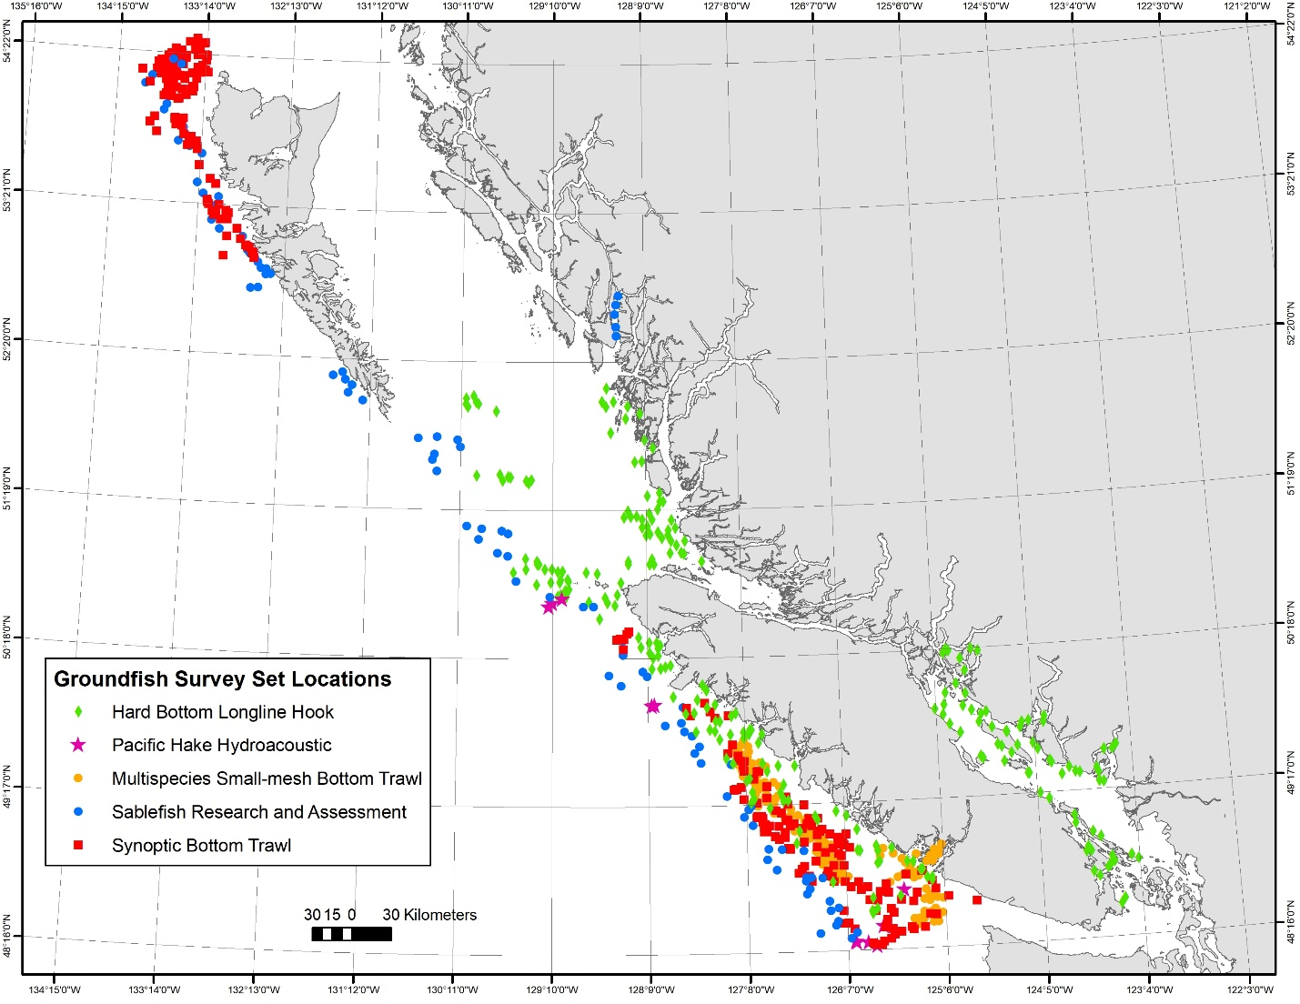

Figure 4. Fishing locations of the 2022 Groundfish surveys.

The **Hard Bottom Longline Hook (HBLL) Surveys** are conducted annually in “outside” waters (not between Vancouver Island and the mainland) and “inside” waters (between Vancouver Island and the mainland). Both the “outside” and “inside” areas are divided into northern and southern regions and surveys annually alternate between the regions such that the whole coast is covered over a two-year period. The outside surveys are conducted under a collaborative agreement with the Pacific Halibut Management Association (PHMA) and occur on chartered commercial fishing vessels with contracted technicians. The inside surveys are conducted by DFO and occur on a Canadian Coast Guard vessel with DFO staff. In aggregate, the HBLL surveys provide coast-wide coverage of most of the untrawlable habitat between 20 and 220 meters depth.

In 2022 the southern regions of both the outside and inside areas were surveyed (Figure 4). The outside HBLL survey was conducted on the chartered commercial longline vessels Banker II and Borealis mid-July to mid-August. A total of 173 sets were completed and the dominant species were Yelloweye Rockfish (*Sebastes ruberrimus*), Quillback Rockfish (*Sebastes maliger*), Sablefish (*Anoplopoma fimbria*), and Pacific Halibut (*Hippoglossus stenolepis*). The inside surveys were conducted on the research vessel Neocaligus during August. A total of 71 random sets were completed and the dominant species in the catch were North Pacific Spiny Dogfish (*Squalus suckleyi*), Yelloweye Rockfish (*Sebastes ruberrimus*), Quillback Rockfish (*Sebastes maliger*), Longnose Skate (*Raja rhina*), and Copper Rockfish (*Sebastes caurinus*).

In addition to the standard randomized sets, the HBLL survey in the inside area included a comparative fishing experiment. This work was a continuation of the pilot work completed in 2019 and is intended to continue into 2023. The goal of this work is to help assess the option of replacing the North Pacific Spiny Dogfish abundance index from the quasi-triennial Strait of Georgia Dogfish (DOG) survey with one from the annual HBLL Inside survey. The ultimate goal is to stop conducting the October DOG survey but the two surveys differ not only in timing, locations and depth range, but also in the hook size, spacing, and bait. The 2022 comparative sets were deployed in the standard DOG sites and depths with both the DOG and HBLL gear and bait configurations. A total of 24 sets were completed.

The **Sablefish Research and Assessment Survey** is an annual longline trap survey targeting Sablefish. This survey releases tagged Sablefish at randomly selected fishing locations in offshore waters as well as at fixed stations in four mainland inlets. The survey also provides catch rates and biological data for use in stock assessments. The survey is conducted under a collaborative agreement with Wild Canadian Sablefish Ltd. and occurs on a chartered commercial fishing vessel by a mix of DFO staff and contracted technicians. This survey covers the depth range of 150 m to 1250 m for the entire outer BC coast as well as several central coast inlets.

In 2022, the survey was conducted on the commercial fishing vessel Pacific Viking from early October to late November. For the third year in a row, the survey experienced many days lost to poor weather. A total of 86 of the 91 intended sets were completed in the offshore areas while only 5 of the intended 20 sets in the inlet portion of the survey were completed (Figure 4). In addition to the offshore and inlet sets, the survey included a research program designed to investigate gear interactions with the substrate and 6 sets designed to simulate commercial fishing were conducted. The most abundant fish species in the catch were Sablefish (*Anoplopoma fimbria*), Lingcod (*Ophiodon elongatus*), North Pacific Spiny Dogfish (*Squalus suckleyi*), and Pacific Halibut (*Hippoglossus stenolepis)*.

The **Multispecies** **Small-mesh Bottom Trawl Survey** is an annual fixed-station survey of commercially important shrimp grounds off the West Coast of Vancouver Island that was initiated in 1973, and occurs on a Canadian Coast Guard Vessel with DFO staff. Catch rate indices generated by the survey have been used to track the abundances of several groundfish stocks. Groundfish staff assist in catch sorting and species identification and also collect biological samples from selected fish species. The 2022 survey was conducted onboard the research vessel Sir John Franklin from late April to mid-May and a total of 126 usable tows were completed (Figure 4). North Pacific Spiny Dogfish (*Squalus suckleyi*), Rex Sole (*Glyptocephalus zachirus*), Pink Shrimp (*Pandalus jordani*), and Slender Sole (*Lyopsetta exilis*).

The **International Pacific Halibut Commission** (IPHC) conducts an annual stock assessment longline survey in waters from California to Alaska, including British Columbia (BC) waters. The survey's main goal is to provide data on Pacific Halibut (*Hippoglosus stenolepis*) for stock assessment purposes. However, data are also recorded on other species caught, making it the longest ongoing groundfish survey in BC waters and hence a valuable source of data for many species. The gfiphc R package (<https://github.com/pbs-assess/gfiphc>), developed at PBS and updated annually, contains much of the relevant data (and enables extraction from **GFBio** for the rest) It also includes code for deriving relative biomass index trends for non-halibut groundfish species within BC, based on methods that take into account the changing survey methodologies (see Anderson et al., 2019). Results for 113 species are directly viewable at <http://htmlpreview.github.io/?https://github.com/pbs-assess/gfiphc/blob/master/vignettes/data_for_all_species.html>, and are incorporated into the groundfish synopsis report (DFO 2022).

Literature Cited:

DFO. 2022. A data synopsis for British Columbia groundfish: 2021 data update. DFO Can. Sci. Advis. Sec. Sci. Resp. 2022/020. <https://www.dfo-mpo.gc.ca/csas-sccs/Publications/ScR-RS/2022/2022_020-eng.html>

# Reserves

Canada has surpassed its marine conservation target commitment of protecting 10 percent of coastal and marine areas through effectively managed networks of protected areas and other effective area-based conservation measures by 2020, a commitment made under the United Nations Convention on Biological Diversity (UN CBD) Aichi Target 11. Approximately 14% of Canada’s EEZ are now protected. Marine Conservation initiatives in British Columbia are illustrated in Figure 5. The Government of Canada is working with First Nations, the Provinces and partners to conserve 25 per cent of Canada’s oceans by 2025 and 30 per cent by 2030.

In the Pacific Region, an initiative is underway to develop a network of Marine Protected Areas (MPAs) in BC’s Northern Shelf Bioregion (NSB). The [Network Action Plan](https://mpanetwork.ca/nap/) resulting from many years of planning to design a network of marine protected areas (MPAs) in the NSB was endorsed and made public during the IMPAC5 conference in Vancouver in February 2023. The Action Plan will guide the establishment and ongoing management of the Network to protect this unique marine area for present and future generations. The first new Marine Refuge in the NSB was also announced. In consultation with the Mamalilikulla First Nation and the Province of British Columbia, [Gwaxdlala/Nalaxdlala](https://www.canada.ca/en/fisheries-oceans/news/2023/02/first-marine-refuge-within-the-northern-shelf-bioregion-is-established.html) – also known as Lull Bay and Hoeya Sound – was identified as an important area that includes a globally unique ecosystem of fragile and slow-growing corals and sponges that provide habitat for more than 240 marine species. This marine refuge is found in Knight Inlet.

Also announced at IMPAC5, the Honourable Joyce Murray, Minister of Fisheries, Oceans and the Canadian Coast Guard together with the Council of the Haida Nation, Nuu-chah-nulth Tribal Council, Pacheedaht First Nation and Quatsino First Nation announced progress on the proposed [Tang.ɢwan — ḥačxwiqak — Tsig̱is Marine Protected Area (MPA)](https://www.canada.ca/en/fisheries-oceans/news/2023/02/government-of-canada-and-coastal-first-nations-announce-progress-to-protect-a-large-ecologically-unique-ocean-area-off-the-pacific-west-coast.html), a large ecologically unique ocean area located on average 150 kilometres off the west coast of Vancouver Island (Figure 6). Covering 133,019 square kilometres, the [proposed MPA](https://www.dfo-mpo.gc.ca/oceans/aoi-si/tht-eng.html) is home to extraordinary seafloor features, including more than 46 underwater mountains, known as seamounts, and all known hydrothermal vents in Canada. These deep-sea biological “hotspots” are globally rare and support deep-water species unique to this area. The MPA regulations were published in the Canada Gazette Part 1 on February 18, 2023.

The Hecate Strait/Queen Charlotte Sound Glass Sponge Reefs MPA that was designated under Canada’s Oceans Act in February 2017 to protect glass sponge reefs in Hecate Strait and Queen Charlotte Sound will be part of the NSB MPA network, as will the Gwaii Haanas National Marine Conservation Area Reserve (NMCAR) and Haida Heritage Site. The Scott Islands marine National Wildlife Area (NWA), an area that conserves a vital marine area for millions of seabirds on the Pacific coast, will also be part of the NSB MPA. Fishing activity is currently not prohibited in the NWA.

Parks Canada and the Archipelago Management Board have introduced new zoning to the NMCAR which includes multiple use zones (IUCN protection level IV-VI) as well as high protection zones (IUCN Ib-III) and two small, restricted access zones that are intertidal/terrestrial. These zones came into effect on May 1, 2019. The two Rockfish Conservation Areas that were formerly within the NMCAR boundaries have been rescinded and replaced with the new zoning. Parks Canada is also still working to establish an NMCAR in the Salish Sea.

The SGaan Kinghlass-Bowie Seamount MPA, which was designated in 2008, protects communities living on Bowie Seamount which rises from depths to 3000 m to within 24 m of the surface, as well as two other seamounts and adjacent areas (<https://dfo-mpo.gc.ca/oceans/mpa-zpm/bowie-eng.html>). A monitoring framework for the SKB MPA was recently reviewed at CSAS and a science advisory report is available (DFO 2023a).

The other 162 Rockfish Conservation Areas (RCAs) designated as fishery closures between 2004-2007 (Yamanaka and Logan, 2010), remain in place. The Glass Sponge Reef Conservation Areas are closed to all commercial and recreational bottom contact fishing activities for prawn, shrimp, crab and groundfish (including halibut) in order to protect the Strait of Georgia and Howe Sound Glass Sponge Reefs (<http://www.dfo-mpo.gc.ca/oceans/ceccsr-cerceef/closures-fermetures-eng.html>).

Literature Cited:

DFO. 2023a. Monitoring Framework for SG̲aan K̲inghlas-Bowie Seamount Marine Protected Area, British Columbia, Canada. [DFO Can. Sci. Advis. Sec. Sci. Advis. Rep. 2023/011](https://www.dfo-mpo.gc.ca/csas-sccs/Publications/SAR-AS/2023/2023_011-eng.pdf).

Yamanaka, K.L., and Logan, G. 2010. Developing British Columbia's inshore rockfish conservation strategy. Marine and Coastal Fisheries: Dynamics, Management, and Ecosystem Science. 2:28–46. DOI: 10.1577/C08-036.1

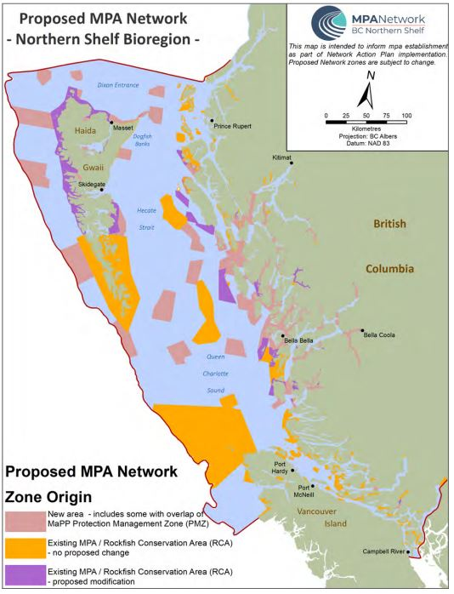

*Figure 5. Proposed Northern Shelf Bioregion MPA Network (Network Action Plan).*

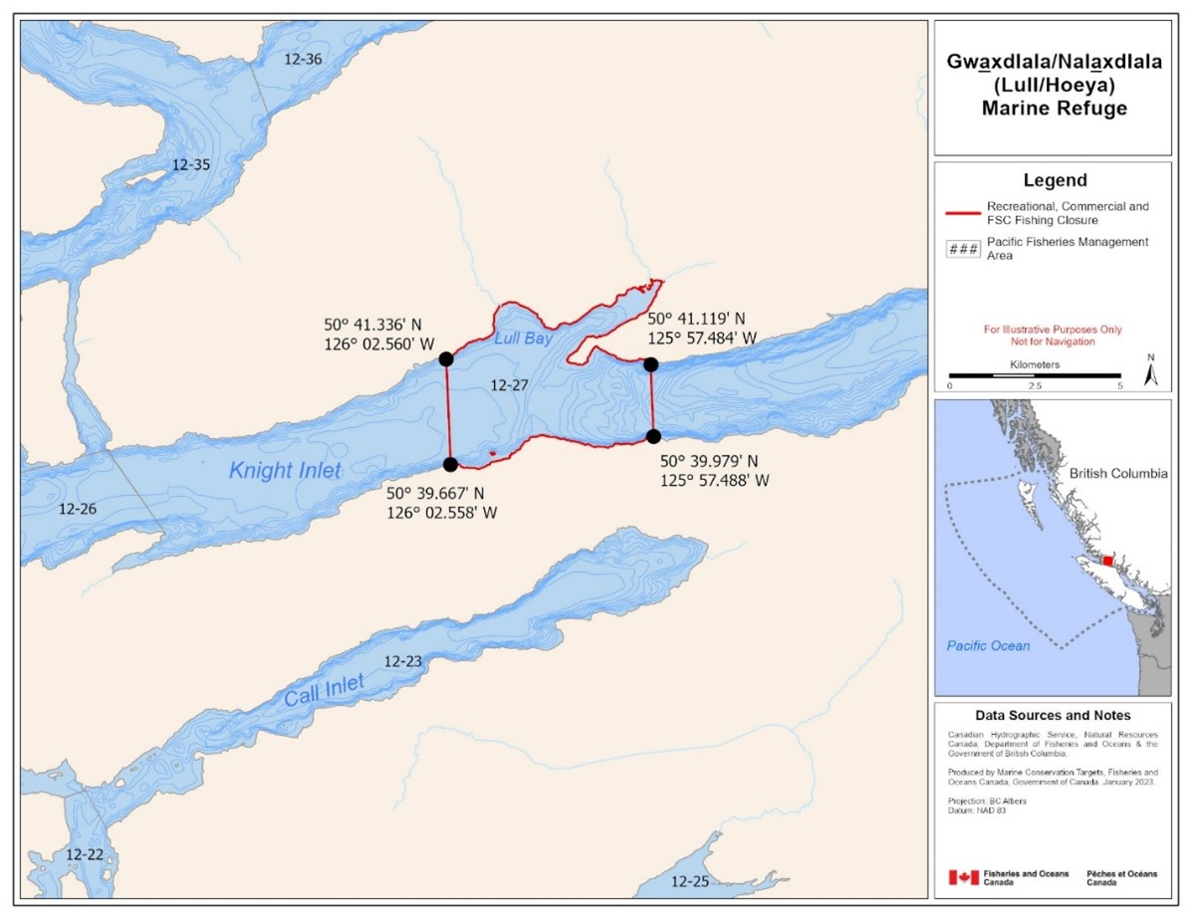

*Figure 6. Gwaxdlala/Nalaxdlala – also known as Lull Bay and Hoeya Sound Marine Refuge.*

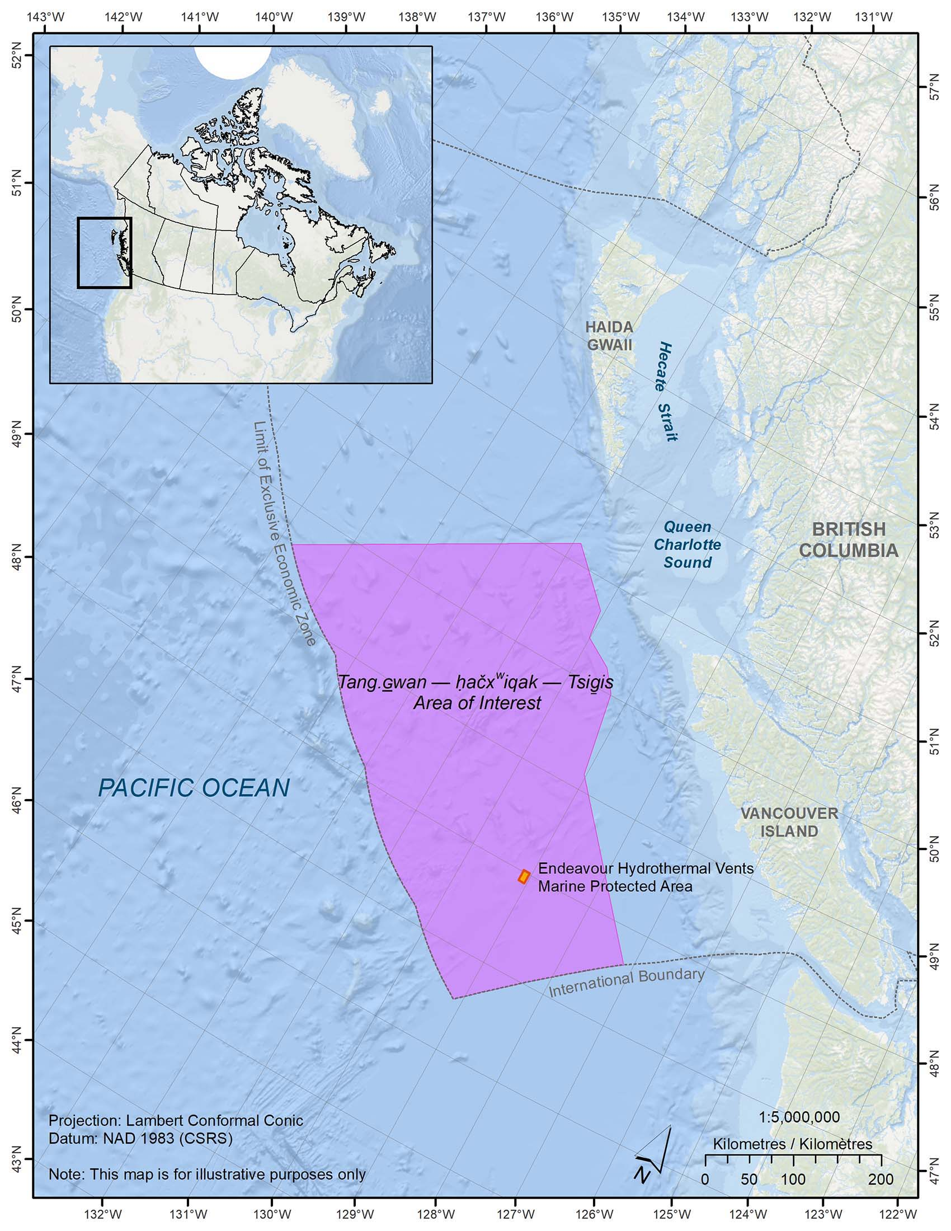

*Figure 7. The proposed Tang.ɢwan – ḥačxwiqak – Tsig̱is Marine Protected Area*

# Review of Agency Groundfish Research, Assessment and Management

## Hagfish

### Research

No new research in 2022.

### Assessment

Nothing to report.

### Management

There is currently no fishery for Hagfish in BC.

## Dogfish and other sharks

### Research

#### North Pacific Spiny Dogfish

Data collection continued in 2022 through the annual groundfish multispecies trawl and longline surveys. Due the suspension of the At Sea Observer Program no biological samples were collected from the commercial fishery in 2022. Several indices of relative abundance for North Pacific Spiny Dogfish in BC waters have declined over the last decade despite relatively little catch compared to historical levels and no directed fishery in recent years. Dr. Lindsay Davidson is a postdoc leading a research project (with Drs. Sean Anderson, Philina English, Jackie King, and Paul Grant, and NOAA collaborators Drs. Cindy Tribuzio, Vladlena Gertseva, and Ian Taylor) examining these declines and evaluating the evidence for possible explanations including climate, predator-prey interactions, seasonal distribution shifts, population declines from historical harvesting, or changes to survey timing.

#### Other Shark Species

Other species of shark are sampled opportunistically during annual groundfish multispecies trawl and longline surveys. In 2022, one Tope Shark, five Blue Sharks, and 25 Brown Cat Sharks were sampled. Due to the suspension of the At Sea Observer Program no biological samples were collected from the commercial fishery. Anecdotal information on encounters with other shark species is also collected through the Shark Sightings Network (<https://www.dfo-mpo.gc.ca/species-especes/sharks/info/sightings-eng.html>).

### Assessment

#### North Pacific Spiny Dogfish

North Pacific Spiny Dogfish, hereafter ‘Spiny Dogfish’ were last assessed by the Committee on the Status of Wildlife in Canada (COSEWIC) in 2011 and the last scientific advisory report was completed in 2011 (Galluci et al 2011). Dogfish are scheduled to be “batched in” as a Major Stock under the Fish Stocks provisions of the *Fisheries Act*. An assessment is currently underway for the outside stock with plans to complete the inside assessment the following year.

In 2011, the Committee on the Status of Wildlife in Canada (COSEWIC) assessed the conservation status of Spiny Dogfish as Special Concern, citing low fecundity, long generation time (51 years), uncertainty regarding trends in abundance of mature individuals, reduction in size composition, and demonstrated vulnerability to overfishing as the causes for concern. Nevertheless, COSEWIC acknowledged that the population remains relatively abundant and that overfishing was unlikely. Spiny Dogfish have been pending a Species at Risk Act listing decision by the Governor in Council since 2011 and recently public consultations have been opened to get feedback on listing Spiny Dogfish ([Consultation check-in on 14 aquatic species under consideration for addition or reclassification to Schedule 1 of the Species at Risk Act - Canada.ca](https://www.canada.ca/en/environment-climate-change/services/species-risk-public-registry/consultation-documents/check-in-14-aquatic.html)).

The Spiny Dogfish COSEWIC status report is available at [North Pacific Spiny Dogfish (Squalus suckleyi) - Species search - Species at risk registry (canada.ca)](https://species-registry.canada.ca/index-en.html#/species/1168-846).

#### Other Shark Species

As no directed commercial fisheries for sharks other than North Pacific Spiny Dogfish exist in British Columbia, there have been no requests for any stock assessments.

The Committee on the Status of Wildlife in Canada (COSEWIC) has assessed the conservation status of several British Columbia shark species, and three species are listed under the Canadian Species at Risk Act (SARA):

* Basking Shark: Designated Endangered in 2007. Status re-examined and confirmed in 2018. Listed under SARA.
* Bluntnose Sixgill Shark: Designated Special Concern in 2007. Currently being re-examined. Listed under SARA.
* Tope Shark: Designated Special Concern in 2007. Currently being re-examined. Listed under SARA.

Blue Shark (North Pacific population) was examined by COSEWIC in 2016 and designated Not at Risk. White Shark and Brown Cat Shark were considered in 2006 and 2007 and placed in the Data Deficient category. Shark species yet to be assessed include the Salmon shark and Pacific Sleeper Shark.

COSEWC status reports are available at <https://www.canada.ca/en/environment-climate-change/services/species-risk-public-registry/cosewic-assessments-status-reports.html>.

### Management

#### North Pacific Spiny Dogfish

Spiny Dogfish are managed as part of the integrated mixed species multi-gear groundfish fishery under the Integrated Fisheries Management Plan (IFMP) and are permitted to be retained in the recreational fishery. There is currently no targeted fishing for Spiny Dogfish. Commercial TACs and landings for 2022 are provided in Appendix 1. To support groundfish research and account for unavoidable mortality incurred during the 2022 Groundfish surveys, research catches are allocated before defining the TAC. See Appendix 1 for details.

#### Other Shark Species

Currently, there is no directed commercial fishery for other sharks in Canadian Pacific waters; only Salmon Shark are permitted to be retained in the recreational fishery. Species at Risk Act prohibitions only apply to species listed as Extirpated, Endangered, or Threatened; thus, they do not apply to species of Special Concern. Nevertheless, commercial fisheries are no longer permitted to retain Species at Risk Act listed shark species--all bycatch for these species is to be released at sea with the least possible harm. Catch limits for the recreational fishery have been reduced to “no fishing” for all species listed under the Species at Risk Act, and “zero retention” (catch and release) for all other shark species except Salmon Shark. Codes of conduct have been developed for encounters with Basking Sharks (<https://www.dfo-mpo.gc.ca/species-especes/publications/sharks/coc/coc-basking/index-eng.html>) and other sharks (<https://www.dfo-mpo.gc.ca/species-especes/publications/sharks/coc/coc-sharks/index-eng.html>).

## Skates and Chimeras

### Research

Data collection continued in 2022 through trawl and longline surveys. Most individual skates encountered on groundfish research surveys are sampled (length, weight if feasible, sex) and released alive, if possible. In 2022, nine Aleutian Skates, 11 Roughtail Skates, 43 Big Skates, 55 Sandpaper skates, and 546 Spotted Ratfish were sampled. Due to the suspension of the At Sea Observer Program no biological samples were collected from the commercial fishery in 2022.

### Assessment

Big Skates and Longnose Skate were assessed in 2013 (King et al 2015). No new assessment is currently planned. No other skate species in British Columbia are assessed.

The Big Skate, Longnose Skate, and Sandpaper Skate have all been assessed at Not at Risk by COSEWIC in 2007. Skate species still to be assessed are those that are less common in British Columbia including the Aleutian skate, Abyssal Skate, Alaska Skate, Roughtail Skate, and Broad Skate. Finally, the Spotted ratfish is not assessed. A coastwide assessment of Spotted Ratfish has been requested to contribute to the implementation of the bycatch policy within the sustainable Fisheries Framework, but this work has been deferred indefinitely.

### Management

Big Skate, Longnose Skate, and Spotted Ratfish comprise most of the non-shark catch (landings + discards from the commercial fisheries). Big and Longnose Skates are currently managed as part of the Integrated Fisheries Management Plan (IFMP) with sector and area TACs. Big and Longnose Skates are IVQ (individual vessel quota) species. Commercial TACs and landings for 2022 are provided in Appendix 1. To support groundfish research and account for unavoidable mortality incurred during the 2022 Groundfish surveys, research catches are allocated before defining the TAC. See Appendix 1 for details. There are no management measures in place for all other species of skate.

Spotted Ratfish have no management measures in place nor are they part of a direct fishery. They are discarded bycatch mostly in the 5CDE management areas.

Literature Cited:

Galluci, V., Taylor, I., King, J., McFarlane, G.A., and McPhie, R. 2011. Spiny Dogfish (*Squalus acanthias*) assessment and catch recommendations for 2010. DFO Can. Sci. Advis. Sec. Res. Doc. 2011/034. xii + 69 p.

King, J.R., Surry, A.M., Garcia, S., and Starr, P.J. 2015. Big Skate (*Raja binoculata*) and Longnose Skate (*R. rhina*) stock assessments for British Columbia. DFO Can. Sci. Advis. Sec. Res. Doc. 2015/070. ix + 329 p. <https://waves-vagues.dfo-mpo.gc.ca/Library/362171.pdf>

## Pacific Cod

### Research

Data collection continued in 2022 through trawl and longline surveys. Due the suspension of the At Sea Observer Program no biological samples were collected from the commercial fishery in 2021.

### Assessment

The last assessments of Pacific Cod stocks in Areas 3CD and 5ABCD were done in 2020 using the same delay-difference model that was used in 2018. The Science Response (SR 2021/002) is available at <https://www.dfo-mpo.gc.ca/csas-sccs/Publications/ScR-RS/2021/2021_002-eng.html>. Full documentation of the stock assessment models is available in the Research Document for the 2018 assessment (Res Doc 2020/70), available at <https://www.dfo-mpo.gc.ca/csas-sccs/Publications/ResDocs-DocRech/2020/2020_070-eng.html>. Four stocks are defined for management purposes in BC: Strait of Georgia (4B); West Coast Vancouver Island (3CD); Queen Charlotte Sound (5AB); and Hecate Strait (5CD). Since the 2018 assessment, data from Areas 5AB and 5CD have been combined into a single stock assessment. This is due to improved fits to the combined data compared to data from area 5AB alone. Area 3CD was assessed separately. Area 4B was not assessed as there is no directed commercial fishery there.

The 2020 assessment updates for Areas 3CD and 5ABCD stock assessments were done following an approximate 75% drop in the synoptic survey index in 2018 in 3CD, accompanied by three years of commercial catches well below average. There was an estimated 2-10% probability that the 3CD stock would fall into the Critical Zone in 2022 under a range of 2021 catch levels. There was an estimated < 0.01% probability that the 5ABCD stock will fall into the Critical Zone in 2022.

Groundfish bottom trawl surveys resumed in the West Coast Vancouver Island, Queen Charlotte Sound and Hecate Strait areas in 2021. Compared to the 2019 index, the median swept area survey index increased by 25% in Hecate Strait and by 15% in Queen Charlotte Sound, representing the third year of increases in Hecate Strait and the second year of increases in Queen Charlotte Sound. Although not included in the stock assessment, the West Coast Haida Gwaii index also increased, with a 132% increase in the median swept area index, compared to 2018. However, the stock continued to decline in the West Coast Vancouver Island Survey, with a 22% decrease in the median swept area index compared to 2018. A West Coast Vancouver Island survey was conducted in 2022, with indices continuing to be at a similar level to 2018 and 2021.

Given the decreases in the 2018, 2021, and 2022 West Coast Vancouver Island survey indices, an update to the 3CD stock assessment is scheduled to occur in 2023. This will be a stock status update only, without management advice, because management advice was not requested in 2023. One concern with the 2023 status update is the absence of commercial length samples since 2019, which are needed to calculate the commercial mean weight index, one of the indices to which the delay-difference model is fit. For 2023, the best available approach will be to use a generalised linear model to predict the commercial mean weight from the survey mean weight, based on historical observations of both indices.

### Management

Pacific Cod is an IVQ (individual vessel quota) species, managed as part of the integrated mixed species multi-gear groundfish fishery under the Integrated Fisheries Management Plan (IFMP). Commercial TACs and landings for 2020 are provided in Appendix 1. To support groundfish research and account for unavoidable mortality incurred during the 2019 Groundfish surveys, research catches are allocated before defining the TAC. Following the 2020 assessment update, the commercial TAC in Area 3CD was reduced to 300 metric tonnes. See Appendix 1 for details. In addition, winter spawning closures are in effect in both Areas 3CD and 5CD.

## Walleye Pollock

### Research

There was no work conducted directly on Walleye Pollock in 2022 but ongoing data collection continues through the Groundfish Synoptic Surveys, port sampling (a new biosampling program will be implemented in 2023 for rockfish species, with expansion to other species later), and recreational creel surveys.

### Assessment

The most recent stock assessment (2017) is publicly available on the CSAS website:  
([Research Document 2021/004](https://www.dfo-mpo.gc.ca/csas-sccs/Publications/ResDocs-DocRech/2021/2021_004-eng.html), [Science Advisory Report 2018/020](http://www.dfo-mpo.gc.ca/csas-sccs/Publications/SAR-AS/2018/2018_020-eng.html), [Proceeding 2021/048](https://www.dfo-mpo.gc.ca/csas-sccs/Publications/Pro-Cr/2021/2021_048-eng.html)).

### Management

Walleye Pollock is an IVQ (individual vessel quota) species, managed as part of the integrated mixed species multi-gear groundfish fishery under the Integrated Fisheries Management Plan ([IFMP 2023](https://waves-vagues.dfo-mpo.gc.ca/library-bibliotheque/41098067.pdf)). Commercial TACs and landings for 2022 are provided in Appendix 1. To support groundfish research and account for unavoidable mortality incurred during the 2022 Groundfish surveys, research catches are allocated before defining the TAC.

## Pacific Whiting (Hake)

### Research

There are two commercially harvested and managed stocks of Pacific Hake in Canada. The offshore stock is the principal target of the commercial fishery comprising the bulk of landings year over year. A smaller and discrete stock residing within the Strait of Georgia is targeted episodically when market demand is sufficient, and the available fish are large enough for processing.

#### Offshore Hake

Triennial (until 2001), then biennial acoustic surveys, covering the known extent of the Pacific Hake stock have been run since 1995. An acoustic survey, ranging from California to northern British Columbia is currently run in odd-numbered years, to continue the biennial time series. The last survey used in the assessment model took place in 2021.

In addition to the samples collected during the hake acoustic survey in 2021, biological samples were collected in 2022 through groundfish trawl surveys. Fishery sampling resumed in 2022 after a drop in sampling due to removal of at-sea observers from the freezer-trawler fleet in 2020-2021. A novel sampling technique was developed to make up for the lack of at-sea observers which involved removal of fish from the offload conveyor belt during fishing operations. The fish were placed into bags by vessel crew and frozen for sampling on shore by Archipelago Marine Resources (AMR).

#### Strait of Georgia Hake

There has been a biennial acoustic survey for Pacific Hake in the Strait of Georgia since 2011, although numerous years have recently been missed. The survey was completed in February-March 2023 and another is planned for 2024. Methods will be developed to calculate a biomass estimate for these surveys, which will then be used as the primary index of abundance for a stock assessment.

### Assessment

#### Offshore Hake

As in previous years, and as required by the Agreement Between the Government of Canada and the Government of the United States of America on Pacific Hake/Whiting (the Pacific Whiting treaty), the 2022 harvest advice was prepared jointly by Canadian and U.S. scientists working together, collectively called the Joint Technical Committee (JTC) as stated in the treaty. The assessment model used was Stock Synthesis 3 (SS3). The 2022 model had the same model structure used in 2021, with updates to catch and age compositions. Standard sensitivities requested by the Scientific Review Group showed little difference when compared with the base model. The largest cohort caught in the fishery was age-5’s, followed by age 7’s which represent the large cohorts for 2016 and 2014 respectively ([Berger et al. 2023](https://media.fisheries.noaa.gov/2023-02/2023-hake-assessment-post-srg_web.pdf)).

Berger, A.M., C.J. Grandin, K.F. Johnson and A.M. Edwards. 2023. Status of the Pacific Hake (whiting) stock in U.S. and Canadian waters in 2023. Prepared by the Joint Technical Committee of the U.S. and Canada Pacific Hake/Whiting Agreement, National Marine Fisheries Service and Fisheries and Oceans Canada. 208 p.

#### Strait of Georgia Hake

There has not been an assessment of Pacific Hake in the Strait of Georgia, although one is planned for 2024-25 following the development of an acoustic biomass estimate.

### Management

Canadian commercial TACs and landings for 2022 are provided in Appendix 1. To support groundfish research and account for unavoidable mortality incurred during the 2022 Groundfish surveys, research catches are allocated before defining the TAC. See Appendix 1 for details.

#### Offshore Hake

Management of Pacific Hake has been under a treaty (The Agreement) between Canada and the United States since 2011. The stock is managed by the Joint Management Committee (JMC) which is made up of fisheries managers and industry representatives from both the U.S. and Canada. These managers receive advice from the JTC and the Scientific Review Group (SRG), which is a committee responsible for the scientific review of the assessment.

The final decision on catch advice for the 2022 fishing season was made at the Joint Management Committee (JMC) meeting in March of 2022. A coastwide TAC of 545,000 t was chosen, which when split with the U.S. gave Canada a TAC of 142,354 t.

The final assessment document and other treaty-related documents are posted at: <https://www.fisheries.noaa.gov/west-coast/laws-and-policies/pacific-hake-whiting-treaty>.

#### Strait of Georgia Hake

Strait of Georgia Pacific Hake is managed by Total Allowable Catch (TAC) and Individual Transferable Quota (ITQ) as part of the integrated groundfish fisheries. Pacific Hake is typically targeted using midwater trawl gear and while historical catches in the Strait are highly variable, catch levels in the last five years have ranged from approximately 5,000 – 7,000 metric tonnes.

## Grenadiers

### Research

There is no directed work conducted on Grenadiers although opportunistic sampling occurs during the Multispecies Synoptic Bottom Trawl surveys. Giant Grenadiers, Pacific Grenadiers and Popeye are routinely encountered during the WCHG survey. Giant Grenadiers and Pacific Grenadiers are encountered during the Sablefish trap survey.

### Assessment

Grenadiers are not commercially harvested in BC and are rarely encountered during commercial fisheries. Consequently, there are no assessment activities planned for these species.

### Management

There are no management objectives or tactics established for these species. These species are caught incidentally in the deep-water rockfish (Rougheye/Shortraker/Thornyhead) and Dover Sole trawl fisheries and in the Sablefish trap fishery. 100% of the catch is discarded.

## Rockfish

### Research

Biological samples are collected on an ongoing basis from annual trawl, longline, and trap surveys. Due the suspension of the At Sea Observer Program no biological samples were collected from the commercial fishery in 2022. A commercial biosampling project is being put in place and the first phase will focus on the collection of offshore rockfish samples from the trawl fleet that are landed in Ucluelet.

#### Inshore Rockfish

Dr. Dana Haggarty continues to collaborate with other scientists at DFO, Dr. Philina English, Dr. Sarah Dudas, and Dr. Stephan Gauthier, as well as external Scientists: Dr. Francis Juanes (UVic), Dr. William Halliday (Wildlife Conservation Society Canada), and Dr. Francis Mouy (NOAA) to develop passive acoustic monitoring (PAM) of rocky reef fishes. Based on the successes of a SPERA funded project, they were awarded Canadian Science Research Funding for three years of study. With this grant, they will support some post-doctoral work of Xavier Mouy who will continue to develop and refine an automatic detector of fish (and hopefully rockfish) calls. They have also brought on a Ph.D. student, Darienne Lancaster, co-supervised by Drs. Francis and Haggarty at UVic who will refine methods to collect passive and active acoustic data of rockfishes. Darienne had a successful first field season in Barkley Sound, BC, and is currently analyzing passive acoustic, active acoustic and video data.

Dr. Haggarty is also collaborating with colleagues at UVic and Ball State University as well as industry (Angler’s Atlas) to improve and monitor compliance in Rockfish Conservation Areas (RCAs) and Marine Protected Areas (MPAs). Angler’s Atlas has already upgraded their smart phone app, MyCatch, to include the location of all RCAs and to provide users with warnings when they are in an RCA. Dana is working with Dr. Venturelli to assess recreational compliance in RCAs using creel overflight data. This project was funded by the BC Salmon Restoration and Innovation Fund (BCSRIF) until the end of 2023-24. A PhD student funded under this program, Hailey Davies, has published a photo-journal on her rockfish barotrauma research in the Fisheries Journal (Davies et al. 2022).

Dana has also collaborated with DFO iREC (Internet Recreational Effort and Catch) staff to develop a questionnaire on the use of descending devices by anglers. The survey is a voluntary add-on to the annual iARC (Internet Annual Recreational Catch Reporting program) survey. The survey ran April 1-23, 2022. 1,748 anglers completed the voluntary survey consisting of 13 questions. 65% of respondents correctly stated that released rockfish needed to be returned to a similar depth from which they were caught using a descending device; 26% were unsure and 9% disagreed. Despite responding “True” to the descending device requirement, 30% of those people had released rockfish at the surface. Only 612 respondents had caught a rockfish and 372 had released any with a descending device. Yelloweye and Quillback Rockfishes were the most commonly descended species. The most commonly used device was the Sequilizer (50, 100, 150 foot version). 92% of respondents report descending rockfish to the same or closest depth to capture and 72% stated that none resurfaced, 25% stated that one or a few resurfaced, and 4% stated that most or all resurfaced. Most people learned about the requirement through word of mouth (33%) or from the condition of license printed in the small print on their sport license (25%). Websites, fishing guides or lodge operators, news article, posters, and apps were other listed sources of information. Numerous written comments in support of the use of descending devices were received.

A comparison of DFO’s recreational catch estimates for rockfish and Lingcod using creel survey and Internet Recreational Effort and Catch (iREC) survey was also completed in 2022. To measure the effect of potential biases, a calibration procedure was developed to relate iREC estimates to those from creel surveys, using data from temporal and geographic strata for which both types of surveys were conducted. Data from the North Coast, Strait of Georgia, and West Coast of Vancouver Island dating from 2012 to 2021 were included in Bayesian Type II regression analyses, run separately for each of twelve taxa and for two disposition types (i.e., kept vs. released). In almost every case, the trendlines indicated that iREC catch estimates are larger than corresponding creel values. The magnitude of the slopes should be reliable estimators of the degree of bias in the iREC estimates, and their use as naïve ‘conversion factors’ should successfully minimize such bias (Robichaud and Haggarty, 2022).

Dr. Matthew Siegle has become the Inshore Rockfish Program Head as Dana’s has become the Groundfish Section Head.

Literature Cited:

Davies, H.L., Gross, S., **Haggarty, D.R.**, and Juanes, F. 2022. Conserving Rockfishes: Barotrauma and Descending Devices in the Northeast Pacific. Fisheries. 47(9): 406-411. https://doi.org/10.1002/fsh.10810

Robichaud, D. and **Haggarty, D.R.** 2022. Comparison of rockfish and lingcod catch estimates from internet recreational effort and catch (iREC) and creel surveys. Can. Tech. Rep. Fish. Aquat. Sci. 3500: v + 46 p.

#### Offshore Rockfish

The Offshore Rockfish program in 2022 continued with one DFO person working in collaboration with an industry-sponsored scientist. All efforts were devoted to stock assessment. To facilitate stock assessment, the Offshore Rockfish program maintains a suite of PBS R software packages (<https://github.com/pbs-software>). The Groundfish Surveys program coordinates all sample collections (otoliths, genetic tissues, morphology measurements, etc.) and the Sclerochronology Lab researches ageing protocols and methods, in addition to performing production ageing for BC finfish stock assessments.

### Assessment

#### Inshore Rockfish

British Columbia (BC) “Inside” stocks are generally those occurring in Area 4B (Queen Charlotte Strait, Strait of Georgia, and Strait of Juan de Fuca), while “Outside” stocks occur outside Area 4B (West Coast Vancouver Island, West Coast Haida Gwaii, Queen Charlotte Sound, Hecate Strait, Dixon Entrance).

##### Outside Yelloweye Rockfish

The Outside population of Yelloweye Rockfish was designated as Threatened in December of 2020 by the Committee on the Status of Endangered Wildlife in Canada (COSEWIC) and DFO was therefore required to complete a Recovery Potential Analysis (RPA) which was published in February 2023 (DFO 2023). It drew from the results presented in the 2019 rebuilding plan analysis ([Cox et al. 2020](https://waves-vagues.dfo-mpo.gc.ca/library-bibliotheque/40951704.pdf)).

##### Inside Yelloweye Rockfish

The Inside population of Yelloweye Rockfish was designated as Threatened in December of 2020 by the Committee on the Status of Endangered Wildlife in Canada (COSEWIC) and DFO was therefore required to complete a Recovery Potential Analysis (RPA) which was published in February 2023. It drew from the results presented in the 2020 rebuilding plan analysis ([Haggarty et al 2022](https://waves-vagues.dfo-mpo.gc.ca/library-bibliotheque/41058136.pdf)).

The results of the two rebuilding plan reviews support a high probability that both Yelloweye Rockfish stocks are above their respective Limit Reference Points (LRPs) of 40% BMSY. This differs from previous results that found Yelloweye Rockfish stocks to be below their LRPs. Much of this discrepancy can be attributed to the use of surplus production models in previous analyses, while the most recent analyses presented in the rebuilding plans use age-structured models. Another significant difference between previous work and the more recent rebuilding plans is that we have moved towards using a Management Strategy Evaluation approach that follows the Management Procedure Framework for Groundfish (Anderson et al. 2021). A recovery potential analysis for Yelloweye Rockfish was also completed in 2022 (DFO 2023).

##### Quillback Rockfish

The Inside and Outside management units of Quillback Rockfish were last assessed in 2010 (Yamanaka et al. 2011) after the Committee on the Status of Endangered Wildlife in Canada (COSEWIC) designated them as threatened in November 2009.

Quillback is due to be reassessed in 2022-2023 in advance of a COSEWIC reassessment. In preparation to do so, we have begun analyzing data for the inside and outside stocks and have developed initial operating models for the inside stock. We also held a series of workshops to discuss the decision context and to develop objectives to be used for the Quillback Rockfish stocks in a Management Procedure (MP) framework analysis (Haggarty et al 2022). The Regional Peer Review meeting for the inside stock was held December 6-7 2022, and the Science Advisory Report is anticipated to be available soon. The Regional Peer Review meeting for the outside stock is scheduled for May 2023.

##### Other Inshore Rockfish Species (Copper, China, Tiger, Brown, Black, Deacon Rockfishes).

Inshore Rockfishes were assessed as a group in 2001, but none of these other inshore species have been assessed individually by DFO. Survey trends are monitored in the GF Synopsis (Anderson et al 2022) and by groundfish staff (Figure 8).

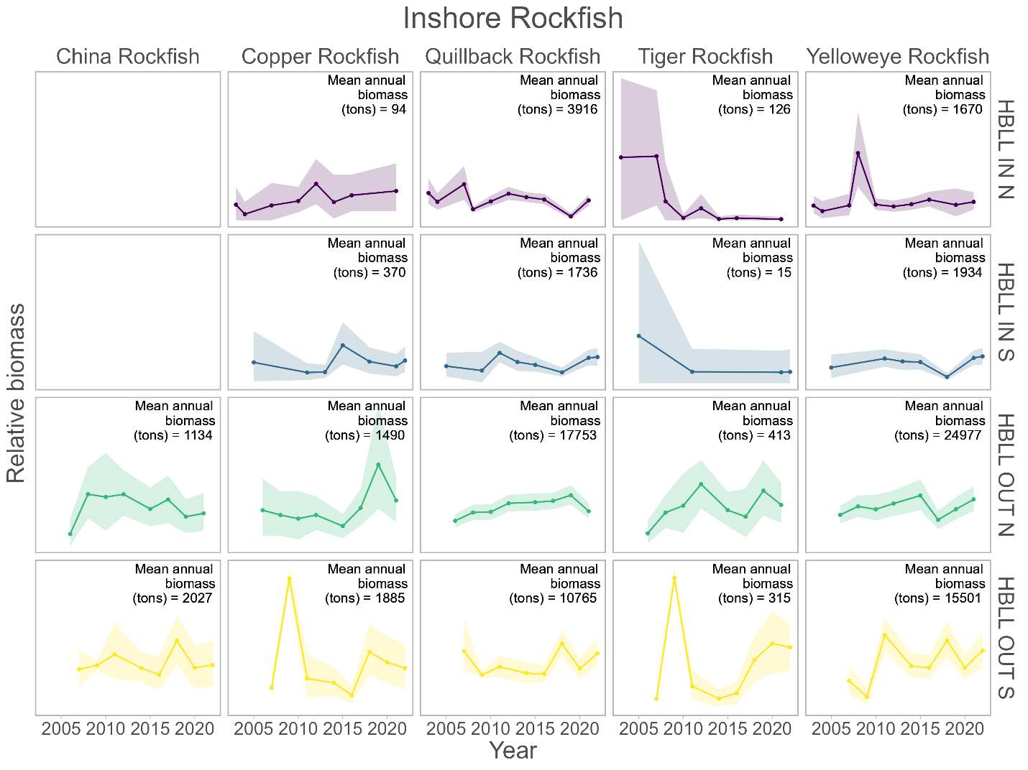

*Figure 8. Relative biomass of Inshore Rockfish Species from the design-based survey index on the Inside and Outside Hard Bottom Longline Surveys (HBLL) conducted in Northern (N) and Southern (S) waters. Dots represent mean estimates of relative biomass and shaded ribbons around the dots and lines represent 95% bootstrap confidence intervals.*

Literature Cited:

Anderson, S.C., Forrest, R.E., Huynh, Q.C., Keppel, E.A. 2021. A management procedure framework for groundfish in British Columbia. DFO Can. Sci. Advis. Sec. Res. Doc. 2021/007. vi + 139 p.

Cox, S.P., Doherty, B., Benson, A.J., Johnson, S.D., and Haggarty, D. 2020. Evaluation of potential rebuilding strategies for Outside Yelloweye Rockfish in British Columbia. DFO Can. Sci. Advis. Sec. Res. Doc. 2019/041.

DFO. 2023b. Recovery Potential Assessment for Yelloweye Rockfish (*Sebastes ruberrimus*) in British Columbia. DFO Can. Sci. Advis. Sec. Sci. Resp. 2023/003. <https://www.dfo-mpo.gc.ca/csas-sccs/Publications/ScR-RS/2023/2023_003-eng.html>

Haggarty, D.R., Huynh, Q.C., Forrest, R.E., Anderson, S.C., Bresch, M.J., Keppel, E.A. 2022. Evaluation of potential rebuilding strategies for Inside Yelloweye Rockfish (*Sebastes ruberrimus*) in British Columbia. DFO Can. Sci. Advis. Sec. Res. Doc. 2022/008. vi + 142 p.

Yamanaka, K.L., McAllister, M.K., Etienne, M.-P., and Flemming, R. 2011. Stock assessment and recovery potential assessment for Quillback Rockfish (*Sebastes maliger*) on the Pacific coast of Canada. DFO Can. Sci. Advis. Sec. Res. Doc. 2011/135: vii + 151 p.

#### Offshore Rockfish

##### Bocaccio

Bocaccio was assessed in 2019 ([Research Document 2022/001](https://www.dfo-mpo.gc.ca/csas-sccs/Publications/ResDocs-DocRech/2022/2022_001-eng.html), [Science Advisory Report 2020/025](https://www.dfo-mpo.gc.ca/csas-sccs/Publications/SAR-AS/2020/2020_025-eng.html), [Proceedings 2021/014](https://www.dfo-mpo.gc.ca/csas-sccs/Publications/Pro-Cr/2021/2021_014-eng.html)), and a very large 2016 cohort was predicted to elevate the stock from the DFO Critical Zone to the Healthy Zone by 2023. An update of the stock assessment model using new survey and commercial CPUE indices was performed in 2021 ([Science Response 2022/001](https://www.dfo-mpo.gc.ca/csas-sccs/Publications/ScR-RS/2022/2022_001-eng.html)), which verified the recovery of this species: *B*2022 /*B*MSY = 1.499 (0.625, 3.416). A second update was requested for 2023.

##### Canary Rockfish

In 2007, Canary Rockfish along the Pacific coast of Canada was designated as ‘Threatened’ by COSEWIC, with commercial fishing identified as the primary threat. A Canary Rockfish stock assessment was conducted in 2007 ([Research Document 2009/013](https://www.dfo-mpo.gc.ca/csas-sccs/publications/resdocs-docrech/2009/2009_013-eng.htm), [Science Advisory Report 2009/041](https://www.dfo-mpo.gc.ca/csas-sccs/Publications/SAR-AS/2009/2009_041-eng.htm), [Proceedings 2009/007](https://www.dfo-mpo.gc.ca/csas-sccs/publications/pro-cr/2009/2009_007-eng.htm)), with an update in 2009 ([Science Response 2009/019](https://www.dfo-mpo.gc.ca/csas-sccs/publications/scr-rs/2009/2009_019-eng.htm)). In 2017, DFO prepared a summary of available information on Canary Rockfish in preparation for a re-assessment by COSEWIC ([Proceedings 2021/035](https://www.dfo-mpo.gc.ca/csas-sccs/Publications/Pro-Cr/2021/2021_035-eng.html)). A new full stock assessment by DFO was conducted in 2022 (Research Document in press, [Science Advisory Report 2023/002](https://www.dfo-mpo.gc.ca/csas-sccs/Publications/SAR-AS/2023/2023_002-eng.html), Proceedings in press).

The Canary Rockfish (CAR) stock assessment evaluated a British Columbia (BC) coastwide population harvested by two fisheries, one using combined bottom and midwater trawl gear and the other using non-trawl gear. Bottom trawl catches were predominant (83% by weight over the period 1996 to 2021), followed by midwater trawl (13%) and hook and line (4%). Analyses of biology and distribution did not support separate regional stocks for CAR.

The CAR stock was assessed using an annual two-sex catch-at-age model, implemented in a Bayesian framework to quantify uncertainty of estimated and derived parameters. The analysis platform adopted was the National Oceanic and Atmospheric Administration’s (NOAA) Stock Synthesis 3. A base run that estimated natural mortality (*M*) and steepness (*h*) fit the available data credibly and was considered sufficient to model the population.

This stock assessment was primarily informed by six CAR abundance series from fishery independent surveys, and a catch per unit effort (CPUE) abundance series. While the CAR survey abundance series had large relative errors, they did not contradict the commercial CPUE index series. Additionally, age frequency data from the commercial trawl fishery (36 years) and three survey series (23 years) were used.

The median (with 5th and 95th percentiles) female spawning biomass at the beginning of 2023 (*B*2023) was estimated to be 0.78 (0.57, 1.05) of the equilibrium unfished female spawning biomass (*B*0). Also, *B*2023 was estimated to be 3.04 (1.92, 4.89) times the equilibrium female spawning biomass at maximum sustainable yield, *B*MSY (Figure 9).

There was an estimated probability of 1 that *B*2023 > 0.4*B*MSY and a probability of 1 that *B*2023 > 0.8*B*MSY (i.e., of being in the Healthy zone). The probability that the exploitation rate in 2022 was below that associated with MSY was 1 for the combined commercial fisheries (Figure 9).

The CAR stock was projected to remain above the limit reference point (LRP, 0.4*B*MSY) and upper stock reference (USR, 0.8*B*MSY) with a probability of >0.99 over the next 10 years at catch levels ≤1500 t/y. Catches ≤1250 t/y were predicted to keep the harvest rate below the harvest rate limit (*u*MSY) in 10 years with probability >95% (Figure 9).

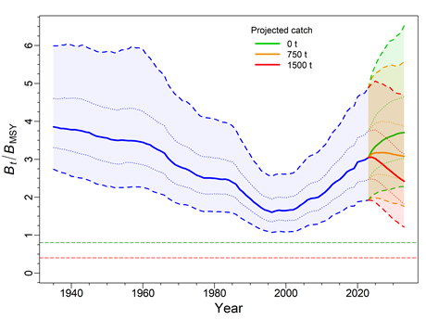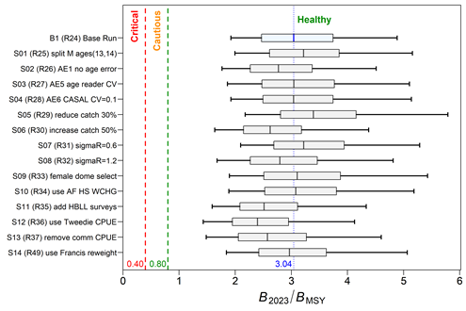

*Figure 9.* ***Left****: estimates of spawning biomass Bt relative to BMSY from the model posteriors (2,000 samples) of the CAR base run. The median biomass trajectory appears as a solid curve surrounded by a 90% credibility envelope (quantiles: 0.05, 0.95) in blue and delimited by dashed lines for years t=1935–2023; projected biomass using constant catch appears in green (no catch), orange (750 t/y), and red (1500 t/y) for years t=2024-2033 (10 years). Also shown is the 50% credibility interval (quantiles: 0.25–0.75) delimited by dotted lines.* ***Right****: Stock status of the CAR base run (top boxplot) and 14 sensitivity runs relative to the DFO Precautionary Approach (PA) provisional reference points of 0.4BMSY and 0.8BMSY for t=2023. Boxplots show the 0.05, 0.25, 0.5, 0.75 and 0.95 quantiles from the MCMC posterior.*

##### Darkblotched Rockfish

In 2009, Darkblotched Rockfish along the Pacific coast of Canada was designated as ‘Special Concern’ by COSEWIC. The last review of this species occurred in 2008 ([Research Document 2008/056](https://www.dfo-mpo.gc.ca/csas-sccs/publications/resdocs-docrech/2008/2008_056-eng.htm), [Proceedings 2009/007](https://www.dfo-mpo.gc.ca/csas-sccs/publications/pro-cr/2009/2009_007-eng.htm)). Currently, there is no stock assessment planned.

##### Pacific Ocean Perch

The most recent stock assessment (2017) is publicly available on the CSAS website ([Research Document 2018/031](https://www.dfo-mpo.gc.ca/csas-sccs/Publications/ResDocs-DocRech/2018/2018_038-eng.html), [Science Advisory Report 2017/043](https://www.dfo-mpo.gc.ca/csas-sccs/Publications/SAR-AS/2017/2017_043-eng.html), [Proceedings 2021/052](https://www.dfo-mpo.gc.ca/csas-sccs/Publications/Pro-Cr/2021/2021_052-eng.html)). An update is planned for 2023 that uses Stock Synthesis 3 to model the three regional stocks (5ABC, 3CD, and 5DE).

##### Redbanded Rockfish

The most recent stock assessment (2014) is publicly available on the CSAS website:  
([Research Document 2017/058](http://www.dfo-mpo.gc.ca/csas-sccs/Publications/ResDocs-DocRech/2017/2017_058-eng.html), [Proceedings 2015/032](https://www.dfo-mpo.gc.ca/csas-sccs/publications/pro-cr/2015/2015_032-eng.html)).

##### Redstripe Rockfish

The most recent stock assessment (2018) is publicly available on the CSAS website:  
([Research Document 2021/014](https://www.dfo-mpo.gc.ca/csas-sccs/Publications/ResDocs-DocRech/2021/2021_014-eng.html), [Science Advisory Report 2018/049](http://www.dfo-mpo.gc.ca/csas-sccs/Publications/SAR-AS/2018/2018_049-eng.html), [Proceedings 2022/014](https://www.dfo-mpo.gc.ca/csas-sccs/Publications/Pro-Cr/2022/2022_014-eng.html)).

##### Rougheye/Blackspotted Rockfish

The most recent stock assessment (2020) is publicly available on the CSAS website:  
 ([Research Document 2022/020](https://www.dfo-mpo.gc.ca/csas-sccs/Publications/ResDocs-DocRech/2022/2022_020-eng.html), [Science Advisory Report 2020/047](https://www.dfo-mpo.gc.ca/csas-sccs/Publications/SAR-AS/2020/2020_047-eng.html), [Proceedings 2022/004](https://www.dfo-mpo.gc.ca/csas-sccs/Publications/Pro-Cr/2022/2022_004-eng.html)).

##### Shortraker Rockfish

The most recent stock assessment (1998) is publicly available on the CSAS website:  
 ([Research Document 1999/184](https://www.dfo-mpo.gc.ca/csas-sccs/publications/resdocs-docrech/1999/1999_184-eng.htm)).

##### Silvergray Rockfish

The most recent stock assessment (2013) is publicly available on the CSAS website:  
 ([Research Document 2016/042](https://www.dfo-mpo.gc.ca/csas-sccs/Publications/ResDocs-DocRech/2016/2016_042-eng.html), [Science Advisory Report 2014/028](https://www.dfo-mpo.gc.ca/csas-sccs/Publications/SAR-AS/2014/2014_028-eng.html)).

##### Widow Rockfish

The most recent stock assessment (2019) is publicly available on the CSAS website:  
 ([Research Document 2021/039](https://www.dfo-mpo.gc.ca/csas-sccs/Publications/ResDocs-DocRech/2021/2021_039-eng.html), [Science Advisory Report 2019/044](https://www.dfo-mpo.gc.ca/csas-sccs/Publications/SAR-AS/2019/2019_044-eng.html), [Proceedings 2021/049](https://www.dfo-mpo.gc.ca/csas-sccs/Publications/Pro-Cr/2021/2021_049-eng.html)).

##### Yellowmouth Rockfish

The most recent stock assessment (2021) is publicly available on the CSAS website:  
 ([Research Document 2022/010](https://www.dfo-mpo.gc.ca/csas-sccs/Publications/ResDocs-DocRech/2022/2022_010-eng.html), [Science Advisory Report 2022/001](https://www.dfo-mpo.gc.ca/csas-sccs/Publications/SAR-AS/2022/2022_001-eng.html), [Proceedings 2022/003](https://www.dfo-mpo.gc.ca/csas-sccs/Publications/Pro-Cr/2022/2022_003-eng.html)).

##### Yellowtail Rockfish

The most recent stock assessment (2014) is publicly available on the CSAS website:  
 ([Science Advisory Report 2015/010](https://www.dfo-mpo.gc.ca/csas-sccs/Publications/SAR-AS/2015/2015_010-eng.html), [Proceedings 2015/020](https://www.dfo-mpo.gc.ca/csas-sccs/publications/pro-cr/2015/2015_020-eng.html)).

### Management

#### Inshore Rockfish

Inside and Outside Yelloweye Rockfish still fall under a rebuilding plan that is documented in Appendix 9 of the 2022 [IFMP](https://waves-vagues.dfo-mpo.gc.ca/library-bibliotheque/41034971.pdf). Most inshore rockfish are managed with Total Allowable Catches (TACs) under the Individual Transferable Quota system.

Commercial TACs and landings for 2022 are provided in Appendix 1. To support groundfish research and account for unavoidable mortality incurred during the 2022 Groundfish surveys, research catches are allocated before defining the TAC. See Appendix 1 for details.

Recreationally, the retention of Yelloweye Rockfish in inside and outside waters is prohibited. In outside waters, recreational fishers are limited to 3 rockfishes daily, only 1 of which may be a China, Tiger, or Quillback Rockfish; possession limits are twice the daily limits, and the season runs from April 1 – November 15. In inside waters (4B), recreational fishers can take 1 rockfish daily (not Yelloweye Rockfish or Bocaccio), possession limits are twice the daily limit and the season runs from May 1 – October 1. A condition of the recreational license is that: “Anglers in vessels shall immediately return all rockfish that are not being retained to the water and to a similar depth from which they were caught by use of an inverted weighted barbless hook or other purpose-built descender device.”

#### Offshore Rockfish

Commercial TACs and landings for 2022 are provided in Appendix 1. To support groundfish research and account for unavoidable mortality incurred during the 2022 Groundfish surveys, research catches are allocated before defining the TAC. See Appendix 1 for details.

## Thornyheads

### Research

Data collection continued in 2022 through trawl and longline surveys. With the suspension of the At Sea Observer program due to COVID-19, there was no commercial sampling.

Attempts to sample Longspine Thornyhead from a deep stratum (800-1300 m) in the WCVI synoptic survey have thus far been unsuccessful. Both Longspine and Shortspine Thornyhead do not have an acceptable protocol for ageing otoliths. Research is ongoing at the Sclerochronology Laboratory at PBS.

### Assessment

Longspine Thornyhead (LST) was designated ‘Special Concern’ by COSEWIC in 2007. An assessment has been requested but not yet scheduled. Attempts to sample LST from a deep stratum (800-1300 m) in the WCVI synoptic survey have thus far been unsuccessful.

Coastwide Shortspine Thornyhead was assessed in 2015 using a delay-difference model.

The most recent stock assessment (2015) is publicly available on the CSAS website:  
 ([Research Document 2017/015](https://www.dfo-mpo.gc.ca/csas-sccs/Publications/ResDocs-DocRech/2017/2017_015-eng.html), [Science Advisory Report 2016/016](https://www.dfo-mpo.gc.ca/csas-sccs/Publications/SAR-AS/2016/2016_016-eng.html), [Proceedings 2016/040](https://www.dfo-mpo.gc.ca/csas-sccs/Publications/Pro-Cr/2016/2016_040-eng.html)).

### Management

Longspine and Shortspine Thornyhead are both IVQ species. Commercial TACs and landings for 2022 are provided in Appendix 1. To support groundfish research and account for unavoidable mortality incurred during the 2022 Groundfish surveys, research catches are allocated before defining the TAC. See Appendix 1 for details.

Current management of Pacific groundfish stocks can be found in the Integrated Fisheries Management Plan ([IFMP 2023](https://waves-vagues.dfo-mpo.gc.ca/library-bibliotheque/41098067.pdf)).

## Sablefish

Management of Sablefish in BC is guided by a Management Strategy Evaluation (MSE) process that has been jointly developed by Fisheries and Oceans Canada (DFO) and the BC Sablefish fishing industry. Annual total allowable catches (TACs) for BC Sablefish have been set in a transparent and sustainable manner using simulation-tested management procedures (MPs) since 2011.

### Research

Collection of biological data continued in 2022 through trawl and trap surveys. With the suspension of the At Sea Observer program due to COVID-19, there has been no commercial sampling from the trawl fishery since March 2020. However, commercial sampling has continued in the directed trap and longline fisheries through a voluntary biosampling program supported by industry. A head-only sampling program was initiated in 2018 whereby commercial fishers follow specific instructions to collect specimens at stepped intervals of their overall cumulative catch for the year (i.e., every 50,000 lbs). Males and females are marked by cutting the operculum and then the heads are frozen to be sampled on shore. Unpublished work has shown a strong relationship between head morphometric measurements and fork length, so frozen head samples are measured on shore to collect estimated length data. Otoliths are also retrieved from frozen heads for ageing. A technical report is being developed for 2023 to describe this new sampling procedure and document the relationship between head morphometrics and fork length.

### Assessment

Sablefish stock status is regularly evaluated as part of the MSE process. An operating model (i.e., representation of alternative hypotheses about ‘true’ Sablefish population dynamics; OM) is used to both estimate stock status and simulate data for prospective testing of management procedure performance relative to stock and fishery objectives.

A revised version of the BC Sablefish OM was developed in 2022 that used data up to the end of 2021 (DFO 2023; Johnson et al., in revision). The revised OM was transitioned to a new software platform for 2022 (Template Model Builder; previous implementations were in AD Model Builder). Transition analyses showed that both implementations produced similar results, while the new platform offered better model diagnostics and computational performance.

Stock status in 2022 was assessed via a weighted-average of five operating model scenarios representing uncertainty about productivity and recent (2021) female spawning stock biomass. BC Sablefish female spawning stock biomass for 2022 (B2022) was estimated to be well above the level of female spawning stock biomass associated with maximum sustainable yield (BMSY). The weighted average estimate of B2022 is above BMSY with 92% probability (median value of 1.32 times BMSY). The estimated harvest rate (U) of legal-sized Sablefish in 2021 is below the harvest rate at MSY (UMSY) with 94% probability (median value of 0.72 times UMSY).

As part of the 2022 OM update, closed-loop simulations were used to test whether the current MP, with a maximum target legal harvest rate of 5.5%, was able to meet operational fishery objectives under the revised OM scenarios. Alternative versions of the current MP with a range of target harvest rates were also tested. Simulation performance showed that an increase in the current maximum target legal harvest rate up to 7.5% could be considered while still meeting conservation objectives aimed at remaining above the LRP and achieving the target reference point.

The 2022 Sablefish OM paper also examined environmental variables (EVs) potentially affecting BC Sablefish population dynamics via pairwise correlations between eight EVs, annual recruitment, and a body condition index. While some EVs showed moderate correlations with body condition, none were strongly correlated to recruitment. These analyses were an initial exploration of potential links. Future research into environmental drivers of Sablefish recruitment strength in BC will need to explore more complex models to explain variability as a function of multiple environmental variables operating at various spatio-temporal scales and life history stages.

The revised operating model continues to assume that the BC Sablefish stock is a closed population, despite evidence of movements among Sablefish stocks in Alaska and US waters south of BC (Hanselman et al. 2014) and little genetic evidence of population structure across these management regions (Jasonowicz et al. 2017). These movements may have implications for the assumptions made about Sablefish stock dynamics in BC (i.e., recruitment, productivity) that are not currently captured by the revised OM or reflected in MP performance evaluations. Ongoing collaboration between DFO, NOAA, and ADFG is working towards the development of a coastwide Sablefish OM to understand the potential consequences of the mismatch between Sablefish stock structure and management.

Literature Cited:

DFO. 2023. A revised operating model for sablefish in British Columbia in 2022. Can. Sci. Advis. Sec. Sci. Advis. Rep. 2023/010.

DFO. In press. Application of the British Columbia Sablefish (*Anoplopoma fimbria*) Management Procedure for the 2023-24 Fishing Year. DFO Can. Sci. Advis. Sec. Sci. Resp. 2023/009.

Hanselman, D.H., Heifetz, J., Echave, K.B., and Dressel, S.C., 2014. Move it or lose it: movement and mortality of sablefish tagged in Alaska. Canadian journal of fisheries and aquatic sciences, 72(2), pp.238-251.

Jasonowicz, A.J., Goetz, F.W., Goetz, G.W. and Nichols, K.M., 2016. Love the one you’re with: genomic evidence of panmixia in the sablefish (*Anoplopoma fimbria*). Canadian Journal of Fisheries and Aquatic Sciences, 74(3), pp.377-387.

Johnson, S.D.N., Cox, S.P., Holt, K.R., Lacko, L.C., and Rooper, C.N. In revision. Stock status and management procedure performance for the BC Sablefish (*Anoplopoma fimbria*) fishery for 2022/23. Can. Sci. Advis. Sec. Res. Doc.

### Management

The MP that is currently in place for the BC Sablefish fishery was evaluated as part of the 2022 OM update (see Assessment section above). This MP is based on a surplus production model fit to time-series observations of total landed catch, and the fishery independent survey CPUE, to forecast Sablefish biomass for the coming year. The surplus production model outputs are then inputs to a harvest control rule each year to calculate a recommended catch limit of legal Sablefish. The harvest control rule selected used for annual application starting in 2023-24 has a maximum target harvest rate of 6.4%. Application of the Sablefish MSE’s management procedure to develop an annual catch limit recommendation for the 2023-24 Sablefish fishery was documented through a CSAS Science Response (DFO, in press) and will be published on the CSAS website in the coming months.

Commercial TACs and landings for 2022 are provided in Appendix 1. To support groundfish research and account for unavoidable mortality incurred during the 2022 Groundfish surveys, research catches are allocated before defining the TAC. See Appendix 1 for details.

## Lingcod

### Research

Data collection continued in 2022 through trawl and longline surveys and recreational creel surveys. With the suspension of the At Sea Observer program in 2020, there was no commercial sampling. Additional biological samples (length, weight, sex, maturity, and fins for ageing) were collected on the Outside HBLL survey done in collaboration with industry. We are currently preparing fins for ageing in order to inform survey selectivity in our next stock assessment. We are also collaborating with the Sclerochronology lab at PBS by collecting paired otolith and fin rays on our surveys in order to compare ageing structures.

### Assessment

Inside, the waters within the Strait of Georgia, and Outside, the rest of the BC Coast, Lingcod populations are assessed and managed as separate units. Outside Lingcod were scheduled to be assessed in the spring of 2019; however, the assessment has been pushed back due to other program demands as well as the desire to have some age-data to inform the catchability of the longline surveys. Fins collected on the IPHC, trawl surveys and Outside HBLL surveys have been processed and an assessment is planned for 2024. Inside Lingcod were last assessed in 2014.

### Management

Commercial TACs and landings for 2022 are provided in Appendix 1. To support groundfish research and account for unavoidable mortality incurred during the 2022 Groundfish surveys, research catches are allocated before defining the TAC. See Appendix 1 for details.

## Atka Mackerel

The distribution of Atka mackerel does not extend into the Canadian zone.

## Flatfish

### Research

Ongoing data collection in support of the flatfish research program, inclusive of Arrowtooth Flounder, Petrale Sole, Southern Rock Sole, Dover Sole, and English Sole continued in 2022 through surveys. With the suspension of the At Sea Observer program due to COVID-19, there was no commercial sampling after March 2020.

### Assessment

##### Arrowtooth Flounder

In the past decade, markets were established for BC Arrowtooth Flounder fillets that were frozen at sea and catches increased peaking in 2014. The stock was last assessed in 2016 prior to declines seen in several survey indices. In 2022, the Arrowtooth Flounder was updated using a two-sex two-fleet Bayesian age-structured assessment model fit to catch, survey index, and age-composition data from the 1996-2021 for a single coastwide stock. Catch data prior to 1996 were not used due to unknown levels of releasing at sea prior to the introduction of at-sea observers. Reference points based on maximum sustainable yield (MSY) were strongly impacted by the relationship between the estimates of maturity and commercial age selectivity; reference points were instead calculated with respect to unfished biomass (B0). The model estimated a decline in spawning stock biomass from shortly after 2010 until around 2020 and suggested this decline was partly a result of increased fishing mortality and partly a result of low recruitment over the last decade. The stock was estimated to be above its Limit Reference Point with high probability but near its Upper Stock Reference point as of 2022. A Reference Removal Rate was estimated that would be expected to take the stock to its Upper Stock Reference in the long run (50 years).

##### Petrale Sole

Petrale Sole was last assessed in 2007. In response to a request for updated harvest advice from fishery managers, aging of otoliths was completed in 2020. Work is currently underway to deliver an updated assessment in 2023-24.

##### Southern Rock Sole

Southern Rock sole was last assessed in 2013. No request for updated advice has been received.

##### Dover Sole

Dover sole was last assessed in 1999. Aging of otoliths up to 2016 was completed in 2020 in anticipation of an updated assessment.

##### English Sole

English sole was also last assessed in 2007. No request for updated advice has been received.

### Management

Arrowtooth Flounder, Petrale Sole, Southern Rock Sole, Dover sole, and English Sole are all managed by annual coastwide or area specific TACs and harvested primarily by the IVQ multi- species bottom trawl fishery. Commercial TACs and landings for 2022 are provided in Appendix 1. To support groundfish research and account for unavoidable mortality incurred during the 2022 Groundfish surveys, research catches are allocated before defining the TAC. See Appendix 1 for details.

## Pacific Halibut & IPHC Activities

Catch and biological data were collected in 2022 on trawl and longline surveys. With the suspension of the At Sea Observer program (ASOP) due to COVID-19, there has been no commercial sampling since April 2020. Current trawl-based halibut mortality is estimated using area-based average weights that were determined using historical ASOP data. DFO is currently working with industry reps and service providers to develop a biosampling program to address gaps created from the suspension of ASOP; halibut length sampling will be considered along with other species in its development. In 2022, DFO collaborated with the Pacific Halibut Management Association to collect biological samples from the IPHC’s Fishery Independent Setline Survey (FISS) during offloads. Sampling was completed by technicians from Archipelago Marine Research. Complete catch data by set was also recorded by skippers in logbooks and uploaded to GFFOS. There were a total of 174 sets in Canadian waters with almost 600 rockfish sampled dockside. All set species catch was submitted by the vessels with 439 Yelloweye Rockfish, 95 Quillback Rockfish and 64 Rougheye/ Blackspotted Rockfish samples attached at the fishing set level using a unique colour/ number tag system.

Work was also undertaken to understand how changes to the IPHC’s Fishery Independent Setline Survey (FISS) design and data collection might affect the assessment and management system for six groundfish stocks in BC, including Outside Yelloweye Rockfish (OYE), Outside Quillback Rockfish, Redbanded Rockfish, Lingcod, North Pacific Spiny Dogfish, and Longnose Skate. Specifically, we evaluate (1) changes to the IPHC FISS design that includes subsampling 2B station off the west coast of Vancouver Island (VI) stations, and (2) different IPHC FISS data collection scenarios that will affect survey precision for indices and age composition data. We used random resampling to estimate abundance indices for different species and areas with VI station subsampling and estimated the variance of age composition data for different sample sizes via simulation. The indices with VI subsampling had higher variability (mean CVs ranging from 11% to 51%) and bias (mean bias ranging from-14.6%to 12.5%) compared to the historical IPHC indices without VI subsampling. We developed different data scenarios that account for 1) and 2), which were used for testing management procedures (MPs) and fitting catch-at-age assessments for OYE via simulation. The increased variability in IPHC indices had a negligible effect on OYE MP performance for long-term biomass objectives and catch metrics for the next 5-10 years (Doherty and Haggarty 2022).

Doherty, B. and **Haggarty, D.R**. 2022. Evaluation of changes to the IPHC Fishery-Independent Setline Survey (FISS) with implications for management of select groundfish species in British Columbia. Can. Tech. Rep. Fish. Aquat. Sci. 3483: vi + 64 p. <https://waves-vagues.dfo-mpo.gc.ca/library-bibliotheque/41090895.pdf>

Commercial TACs and landings for 2022 are provided in Appendix 1.

## Other Groundfish Species

Nothing to report at this time.

# Ecosystem Studies

##### Groundfish Data Synopsis

The first phase consisted of a groundfish data synopsis, as described in the 2019 TSC report. The synopsis provides a visual snapshot of temporal trends and spatial distributions of commercial catches and survey indices, growth and maturity characteristics, and data availability for over 100 BC groundfish stocks. The synopsis was peer reviewed through a Canadian Science Advisory Secretariat (CSAS) Regional Peer Review (RPR) process in 2018 and published in 2019 as a Research Document (Anderson et al. 2019). An article described the approach to a wider audience (Anderson et al. 2020). An updated synopsis with data up to 2021 was published in 2022 as a [Science Response](https://waves-vagues.dfo-mpo.gc.ca/library-bibliotheque/41074191.pdf) (DFO 2022). The authors expect to publish an update in 2023 as a DFO Technical Report. The synopsis code and link to the latest version are available on [GitHub](https://github.com/pbs-assess/gfsynopsis).

*Disentangling the impacts of environmental change and commercial fishing on Canadian Groundfish biodiversity*

Using a spatiotemporal multispecies model based on fisheries independent data from the synoptic bottom trawls, Thompson et al. ([2022](https://doi.org/10.3354/meps14034)) found that groundfish species density (number of species per area) and community biomass have increased since 2003. Environmental changes during this period were associated with temporal fluctuations in the biomass of species and the community as a whole. However, environmental changes were less associated with changes in species occurrence. Thus, the estimated increases in species density are not likely to be due to environmental change. Instead, the results are consistent with an ongoing recovery of the demersal fish community from a reduction in commercial fishing intensity from historical levels. These findings provide key insight into the drivers of biodiversity change that can inform ecosystem-based management. The results are important to understanding the joint influence of ongoing environmental change and fishing pressure and emphasizes the value of robust biodiversity monitoring and analyses that jointly account for potential drivers of change.

*Groundfish Species Distribution Modeling*

Species distribution models were made for numerous Canadian Groundfish using data from synoptic trawl and longline fishery-independent surveys Species (Thompson et al. 2023a). They demonstrated a method for integrating presence–absence data across surveys and gear types that allows them to predict the coastwide distributions of 65 groundfish species in British Columbia. The model leverages data from multiple surveys to estimate how species respond to environmental gradients while accounting for differences in survey catchability. They found that this method had two main benefits: (1) it increases the accuracy of predictions in data-limited surveys and regions while having negligible impacts on accuracy when data are already sufficient, and (2) it reduces uncertainty, resulting in tighter confidence intervals on predicted occurrences. These benefits are particularly relevant in areas of our coast where our understanding of habitat suitability is limited due to a lack of spatially comprehensive long-term groundfish surveys. The authors also coded a [Shiny App](https://msea.science/integrated_gf_shiny/) to plot the species distribution of species of interest.

Similar techniques were applied to International Pacific Halibut Commission longline survey data stretching from Alaska to California in order to assess the potential distributional changes of the species under future climate change scenarios ([Thompson et al. 2023b).](https://doi.org/10.1016/j.fishres.2022.106540) The results of this modeling showed that Pacific halibut appear sensitive to changes in dissolved oxygen, yet relatively tolerant of increases in temperature. The climate projections resulted in decreases in dissolved oxygen near the seafloor in shallow waters which is likely to decrease the overall abundance of smaller halibut by the middle of the century. In contrast, larger halibut, which inhabit deeper waters showed a mixed response to future climate change, but this mostly reflected uncertainty around trends in oxygen concentration at mid-depths (300-600 m). A complementary analysis was published in by Franco et al (2022) and indicates that the projected decrease in suitable habitat for halibut will likely continue until the end of the 21st century. The Thompson et al (2023b) paper was part of a collection of papers on Pacific halibut that arose from a 2018 PICES workshop held in Victoria BC. The full issue can be found [here](https://www.sciencedirect.com/journal/fisheries-research/special-issue/107XBM3GX7H).

Literature Cited:

**Anderson, S.C., Keppel, E.A., and Edwards, A.M**. 2019. A reproducible data synopsis for over 100 species of British Columbia groundfish. DFO Can. Sci. Advis. Sec. Res. Doc. 2019/041. vii + 321 p. <http://www.dfo-mpo.gc.ca/csas-sccs/Publications/ResDocs-DocRech/2019/2019_041-eng.html>

**Anderson, S.C., Keppel, E.A., and Edwards, A.M**.. 2020. Reproducible visualization of raw fisheries data for 113 species improves transparency, assessment efficiency, and monitoring. Fisheries, 45(10):535-543. <https://doi.org/10.1002/fsh.10441>

Franco, A.C., Kim, H., Frenzel, H., Deutsch, C., **Ianson, D.,** Sumaila, R.U., Tortell, P.D., 2022 Impact of warming and deoxygenation on the habitat distribution of Pacific halibut in the Northeast Pacific. Fisheries Oceanography, 31(6): 601-614. <https://doi.org/10.1111/fog.12610>

DFO. 2022. A data synopsis for British Columbia groundfish: 2021 data update. DFO Can. Sci. Advis. Sec. Sci. Resp. 2022/020. <https://www.dfo-mpo.gc.ca/csas-sccs/Publications/ScR-RS/2022/2022_020-eng.html>

**Thompson, P.J., Anderson, S.C., Nephin, J., Haggarty, D.R. Peña, M.A., English, P.A., Gale, K.S.P., Rubidge, E**. 2022. Disentangling the impacts of environmental change and commercial fishing on demersal fish biodiversity in a northeast Pacific ecosystem. Marine Ecology Progress Series. 689:137-154. <https://doi.org/10.3354/meps14034>

**Thompson, P.L., S.C. Anderson, J. Nephin, C.K. Robb, B. Proudfoot, A.E. Park, D.R. Haggarty, E.M. Rubidge.** 2023a. Integrating trawl and longline surveys across British Columbia improves groundfish distribution predictions. Can. J. Fish. Aquat. Sci. 80(1): 195–210. https://doi.org/10.1139/cjfas-2022-0108.

**Thompson, P.L., Rooper, C.N., Nephin, J., Park, A.E., Christian, J.R., Davies, S.C., Hunter, K., Lyons, D.A., Peña, M.A., Proudfoot, B. and Rubidge, E.M.,** 2023b. Response of Pacific halibut (*Hippoglossus stenolepis*) to future climate scenarios in the Northeast Pacific Ocean. Fisheries Research, 258, p.106540. https://doi.org/10.1016/j.fishres.2022.106540

# Other related studies

*State of the Pacific Ocean Report*

Anderson, English, and Dunic contributed a chapter to the 2023 State of the Pacific Ocean report and presented on the work at the annual meeting. This involved synthesizing the most recent stock status for all assessed stocks since 2010, fitting a state-space time series model to trends in stock status to derive an overall average trend, and combining assessed status time series with recent geostatistical survey indices to provide insight into recent stock trends since stocks were last assessed. The state-space time series modelling indicated that average BC groundfish stock status declined from 1950 to around 2000, and following management changes, has remained relatively stable since. The geostatistical survey modelling revealed several findings. First, survey indices increased for ~70% of stocks over the last two decades, remained neutral for ~15%, and declined for ~15% of stocks. Second, over the last 5-7 years, all assessed shelf rockfish (Bocaccio, Canary, Redstripe, Silvergray, Widow, Yellowtail) and several slope rockfish increased in surveyed biomass. Over the last 5-10 years, survey indexes also increased for several flatfish (Petrale, English, Rex, and Dover Sole) but declined for Arrowtooth Flounder. Third, despite low levels of fishing mortality compared to historical levels, survey indices for North Pacific Spiny Dogfish stocks had the steepest declines across all stocks.

*Hook Competition*

Competition for bait on a finite number of hooks leads to biased estimates of relative abundance. If 1000 baited hooks are deployed and all the hooks catch a fish it is important to account for the fish that would have been caught if more hooks had been used. Additionally, fish that are not as quick to get to the baits as the fish that were caught can affect relative abundance estimates. Watson et al. (2023) developed a new statistical method for dealing with this long-standing problem. This method treats some observations as right-censored, such that observed catch counts are considered as a lower bound on what would have been observed in the absence of hook competition, outperformed previous methods. By using simulation experiments and applying it to data from Canadian waters, from the International Pacific Halibut Commission fishery-independent setline survey, they found that it can greatly change estimates of fish abundance. It can halve them or even double them compared to existing methods. Template R code is provided for users to apply the method to their own data.

Literature Cited:

**Watson, J., A.M. Edwards**, and M. Auger-Méthé. 2023. A statistical censoring approach accounts for hook competition in abundance indices from longline surveys. Canadian Journal of Fisheries and Aquatic Sciences, 80:468-486. [<https://cdnsciencepub.com/doi/10.1139/cjfas-2022-0159>](https://cdnsciencepub.com/doi/10.1139/cjfas-2022-0159)

# Publications

## Primary Publications

Ban, N.C., Miltner, C., Matthews, C., Ankenman, M., Stelte, S., **Haggarty**, **D.**, Davies, H.L., Venturelli, P.A., Juanes, F. 2022. Decrease in recreational fisher compliance during the COVID-19 pandemic: the case of Rockfish Conservation Areas. ICES Journal of Marine Science. 79 (8): 2277-2285. https://doi.org/10.1093/icesjms/fsac160

Barnes, C.L., Essington, T.E., Pirtle, J.L., **Rooper, C.N.**, Laman, E.A., Holsman, K.K., Aydin, K.Y., and Thorson, J.T. 2022. Climate-informed models benefit hindcasting but present challenges when forecasting species–habitat associations. Ecography. e06189. https://doi.org/10.1111/ecog.06189

Brodie, S., Smith J.A., Muhling, B.A., Kaplan, I., Barnett, L.A.K., Carroll, G., Fiedler, P., Bograd, S.J., Hazen, E.L., Jacox, M.G., Andrews, K.S., Barnes, C.L., Crozier, L., Fiechter, J., Fredston, A., Haltuch, M.A., Harvey, C., Holmes, E., Karp, M.A., Liu, O.R., Malick, M.J., Pozo-Buil, M., Richerson, K., **Rooper, C.N.**, Samhouri, J., Seary, R., Selden, R.L., Thompson, A.R., Thorson, J.T., Tommasi, D., Ward, E.J., and Zabel, R., 2022. Recommendations for quantifying and reducing uncertainty in climate projections of species distributions. Global Change Biology. 28(22): 6586-6601. https://doi.org/10.1111/gcb.16371

Campbell, J. Yakimishyn, J., **Haggarty, D.R.**, Juanes, F., Dudas, S. 2023. Citizen Science Surveys Provide Novel Nearshore Data. Fisheries. 48: 8-19. https://doi.org/10.1002/fsh.10831.

Commander, C.J.C, Barnett, L.A.K., Ward, E.J., **Anderson**, **S.C.,** and Essington, T.E. 2022. The shadow model: how and why small choices in spatially explicit species distribution models affect predictions. PeerJ. 10: e12783. https://doi.org/10.7717/peerj.12783.

Davies, H.L., Gross, S., **Haggarty, D.R.**, and Juanes, F. 2022. Conserving Rockfishes: Barotrauma and Descending Devices in the Northeast Pacific. Fisheries. 47(9): 406-411. https://doi.org/10.1002/fsh.10810

Essington, T.E., **Anderson**, **S.C.**, Barnett, L.A.K., Berger, H.M., Siedlecki, S.A., and Ward, E.J. 2022. Advancing statistical models to reveal the effect of dissolved oxygen on the spatial distribution of marine taxa using thresholds and a physiologically based index. Ecography. 2022(8): e06249. <https://doi.org/10.1111/ecog.06249>.

Gale, K.S.P., **Forrest, R.E.**, **Rooper, C.N.**, Nephin, J., Wallace, S., Driscoll, J., and Rubidge, E. 2022. Evaluation of collaboratively-developed management measures to reduce coral and sponge bycatch in a fully-monitored multispecies trawl fishery. Canadian Journal of Fisheries and Aquatic Sciences. cjfas-2021-0274. https://doi.org/10.1139/cjfas-2021-0274

Hunsicker, M.E., Ward, E.J., Litzow, M.A., **Anderson, S.C.**, Harvey, C.J., Field, J.C., Gao, J., Jacox, M.G., Melin, S., Thompson, A.R., and Warzybok, P. Tracking and forecasting community responses to climate perturbations in the California Current Ecosystem. PLOS Climate. 1(3): e0000014. <https://doi.org/10.1371/journal.pclm.0000014>.

Love, M.S., Bizzarro, J.J., **Cornthwaite, M**., Frable, B.W., and Maslenikov, K.P. 2021. Checklist of marine and estuarine fishes from the Alaska-Yukon Border, Beaufort Sea, to Cabo San Lucas, Mexico. Zootaxa. 5053(1): 1-285 .

Planas J.V., **Rooper C.N.**, and Kruse G.H. 2022. Integrating biological research, fisheries science and management of Pacific halibut (*Hippoglossus stenolepis*) across the North Pacific Ocean. Fisheries Research. 259: 106559. https://doi.org/10.1016/j.fishres.2022.106559

Shotwell, S.K., J.L. Pirtle, J.T. Watson, A. Deary, M. Doyle, S. Barbeaux, M. Dorn, G.A. Gibson, E. Goldstein, D.H. Hanselman, A.J. Hermann, P.J.F. Hulson, B. Laurel, J. Moss, O. Ormseth, D. Robinson, L. Rogers, **C. Rooper**, I. Spies, W. Strasburger, R. Suryan, J.J. Vollenweider. 2022. Using integrated ecosystem research to develop informed stock-specific indicators for next generation stock assessment. Deep-Sea Research II. 198. http://dx.doi.org/10.1016/j.dsr2.2022.105070

Thompson, P.J., **Anderson, S.C.**, Nephin, J., **Haggarty, D.R.** Peña, M.A., **English, P.A.,** Gale, K.S.P., and Rubidge, E. 2022. Disentangling the impacts of environmental change and commercial fishing on demersal fish biodiversity in a northeast Pacific ecosystem. Marine Ecology Progress Series. 689:137-154. <https://doi.org/10.3354/meps14034>

Thompson, P.L., **Anderson**, **S.C.**, Nephin, J., Robb, C.K., Proudfoot, B., Park, A.E., **Haggarty, D.R.**, and Rubidge, E.M. 2023a. Integrating trawl and longline surveys across British Columbia improves groundfish distribution predictions. Canadian Journal of Fisheries and Aquatic Sciences. 80(1): 195–210. https://doi.org/10.1139/cjfas-2022-0108.

Thompson, P.L., **Rooper, C.N.**, Nephin, J., Park, A.E., Christian, J.R., Davies, S.C., Hunter, K., Lyons, D.A., Peña, M.A., Proudfoot, B. and Rubidge, E.M., 2023b. Response of Pacific halibut (*Hippoglossus stenolepis*) to future climate scenarios in the Northeast Pacific Ocean. Fisheries Research. 258: 106540. https://doi.org/10.1016/j.fishres.2022.106540

Ward, E.J., Barnett, L.A.K., **Anderson, S.C.**, Commander, C.J.C., and Essington, T.E. 2022. Incorporating non-stationary spatial variability into dynamic species distribution models. ICES Journal of Marine Science. 79(9): 2422-2429. https://doi.org/10.1093/icesjms/fsac179.

Ward, E.J., **Anderson, S.C.**, Hunsicker, M.D., and M.A. Litzow. 2022. Smoothed dynamic factor analysis for identifying trends in multivariate time series. Methods in Ecology and Evolution. 13(4): 908-918. https://doi.org/10.1111/2041-210X.13788.

Watson, J., **Edwards, A.M.**, and Auger-Méthé, M.. 2023. A statistical censoring approach accounts for hook competition in abundance indices from longline surveys. Canadian Journal of Fisheries and Aquatic Sciences. 80:468-486. [<https://cdnsciencepub.com/doi/10.1139/cjfas-2022-0159>](https://cdnsciencepub.com/doi/10.1139/cjfas-2022-0159)

## Other Publications

**Anderson, S.C.**, E.J. Ward, **P.A. English**, L.A.K. Barnett. 2022 sdmTMB: an R package for fast, flexible, and user-friendly generalized linear mixed effects models with spatial and spatiotemporal random fields. bioRxiv 2022.03.24.485545. https://doi.org/10.1101/2022.03.24.485545.

Berger, A.M., **C.J. Grandin**, K.F. Johnson and **A.M. Edwards**. 2023. Status of the Pacific Hake (whiting) stock in U.S. and Canadian waters in 2023. Prepared by the Joint Technical Committee of the U.S. and Canada Pacific Hake/Whiting Agreement, National Marine Fisheries Service and Fisheries and Oceans Canada. 208 p. <https://media.fisheries.noaa.gov/2023-02/2023-hake-assessment-post-srg_web.pdf>

**Cornthwaite, A.M.**, King, J.R., Bresch, M.J., and **Granum, L.J.** 2022. Pacific Spiny Dogfish (*Squalus suckleyi*) longline survey in the Strait of Georgia, October 2-13, 2014. Can. Manuscr. Rep. Fish. Aquat. Sci. 3246: v + 19 p.

DFO. 2022a. Update of the 2019 Bocaccio (*Sebastes paucispinis*) stock assessment for British Columbia in 2021. DFO Can. Sci. Advis. Sec. Sci. Resp. 2022/001.

DFO. 2022b. Yellowmouth Rockfish (*Sebastes reedi*) Stock Assessment for British Columbia in 2021. DFO Can. Sci. Advis. Sec. Sci. Advis. Rep. 2022/001.

DFO. 2022c. A data synopsis for British Columbia groundfish: 2021 data update. DFO Can. Sci. Advis. Sec. Sci. Resp. 2022/020. <https://www.dfo-mpo.gc.ca/csas-sccs/Publications/ScR-RS/2022/2022_020-eng.html>

DFO. 2023a. Canary Rockfish (*Sebastes pinniger*) Stock Assessment for British Columbia in 2022. DFO Can. Sci. Advis. Sec. Sci. Advis. Rep. 2023/002.

DFO. 2023b. Recovery Potential Assessment for Yelloweye Rockfish (*Sebastes ruberrimus*) in British Columbia. DFO Can. Sci. Advis. Sec. Sci. Resp. 2023/003.

DFO. 202c. A Revised Operating Model for Sablefish in British Columbia in 2022. DFO Can. Sci. Advis. Sec. Sci. Advis. Rep. 2023/010.

Doherty, B. and **Haggarty, D.R**. 2022. Evaluation of changes to the IPHC Fishery-Independent Setline Survey (FISS) with implications for management of select groundfish species in British Columbia. Can. Tech. Rep. Fish. Aquat. Sci. 3483: vi + 64 p. <https://waves-vagues.dfo-mpo.gc.ca/library-bibliotheque/41090895.pdf>

**Haggarty, D.R.**, Huynh, Q.C., **Forrest, R.E.**, **Anderson, S.C.**, Bresch, M.J., and **Keppel, E.A.** In press. Evaluation of potential rebuilding strategies for Inside Yelloweye Rockfish (*Sebastes ruberrimus*) in British Columbia. DFO Can. Sci. Advis. Sec. Res. Doc. 2021/0008. vi + 142 p.

**Haggarty, D.R.**, **Siegle, M.R.**, Litt, M.A., and Huynh, Q. 2022. Quillback Rockfish Fishery and Conservation Objectives Workshop Summary Report. Can. Tech. Rep. Fish. Aquat. Sci. 3488: viii + 56 p.

**Lacko, L.C., Acheson, S.M.,** and **Holt, K.R.** 2023. Summary of the annual 2021 Sablefish (*Anoplopoma fimbria*) trap survey, October 6 - November 21, 2021. Can. Tech. Rep. Fish. Aquat. Sci. 3530: vii + 48 p.

Lindmark, M., **S.C. Anderson**, M. Gogina, and M. Casini. 2022. Evaluating drivers of spatiotemporal individual condition of a bottom-associated marine fish. bioRxiv 2022.04.19.488709. https://doi.org/10.1101/2022.04.19.488709.

Robichaud, D. and **Haggarty, D.R.** 2022. Comparison of rockfish and lingcod catch estimates from internet recreational effort and catch (iREC) and creel surveys. Can. Tech. Rep. Fish. Aquat. Sci. 3500: v + 46 p.

**Siegle, M.**, **D.R. Haggarty**, Q. Huynh, B. Doherty, and J. Banning. 2022. Recovery Potential Assessment for Yelloweye Rockfish (*Sebastes ruberrimus*) in British Columbia. DFO Can. Sci. Advis. Sec. Sci. Resp. 2022/nnn.

Starr, P.J. and **Haigh, R**. 2022. Bocaccio (*Sebastes paucispinis*) stock assessment for British Columbia in 2019, including guidance for rebuilding plans. DFO Can. Sci. Advis. Sec. Res. Doc. In press

Starr, P.J. and **Haigh, R.** 2022. Yellowmouth Rockfish (*Sebastes reedi*) stock assessment for British Columbia in 2021. DFO Can. Sci. Advis. Sec. Res. Doc. 2022/010. viii + 288 p.

**Williams, D.C.** and **Haggarty, D**. 2022. Summary of the 2021 Hard Bottom Longline Inside Surveys in British Columbia. Can. Manuscr. Rep. Fish. Aquat. Sci. 3245: v + 31 p.

Appendix 1: British Columbia commercial groundfish TACs, landings, and research allocations for 2022.

Table 1. British Columbia Groundfish Total Allowable Catch (TAC) and commercial landings in metric tonnes (t) for the 2022 fishing year. Except where noted, TACs are from the 2022 Groundfish Integrated Fisheries Management Plan (<https://waves-vagues.dfo-mpo.gc.ca/Library/40990151.pdf>). Landings are from the Dockside Monitoring Program.

| **Species or Species Group** | **Trawl Sector (t)** | | **Combined Line Sectors (t)** | | **Total (t)** | |
| --- | --- | --- | --- | --- | --- | --- |
| **TAC** | **Landings** | **TAC** | **Landings** | **TAC** | **Landings** |
| *Sharks And Skates* |  |  |  |  |  |  |
| North Pacific Spiny Dogfish | 4,480 | 109 | 9,520 | 0 | 14,000 | 109 |
| Big Skate | 914 | 202 | 117 | 12 | 1,031 | 214 |
| Longnose Skate | 138 | 72 | 263 | 71 | 401 | 143 |
| Pacific Cod | 1,250 | 835 | 0 | 4 | 1,250 | 839 |
| Walleye Pollock | 4,935 | 38,556 | 0 | 0 | 4,935 | 38,556 |
| Pacific Hake 1 | 7,000 gulf & 142,354 offshore | 9,411 | 0 | 0 | 142,354 | 9,411 |
| *Rockfishes* |  |  |  |  |  |  |
| Rougheye/Blackspotted Rockfish Complex | 614 | 586 | 463 | 281 | 1,077 | 867 |
| Pacific Ocean Perch | 5,192 | 3,497 | 1 | 0 | 5,193 | 3,498 |
| Redbanded Rockfish | 295 | 198 | 284 | 240 | 579 | 438 |
| Shortraker Rockfish | 126 | 54 | 111 | 127 | 237 | 181 |
| Silvergray Rockfish | 1,945 | 1,182 | 254 | 45 | 2,199 | 1,227 |
| Widow Rockfish | 2,500 | 2,811 | 46 | 0 | 2,546 | 2,811 |
| Yellowtail Rockfish | 5,440 | 3,456 | 60 | 2 | 5,500 | 3,458 |
| Quillback Rockfish | 4 | 1 | 147 | 83 | 151 | 85 |
| Bocaccio | 1486 | 1,080 | 0 | 17 | 1,486 | 1,097 |
| Canary Rockfish | 965 | 1,020 | 135 | 12 | 1,100 | 1,032 |
| Redstripe Rockfish | 1,550 | 674 | 43 | 0 | 1,593 | 674 |
| Yellowmouth Rockfish | 2,419 | 1,521 | 81 | 7 | 2,500 | 1,529 |
| Yelloweye Rockfish | 3 | 12 | 129 | 154 | 132 | 166 |
| Copper, China, And Tiger Rockfish | 1 | 1 | 60.3 | 37 | 61.3 | 38 |

Table 1. Continued.

| **Species or Species Group** | **Trawl Sector (t)** | | **Combined Line Sectors (t)** | | **Total (t)** | |
| --- | --- | --- | --- | --- | --- | --- |
| **TAC** | **Landings** | **TAC** | **Landings** | **TAC** | **Landings** |
| *Thornyheads* |  |  |  |  |  |  |
| Shortspine Thornyhead | 736 | 173 | 34 | 149 | 770 | 149 |
| Longspine Thornyhead | 405 | 4 | 20 | 0 | 425 | 0 |
| Sablefish | 215 | 224 | 2,246 | 3,759 | 2,461 | 3,759 |
| Lingcod | 2572 | 767 | 1168 | 966 | 3,740 | 966 |
| *Flatfishes* |  |  |  |  |  |  |
| Arrowtooth Flounder | 5000 | 4,098 | 0 | 0 | 5,000 | 0 |
| Petrale Sole | 900 | 703 | 0 | 0 | 900 | 0 |
| Southern Rock Sole | 1,552 | 231 | 0 | 0 | 1,552 | 0 |
| Dover Sole | 3,073 | 1,147 | 0 | 0 | 3,073 | 0 |
| English Sole | 822 | 519 | 0 | 0 | 822 | 0 |
| Pacific Halibut 2,3 | 454 | 7 | 2,555 | 3,224 | 3,009 | 3,224 |

1 Hake TAC provided by Chris Grandin and Deirdre Finn

2 Halibut weights are dressed, head-off, where dressed, head-off weight = round weight * 0.75.

3The groundfish trawl fishery has a bycatch mortality cap of 454 tonnes that is not part of the allocated commercial TAC. Halibut caught while fishing under the authority of a groundfish trawl licence cannot be retained and must be returned to the water as quickly as possible

Table 2. British Columbia Groundfish research allocations in metric tonnes (t) for 2022. Except where noted, research allocations are deducted from the fish available to the commercial fishery by sector prior to the definition of commercial TACs. Values are copied from the 2022 Groundfish Integrated Fisheries Management Plan (<https://waves-vagues.dfo-mpo.gc.ca/Library/40990151.pdf>).

|  |  |  |  |  |
| --- | --- | --- | --- | --- |
| **Species or Species Group** | **Trawl surveys (t)** | **Longline surveys (t)** | **Sablefish surveys (t)** | **Total (t)** |
| *Sharks And Skates* |  |  |  |  |
| North Pacific Spiny Dogfish | 9.0 | -- | -- | 9.0 |
| Big Skate | 0.3 | -- | -- | 0.3 |
| Longnose Skate | 1.3 | -- | -- | 1.3 |
| Pacific Cod | 1.9 | 1.2 | -- | 3.1 |
| Walleye Pollock | 0.9 | -- | -- | 0.9 |
| Pacific Hake | 4.8 | -- | -- | 4.8 |
| *Rockfishes* |  |  |  |  |
| Rougheye/Blackspotted Rockfish Complex | 13.6 | 22.6 | -- | 36.2 |
| Pacific Ocean Perch | 116.3 | -- | -- | 116.3 |
| Redbanded Rockfish | 1.7 | 11.6 | -- | 13.3 |
| Shortraker Rockfish | 0.7 | 5.4 | -- | 6.1 |
| Silvergray Rockfish | 12.9 | 12.7 | -- | 25.6 |
| Widow Rockfish | 0.8 | -- | -- | 0.8 |
| Yellowtail Rockfish | 5.7 | 2 | -- | 7.7 |
| Quillback Rockfish | 0.0 | 5.8 | -- | 5.8 |
| Bocaccio | 2.8 | -- | -- | 2.8 |
| Canary Rockfish | 7.5 | 6.5 | -- | 14.0 |
| Redstripe Rockfish | 14.6 | -- | -- | 14.6 |
| Yellowmouth Rockfish | 7.2 | 3.0 | -- | 10.2 |
| Yelloweye Rockfish | 0.1 | 16.4 | -- | 16.5 |
| Copper, China, And Tiger Rockfish | 0.0 | 2.8 | -- | 2.8 |
| *Thornyheads* |  |  |  |  |
| Shortspine Thornyhead | 6.9 | 0.9 | -- | 7.8 |
| Longspine Thornyhead | 0.4 | 0.0 | -- | 0.4 |

Table 2. Continued.

|  |  |  |  |  |
| --- | --- | --- | --- | --- |
| **Species or Species Group** | **Trawl surveys (t)** | **Longline surveys (t)** | **Sablefish surveys (t)** | **Total (t)** |
| Sablefish | 14.3 | 1 | 100 | 115.3 |
| Lingcod | 2.2 | 3.8 | -- | 6.0 |
| *Flatfishes* |  |  |  |  |
| Arrowtooth Flounder | 15.5 | 0.0 | -- | 15.5 |
| Petrale Sole | 1.8 | -- | -- | 1.8 |
| Southern Rock Sole | 0.5 | -- | -- | 0.5 |
| Dover Sole | 6.4 | -- | -- | 6.4 |
| English Sole | 2.7 | -- | -- | 2.7 |
| Pacific Halibut 1 | 1.4 | 27.2 | -- | 28.6 |

1 The halibut poundage for the groundfish trawl survey is part of the trawl fishery’s halibut bycatch mortality cap. The groundfish trawl fishery has a bycatch mortality cap of 454 tonnes that is not part of the allocated commercial TAC.