Alaska Fisheries Science Center of the National Marine Fisheries Service
2022 Agency Report to the Technical Subcommittee of the Canada-US Groundfish Committee
April 2023

Compiled by Ned Laman, Cara Rodgveller, and Meaghan Bryan

TABLE OF CONTENTS

VIII. REVIEW OF AGENCY GROUNDFISH RESEARCH, ASSESSMENTS, AND MANAGEMENT IN 2022 7
I. Agency Overview 7
A. RACE DIVISION 7
B. REFM DIVISION 9
C. AUKE BAY LABORATORIES 10
D. FMA DIVISION 10
E. HEPR 11
Loss of Sea Ice 11
Essential Fish Habitat 11
Habitat Research in Alaska 11
II. Surveys 11
2022 Eastern Bering Sea Continental Shelf and Northern Bering Sea Bottom Trawl Surveys – RACE-GAP 11
2022 Aleutian Islands Biennial Bottom Trawl Survey – RACE-GAP 16
Winter acoustic-trawl survey of pre-spawning walleye pollock in the Gulf of Alaska – MACE 20
Summer acoustic-trawl survey of walleye pollock in the eastern Bering Sea – MACE 21
Summer acoustic vessel of opportunity (AVO) index for midwater Bering Sea pollock – MACE 24
Longline Survey – ABL 25
Northern Bering Sea Surface Trawl and Ecosystem Survey – ABL 26
North Pacific Groundfish Observer Program (Observer Program) – FMA 27
III. Reserves 28
IV. Review of Agency Groundfish Research, Assessment, and Management 28
A. Multispecies assessment 28
B. Hagfish 33
C. Dogfish and other sharks 33
1. Research 33
Population Genetics of Pacific Sleeper Sharks – ABL 33
Ageing of Pacific Sleeper Sharks – ABL 33
Shark tagging – ABL 35
Electronic Monitoring: large shark size estimation – ABL 36
2. Stock Assessment 37
Sharks – ABL 37
D. Skates 38
1. Research 38
2. Assessment 38
Bering Sea and Aleutian Islands – REFM 38
Gulf of Alaska – REFM 39
E. Pacific Cod 40
1. Research 40
Multiple AFSC research activities regarding Pacific cod – REFM/RACE/ABL 40
Eastern Bering Sea – REFM 46
Aleutian Islands – REFM 47
Gulf of Alaska – ABL 47
F. Walleye Pollock 47
1. Research 47
Pre- and Post-Winter Temperature Change Index and the Recruitment of Bering Sea Pollock – ABL 47
Large copepod abundance sample-based and modeled) as an indicator of pollock recruitment to age-3 in the southeastern Bering Sea – ABL 49
Ontogenic Shifts in the Diet of Walleye Pollock – ABL 52
Condition and Diet of Juvenile Walleye Pollock – ABL 53
RACE Recruitment Processes Program – RPP 53
Changes in spawn timing and availability of walleye pollock to assessment surveys in the Gulf of Alaska 53
Management strategies for the eastern Bering Sea pollock fishery with climate change – ESSR 54
An examination of size-targeting in the Bering Sea pollock catcher processor fishery – ESSR 54
2. Stock Assessment 54
Eastern Bering Sea – REFM 54
Aleutian Islands – REFM 56
Bogoslof Pollock – REFM 56
Gulf of Alaska – REFM 57
G. Pacific Whiting (hake) 59
H. Rockfish 59
1. Research 59
Rockfish Condition and Reproductive Studies – RACE-GAP Kodiak 59
Northern Rockfishes and Pacific ocean perch – RACE-GAP 60
Whole genome resequencing of rockfish – ABL 60
2. Assessment 60
Pacific ocean perch (POP) – Bering Sea and Aleutian Islands – REFM 61
Pacific ocean perch – Gulf of Alaska – ABL 62
Dusky Rockfish-- Gulf of Alaska – ABL 63
Northern Rockfish – Bering Sea and Aleutian Islands – REFM 63
Northern Rockfish – Gulf of Alaska – ABL 64
Shortraker Rockfish – Bering Sea and Aleutian Islands – REFM 64
Shortraker Rockfish – Gulf of Alaska – ABL 65
Other Rockfish – Bering Sea and Aleutian Islands – ABL 65
Other Rockfish – Gulf of Alaska – ABL 66
Blackspotted/rougheye Rockfish Complex – BSAI – REFM 66
Blackspotted/rougheye Rockfish Complex – Gulf of Alaska – ABL 67
I. Thornyheads 68
1. Research 68
2. Stock Assessment 68
Gulf of Alaska – ABL 68
J. Sablefish 68
1. Research 68
Coastwide Research for Sablefish – REFM and ABL 69
2022 slinky pot and hook-and-line experiment on the NMFS sablefish longline survey – ABL 69
Groundfish Tag Program – ABL 71
Juvenile Sablefish Studies – ABL 71
Ontogenetic Shifts in Sablefish Diet – ABL 71
Young of the Year Sablefish Feeding Ecology and Growth – ABL 72
Sablefish Point of No Return Studies – RPP 72
2. Stock Assessment 72
Sablefish in the Bering Sea, Aleutian Islands, and Gulf of Alaska – ABL 72
Sablefish Spatial Dynamics and Harvest Strategies – ABL 73
K. Lingcod 74
L. Atka Mackerel 74
1. Research 74
Condition and Diet – ABL 74
2. Stock Assessment 74
Bering Sea and Aleutian Islands – REFM 74
Gulf of Alaska – REFM 75
M. Flatfish 76
1. Research 76
2. Assessment 76
Yellowfin sole – Bering Sea and Aleutian Islands – REFM 76
Greenland turbot – Bering Sea and Aleutian Islands – REFM 76
Arrowtooth flounder – Bering Sea and Aleutian Islands – REFM 77
Arrowtooth flounder – Gulf of Alaska – REFM 77
Kamchatka flounder – Bering Sea and Aleutian Islands – REFM 78
Northern rock sole – Bering Sea and Aleutian Islands – REFM 78
Northern and southern rock sole – Gulf of Alaska – REFM 79
Flathead sole – Bering Sea and Aleutian Islands – REFM 79
Flathead sole – Gulf of Alaska – REFM 79
Alaska plaice – Bering Sea and Aleutian Islands – REFM 80
Rex sole – Gulf of Alaska – REFM 80
“Other flatfish” complex – Bering Sea and Aleutian Islands – REFM 81
Shallow-water flatfish complex – Gulf of Alaska – REFM 81
Deep-water flatfish complex – Gulf of Alaska – REFM 82
N. Pacific halibut 82
1. Research 82
Abundance-based management of halibut bycatch in Alaska’s federal fisheries 82
O. Other Groundfish Species 83
Other groundfish stocks assessed by the AFSC – REFM 83
Understanding transboundary stocks availability by combining multiple fisheries-independent surveys and oceanographic conditions in spatiotemporal models – RACE-GAP/HEPR/REFM 83
Nearshore bathymetric changes along the Alaska Beaufort Sea coast and possible physical drivers – RACE-GAP 84
Accounting for trophic relationships in Essential Fish Habitat designations – RACE/CICOES/ABL/EMA/EcoFOCI/AKRO 85
Groundfish Assessment Program Systematics Lab – RACE-GAP 86
Sponge Identification and Genetics in the Gulf of Alaska and Aleutian Islands – RACE-GAP/NWFSC 87
Science-Industry Rockfish Research Collaboration in Alaska (SIRRCA) – RACE-GAP/APU FAST 91
V. Ecosystem Studies 97
Ecosystem and Socioeconomic Profiles (ESP) – REFM 97
Gulf of Alaska Climate Integrated Modeling Project – REFM and other divisions 100
Resource Ecology and Ecosystem Modeling Program – REFM/REEM 101
Ecosystem Status Reports 2022: the Status of Alaska’s Marine Ecosystems completed and posted online 101
Groundfish Stomach Sample Collection and Analysis – REFM/REEM 101
Economics and Social Sciences Research – REFM/ESSR 102
Summary of the 2022 Groundfish Economic SAFE Report 102
VI – AFSC GROUNDFISH-RELATED PUBLICATIONS: PUBLICATIONS DATABASE 104
APPENDIX I. RACE ORGANIZATION CHART 107
APPENDIX II. REFM ORGANIZATION CHART 108
APPENDIX III. AUKE BAY LABORATORY ORGANIZATIONAL CHART 109
APPENDIX IV. FMA ORGANIZATIONAL CHART 110

VIII. REVIEW OF AGENCY GROUNDFISH RESEARCH, ASSESSMENTS, AND MANAGEMENT IN 2022

I. Agency Overview

Groundfish research at the Alaska Fisheries Science Center (AFSC) is conducted within the following Divisions: Resource Assessment and Conservation Engineering (RACE), Resource Ecology and Fisheries Management (REFM), Fisheries Monitoring and Analysis (FMA), the Auke Bay Laboratories (ABL), and the Habitat and Ecological Processes Research program (HEPR). All Divisions work closely together to accomplish the mission of the Alaska Fisheries Science Center.

In 2022, our activities were guided by our Alaska Geographic Strategic Science Plan with annual priorities specified in the AFSC Annual Guidance Memorandum FY21 Annual Guidance and priorities. A review of pertinent work by these groups during the past year is presented below. A list of publications relevant to groundfish and groundfish issues is included in Appendix I. Lists of publications, posters and reports produced by AFSC scientists are also available on the AFSC Publications Center website, where you will also find a link to the searchable AFSC Publications Database.

Lists or organization charts of groundfish staff of these four Center divisions are included as Appendices II – V.

RACE DIVISION

The Resource Assessment and Conservation Engineering (RACE) Division of the Alaska Fisheries Science Center (AFSC) conducts quantitative fishery-independent surveys and related research on groundfishes and crabs in Alaska. Our efforts support implementation of the U.S. Magnuson-Stevens Fishery Conservation and Management Act and other enabling legislation for stewardship of living marine resources. Surveys and research are principally focused on species from the five large marine ecosystems (LMEs) of Alaska (Gulf of Alaska, Aleutian Islands, eastern Bering Sea, Northern Bering and Chukchi Seas, Beaufort Sea). The range of surveys conducted by RACE encompass the entire life history of the focal species, from egg to adult. All surveys provide a suite of environmental data supporting an ecosystem approach to fisheries management (EBFM). In addition, RACE works collaboratively with Industry to investigate ways to reduce bycatch, bycatch mortality, and the effects of fishing on habitat.

RACE staff are composed of fisheries ecologists and oceanographers, geneticists, technicians, IT Specialists, fishery equipment specialists, administrative support staff, and contract research associates. The status and trend data derived from regular surveys are used by AFSC stock assessment scientists to develop our annual Stock Assessment & Fishery Evaluation (SAFE) reports for 46 unique combinations of species and regions. The research conducted by RACE on our bottom trawl surveys develops our understanding of groundfish population fluctuations and provides environmental data used in stock assessments, Ecosystem Status Reports (ESRs) and Ecosystem Socioeconomic Profiles (ESPs) for selected species. These products and related research communicate explanations for groundfish population trajectories to our stakeholders. The RACE Division science programs include: Fisheries Behavioral Ecology (FBE), Groundfish Assessment Program (GAP), Midwater Assessment and Conservation Engineering (MACE), Recruitment Processes Program (RPP), Shellfish Assessment Program (SAP), and Research Fishing Gear/Survey Support. These Programs operate from three locations: Seattle, WA; Newport, OR; and Kodiak, AK.

The Fisheries Behavioral Ecology Program (FBE) conducts laboratory experimental studies and field studies on the ecology, energetics, behavior, habitat associations, and climate responses of the early life stages of groundfish and crab species including walleye pollock, Pacific cod, Arctic cod, sablefish, northern rock sole, yellowfin sole, Tanner crab, and snow crab. Laboratory studies are performed at NOAA’s Newport Research Station in Newport, OR. Areas of investigation include the effects of temperature, elevated CO₂, and oil exposure on the survival and growth performance of eggs, larvae and juveniles. In addition to targeted field studies on habitat associations, FBE performs an annual beach seine and camera survey of age-0 and age-1 Pacific cod in the central Gulf of Alaska.

The primary mission of RACE-GAP is the continued fishery-independent stock assessment surveys of groundfish and crab species of the northeast Pacific Ocean and Bering Sea. Regularly scheduled bottom trawl surveys in Alaska waters include an annual survey of the crab and groundfish resources of the eastern Bering Sea shelf and biennial surveys of the Gulf of Alaska (odd years) and the Aleutian Islands (even years). RACE-GAP surveys in the Bering Sea continue to monitor changes to groundfish distribution and abundance related to climate-mediated ocean warming and loss of sea ice. In 2022, the cold pool was larger than in 2019, extending farther south on the Bering Sea shelf than in any other year since 2017. Overall mean surface and bottom temperatures across the Bering Sea shelf measured during the surveys were near the 40-year mean. Shifts in fish distribution due to variations in the extent of seasonal sea ice, and the resultant extent of the summer cold pool, can lead to variation in the fractions of populations located outside of our historical survey boundaries. This variation may violate our assumptions that our indices of abundance represent a constant proportion of the population from one year to the next. The upper continental slope survey of the eastern Bering Sea was quasi-biennial in even years, but has not been conducted since 2016. RACE-GAP and SAP scientists also conduct bottom trawl surveys of Alaska groundfish and invertebrate resources over the eastern Bering Sea shelf and Northern Bering Sea. RACE-GAP personnel continued to conduct cooperative Pacific cod satellite tagging studies as well as cooperative fishing industry surveys in the Gulf of Alaska investigating locations untrawlable by the RACE-GAP Gulf of Alaska survey trawls. In the Aleutian Islands in 2022, surface and bottom temperatures remained slightly above the 20 year average of observed temperatures from previous bottom trawl surveys. Abundance indexes fishes like Atka mackerel, arrowtooth flounder, and walleye pollock remained stable and near the long term averages while Pacific cod abundance was lower than the long term average and POP abundance was higher.

The Midwater Assessment and Conservation Engineering (MACE) Program conducts acoustic-trawl surveys of pollock and other pelagic fishes in the Gulf of Alaska and eastern Bering Sea (winter) and the western and central Gulf of Alaska and eastern Bering Sea (summer). MACE and GAP continue to work collaboratively toward an acoustical-optical survey for fish in grounds that are inaccessible to fisheries research trawls in the Gulf of Alaska and Aleutian Islands. Once implemented, survey results from this proposed survey will reduce bias in our survey assessments of fishes found in these untrawlable areas. MACE also conducts cooperative conservation engineering research with Alaska fishing groups and other scientists to better understand and mitigate bycatch, bycatch mortality, and fishing gear impacts to fish habitat. This is done through the evaluation of fish biology and behaviour, and gear design and use.

The Recruitment Processes Alliance (RPA: RACE RPP and ABL Ecological and Monitoring Assessment (EMA) Programs) conduct surveys on the early life history stages of groundfish species in the spring and summer, as well as observing the environmental conditions necessary to explain growth and mortality of fishes. Spring surveys focus on the distribution, abundance, and survival of larvae of groundfish species such as walleye pollock, Pacific cod, arrowtooth flounder, and northern and southern rock sole. The objective of the summer survey is to describe the abundance and distribution of the age-0 and age-1 juvenile stages of groundfish species, as well as forage fishes including capelin, eulachon, and Pacific herring. Additionally, environmental variables that can potentially affect the ecology of those fishes are measured. This survey also estimates whether age-0 fish have sufficient energy reserves to survive their first winter.

In 2022, RACE scientists continued research on environmental effects as well as essential habitats of groundfishes in Alaska. Research on impacts of ocean acidification on early life history growth and survival continue at our Newport, Oregon, and Kodiak facilities. Similarly, the Newport lab is engaged in a novel line of research to examine oil toxicity for arctic groundfish (arctic cod). This effort attempts to understand risks associated with oil and natural gas extraction as well as increased maritime traffic across the Arctic Ocean. Work on essential fish habitat (EFH) has identified suitable predictor variables for building quantitative habitat models and developing tools to map species distributions and abundances. For the first time, these scientists have mapped EFH in nearshore nursery areas for early life stages of fishes in Alaska. Independent but related EFH projects have estimated habitat-related survival rates based on individual-based models, investigated activities with potentially adverse effects on EFH, and determined optimal thermal and nearshore habitat for overwintering juvenile fishes. Juvenile fish growth and condition research characterizing groundfish habitat requirements is ongoing as well.

The RACE Division continues collaborating with an international team of scientists to examine the impacts of reduced survey effort on the accuracy and precision of survey biomass estimates and stock assessments. AFSC hosted an ICES workshop on the impacts of unavoidable survey effort reduction (ICES WKUSER) in the winter 2019/2020 to determine the impact of effort changes on estimates of abundance from fishery-independent surveys. Work on the topic began in late 2018 and substantial progress was made before the 2020 meeting (Kupschus et al. 2020). In 2022, a second ICES WKUSER workshop (WKUSER2) convened to begin addressing the impacts to population estimates and stock assessments that result from unavoidable survey effort reductions and how the effects of those reductions can potentially be magnified or in the population modeling process.

For more information on all RACE Division programs, contact Division Director Lyle Britt at (206) 526-4501 or Deputy Director Michael Martin at (206) 526-4103.

Literature Cited:

Kupschus, S., S. Kotwicki, and W. Palsson. 2020. ICES Workshop on unavoidable survey effort reduction (WKUSER). ICES Scientific Reports. 2:72. 92pp. http://doi.org/10.17895/ices.pub.7453

REFM DIVISION

The research and activities of the Resource Ecology and Fisheries Management Division (REFM) are designed to respond to the needs of the National Marine Fisheries Service (NMFS) regarding the conservation and management of fishery resources within the US 200-mile Exclusive Economic Zone (EEZ) of the northeast Pacific Ocean and Bering Sea. The activities of REFM are organized under several programs that have specific responsibilities but also interact:
- The Age and Growth Studies program performs production ageing of thousands of otoliths each year and performs research regarding new technologies, reproductive biology, and enhancing age and growth data for less well known species.
- Economics and Social Sciences Research (ESSR) performs analyses of fisheries economics as well as sociological studies of Alaska fishing communities, and produces an annual economic report on federal fisheries in Alaska.
- The Resource Ecology and Ecosystem Modeling (REEM) program maintains an ever-growing database of groundfish diets, constructs ecosystem models, and produces an extensive annual report on the status of Alaska marine ecosystems.
- Status of Stocks and Multispecies Assessment (SSMA), in collaboration with the Auke Bay Laboratories, prepares annual stock assessment documents for groundfish and crab stocks in Alaska and conducts related research. Members of REFM provide management support through membership on regional fishery management teams.

For more information on overall REFM Division programs, contact Division Director Ron Felthoven (ron.felthoven@noaa.gov).

AUKE BAY LABORATORIES

The Auke Bay Laboratories (ABL), located in Juneau, Alaska, is a division of the NMFS Alaska Fisheries Science Center (AFSC). ABL’s Marine Ecology and Stock Assessment Program (MESA) publishes groundfish stock assessments for rockfish in the Gulf of Alaska, for sharks, sablefish, and grenadiers for all of Alaska, and conducts management strategy evaluations (MSEs). MESA also conducts biological research, such as movement, growth, stock structure, ageing, and maturity. Presently, the program is staffed by 11 full time emloyees. ABL’s Ecosystem Monitoring and Assessment Program (EMA) captures groundfishes in their surveys of the Bering Sea and the eastern Gulf of Alaska and conducts research on impacts of the environment on groundfish, growth, survival, and recruitment. The Recruitment Energetics and Coastal Assessment Program (RECA) studies the energetics and diet of juvenile groundfish under different environmental conditions, and the Genetics Program conducts research on Pacific cod, Alaska pollock, sablefish, rockfish, shark, and forage fish stock structure and distribution.

Projects at ABL included: 1) ageing, movement, and studies of sharks, 2) estimating large shark size in hook and line fisheries, 3) predicting pollock recruitment from a temperature change index, 4) researching copepods as an indicator of walleye pollock recruitment, 5) whole genome sequencing of multiple groundfish, 6) conducting the AFSC’s annual longline survey throughout Alaska, 7) comparing hook and line and pot CPUE and size distributions, 8) the development of a random effects model for biomass-based stock assessments, 9) detection of trophic shifts in sablefish and walleye pollock using stable isotopes, and 10) continued tagging or adult and juvenile sablefish and management of tag returns.

In 2022, ABL prepared 11 stock assessment and fishery evaluation reports for Alaska groundfish: Alaska sablefish, Gulf of Alaska (GOA), Pacific ocean perch, GOA Pacific cod, GOA northern rockfish, GOA dusky rockfish, GOA rougheye/blackspotted rockfish, GOA shortraker rockfish, Bering Sea/Aleutian Islands (BSAI) “Other Rockfish”, GOA thornyheads, and BSAI and GOA sharks, and BSAI Octopus.

For more information on overall programs of the Auke Bay Laboratories, contact the ABL Laboratory Director Dana Hanselman at (dana.hanselman@noaa.gov). For more information on the ABL reports, contact Cara Rodgveller (cara.rodgveller@noaa.gov).

FMA DIVISION

The Fisheries Monitoring and Analysis Division (FMA) monitors groundfish fishing activities in the U.S. Exclusive Economic Zone (EEZ) off Alaska and conducts research associated with sampling commercial fishery catches, estimation of catch and bycatch mortality, and analysis of fishery-dependent data. The Division is responsible for training, briefing, debriefing and oversight of observers who collect catch data onboard fishing vessels and at onshore processing plants and for quality control/quality assurance of the data provided by these observers. Division staff process data and make it available to the Sustainable Fisheries Division of the Alaska Regional Office for quota monitoring and to scientists in other AFSC divisions for stock assessment, ecosystem investigations, and an array of research investigations. For further information please contact Jennifer Ferdinand, (206) 526-4194.

HEPR

The Habitat and Ecological Processes Research Program focuses on integrated studies that combine scientific capabilities and create comprehensive research on habitat and ecological processes. The HEPR Program focuses on four main research areas.

Loss of Sea Ice
Climate change is causing loss of sea ice in the Bering, Chukchi and Beaufort Seas. Addressing ecosystem-related shifts is critical for fisheries management, because nationally important Bering Sea commercial fisheries are located primarily within the southeastern Bering Sea, and for successful co-management of marine mammals, which at least thirty Alaska Native communities depend on.

Essential Fish Habitat
Alaska has more than 50 percent of the U.S. coastline and leads the Nation in fish habitat area and value of fish harvested, yet large gaps exist in our knowledge of Essential Fish Habitat (EFH) in Alaska.

Habitat Research in Alaska
The major research needs are
- to identify habitats that contribute most to the survival, growth, and productivity of managed fish and shellfish species; and
- to determine how to best manage and protect these habitats from human disturbance and environmental change.
The Essential Fish Habitat Research Plan in Alaska is currently Sigler et al. (2017). The updated Research Plan is in preparation. Contact Dr. James Thorson (james.thorson@noaa.gov) for more information.

Literature Cited:

Sigler, M. F., M. P. Eagleton, T. E. Helser, J. V. Olson, J. L. Pirtle, C. N. Rooper, S. C. Simpson, and R. P. Stone. 2017. Alaska Essential Fish Habitat Research Plan: A Research Plan for the National Marine Fisheries Service’s Alaska Fisheries Science Center and Alaska Regional Office. AFSC Processed Rep. 2015-05, 22 p. Alaska Fish. Sci. Cent., NOAA, Natl. Mar. Fish. Serv., 7600 Sand Point Way NE, Seattle WA 98115.

II. Surveys

2022 Eastern Bering Sea Continental Shelf and Northern Bering Sea Bottom Trawl Surveys – RACE-GAP

The fortieth in a series of standardized annual bottom trawl surveys of the eastern Bering Sea (EBS) continental shelf was completed in 2022 aboard the AFSC chartered fishing vessels Vesteraalen and Alaska Knight, which together bottom trawled at 376 stations over a survey area of 492,990 km². Researchers processed and recorded the data from each trawl catch by identifying, sorting, and weighing all the different crab and groundfish species and then measuring samples of each species. Supplementary biological and oceanographic data were also collected during the bottom trawl survey to improve the understanding of groundfish and crab life histories and the ecological and physical factors affecting their distribution and abundance.
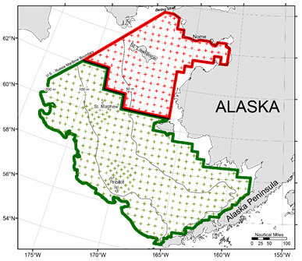
Figure 1. Map showing survey stations sampled during the 2022 eastern and northern Bering Sea shelf bottom trawl survey.

Survey estimates of total biomass on the eastern Bering Sea shelf for 2022 were 4.1 million metric tons (mt) for walleye pollock, 647.4 thousand mt for Pacific cod, 2.0 million mt for yellowfin sole, 1.3 million mt for northern rock sole, 7.9 thousand mt for Greenland turbot, and 149.0 thousand mt for Pacific halibut. Most of the commercially important fish species showed increases in estimated survey biomass compared to 2021 levels. Walleye pollock biomass increased 37%, yellowfin sole 25%, northern rock sole 24%, Alaska plaice 14%, Pacific halibut 13%, Pacific cod 5%, and flathead sole biomass increased 4%. Bering flounder biomass decreased 34%, Greenland turbot 26%, and Kamchatka flounder biomass decreased 10%.
After the completion of the EBS shelf survey, which started for both vessels in Dutch Harbor on 30 May 2021, both vessels transitioned into sampling survey stations in the southwest corner of the NBS survey region. After a crew change, the F/V Alaska Knight sampled the stations west of Norton Sound moving to the Bering Strait and working south. The F/V Vesteraalen conducted sampling in the Norton Sound area traveling east to west. The F/V Vesteraalen and the F/V Alaska Knight conducted sampling in the NBS from 29 July to 19 August. A total of 520 20 x 20 nautical mile sampling grid stations in the combined EBS and NBS were successfully sampled in 2022.

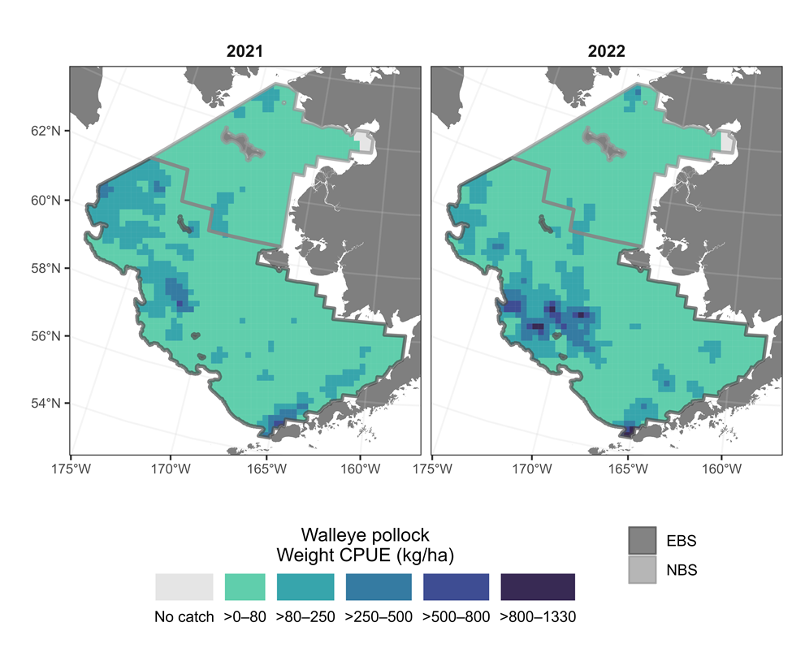
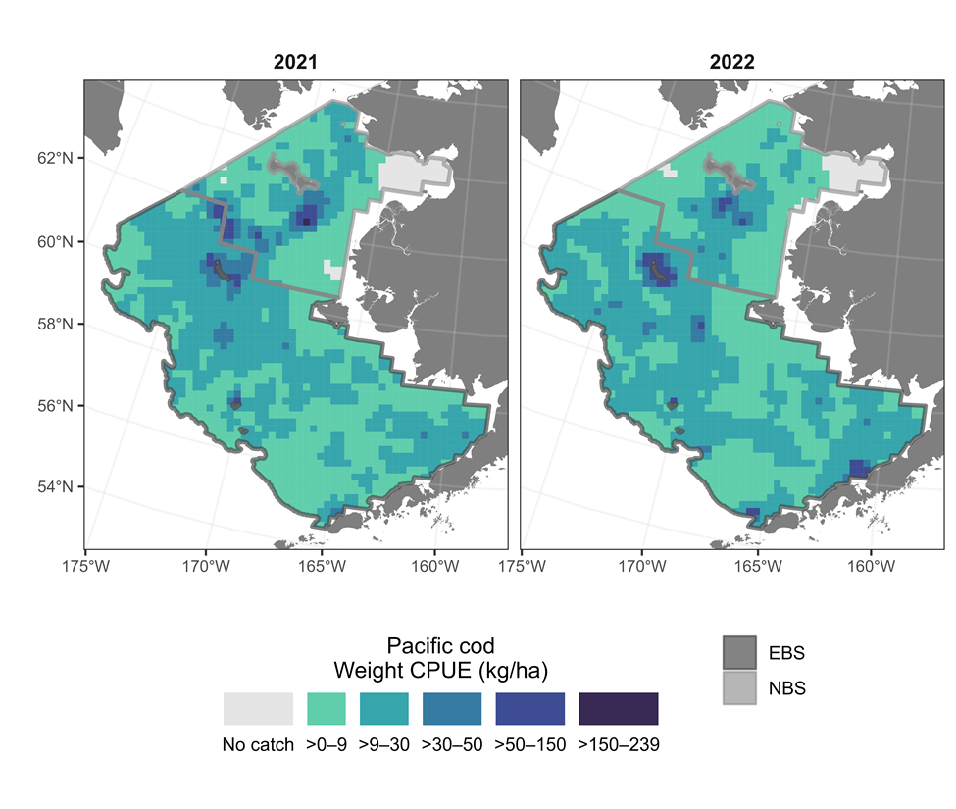

Figure 2. Spatial distribution of large gadids, in terms of mean CPUE (kg/ha), observed during the 2021 and 2022 bottom trawl surveys of the EBS and NBS: Top panel is walleye pollock; bottom panel is Pacific cod.

The NBS region was fully surveyed using the same standardized protocols and sampling resolution as the EBS survey in 2010, 2017, 2019, 2021, and 2022. In recent years, distributions of walleye pollock and Pacific cod have been completely different than those observed in 2010. In 2010, pollock were mostly concentrated on the outer shelf at depths of 70–200 m north of 56°N. Pollock biomass was consistently low on the inner and middle shelf, and pollock were almost completely absent from the NBS. In 2017-2019, pollock biomass in the EBS was concentrated mostly on the middle shelf, and there were large concentrations of pollock in the NBS. In 2021 and again in 2022, pollock distribution has been more similar to historical (2010) distribution patterns, with aggregations in the EBS in the middle and outer domains, particularly to the north of the Alaska Peninsula, and to the north and west of the Pribilof Islands (Fig. 2). For the past two survey years, walleye pollock have been relatively rare throughout the NBS survey area, with a small area of higher density in the Chirikov Basin just south of the Bering Strait.
In 2010, Pacific cod biomass in the EBS was concentrated in Bristol Bay and on the middle and outer shelf from the Pribilof Islands north to St. Matthew and cod biomass was low throughout the NBS. In contrast, the 2017-2019 surveys revealed high densities of Pacific cod in the NBS both to the north and south of St. Lawrence Island, and Pacific cod were concentrated in only a few areas of the EBS. In the two most recent survey years (2021 and 2022) Pacific cod distribution has moved south again, with the largest concentrations located near St. Matthew Island and to the south of St. Lawrence Island, although moderate densities have also been recorded throughout the EBS shelf (Fig. 2). In all survey years, Pacific cod were concentrated in areas with bottom temperatures >0°C.
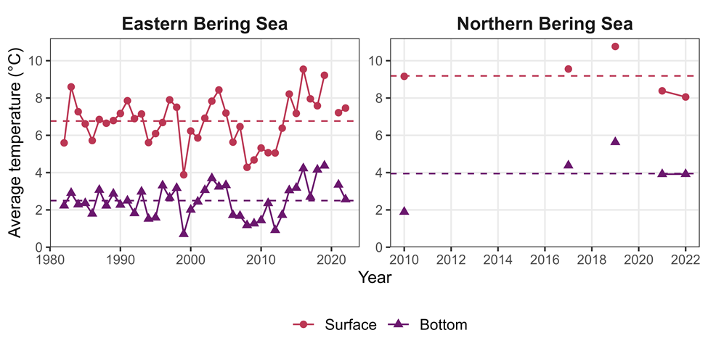
Figure 3: Average annual surface and bottom temperature during the survey period for the eastern and northern Bering Sea shelf survey with the survey mean temperature (1982-2022).

The surface and bottom temperature mean for the 2022 eastern Bering Sea shelf was similar to 2021 estimates. Both were slightly warmer than the long-term time-series mean (Fig. 3). The 2022 mean surface temperature was 7.5°C, which was slightly warmer than 2021 (7.2°C), and warmer than the time-series mean (6.8°C). The mean bottom temperature was 2.6°C in 2022, which was colder than 2021 (3.3°C), but still slightly above the time-series mean (2.5°C). In the NBS, mean surface temperature for 2022 (8.1°C) was slightly cooler than in 2021 (8.4°C), and mean bottom temperature (3.9°C) was nearly identical for both years. The 'cold pool', defined as the area with bottom temperatures <2°C, was more extensive in 2022 than in other recent years (Fig. 4), extending south from the NBS through the middle domain of the EBS and almost into Bristol Bay. Among recent survey years, only 2017 had a similarly extensive cold pool. During the 40-year time series, the cold pool area has ranged from 1.2% to 78.2% of the total EBS shelf area (Fig. 5). In 2022, the cold pool occupied 36.2% of the EBS shelf area, which was much larger than in 2021 (12.0 %).
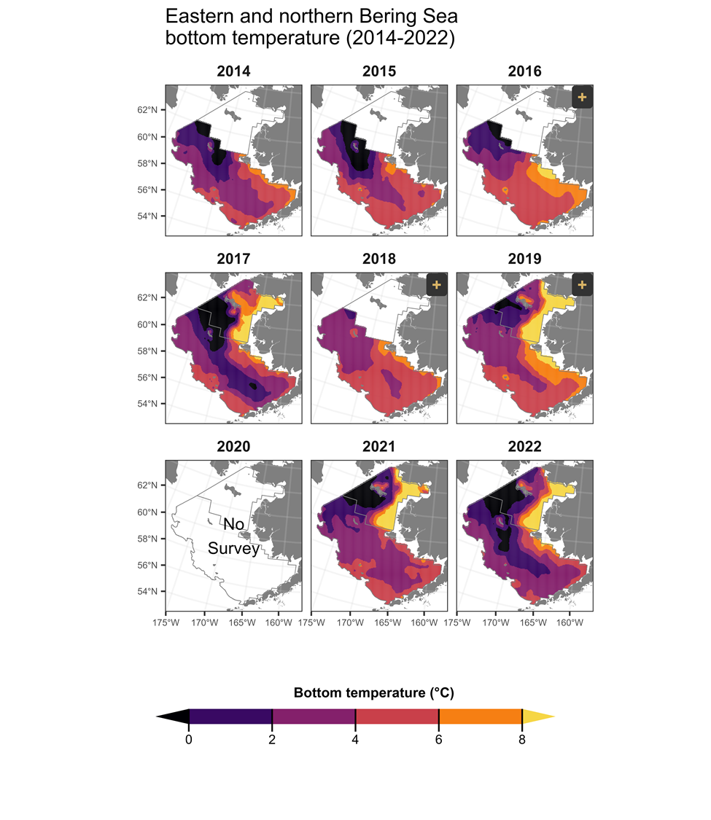
Figure 4: Distribution of survey bottom temperatures for recent survey years (2014-2022).

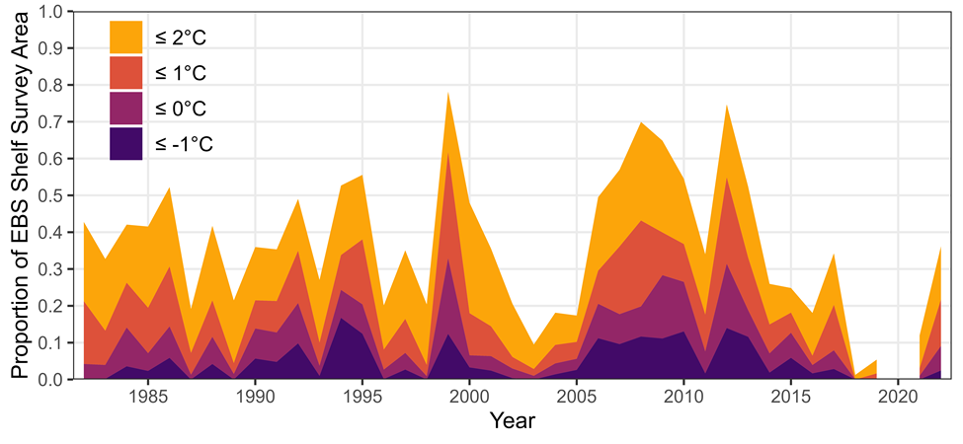

Figure 5: Areal extent of the summer cold pool on the eastern Bering Sea shelf, based on observations from the eastern Bering Sea bottom trawl surveys (1982-2022), shown as a percentage of the total EBS survey area.

2022 Aleutian Islands Biennial Bottom Trawl Survey – RACE-GAP

The AFSC RACE Groundfish Assessment Program (RACE-GAP) chartered the fishing vessels Ocean Explorer and Alaska Provider for 70 days each to conduct the 2022 Aleutian Islands Biennial Bottom Trawl Survey of groundfish resources in the region. This was the seventeenth survey in the time series dating back to 1980. This summer’s cruise began in Dutch Harbor, Alaska in June and concluded in Dutch Harbor in August. Trawl catch samples were collected from nearshore waters to a depth of 500 m on the continental shelf and upper continental slope between 170º E and 170º W longitude and in the southern Bering Sea from 165º W to 170º W longitude.
A variety of data are collected on this platform during the summer surveys. Oceanographic and environmental parameters are collected along with identified and enumerated collections of fishes and invertebrates from the trawl catches. Among the objectives of the 2022 Aleutian Islands bottom trawl survey were defining the distribution and estimating the relative abundance of principal groundfishes and important invertebrate species that inhabit the Aleutian Islands, measuring biological parameters for selected species, and collecting age structures and other samples. The survey design is random and stratified across 45 strata based on depth, statistical management zone, and regional boundaries overlaid with 25 km² grid cells. Stations identified as untrawlable are excluded from the sampling frame and trawlable or unknown stations are allocated to strata using a Neyman optimization weighted by stratum area, stratum variance, and the ex-vessel values of key species. The survey deploys the RACE Division’s standard four-seam, high-opening Poly Nor’Eastern survey trawl equipped with rubber bobbin roller gear. This trawl has a 27.2 m headrope and 36.75 m footrope consisting of a 24.9 m center section with adjacent 5.9 m “flying wing” extensions. Accessory gear for the Poly Nor’Eastern trawl includes 54.9 m triple dandylines and 1.8 × 2.7 m steel V-doors weighing approximately 850 kg each. Charter vessels conducted 15-minute trawls at pre-assigned stations and catches of all live animals were identified to the lowest possible taxon. Biological samples (e.g., length, age structures, individual weights, stomach contents, etc.) were collected for selected groundfish species. Specimens and data for special studies (e.g., maturity observations, tissue samples, photo vouchers) were also collected as requested by AFSC researchers and other cooperating agencies and institutions. Specimens of uncommon fishes or invertebrates were collected on an opportunistic basis and logged into the AFSC voucher system.
Surface and bottom temperatures have historically been part of the standard data collection on Aleutian Islands bottom trawl surveys (Figure 1). These temperatures have been collected using a variety of methods that may not be directly comparable (see von Szalay and Raring 2018 for methods). The temperatures presented here have not been intercalibrated for collection methods nor have they been adjusted for tidal cycles. Here we plot the residuals from our temperature observations relative to the 20 year average of surface or bottom temperature observations from the survey (1994-2014). The plot suggests that surface and bottom temperatures from our survey observations in 2022 remain above the long term average, as they have since the 2014 survey.
There were 420 stations planned for the shelf and upper slope of the Aleutian Islands to a depth of 500 m (Figure 2). In 2022, we recognized that the level of ergonomic injuries correlated with repetitive motion activities and lifting heavy baskets at sea was not sustainable. We responded by reducing overall sampling effort by eliminating some allocated stations, reducing the number of sexed lengths and otoliths collected, and generally slowing the pace of the survey to try and reduce injury rates. Therefore, 398 stations were successfully trawled in this Aleutian survey which was about a 5% reduction over previous years’ efforts. There were 587 unique taxa encountered at successfully sampled Aleutian stations. Most of these taxa were invertebrates ranging from decapods to sponges; 151 of those were fishes. The total fish catch from the survey was around 466 mt; total invertebrate catch was around 9 mt. A total of 51 taxa were saved to the AFSC RACE voucher collection, around 97,000 fish lengths were collected, and close to 7,600 otolith pairs were returned to AFSC for ageing. Special collections for fisheries acoustics, environmental monitoring, population genetics, feeding habits, and International Pacific Halibut Commission monitoring were all prosecuted during the summer survey. Validated data were finalized on 19 September, 2022 and estimates of abundance and length composition of managed species and species groups were delivered to the Joint Groundfish Plan Team of the North Pacific Fisheries Management Council (NPFMC) at their September meeting. Data from the survey were made available at that time on the Pacific States Marine Fisheries Commission’s Alaska Fisheries Information Network (AKFIN) as well is in NMFS’ Fisheries One-Stop Shop (FOSS).
Species composition of the more abundant fishes in 2022 was similar to previous years (Figure 3). Pacific ocean perch (POP) and Atka mackerel generated the highest survey biomass estimates followed by Alaska pollock and Pacific cod which present lower biomass estimates than were seen in the 1980s. Cod and pollock biomass was fairly consistent throughout the 2000s in survey estimates with the possible exception of the relatively lower biomass estimated in 2012. Among fishes caught in 2022, arrowtooth flounder, POP, and Pacific cod were among the most common, occurring in ~65% of more of all successful trawl hauls. Rougheye and shortraker rockfish were among the least common in our catches, occurring in <7% of successful trawl catches.
For further information contact Gulf-Aleutian Bottom Trawl Team Leader, Ned Laman (206) 526-4832, Ned.Laman@NOAA.gov
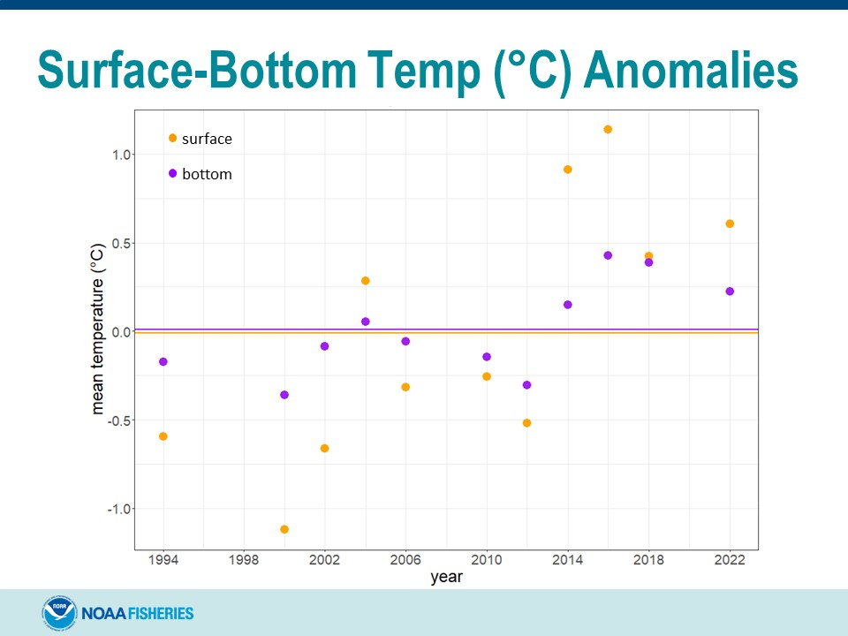
Figure 1. Surface (SST) and bottom temperature (Bottom Temp) anomalies compared to the 20-year averages of those temperatures collected on the Aleutian Islands summer bottom trawl survey aboard chartered commercial fishing vessels.

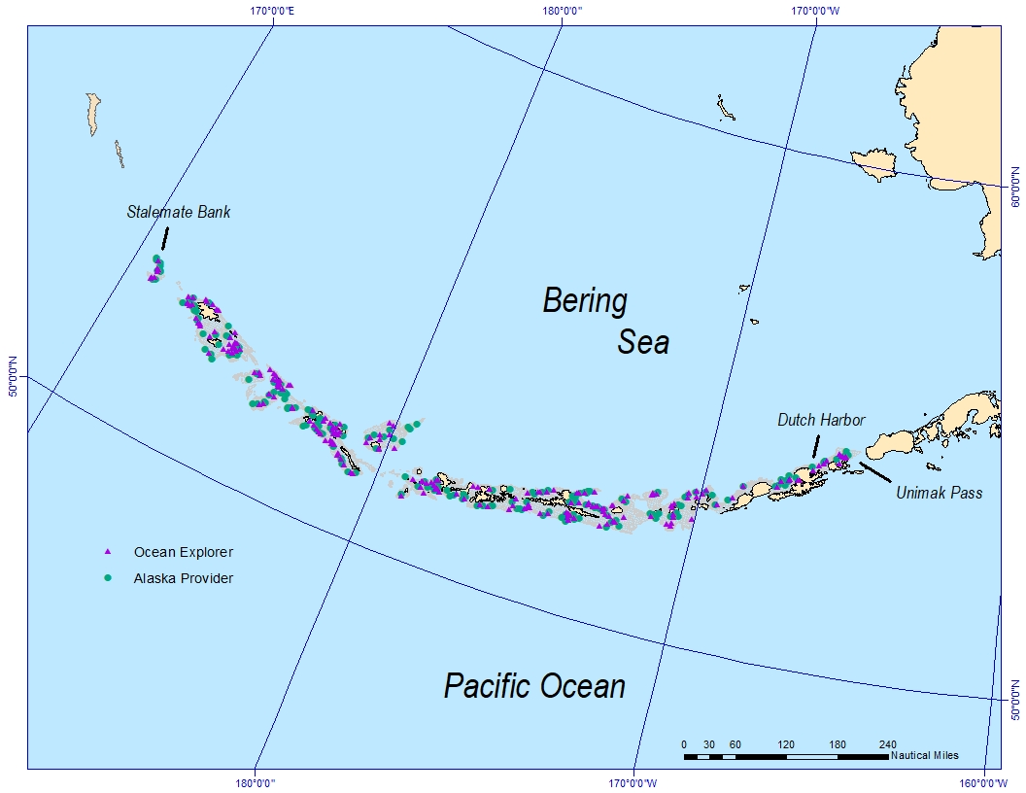

Figure 2. Planned station allocation (N = 420) for the 2022 Aleutian Islands biennial summer bottom trawl Survey; 398 stations were successfully trawled.
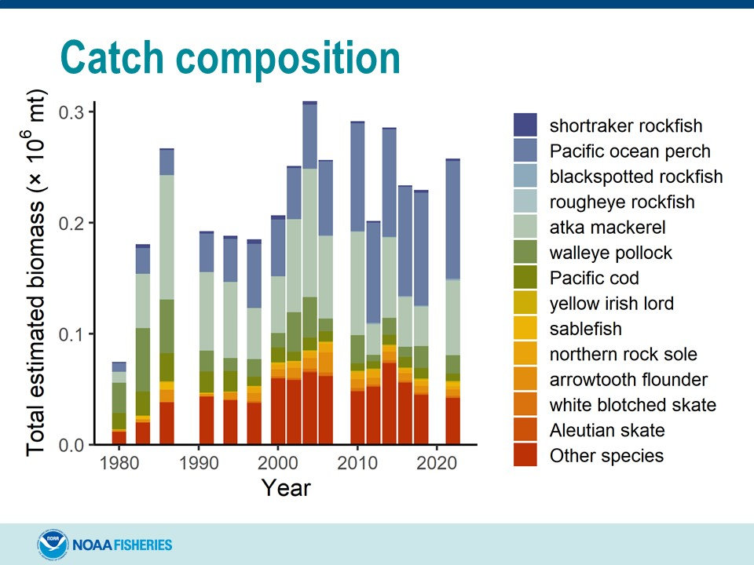
Figure 3. Catch composition of the most abundant fishes from the 2022 Aleutian Islands summer bottom trawl survey.

Literature Cited:

von Szalay, P. G., and N. W. Raring. 2018. Data Report: 2017 Gulf of Alaska bottom trawl survey. U.S. Dep. Commer., NOAA Tech. Memo. NMFS-AFSC-374, 260 p.

Winter acoustic-trawl survey of pre-spawning walleye pollock in the Gulf of Alaska – MACE

Scientists from the Alaska Fisheries Science Center conducted acoustic-trawl surveys in the Gulf of Alaska during late winter 2022 to estimate the distribution and abundance of pre-spawning walleye pollock (Gadus chalcogrammus, hereafter pollock). Historical surveys have frequently included the Shumagin Islands, Sanak Trough, Morzhovoi Bay, and Pavlof Bay as part of the Shumagin survey, and Shelikof Strait, the continental shelf break near Chirikof Island, and Marmot Bay as part of the Shelikof survey. Due to the continuation of the global COVID-19 pandemic in 2022 as well as vessel mechanical issues, only Shelikof Strait was successfully surveyed. The Shelikof Strait area has been surveyed annually in winter since 1981 (except in 1982, 1989, and 2011). The timing of the survey has been advanced by a few days in each survey since 2019 because of the relatively high percentages of spawning and spent female pollock observed in the 2017, 2018, and 2019 surveys. The 2022 Shelikof Strait survey (DY2204) occurred March 09 – 16, 2022.
The surveys were conducted with the NOAA ship Oscar Dyson, a 64-m stern trawler equipped for fisheries and oceanographic research. Midwater and near-bottom acoustic backscatter at 38 kHz was sampled to estimate the abundance of pollock using an LFS1421 trawl with a trawl-mounted stereo camera (CamTrawl), and a poly Nor’eastern (PNE) bottom trawl. Backscatter data were also collected at 4 other frequencies (18-, 70-, 120-, and 200-kHz) to support multifrequency species classification techniques.
Acoustic backscatter in Shelikof Strait was measured along 1,525.8 km (823.9 nmi) of transects spaced mainly 13.9 km (7.5 nmi) apart, with spacing varying from 11.3 km to 15.6 km (6.1 to 8.4 nmi) in the survey area. Pollock and eulachon (Thaleichthys pacificus) were the most abundant species in the 19 LFS1421 hauls, contributing 91.5% and 5.8% of the total catch by weight and 57.5% and 23% of the total catch by numbers, respectively. Pollock and eulachon were also the most abundant species in one PNE haul, contributing 95.8% and 3.7% of the total catch by weight and 44.7% and 35.8% of the total catch by numbers, respectively.
Adult pollock were detected throughout the Strait, with the largest aggregations concentrated in the center of the sea valley south of Cape Igvak. Compared to previous years, adult pollock were notably less abundant along the Alaska Peninsula side of the Strait between Cape Nukshak and Cape Kekurnoi where large numbers of pre-spawning fish have been observed during most previous Shelikof surveys. Juvenile pollock (< 30 cm FL and largely comprised of age-2 fish from 2020 year class)—typically found in large midwater aggregations shallower than but in proximity to adult aggregations in the middle portion of the Strait in prior surveys—were observed near the ends of transects in the southern portion of the Strait distinctly separated from adult aggregations. Most adult pollock were detected between depths of 215–275 m, while most juvenile pollock were between depths of 95–175 m. Pollock 10–16 cm FL, indicative of age-1 pollock, accounted for 1.7 % of the numbers and ≤ 0.1% of the biomass of all pollock observed in Shelikof Strait. Pollock 17–29 cm FL, indicative of age-2s, accounted for 29.0% by numbers and 2.7% by biomass of all pollock. Pollock ≥ 30 cm FL accounted for 69.3% and 97.3% of the numbers and biomass, respectively. The maturity composition of females > 40 cm FL (n = 377) was 1% immature, 13% developing, 80% pre-spawning, 6% spawning, and 0% spent, while the maturity composition of males > 40 cm FL (n = 315) was 1% immature, 7% developing, 35% pre-spawning, 56% spawning, and 1% spent.
The abundance estimate of 666.6 million pollock weighing 365,408.7 t (relative estimation error 10.35%) was 69.3% of that observed in 2021 (526,974 t) and 51.6% of the historical mean of 708,800 t. These estimates were based on an analysis where length-frequency distributions of all species were assigned to observed backscatter using biological data and species compositions of the hauls nearest that backscatter. It also included a correction for escapement of fishes and other catch from the survey trawl (i.e., net selectivity).
For more information, contact MACE Program Manager, Sandra Parker-Stetter, sandy.parker-stetter@noaa.gov.

Summer acoustic-trawl survey of walleye pollock in the eastern Bering Sea – MACE
The MACE Program conducted an acoustic-trawl survey of Eastern Bering Sea shelf age-1 and older walleye pollock (“pollock”; Gadus chalcogrammus) between 2 June and 5 August 2022. Midwater abundance and distribution were assessed from Bristol Bay to the U.S.-Russia Convention Line using acoustic-trawl survey methods aboard the NOAA ship Oscar Dyson, a 64-m stern trawler equipped for fisheries and oceanographic research. This survey has been conducted since 1979; triennially through 1994, and biennially or annually since then. The survey design covered the EBS shelf between roughly the 50-60 m and 200 m isobaths, from 162° W to the U.S.–Russian Convention line. The adjoining Russian portion of the EBS shelf was not surveyed as permission to survey that region was not granted in 2022. The survey design initially consisted of 28 north-south oriented parallel transects spaced 20 nmi apart over the Bering Sea shelf from 162° W (west of Port Moller, Alaska) to about 178° 20 E (i.e., the “core area”), surveyed over 3 legs. The initial plan was amended with the following three changes:
1) due to Oscar Dyson potentially only being able to provide sufficient crew for survey operations on 2 of the legs, the odd transects were dropped, resulting in 14 north-south oriented parallel transects spaced 40 nmi apart over the core area, surveyed over 2 legs. Near the end of Leg 2, there was enough time remaining to increase sampling density, so the NW core area was sampled at 20 nmi resolution over 5 transects (i.e., transects 25-28 in the initial plan);
2) ultimately, the Dyson was able to provide crew for Leg 3, so a northern extension beyond the core survey area (i.e., “northern extension”) was conducted, based on observations of pollock extending north of the core survey area in 2016 and 2018 (Honkalehto et al. 2018, McCarthy et al. 2022), saildrone observations (Mordy et al. 2017), and analysis of fish backscatter data collected in this northern region from the NOAA summer EBS bottom trawl survey in 2017. This was done by extending the 11 eastern core transects (i.e., those transects whose northern terminus did not end at the US-Russian convention line) northward to water depths of ~40 m; and,
3) two cross-shelf transects were surveyed enroute back to port at the end of the survey to examine spatial variability of pollock in the core area. Results of this cross-transect work will be reported elsewhere.
The primary survey objective was to collect daytime 38 kHz acoustic backscatter and trawl data to estimate the abundance of pollock. An estimate of the distribution and abundance of euphausiids (“krill”, mainly Thysanoessa spp.) was also produced. Sampling devices used during the survey include an LFS1421 trawl (LFS) rigged with pocket nets to estimate fish escapement and a trawl-mounted stereo camera (CamTrawl) designed to identify species and determine size and density of animals as they pass by the camera during a haul; an 83-112 Eastern bottom trawl without roller gear; and a Methot trawl. Additional survey sampling included conductivity-temperature-depth (CTD) measurements to characterize the Bering Sea shelf temperature conditions. Two moorings were also retrieved and/or deployed for the National Marine Mammal Laboratory (NMML) researchers during the survey.
Biological data and specimens were collected from 43 and 16 LFS trawl hauls in the core area and northern extension, respectively. Additional specimens were collected from 2 and 1 bottom trawls in the core area and northern extension, respectively. All of these hauls targeted backscatter believed to be pollock during a daily 12-hour daytime window for species classification and length-frequency distribution. Four Methot tows targeted backscatter believed to be euphausiids. CamTrawl image data were successfully collected for all LFS hauls. Among midwater hauls in the core area, pollock was the most abundant species by weight (89.0%) and by number (93.8%), followed by Pacific ocean perch (Sebastes alutus; 5.4% by weight and 2.4% by number) and northern sea nettle jellyfish (Chrysaora melanaster; 5.2% by weight and 3.2% by number). Among bottom trawls done in the core area, pollock was the most abundant species by weight (82.9%) and by number (89.3%), followed by northern sea nettle jellyfish (9.8% by weight and 3.8% by number). Among midwater hauls in the northern extension, pollock was the most abundant species by weight (48.4%) followed by northern sea nettle jellyfish (25.4%), but pollock born earlier in 2022 (“age-0 pollock”) was the most abundant organism by number (99.7%). In the bottom trawl done in the northern extension, yellowfin sole (Limonda aspera) was the most abundant species by weight (9.9%) followed by pollock (4.1%), but again, age-0 pollock was the most abundant organism by number (93.1%).
Temperature measurements during the 2022 survey produced an estimated mean SST of 7.4 (range 3.4°-10.1°C). The estimate was similar to that since 2014 (mean SST range 6.4°- 12.4°C), and warmer than sea surface temperatures in previous cold years 2006-2012 (SST means between 4.9° – 6.8°C). Temperature profiles from conductivity-temperature-depth (CTD) casts and trawling indicated bottom water temperatures characteristic of the ‘cold pool’ (< 2°C) on the shelf north and west of the Pribilof Islands.
About 55% of the summed acoustic backscatter observed in the core survey area between 16 m below the surface and 3 m off bottom (the midwater layer) during the 2022 survey was attributed to pollock. This was higher than the percentage of pollock observed in 2018 (35%), less than that observed in 2010 (82%), and similar to that observed in between (2016 (52%), 2014 (45%) and 2012 (56%). The remaining non-pollock midwater backscatter was attributed to an undifferentiated plankton-fishes mixture (33%), or in a few isolated areas, to other fishes (0.05%). In the northern extension area, about 43% of the backscatter was attributed to age-1+ pollock. Pollock were observed in a variety of aggregations including near-bottom layers, small dense schools (cherry balls) in midwater, and diffuse aggregations of individual fish. The near-bottom analysis (Lauffenburger et al. 2017) attributed ~ 78% of the backscatter in the near-bottom zone (0.5-3.0 m above the seafloor) in the core survey area to pollock, and ~86% of the backscatter in the near-bottom of the northern extension area to pollock.
Estimated numbers and biomass of age-1+ pollock in midwater to within 0.5 m of the bottom along the U.S. Bering Sea shelf in the core survey area were 9.67 billion fish weighing 3.83 million metric tons (t). This 2022 biomass estimate represents just over a 50% increase from the estimate of 5.57 billion fish with a biomass of 2.50 million t in 2018, the last time a standard acoustic-trawl survey was conducted on the eastern Bering Sea shelf. This is a 6% increase over the estimate of 3.6 million tons in 2020 made by the acoustics-only Saildrone survey (De Robertis et al. 2021). The relative estimation error for the core area U.S. EEZ pollock biomass estimate for the entire water column was 0.068, which was almost double that of 2018 (0.039), and is largely a result of increasing the transect spacing by 100% in most of the core area in 2022. Pollock east of 170° W numbered 2.99 billion fish and weighed 1.36 million t (36% of the total biomass found in the core survey area, and 31% of the biomass found shelf-wide, including the northern extension). Four year-old pollock composed 59% of the biomass east of 170° W. Pollock abundance west of 170° W was 6.68 billion fish weighing 2.47 million t (64% of total core survey area biomass and 57% of the shelf-wide biomass, including the northern extension). Four year-old pollock composed 68% of the biomass west of 170° W. Very few 1 and 2 year old pollock were observed in the core area (they composed 1.5% of the core survey area biomass). Pollock biomass increased inside the SCA from 0.23 million t in 2018 to 0.54 million t in 2022. The pollock biomass within the SCA in 2022 was the same as it was in 2016 (0.54 million t). Estimates for the entire core area and the SCA correlate well (r² = 0.72) throughout the 1994-2022 time series. The pollock estimate in the northern extension area was 76.6 million fish weighing 0.54 million metric tons, contributing an additional 14% by number and weight compared with the amount of pollock estimated within the core survey area. In the northern extension, fish were sparsely but evenly distributed between the 50- and 100-m isobaths.
Pollock length compositions differed slightly between the east and west core area. East of 170° W, pollock in the core area ranged between 30 and 50 cm FL with a mode of 40 cm. West of 170° W, pollock in the core area ranged between 30 and 50 cm FL with a mode of 36 cm. Very few fish smaller than 30 cm were observed in the core area. Pollock in the northern extension ranged between 35 and 60 cm FL with a mode of 50 cm.
Literature Cited (for summer EBS survey)
De Robertis, A., M. Levine, N. Lauffenburger, T. Honkalehto, J. Ianelli, C. Monnahan, R. Towler, D. Jones, S. Stienessen, and D. McKelvey. 2021. Uncrewed surface vehicle (USV) survey of walleye pollock, Gadus chalcogrammus, in response to the cancellation of ship-based surveys. ICES J. Mar. Sci. https://doi.org/10.1093/icesjms/fsab155
Honkalehto, T., A. McCarthy, and N. Lauffenburger. 2018. Results of the acoustic-trawl survey of walleye pollock (Gadus chalcogrammus) on the U.S. Bering Sea shelf in June – August 2016 (DY1608). AFSC Processed Rep. 2018-03, 78 p. Alaska Fish. Sci. Cent., NOAA, Natl. Mar. Fish. Serv., 7600 Sand Point Way NE, Seattle WA 98115.
Lauffenburger, N., A. De Robertis, S. Kotwicki. 2017. Combining bottom trawls and acoustics in a diverse semipelagic environment: What is the contribution of walleye-pollock (Gadus chalcogrammus) to near-bottom acoustic backscatter in the eastern Bering Sea. Can. J. Fish. Aquat. Sci. 74:256-264.
McCarthy, A., T. Honkalehto, N. Lauffenburger, and A. De Robertis. 2020. Results of the acoustic-trawl survey of walleye pollock (Gadus chalcogrammus) on the U. S. Bering Sea shelf in June – August 2018 (DY1807). AFSC Processed Rep. 2020-07, 83 p. Alaska Fish. Sci. Cent., NOAA, Natl. Mar. Fish. Serv., 7600 Sand Point Way NE, Seattle, WA 98115.
Mordy, C., Cokelet, E., De Robertis, A., Jenkins, R., Kuhn, C. E., Lawrence-Slavas, N., Brerchok, C., et al. 2017. Saildrone Surveys of Oceanography, Fish and Marine Mammals in the Bering Sea. Oceanography, 30(2):113-116.
For more information, contact MACE Program Manager, Sandra Parker-Stetter, sandy.parker-stetter@noaa.gov.

Summer acoustic vessel of opportunity (AVO) index for midwater Bering Sea pollock – MACE
Acoustic backscatter data (Simrad ES60, 38 kHz) were collected aboard two fishing vessels chartered for the AFSC summer 2022 EBS bottom trawl surveys (F/V Alaska Knight, F/V Vesteraalen). These Acoustic Vessels of Opportunity (AVO) data were processed according to Honkalehto et al. (2011) to provide an index of age-1+ midwater walleye pollock (Gadus chalcogrammus) abundance for summer 2022. The 2022 AVO index of midwater pollock abundance on the eastern Bering Sea shelf was the highest on record, with an increase of 60% from 2019 and an increase of 16% from 2021 (no AVO estimate was made in 2020 due to the covid-19 driven cancellation of the bottom trawl survey). The AFSC biennial acoustic-trawl (AT) survey conducted using NOAA Ship Oscar Dyson in summer 2022 increased by 6% from the Saildrone survey estimate made in 2020. The correlation between the AVO index and the AT survey biomass decreased (r²= 0.68, n= 10 surveys, vs. r²= 0.76, n=9 surveys for the period 2006-2018). The percentage of pollock backscatter east of the Pribilof Islands was 17%. Although this is larger than the percentages in summers 2010-2012 (range 4-9%), it is similar to 2021 (18%) and to the historical average since 2006 of 15%.
Literature Cited (for summer AVO)
Honkalehto, T.H., P.H. Ressler, R.H. Towler, and C.D. Wilson. 2011. Using acoustic data from fishing vessels to estimate walleye pollock abundance in the eastern Bering Sea. Canadian Journal of Fisheries and Aquatic Sciences 68(7): 1231–1242
For more information, contact MACE Program Manager, Sandra Parker-Stetter, sandy.parker-stetter@noaa.gov.

Longline Survey – ABL
The AFSC has conducted an annual longline survey of sablefish and other groundfish in Alaska from 1987 to 2022. The survey is a joint effort involving the AFSC’s Auke Bay Laboratory and Resource Assessment and Conservation Engineering (RACE) Divisions. It replicates as closely as practical the Japan-U.S. cooperative longline survey conducted from 1978 to 1994 and samples gullies not previously sampled during the cooperative longline survey. In 2022, the 45th annual longline survey sampled the upper continental slope of the Gulf of Alaska and the eastern Aleutian Islands. One hundred forty-six longline sets were made from June 3 – August 26 by the chartered fishing vessel Alaskan Leader. In the Gulf of Alaska, total groundline set each day was 18 km (9.7 nmi) and consisted of 180 skates with a total of 8,100 hooks. In the eastern Aleutian Islands, 16 km (8.6 nmi) of groundline was set, consisting of 160 skates with a total of 7,200 hooks.
Sablefish (Anoplopoma fimbria) was the most frequently caught species, followed by giant grenadier (Albatrossia pectoralis), shortspine thornyhead (Sebastolobus alascanus), Pacific cod (Gadus macrocephalus), rougheye/blackspotted rockfish (Sebastes aleutianus/S. melanostictus), and Pacific halibut (Hippoglossus stenolepis). A total of 179,709 sablefish, with an estimated total round weight of 421,223 kg (928,638 lb) were caught during the survey. This represents increases of 10,096 fish and 28,326 kg (62,448 lb) of sablefish over the 2021 survey catch. The number of sablefish caught in 2022 is the highest number recorded in the time series. Sablefish (5,422), shortspine thornyhead (434), and Greenland turbot (Reinhardtius hippoglossoides, 3) were tagged with external Floy tags and released during the survey. Length-weight data and otoliths were collected from 3,777 sablefish. Killer whales (Orcinus orca), depredating on the catch, occurred at one station in the eastern Aleutian Islands and four stations in the western Gulf of Alaska. Sperm whales (Physeter macrocephalus) were present during survey operations at 13 stations and were observed depredating on the gear at 2 stations in the central Gulf of Alaska, one station in the West Yakutat region, and 6 stations in the East Yakutat/Southeast region.
In 2020, no AFSC staff participated onboard the survey vessel and in 2021, AFSC staff participated on four of the six legs. In 2022, COVID-19 precautions, including 3-day shelter-in-place isolation periods at each port of departure, allowed AFSC staff to participate on each of the six legs of the survey. In 2022, several special projects continued, including 3 days of comparisons between hook and line and slinky pots to investigate gear selectivity and catch efficiency. Spiny dogfish samples continued to be collected for refining ageing and maturity determination methods. A second year of sablefish eyeball collections from across the survey region was completed to examine isotopic growth layers of the eye lens of adult sablefish to obtain individual chronologies (young-of-year to time of collection) of their dietary and migratory behavior. Temperature profiles were collected that continue a time series starting in 2005 and show a continuation of above-average temperature in the AI and a slight increase in subsurface temperature for 2022 from 2021 in all GOA areas.
Longline survey catch and effort data summaries are available through the Alaska Fisheries Science Center’s website: https://apps-afsc.fisheries.noaa.gov/maps/longline/Map.php. Full access to the longline survey database is available through the Alaska Fisheries Information Network (AKFIN). Catch per unit effort (CPUE) information and relative population numbers (RPN) by depth strata and management regions are available for all species caught in the survey.
For more information, contact Pat Malecha (pat.malecha@noaa.gov). For data access, contact Cara Rodgveller (cara.rodgveller@noaa.gov).
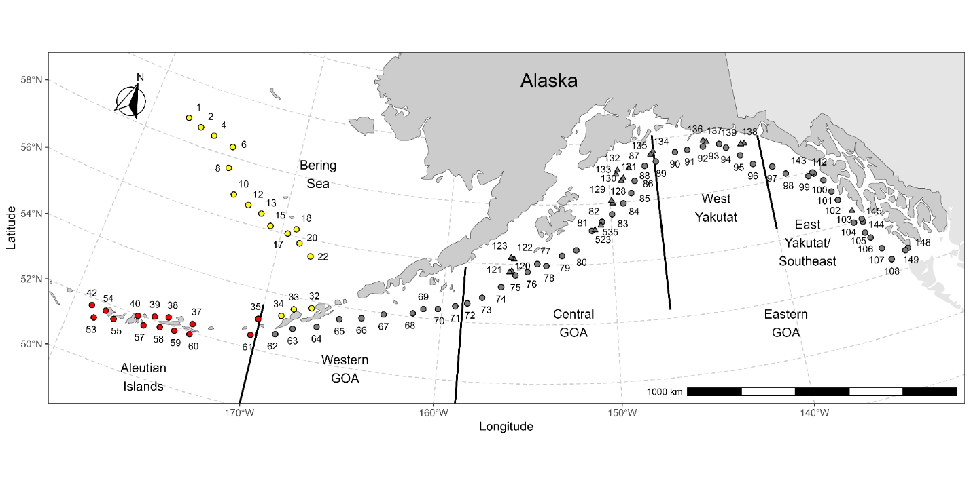
Map of AFSC longline survey station locations. Bering Sea stations (yellow) are sampled in odd years, Aleutian Islands stations (red) are sampled in even years, and Gulf of Alaska (GOA) stations (gray) are sampled every year. Circles indicate stations included in abundance index calculations while triangles indicate stations that are not.
Northern Bering Sea Surface Trawl and Ecosystem Survey – ABL – CARA CHECK
The 2021 survey occurred at standard stations in the northern Bering Sea in 2021. Station sampling included phytoplankton, zooplankton, invertebrate nekton, fish, seabird, and marine mammals. The average surface temperature (9.4°C) in 2021 was just above the overall average annual temperature (8.8°C) recorded during the survey from 2003 to 2021. The most abundant benthic fish species captured was yellowfin sole and they were present at nearshore stations throughout the survey. We plan to continue the survey on an annual basis to provide scientific support for salmon, groundfish, and crab resources in the northern Bering Sea.

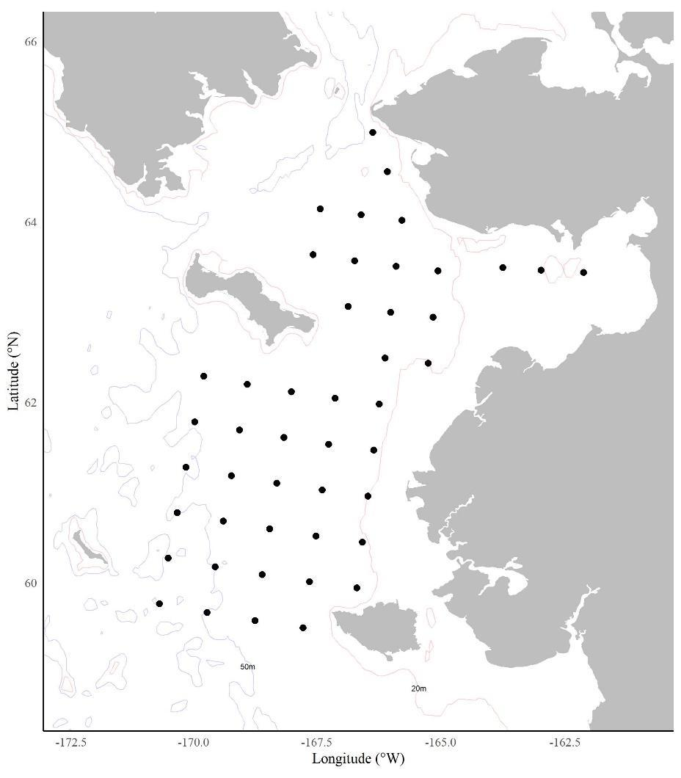
Figure 1. Standard stations sampled during 2021 Northern Bering Sea Surface Trawl and Ecosystem Survey, August 27 to September 20, 2021.

North Pacific Groundfish Observer Program (Observer Program) – FMA

The Fisheries Monitoring and Analysis (FMA) Division administers the North Pacific Observer Program (Observer Program) and Electronic Monitoring (EM) Program which play a vital role in the conservation and management of the Bering Sea, Aleutian Islands, and Gulf of Alaska groundfish and halibut fisheries.

FMA observers and EM systems collect fishery-dependent data onboard fishing vessels and at onshore processing plants that is used for in-season management, to characterize interactions with protected resources, and to contribute to assessments of fish stocks, provide data for fisheries and ecosystem research and fishing fleet behavior, and characterize fishing impacts on habitat. The Division ensures that the data collected by observers and through EM systems are of the highest quality possible by implementing rigorous quality control and quality assurance processes.

During 2020 the FMA Division was faced with enormous challenges in facilitating observer training and deployment. Data from observers is essential for managing federal fisheries and choosing to not deploy them was simply not an option. Training and equipping observers from the Seattle campus was challenging because the campus was closed to all but essential staff, and multiple layers of precaution were necessary due to the pandemic. Deployment of observers was difficult due to limits on travel, quarantine requirements, and the risk of infection. In addition, the challenges varied considerably during the year as the assessment of the pandemic, the state and national standards for preventing infection, and the fishing industry’s implementation of those standards changed. For further information regarding FMA activities please access the AFSC website or contact Jennifer Ferdinand at Jennifer.Ferdinand@noaa.gov.

III. Reserves

IV. Review of Agency Groundfish Research, Assessment, and Management

Note: Management of federal groundfish fisheries in Alaska is performed by the NPFMC with scientific guidance (research and stock assessments) from the AFSC and other institutions. Assessments are conducted annually for major commercial groundfish stocks, with biennial or quadrennial assessments for most of the other stocks. Groundfish populations are typically divided into two geographic stocks: Bering Sea and Aleutian Islands (BSAI) and Gulf of Alaska (GOA). Some BSAI stocks are further divided into Eastern Bering Sea (EBS) and Aleutian Islands (AI). In the GOA, assessment and management for many stocks is structured around large-scale spatial divisions (western, central, and eastern GOA) although the application of these divisions varies by stock. Current and past stock assessment reports can be accessed on the AFSC website (https://www.fisheries.noaa.gov/alaska/ population-assessments/north-pacific-groundfish-stock-assessments-and-fishery-evaluation).

Multispecies assessment

  - Gulf of Alaska

Overfished or approaching an overfished condition is determined for all age-structured stock assessments by comparison of the stock level in relation to its MSY level according to the following two harvest scenarios (Note for Tier 3 stocks, the MSY level is defined as B35%):
Overfished (listed in each assessment as projection scenario 6): In all future years, F is set equal to FOFL. (Rationale: This scenario determines whether a stock is overfished. If the stock is expected to be 1) above its MSY level in 2022 or 2) above ½ of its MSY level in 2022 and above its MSY level in 2032 under this scenario, then the stock is not overfished.)

Approaching an overfished condition (listed in each assessment as scenario 7): In 2023 and 2024, F is set equal to max FABC, and in all subsequent years, F is set equal to FOFL. (Rationale: This scenario determines whether a stock is approaching an overfished condition. If the stock is 1) above its MSY level in 2024 or 2) above 1/2 of its MSY level in 2024 and expected to be above its MSY level in 2034 under this scenario, then the stock is not approaching an overfished condition.)

The status of individual groundfish stocks managed under the FMP is summarized in this section. The spawning biomass estimates of pollock (W/C GOA), sablefish, Dover sole, flathead sole, rex sole, arrowtooth flounder, Pacific ocean perch, rougheye and blackspotted rockfish, northern rockfish, and dusky rockfish are above target stock size (Figure below). The spawning biomass of Pacific cod is below the proxy for BMSY. The target biomass levels for EGOA pollock, deep-water flatfish (excluding Dover sole), shallow-water flatfish, shortraker rockfish, other rockfish, demersal shelf rockfish, thornyhead rockfish, Atka mackerel, skates, octopus, and sharks are unknown.
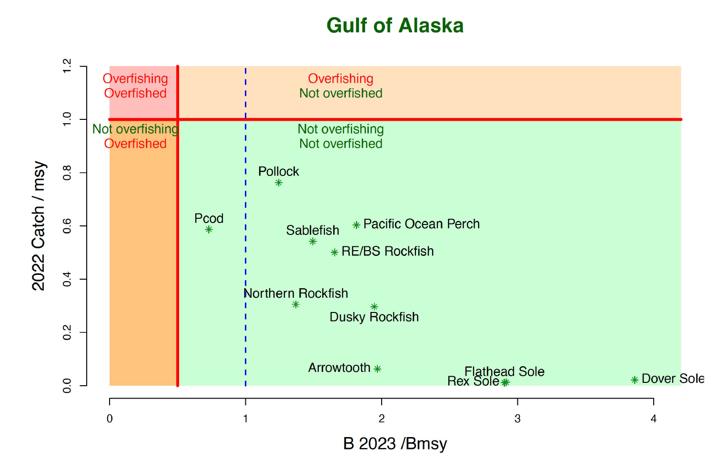
Summary of Gulf of Alaska stock status next year (spawning biomass relative to BMSY; horizontal axis) and current year catch relative to fishing at FMSY (vertical axis). Note that sablefish is for Alaska-wide values including the BSAI catches.

Revised Stock Assessment Schedule

Based on consideration of stock prioritization including assessment methods and data availability, some stocks are assessed on an annual basis while others are assessed less frequently. The following table provides an overview of the level of assessment presented in this year’s SAFE report, the Tier level and schedule, as well as the year of the next full assessment by stock.]\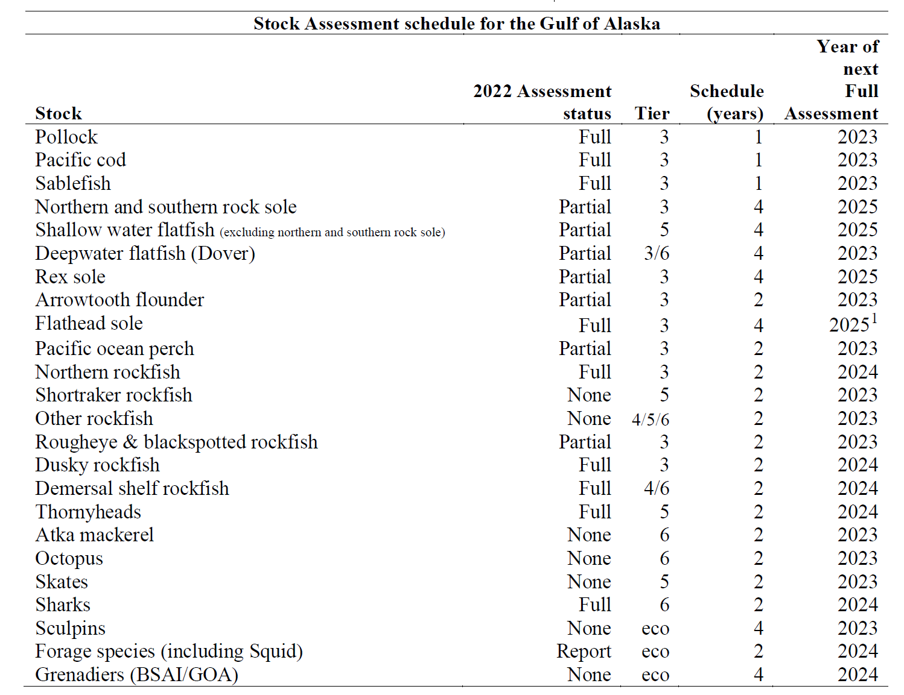
For more information contact the Gulf of Alaska Plan Team Co-chair, Chris Lunsford, Chris.Lunsford@noaa.gov . Report: https://meetings.npfmc.org/CommentReview/DownloadFile?p=b0e846bf-0674-4707-97ed-32f55af846aa.pdf&fileName=C5%20GOA%20Groundfish%20SAFE%20Intro.pdf

  - Bering Sea

The status of individual groundfish stocks managed under the FMP is summarized in this section. The spawning biomass of all stocks are above target stock size.

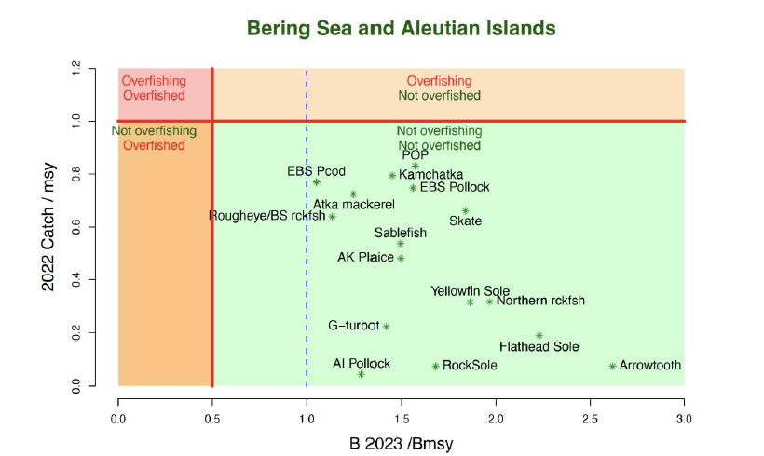
Summary of Bering Sea and Aleutian Islands stock status next year (spawning biomass relative to BMSY; horizontal axis) and current year catch relative to fishing at FMSY (vertical axis).

Revised Stock Assessment Schedule

Based on consideration of stock prioritization including assessment methods and data availability, some stocks are assessed on an annual basis while others are assessed less frequently. The following table provides an overview of the level of assessment presented in this year’s SAFE report, the Tier level and schedule, as well as the year of the next full assessment by stock.
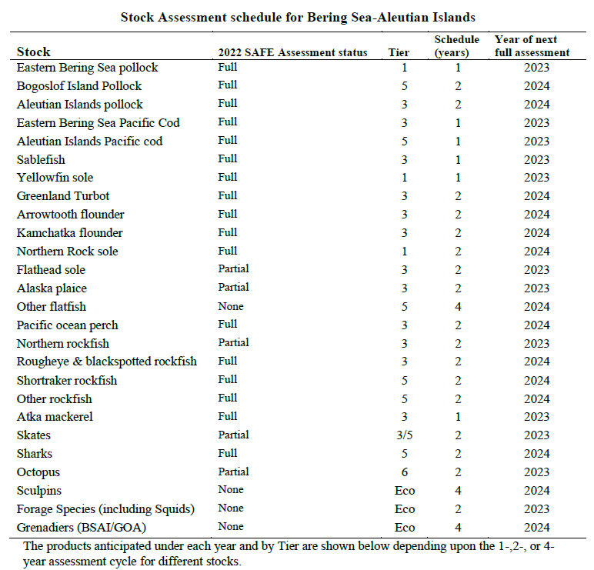

For more information contact the BSAI Plan Team Co-chairs, Kaleo Shotwell kalei.shotwell@noaa.gov and Steve Barbeaux steve.barbeaux@noaa.gov

  - Alaska-wide

REMA – An R package and consensus version of the random effects model for biomass-based stock assessment and apportionment at the Alaska Fisheries Science Center – ABL

The random effects (RE) model was developed by the North Pacific Fisheries Management Council (NPFMC) Groundfish Plan Team's (GPT) Survey Averaging working group and has been used at the Alaska Fisheries Science Center (AFSC) since 2013 to estimate biomass in data-limited groundfish and crab stock assessments (i.e., Tiers 4/5) and apportion estimates of Acceptable Biological Catch (ABC) by area (Oct 2013 Joint GPT minutes). The RE model was developed as a way to partition observation errors from survey biomass estimates with plausible process errors related to the true (but unobserved) population biomass. In this model, the process errors are treated as random effects, where the underlying state dynamics are modeled as a random walk.

A comprehensive analysis of current methods revealed there were multiple versions of the original RE model code in use and several inconsistencies (Monnahan et al. 2021). We developed an R package to unify these variants and improve transparency and reproducibility of applications within assessments (Sullivan et al. 2022). The new R package rema was reviewed and recommended by the GPTs and NPFMC’s Scientific and Statistical Committee in 2022. It was used for several stock assessments in 2022, including the Bering Sea and Aleutian Islands (BSAI) shortraker rockfish, BSAI other rockfish, and Gulf of Alaska thornyhead, and will be used for Tiers 4 and 5 assessments and area apportionments in the future.
Background information, model documentation, and code tutorials for the rema R package are available online: https://afsc-assessments.github.io/rema/

For more information contact Jane Sullivan, ABL, at 907 789-6000 or jane.sullivan@noaa.gov

Hagfish

There are currently no state or federal commercial fisheries for hagfish in Alaska waters. However since 2017 the Alaska Department of Fish & Game has been conducting research to explore the potential for small-scale hagfish fisheries.

Dogfish and other sharks

Research

Population Genetics of Pacific Sleeper Sharks – ABL

The purpose of this study is to investigate the population structure of Pacific sleeper sharks (Somniosus pacificus) in the eastern North Pacific Ocean. Tissue samples have been opportunistically collected from ~400 sharks from the West Coast, British Columbia, the Gulf of Alaska, and the Bering Sea. Samples of Greenland shark (S. microcephalus) and southern sleeper sharks (S. antarcticus) were also used in this study. We generated next-generation sequencing data using the reduced representation library method RADseq and conducted phylogenomic and population genomics analyses to provide novel information for use in stock assessments. Our results strongly support the species status of S. microcephalus (n = 79), but recover S. antarcticus (N = 2) intermixed within the S. pacificus (N = 170) clade. Population genomic analyses reveal genetic homogeneity within S. pacificus and S. microcephalus, and estimates of effective population size suggest populations of hundreds of individuals. Kinship analysis identified two first-degree relative pairs within our dataset (one within each species). Overall, our research provides insight into the evolutionary relationships within the Somniosus Somniosus subgenus. Results were published in Timm et al. 2022. For more information, contact Cindy Tribuzio at (907) 789-6007 or cindy.tribuzio@noaa.gov.

Ageing of Pacific Sleeper Sharks – ABL
A pilot study is underway by staff at ABL, REFM, the Lawrence Livermore National Laboratory and the American River College to investigate potential ageing methods for Pacific sleeper sharks. A recent study suggested extreme longevity in a closely related species by examining the levels of bomb-derived radiocarbon (14C) in the eye lens. The eye lens is believed to be a metabolically inert structure and therefore the levels of 14C could reflect the environment during gestation, which may be used to compare to existing known age 14C reference curves to estimate either a rough age, or a “at least this old” age estimate. For the pilot study, eyes from six animals were removed whole and stored frozen until lab processing. One lens from each shark was excised and lens layers were removed and cleaned by sonication and dried. For larger sharks, both the lens core (earliest deposited material) and outer layer (most recently deposited material) were saved for analysis. Dry samples were sent to an accelerator mass spectrometry (AMS) facility for carbon isotope analyses (¹⁴C, ¹³C), measurement error, and conventional radiocarbon age, when applicable (pre-bomb (<1950); Gagnon et al. 2000) — it was expected that all outer layer samples would be modern and that some cores could have pre-bomb or early bomb ¹⁴C rise levels based on rough estimates of age. Preliminary results demonstrate that ¹⁴C is measurable in the eye lens cores and outer layers, and two of the PSS had values that could be correlated with the ¹⁴C rise period (late 1950s to mid-1960s; Figure XX). Specifically, results from the largest shark sampled (310 cm TL) indicate the age was not older than 50 years. This observation is in contrast to the Nielsen et al. (2016) study, which estimated an age of 105 years for a Greenland shark of the same length. Further, our results suggest that the growth rate of PSS could be twice as high as that of the Greenland shark (Figure XX, inset). For the pilot study, we assumed that the regional bomb ¹⁴C reference curve was from two long-lived teleost fishes from the GOA and that exposure and uptake of ¹⁴C by PSS was similar. Proposals are pending which would further fund this study and address the concerns and assumptions highlighted by the pilot study work.
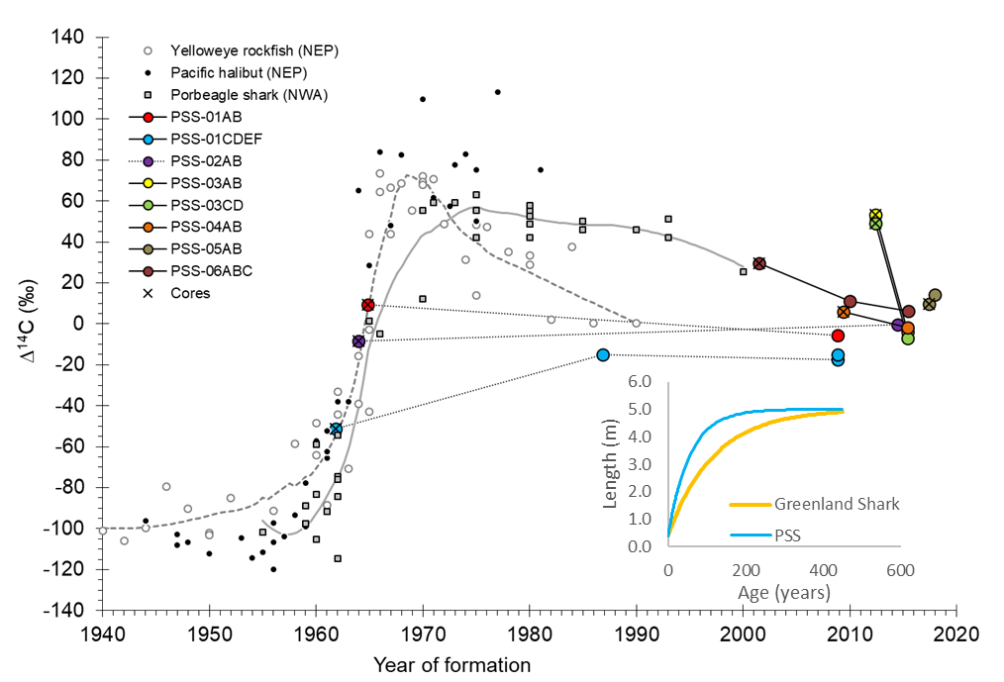
Pacific sleeper shark (PSS) eye lens 14C values from the pilot study plotted as estimated year of formation relative to regional 14C references. Data from six sharks are shown as a series of samples from the core to the outer eye lens. Both eye lenses were sampled in two sharks (PSS-01 and PSS-03). Core (“birth year”) layers are indicated with an X over the colored specimen symbol. Published bomb 14C chronologies were used as temporal references from the northeastern Pacific Ocean (yelloweye rockfish (Kerr et al. 2004) and Pacific halibut (Piner and Wischniowski 2004). A shark chronology from the northwestern Atlantic Ocean is shown for comparison (porbeagle shark; Campana et al. 2002). (inset) Von Bertalanffy growth curves based on pilot study results. The PSS growth curve is adjusted from the Greenland shark curve to intersect the data for the largest fish in our pilot study, resulting in the blue curve. These results suggest that the PSS growth coefficient (k) is roughly two times greater than that of the Greenland shark. For more information, contact Cindy Tribuzio at (907) 789-6007 or cindy.tribuzio@noaa.gov.

Shark tagging – ABL

A tagging program for spiny dogfish began in 2009, with 186 pop-off satellite archival tags (PSATs) deployed between 2009 – 2018. Data were recovered from 157 of those tags (nine tags are still at liberty), with eight tags physically recovered. The PSATs record depth, temperature, light levels and sunrise/sunset for geolocation. Staff at ABL, along with Julie Nielsen (Kingfisher Marine Research) have developed a Hidden Markov Movement (HMM) model based on these tag data which incorporates environmental variables (e.g. temperature/depth profiles and sea-surface temperature), see Nielsen and Tribuzio 2023. The HMM model provides daily locations in the form of probability surfaces as well as total residence probabilities for the duration of deployment for each tag. The results will be used to define habitat utilization distributions, and eventually inform Essential Fish Habitat. Ongoing analytics include habitat utilization and migration to inform Essential Fish Habitat and to evaluate fisheries interactions; simulation testing of the HMM from tags recovered from spiny dogfish double tagged with acoustic transceivers.

Staff at ABL, collaborating with UAF, the Alaska Sea Life Center, Kingfisher Marine Research and Wildlife Technology Frontiers on a collaborative tagging project on Pacific sleeper shark. This NPRB funded project will apply modern modelling techniques to historical PSAT data, as well as deploy and analyze data from recent and future tags.

Staff at ABL are collaborating with ADF&G, UAF and Kingfisher Marine Research to deploy tags on salmon shark in the GOA and Bering Sea. To date, five male and one female salmon shark have been tagged in the Northern Bering Sea, Of these six sharks, one was tagged with a PSAT, three were double-tagged with both a SPOT (i.e., GPS) and PSAT tag, and two were tagged with a SPOT tag. One male and one female salmon shark were tagged in the North Pacific Ocean/Gulf of Alaska, and both of these sharks were double-tagged with a SPOT and PSAT tag. The SPOT tags provide multiple years of position data when the shark is at the surface, while the PSAT provides detailed temperature and depth movement. The two data sets will be combined to validate the HMM model. This study is unique in that nearly all previous tagging on the species was on females captured in Prince William Sound. Early results suggest seasonal migration to/from the Northern Bering Sea, but not necessarily the same movement pattern between years. Regular updates are posted to the ADF&G – The Undersea World of Salmon and Sharks Facebook page. Further tags are planned for 2023 and onwards as tags and opportunities are available.

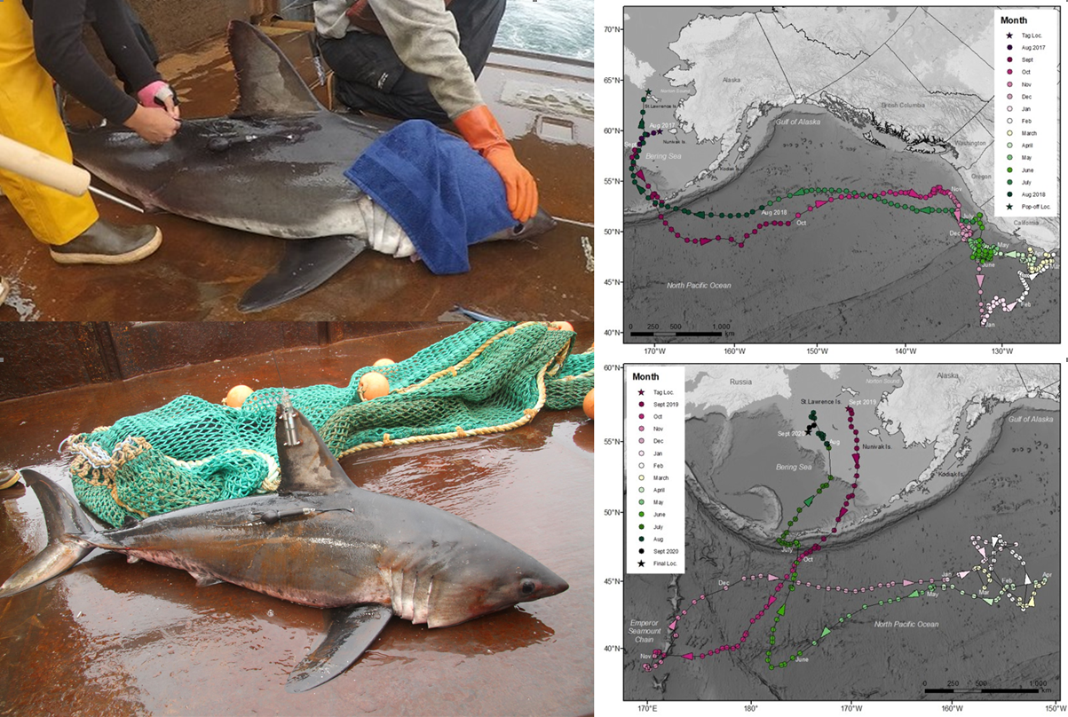
Figure. (Left) Shark A (top) being tagged with a PSAT using two tethers on August 27, 2017. The harness of the second tether attachment is being looped around the body of the tag. Shark B (bottom) with a SPOT-257 tag affixed to the dorsal fin and a PSAT attached with two tethers in the musculature beneath the dorsal fin. Data from Shark B’s PSAT are not reported here. (Right) Monthly HMM-derived locations from August 27, 2017 – August 28, 2018 for Shark A (top) and best daily locations transmitted by a SPOT tag carried by Shark B (bottom) from September 7, 2019 through September 6, 2020. Arrows depict swim direction. For more information, contact Cindy Tribuzio at (907) 789-6007 or cindy.tribuzio@noaa.gov.

Electronic Monitoring: large shark size estimation – ABL

Staff at ABL are collaborating with AFSC FMA division, AKRO, PSMFC, APU and the UW to develop artificial intelligence tools for expanding data collections from vessels using electronic monitoring (EM) equipment in lieu of at-sea observers. This specific project is funded through the NOAA Catch Shares program, but is also in parallel with the Electronic Monitoring Initiative project underway with FMA and PSMFC. This project aims to develop tools which will automate the review of EM videos from longline vessels by detecting and speciating catch. Large sharks are a special case, they are generally not brought onboard, and therefore not available to observers to collect any size information. Thus, a global average weight is applied to all large shark catches from longline vessels, which has been shown to underestimate the size of the animals caught, and thus underestimating total catch estimates. The second AI tool from this project will size grade large sharks caught by vessels using EM, and analysts will be able to provide an informed range of sizes to adjust total catch estimates to be more reflective of true catch. Project staff conducted two surveys in 2022 to collect EM video of catching sharks and collect groundtruth size data (Fig XXX). These tools are being designed to be portable and applicable beyond Alaska fisheries. For more information, contact Cindy Tribuzio at (907) 789-6007 or cindy.tribuzio@noaa.gov.
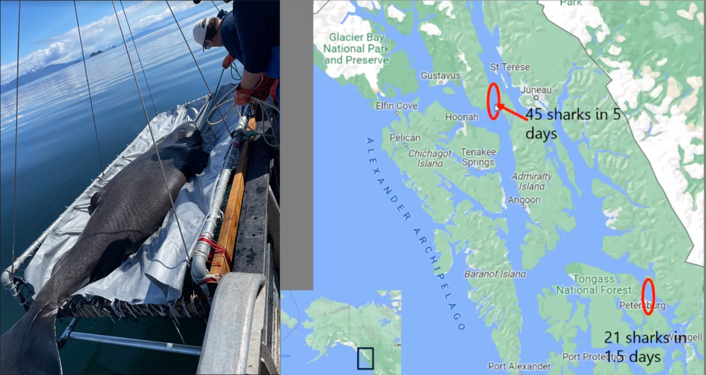
Directed survey for Pacific sleeper shark to collect Electronic Monitoring video of sharks being caught and groundtruth length data. It’s always this sunny. (right) Map of two survey locations in Southeast Alaska.

Stock Assessment

Sharks – ABL

The shark assessments in the Bering Sea/Aleutian Islands (BSAI) and the Gulf of Alaska (GOA) are on biennial cycles in even years. There are currently no directed commercial fisheries for shark species in federally or state managed waters of the BSAI or GOA, and most incidentally captured sharks are not retained.

The separate assessments were combined for the 2022 assessment, creating a unifed assessment document, which still provided management advice separated by FMP. Catch estimates from 2003-2021 were updated from the NMFS Alaska Regional Office’s Catch Accounting System. In the GOA, total shark catch in 2022 (as of Oct 1, 2022) was 1,550 t, which was down from the 2021 catch of 1,917 t. The GOA assessment also reports catch of sharks occurring in federally managed fisheries in NMFS areas 649 (Prince William Sound) and 659 (Southeast Alaska inside waters), 197 t in 2021 and 114 t in 2020 (as of Oct 1, 2022), however these do not accrue against the TAC. The assessment authors have been tasked with working with Council staff to explore options for incorporating these catches into the assessment.

The most recent GOA trawl survey was in 2021, with the next planned for 2023. The trawl survey biomass estimates are used for ABC and OFL calculations for spiny dogfish and are not used for other shark species. The 2021 survey biomass estimate for spiny dogfish (32,319 t, CV = 18%), up from the 2019 estimate which was the lowest biomass since the 1990 survey. Such variability in annual estimates is expected due to the patchy distribution of this species.

The GOA shark assessment is a complex of both Tier 5 and 6 species. Spiny dogfish are Tier 5, where the random effects biomass estimates are adjusted by a catchability parameter and multiplied by F_{OFL} = F_{max} from a demographic analysis to estimate the OFL. The Tier 6 species in the complex remained consistent, using the historical mean catch to calculate ABC and OFLs. The recommended GOA-wide ABC and OFL for the entire complex is based on the sum of the ABC/OFLs for the individual species, which resulted in an author recommended ABC = 4,756 t and OFL = 6,341 t for 2023 and 2024.

The shark stock complex in the BSAI are all considered Tier 6 because the survey biomass estimates are highly uncertain and not informative. The Tier 6 calculations in the BSAI are based on the maximum catch of all sharks from the years 2003-2015. The resultant recommended values for 2023 and 2024 were ABC = 517 t and OFL = 689 t. In the BSAI, estimates of total shark catch from the Catch Accounting System from 2021 were 221 t, which is not close to the ABC or OFL.

The assessment authors proposed an alternative model for Pacific sleeper shark in the 2022 assessment. While this model was not accepted for harvest specifications, sufficient concerns were demonstrated to warrant a reduction from maximum permissible ABC in the BSAI. In the GOA, this was also discussed as a substantial concern, but because the Pacific sleeper shark is such a small component of the total complex (dominated by the Tier 5 spiny dogfish), and catches are well below ABC, a reduction in the Pacific sleeper shark ABCs would have no impact on the management of shark bycatch, thus reductions were not put in place. In the BSAI, a proportional reduction to the complex ABC was recommended based on the alternative model results, which was accepted by the SSC. Therefore, the final ABC for the BSAI shark stock complex was 450 t.

For more information, contact Cindy Tribuzio at (907) 789-6007 or cindy.tribuzio@noaa.gov.

Skates

Research

Assessment

Bering Sea and Aleutian Islands – REFM
An assessment was not conducted in 2022. The Alaska Fisheries Science Center’s projection model with updated catch values was used to provide the 2023 and 2024 management advice for the Tier 3 Alaska skate stock. The values generated from the 2021 stock assessment were used for the Tier 5 other skates, 2023 and 2024 management specifications. A full assessment is scheduled for 2023 if resources allow.
The biomass (t) and catch specifications (t) of skates in recent years are shown below. Biomass for each year corresponds to the projection given in the SAFE report issued in the preceding year. The OFL and ABC for 2023 and 2024 are those recommended by the BSAI Groundfish Plan Team. Catch data are current through November 5, 2022.
Area | Year | Biomass | OFL | ABC | TAC | Catch
BSAI | 2021 | 611,865 | 49,297 | 41,257 | 20,000 | 20,029
 | 2022 | 597,042 | 47,790 | 39,958 | 30,000 | 27,799
 | 2023 | 580,701 | 46,220 | 38,605 | n/a | n/a
 | 2024 | 557,853 | 44,168 | 36,837 | n/a | n/a
For more information contact Cindy Tribuzio cindy.tribuzio@noaa.gov

Gulf of Alaska – REFM
An assessment was not conducted in 2022, in accordance to the approved assessment schedule. The values from the last full assessment were rolled over for the 2023 management specifications. The last full assessment can be found at: https://apps-afsc.fisheries.noaa.gov/refm/docs/2021/GOAskate.pdf) in 2021.

Species | Year | Biomass | OFL | ABC | TAC | Catch
Big skate | 2021 |  | 4,278 | 3,208 | 3,208 | 765
 | 2022 |  | 3,822 | 2,867 | 2,867 | 944
 | 2023 |  | 3,822 | 2,867
 | 2024 |  | 3,822 | 2,867
Longnose skate | 2021 |  | 3,449 | 2,587 | 2,587 | 1,035
 | 2022 |  | 3,616 | 2,712 | 2,712 | 940
 | 2023 |  | 3,616 | 2,712
 | 2024 |  | 3,616 | 2,712
Other skates | 2021 |  | 1,166 | 875 | 875 | 732
 | 2022 |  | 1,311 | 984 | 984 | 822
 | 2023 |  | 1,311 | 984
 | 2024 |  | 1,311 | 984

For more information contact Melissa Haltuch melissa.haltuch@noaa.gov and Sandra Lowe sandra.lowe@noaa.gov

Pacific Cod

Research

Multiple AFSC research activities regarding Pacific cod – REFM/RACE/ABL

There have been dramatic developments regarding the Pacific cod populations in Alaskan waters over the last few years. In the BSAI region, there is strong evidence that cod moved north in the Bering Sea when temperatures were warm and ice cover was reduced. In the GOA region, the mid-decade marine heat wave appears to have negatively impacted the cod stock with lingering aftereffects. For these reasons and others, Pacific cod have become a major research focus for the AFSC.

Cod appear unique in their spatial distribution, migration patterns, and sensitivity to temperature. The projects outlined here are designed to test and implement the performance of an ecosystem-based fisheries management approach for Pacific cod in the eastern Bering Sea (EBS), Aleutian Islands (AI), and GOA and to examine key mechanisms governing the past, current, and future role of climate variability and change on the distribution and abundance of Pacific cod stocks. Tagging work conducted in 2021 has shown that a large proportion of cod tagged in the western Gulf of Alaska moved as far north as the northern Bering Sea. More work is needed to understand spawning and migration patterns and responses to climate change that can be integrated into model projections.

The research activities listed below are designed to provide resolution to pressing issues related to Pacific cod:

a. Pacific cod juveniles in the Chukchi Sea – RPP (Dan Cooper, Kris Cieciel, Louise Copeman, Libby Logerwell, Pavel Emelin, Robert Levine, Robert Lauth, Lyle Britt, Rebecca Woodgate, Jesse Lamb, Ben Laurel, Nissa Ferm, Johanna Vollenweider, and Alexei Orlov).

Past data have shown that the spatial distribution of Pacific cod shifted northward in the Bering Sea between 2010 and 2017, during the recent warm period (Stevenson and Lauth, 2019). In the Chukchi Sea, however, although Pacific cod juveniles have historically been present in some years, there are no known (to us) records of adults. From 2010 to 2019, we surveyed the eastern and western Chukchi Sea using a variety of trawl gears. We use length modes of juvenile Pacific cod to assign fish to age-0 and age-1 age classes. Age-0 Pacific cod were present in the eastern Chukchi Sea in 2017 and 2019, but were absent in 2012. Our data show that age-0 fish in the eastern Chukchi Sea use both pelagic and benthic habitat to feed on different prey resources, however fatty acid analysis indicates that the fish may move between pelagic and benthic habitat, and poor lipid accumulation by juvenile fish may lead to high mortality. Age-1 fish were present in the eastern Chukchi Sea in 2012, and in the western Chukchi Sea in 2018 and 2019, suggesting that the 2011, 2017, and 2018 year classes either successfully recruited to the Chukchi Sea and overwintered, or moved into the Chukchi Sea from the northern Bering Sea. We suggest that age-0 recruitment to the eastern or western Chukchi Sea is associated with warm temperatures and increased northward transport through the Bering Strait in the spring, when Pacific cod larvae are present in the northern Bering Sea. We found no evidence that Pacific cod juveniles in the Chukchi Sea survive past age-1. The first known (to us) adult Pacific cod were present in the western Chukchi Sea in 2018 and 2019, although estimated densities were very low. One adult Pacific cod was caught in the eastern Chukchi Sea in 2019, however estimated densities in the eastern Chukchi Sea are unknown due to lack of monitoring with a benthic trawl capable of catching adult fish. It is unknown whether the Pacific cod observed in the Chukchi Sea will perish, migrate somewhere else, or survive in the Chukchi Sea as part of a further northward range expansion.

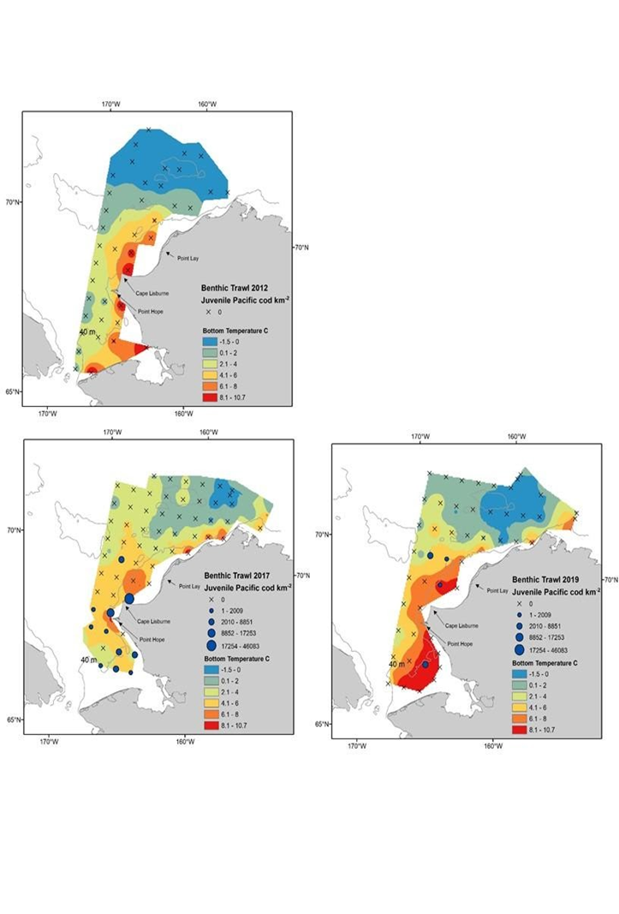Figure 1. Age-0 Pacific cod catch per unit effort and bottom temperature interpolations from 2012, 2017, and 2019.

b. Bioinformatics support to prepare GTseq panel for rapid identification of spawning population of origin of Pacific cod: Ongoing work since 2017 (funded by a Saltonstall-Kennedy grant and AFSC) has successfully sequenced the whole genome of 384 cod throughout their range in Alaska and development of a genotyping-by-sequencing panel (GTseq) is underway. The GTseq panel will incorporate several hundred SNPs that identify Pacific cod to their spawning population of origin.

c. Incorporating Pacific cod novel spatial dynamics in the stock assessment model: During recent years, Pacific cod movement patterns have changed in the EBS, increasing the displacement northwards into the NBS. These patterns are expected to persist in future due to global climate change, and will cause changes in several aspects of the cod population dynamics such as spawning and recruitment areas and natural mortality rates, aspects that need to be considered in the assessment. The Pacific cod stock assessment is implemented in Stock Synthesis (SS), a flexible modeling platform that allows for a wide range of data types, including movement patterns. Using SS and information from previous and ongoing studies, we evaluate the effects of observed spatial patterns on stock assessment outputs by simulating: i) spatial changes in spawning grounds and recruitment areas, and ii) variations in survival and growth of new recruits. Also, we will evaluate effective ways to incorporate this complex spatial dynamic into the stock assessment model. The results of this effort will provide an important improvement to the current assessment and plan for future consequences to the productivity of the stock.

d. Understanding Pacific cod availability to survey vs. fishery: This work will analyze existing fishery and survey catch data from EBS and Aleutian Islands including spatial and temporal comparison of catch rates and length distribution and existing tag data (conventional, PSAT, and archival) to better understand cod availability to the survey vs. fishery. Project will incorporate existing selectivity ratio estimation methodology developed by Kotwicki and will result in a peer-reviewed publication and priors for stock assessment. Further, this study will incorporate food habits data to identify occurrences of midwater species prey.

e. Assessment of age-0 juvenile cod in the Western GOA: This is the 4th year of annual sampling using a beach seine in 0-3 m water along 13 different bays from the east side of Kodiak Island, the Alaska Peninsula, and into the Shumagin Islands. Sampling covers 72 fixed-site locations and 36 non-fixed sets of video surveys (baited cameras, 5 – 20 m). The project provides CPUE data for age-0 Pacific cod and other key species. Age-0 Pacific cod length, weight, condition, diet, and tissue samples (for lipids and genetics) are also obtained from each of the 13 bays. This survey, along with a smaller-scale Kodiak survey, provides direct observations on the lingering effects of marine heatwaves on Pacific cod populations in the GOA at a spatial scale that overlaps with the presumed main spawning area of the region. This work is also a sampling platform for a funded genetics project to identify the natal spawning area of sampled juveniles.

f. Can cod spawn North? Pacific cod larval and juvenile dispersal from the NBS: Using retrospective analyses on Pacific cod larval and juvenile distribution in the Bering Sea, we will: 1) statistically determine phenology and habitat features that correlate with Pacific cod larvae and juveniles, and 2) simulate larval dispersal trajectories, foraging, and growth, from newly putative spawning areas, using IBM and hindcast/forecast of existing ocean circulation models. Simulations will include scenarios to address potential adaptive strategies, such as change in phenology and pelagic larval duration (PLD). These simulations will reveal whether new spawning activity northward of current spawning grounds is likely to be successful, given the foraging and nursery requirements of larval and juvenile cod, and whether there is adaptive potential (phenology, PLD) for establishing new spawning areas. Specifically this project will fund a post-doc for 1 year.
g. Management stock structure of Pacific cod in the Gulf of Alaska
PI: Lorenzo Ciannelli, College of Earth, Ocean and Atmospheric Sciences, Oregon State University, Corvallis OR, 97330.
Email: lorenzo.ciannelli@oregonstate.edu, Tel: (541) 737-3142

The primary objectives for this project are to:
1. Perform empirical retrospective analyses of Pacific cod over different life history stages.
2. Develop mechanistic feeding and transport model of cod movement and survival during early life-history stages, and conduct simulation scenarios for assessing habitat connectivity.
3. Build scenarios and assess consequences of multi-stock configurations forPacific cod in the GOA.

The objective of this project is to develop a spatial management model to improve stock assessment and management of Pacific cod in the western Gulf of Alaska (GOA). The spatial structure of a population can be defined with different disciplinary lenses, including oceanographic (i.e., based on ocean conditions experienced by different group of individuals), demographic (i.e., rate of changes of individuals), ecological (i.e., variations of life history traits), genetic (i.e., variations of coding and neutral portion of genome), and socio-economic (i.e., based on harvest technologies, cultural links with the resource, and policy boundaries). All of these structures influence the way in which
resources are surveyed, their abundance are assessed, and their harvest is managed. Currently the western GOA Pacific cod is assessed and managed as a single stock that is combined with the rest of the GOA, but recent genetic, tagging and oceanographic studies, challenge this assumption. To date, an assessment of how different stock structures influence metrics relevant to management is missing. This project will fill in this knowledge gap.

h. Evaluation of Pacific Cod Movement, Stock Structure and Habitat Use in the Gulf of Alaska using Pop-up Satellite Tagging
PI: Charlotte Levy, Aleutians East Borough, Natural Resources Department, 3380 C Street Suite 205 Anchorage, AK 99502, (206) 457-7197, clevy@aeboro.org

The primary objectives for this project are to:
1. Assess connectivity of Pacific cod stocks by estimating seasonal movement of GOA Pacific cod in relation to management boundaries and environmental variables.
2. Examine Pacific cod spatial stock structure by linking seasonal movement patterns to genetic, demographic, and maturity data.
3. Better understand Pacific cod ecology and habitat use by linking seasonal movement and environmental data to depth, temperature, and behavioral data from tagged fish.

Recent marine heatwaves have caused dramatic changes in Pacific cod abundance in the Gulf of Alaska (GOA), which were attributed to increased mortality, reduced recruitment, and possible migration of adult fish to colder waters in the Bering Sea (BS) in the summer. Information on Pacific cod movement patterns, behavior, demographics, and genetics is essential to understanding stock structure and population responses to changing environmental conditions. This study proposes to estimate seasonal movement patterns of GOA Pacific cod by deploying 173 pop-up satellite tags 1) at GOA spawning sites in March of 2023 and 2024 from a chartered fishing vessel, and 2) opportunistically during the Alaska Fisheries Science Center summer surveys in the GOA and the BS. We will also collect genetic information and demographic characteristics for each spawning location. Satellite tag data will be incorporated in a geolocation model that can estimate movement paths for individual fish. Linking movement patterns to genetic data will give us insight into the stock structure of the Western and Central GOA Pacific cod stock. Movement patterns will be linked to geographical, oceanographic, and biological data to study the connectivity between GOA and BS stocks and characterize habitat use. A high degree of seasonal movement between management regions could adversely impact the sustainability of individual stocks and stakeholders who depend on them, because fish in each region are managed as separate stocks with varying stock assessment parameters such as growth, recruitment, and natural mortality.

i. Leveraging a stock collapse to produce climate-enhanced stock assessment models for the
Gulf of Alaska and Bering Sea Pacific cod
PI: Bradley Harris, Institute of Culture and Environment, Alaska Pacific University, Anchorage, AK. bharris@alaskapacific.edu

The primary objectives for this project are to:
1. Re-analysis and evaluation of alternative parameterizations within the GOA Pacific cod stock assessment model that explain the stock collapse leading to the 2018 fishery disaster and whether this collapse could have been predicted.
2. Investigation of environmental links to growth, mortality, recruitment, survey catchability, and survey/fishery selectivity within the GOA and BS Pacific cod assessments to evaluate the similarities and differences in response to climate change between these two stocks.

To undertake objective 1, the performance of the current GOA stock assessment model with several alternative parameterizations will be evaluated. These include parameters that estimate mortality, selectivity, and catchability, all of which may be influenced by environmental conditions, and which can result in shifts in population size and cod availability to the survey. Further, a suite of techniques to estimate time-dependence in parameters will be explored. These include time-blocks following the approach currently used on the assessment, smoothing techniques (e.g. random walks or splines), and inclusion of environmental indices through covariance modeling. Both retrospective analyses and comparisons of fit will be used to evaluate model performance and the appropriateness and effectiveness of the hypothesized scenarios and associated parameterizations, focusing in particular on the ability of the model to predict the GOA Pacific cod collapse.

To accomplish objective 2, environmental indices that have been identified and collected for both the GOA and BS will be leveraged to explore mechanistic links with growth, mortality, recruitment, and other demographic processes, to refine model parameters within the GOA and BS assessment models. Through retrospective analysis, cross-validation, and model fit diagnostics, we will evaluate the similarities and differences between the responses of the GOA and BS models to the inclusion of environmental links. Ultimately, these analyses and diagnostics will shed light on how the suite of environmental covariates affects the predictive ability and therefore the efficacy of employing these indices in the assessment models to provide forewarning of sudden shifts in population abundance. We will focus on the retrospective aspect of these evaluations to investigate the robustness of the environmental links across time.

For more information please contact Steve Barbeaux (steve.barbeaux@noaa.gov) or Ingrid Spies (ingrid.spies@noaa.gov).
j. Ocean warming and acidification effects on Pacific cod early life stages (RACE-FBEP):
Laboratory experiments were conducted to assess how combined ocean warming and ocean acidification may impact the early life stages of Pacific cod as previous studies demonstrated sensitivity to both temperature and CO₂ level. Pacific cod embryos and larvae were reared across three temperatures (3, 6, 10°C) and two CO₂ levels (ambient: ~360μtm; high: ~1560μatm) to 5-weeks post-hatch. Survival, size, growth, and condition were examined. Temperature had a pervasive influence on all measured traits. The optimal temperature for Pacific cod development was 6°C, which led to high condition, low mortality, and rapid growth. At 10°C, Pacific cod mortality at both the embryonic and larval stages was very high, suggesting this temperature was outside their thermal tolerance. Compared to temperature, the effect of elevated CO₂ was not consistent across developmental stages and measured traits. Elevated CO₂ reduced embryonic mortality rates and increased growth rates of early stage fish, but as fish aged, these CO₂ effects diminished. At 6°C, high CO­₂ resulted in reduced condition as fish developed. There were no interactive effects of elevated CO­₂ and high temperature (10°C) indicating the negative effects from ocean warming were not exacerbated by ocean acidification. These findings suggest ocean warming will likely be more detrimental to Pacific cod than ongoing ocean acidification and provide additional insight into changing habitat suitability in the Gulf of Alaska and Bering Sea. Samples from these experiments are being analyzed for metabolic enzyme activities and gene expression to examine the physiological processes responsible for observed patterns of vulnerability and resilience to climate conditions identified in this study.
For further information contact Tom Hurst thomas.hurst@noaa.gov or Emily Slesinger emily.slesinger@noaa.gov
      - Stock Assessment

Eastern Bering Sea – REFM
Pacific cod (Gadus macrocephalus) is a transoceanic species, ranging from Santa Monica Bay, California, northward along the North American coast; across the Gulf of Alaska and Bering Sea north to Norton Sound; and southward along the Asian coast from the Gulf of Anadyr to the northern Yellow Sea; and occurring at depths from shoreline to 500 m. The southern limit of the species’ distribution is about 34 N latitude, with a northern limit of about 65 N latitude. Pacific cod is distributed widely over the eastern Bering Sea (EBS) as well as in the Aleutian Islands (AI) area. Tagging studies have demonstrated significant migration both within and between the EBS, AI, and Gulf of Alaska (GOA). However, recent research indicates the existence of discrete stocks in the EBS and AI (Spies, 2012). Research conducted in 2018 indicates that the genetic samples from the NBS survey in 2017 are very similar to those from the EBS survey area, and quite distinct from samples collected in the Aleutian Islands and the Gulf of Alaska (Spies et al., 2020). Although the resource in the combined EBS and AI (BSAI) region had been managed as a single unit from 1977 through 2013, separate harvest specifications have been set for the two areas since the 2014 season.
The EBS Pacific cod model has undergone numerous model changes and refinements over the last decade. The model uses the Stock Synthesis 3 framework. A major issue in recent years has been an apparent shift in the distribution of EBS Pacific cod into the northern Bering Sea (NBS), an area which historically has not been surveyed. Surveys in the NBS were conducted in 2010, 2017-2019, and 2021. Regular NBS surveys are likely to be conducted into the future as EBS groundfish stocks experience changes in distribution. The lack of survey data in the NBS has caused assessment difficulties for Pacific cod and other stocks.
Authorship of EBS Pacific cod transitioned from Dr. Grant Thompson, who led the assessment from 1988-2021, to Dr. Steve Barbeaux. The ensemble of models presented and accepted for use in 2021 were rerun with new data as parameterized in last year’s assessment.
Recruitment is estimated to have been below average for the 2014-2017 and 2019 year classes, above average for 2018, and near average for 2020. Estimated spawning biomass from the ensemble increased from 2010 through 2019 to 332,967 t and has been on a downward trajectory since that time. Spawning biomass is projected to be 245,594 in 2023.
The 2023 maxABC in this tier as calculated using the weighted average of the models in the ensemble is 144,834 t and the projected 2024 maxABC is 140,159 t. The 2023 OFL from the weighted ensemble is 172,495 t. The 2024 projected OFL is 166,814 t.

Aleutian Islands – REFM
This stock has been assessed separately from Eastern Bering Sea Pacific cod since 2013 and managed separately since 2014. The stock has been managed under Tier 5 since it was first assessed separately. The authors presented two alternative age-structured models this year. However, these models were not accepted for management by the BSAI Groundfish Plan Team. Therefore, no changes were made to the methodology used for recommending harvest specifications. Catch data from 1991-2021 were updated and preliminary catch data for 2022 were included in the assessment, but these have no impact on recommended harvest specifications under Tier 5. The 2022 Aleutian Islands bottom trawl survey biomass index was added to the Tier 5 random effects model.
After declining by more than 50% between 1991 and 2002, survey biomass has since stayed in the range of 50-90 kilotons. The 2018 Aleutians survey biomass estimate (81,272 t) was down approximately 4% from the 2016 estimate (84,409 t). There was no Aleutian Island survey in 2020 and the most recent Aleutian Island survey for Pacific cod conducted in 2022 was 51,539 t, 37% below the 2018 estimate.
The Plan Team’s recommended ABC is 13,812 t, and OFL is 18,416 t. The estimate of the natural mortality rate is 0.34, which is unchanged from the previous assessment.

Gulf of Alaska – ABL
In 2022, an assessment was conducted for Gulf of Alaska Pacific cod. Data updated for the 2022 assessment included federal and state catch data for 2021, preliminary federal and state catch data for 2022, commercial federal and state fishery size composition data for 2021, and preliminary commercial federal and state fishery size composition data for 2022. The AFSC longline survey Pacific cod abundance index and length composition data for the GOA for 2022, the AFSC bottom trawl survey conditional length-at-age data for 2021, commercial federal conditional length-at-age data for 2021 were included, and commercial state catch from 1997 – 2002 were added to the model’s catch time series. The AFSC longline survey Relative Population Number index in 2022 compared to 2021 declined by 24%.
Spawning biomass was above the B_{40%} reference point and projected to be 42,764 t in 2023 and to slightly decrease in 2024. The SSC has determined that reliable estimates of B_{40%}, F_{40%}, and F_{35%} exist for this stock, thereby qualifying Pacific cod for management under Tier 3. The current estimates of B_{40%}, F_{40%}, and F_{35%} are 66,966 t, 0.41, and 0.51, respectively. Spawning biomass for 2023 is projected to be lower than B_{40%}, thereby placing Pacific cod in sub-tier “b” of Tier 3. The 2023 and 2024 catches associated with the F_{40%} level of 0.41 are 24,634 t and 22,683 t, respectively, and were the authors’ and Plan Team’s recommended ABCs. The 2023 and 2024 OFLs are 29,737 t and 27,507 t.

A random effects model was used to set regional ABCs based on the proportions of model-based estimates for 2023: Western GOA = 7,464 t, Central GOA = 14,830 t, and Eastern GOA = 2,340 t. Pacific cod is not being subjected to overfishing, is not overfished, and is not approaching an overfished condition.
For more information contact Pete Hulson, ABL, at (907) 789-6060 or pete.hulson@noaa.gov.

Walleye Pollock

Research

Pre- and Post-Winter Temperature Change Index and the Recruitment of Bering Sea Pollock – ABL

According to the original Oscillating Control Hypothesis (OCH), warmer spring temperatures and earlier ice retreat led to a later oceanic and pelagic phytoplankton bloom and more food in the pelagic waters at an optimal time for use by pelagic species. The revised OCH indicated that age-0 pollock were more energy-rich and have higher overwintering survival to age-1 in a year with a cooler late summer. Therefore, the warmer later summers during the age-0 phase followed by warmer spring temperatures during the age-1 phase are assumed unfavorable for the survival of pollock from age-0 to age-1.

The temperature change (TC) index is a composite index for the pre- and post-winter thermal conditions experienced by walleye pollock (Gadus chalcogrammus) from age-0 to age-1 in the eastern Bering Sea (Martinson et al., 2012). The TC index (year t) is calculated as the difference in the average monthly sea surface temperature in June (t+1) and August (t) (Figure 1) in the southern region of the eastern Bering Sea. Less negative values represent a cool late summer during the age-0 phase followed by a warm spring during the age-1 phase for pollock. The 2020 year class of pollock experienced above average summer temperatures during the age-0 stage and a warm spring in 2021 during the age-1 stage indicating below average conditions for overwintering survival from age-0 to age-1. The 2021 TC index value of -4.36 was similar to the long-term average of -4.59, therefore we expect average recruitment of pollock to age-4 in 2025 from the 2021 year class (Figure 2).
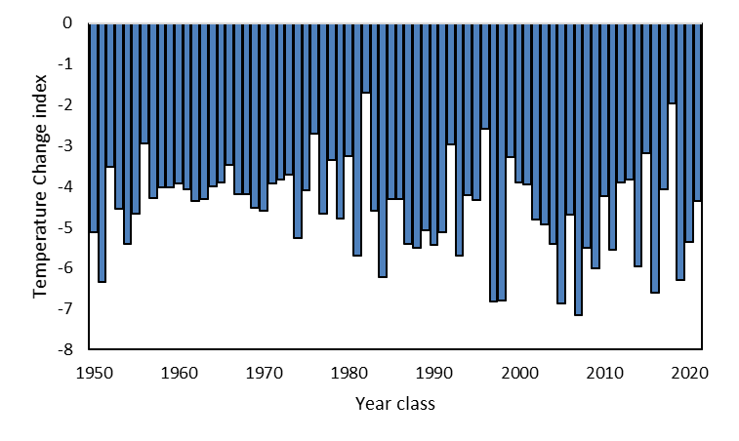
Figure 1: The Temperature Change index values for the 1950 to 2021 year classes of pollock. Values represent the differences in sea temperatures in the south eastern Bering Sea shelf. Less favorable conditions (more negative values) represent a warm summer during the age-0 life stage followed by a relatively cool spring during the age-1 life stage.
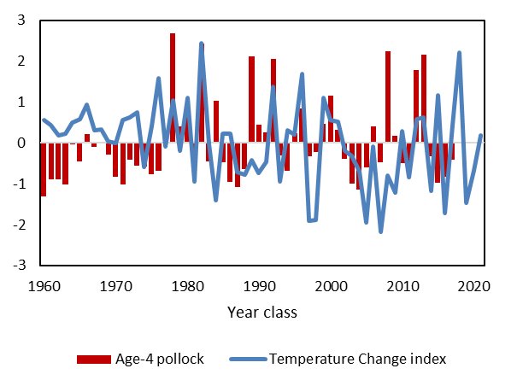
Figure 2: Normalized time series values of the temperature change index indicating conditions experienced by the 1960-2021 year classes of pollock during the summer age-0 and spring age-1 life stages. Normalized values of the estimated abundance of age-4 walleye pollock in the eastern Bering Sea from 1964-2021 for the 1960-2017 year classes. Age-4 walleye pollock estimates are from the Alaska walleye pollock stock assessment (Ianelli et al. 2021).

Literature Cited

Martinson, E. C., Stokes, H. H., & Scarnecchia, D. L. 2012. Use of juvenile salmon growth and temperature change indices to predict groundfish post age‐0 yr class strengths in the Gulf of Alaska and eastern Bering Sea. Fisheries Oceanography, 21(4), 307-319.
For more information contact Ellen.Yasumiishi@noaa.gov

Large copepod abundance sample-based and modeled) as an indicator of pollock recruitment to age-3 in the southeastern Bering Sea – ABL

Interannual variations in large copepod abundance during the pollock age-0 life stage were compared to age-3 walleye pollock (Gadus chalcogrammus) abundance (billions of fish) for the 2002-2018 year classes on the southeastern Bering Sea shelf, south of 60°N, < 200 m bathymetry. The large copepod index sums the abundances of Calanus marshallae/glacialis (copepodite stage 3 (C3)-adult), Neocalanus spp. (C3-adult), and Metridia pacifica (C4-adult), taxa typically important in age 0 pollock diets. Data were collected on the Bering Arctic Subarctic Integrated Survey (BASIS) fishery oceanography surveys and along the 70 misobath during mid-August to late September, for four warm years (2002-2005) followed by one average (2006), six cold (2007-2012), four warm (2014-2016, 2018) and an average year (2017, 70 m isobath only). Zooplankton data were not available for 2013. Age-3 pollock abundance was obtained from the stock assessment report for the 2002-2018 year classes. Two estimates of large copepod abundances were calculated, the first using means among stations (sample-based), and the second using the means estimated from the geostatistical model, Vector Autoregressive Spatial Temporal (VAST) package version 9.4.0.
Positive, significant linear relationships were found between age-3 pollock abundance and the 1) the BASIS sample-based mean abundances and 2) the BASIS VAST-modeled mean abundances of large copepods collected during the age-0 stage for the 2002-2018 year classes (Figure 1). There was a stronger relationship between the VAST model copepod estimates and the age-3 pollock abundance (R² = 0.57 vs R²= 0.27). This appeared to be partially due to the VAST model filling in data for survey areas missed in some years (e.g., 2008). The results show a low availability of large copepod prey for age-0 pollock during the first year of life in 2019 and 2020 (Figure 2).
These large zooplankton taxa contain high lipid concentrations (especially in cold, high ice years) which in turn increases the lipid content in their predators such as age-0 pollock and other fish that forage on these taxa. Increases in energy density (lipids) in age-0 pollock allow them to survive their first winter (a time of high mortality) and eventually recruit into the fishery (Heintz et al., 2013). Accordingly, a strong relationship has been shown for energy density in age-0 fish and age-3 pollock abundance (Heintz et al., 2013). This relationship provides further support for the revised oscillating control hypothesis that suggests as the climate warms, reductions in the extent and duration of sea ice could be detrimental to large crustacean zooplankton and subsequently to the pollock fishery in the southeastern Bering Sea.
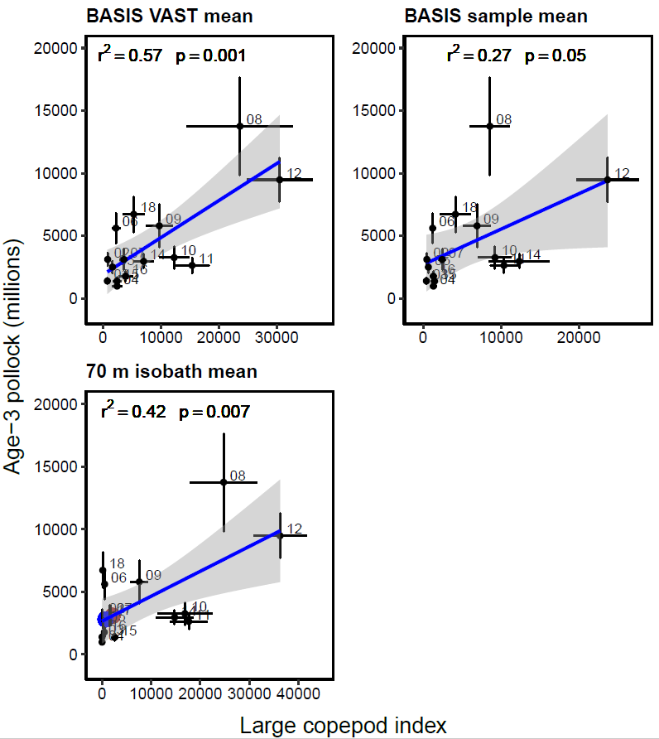
Figure 1. Linear relationships between sample-based (top) from the BASIS and 70 m isobaths surveys and BASIS VAST-model (bottom) estimated mean abundance of large copepods (C+MN, sum of Calanus marshallae/glacialis, Metridia pacifica and Neocalanus spp.) during the age-0 life stage of pollock, and the estimated abundance (millions) of age-3 pollock from Ianelli et al. (2019) for 2002-2018 year classes. No zooplankton data were available for 2013. The brown dot represents the values for the large copepod index in 2019 and the blue dot for the 2020 year class.
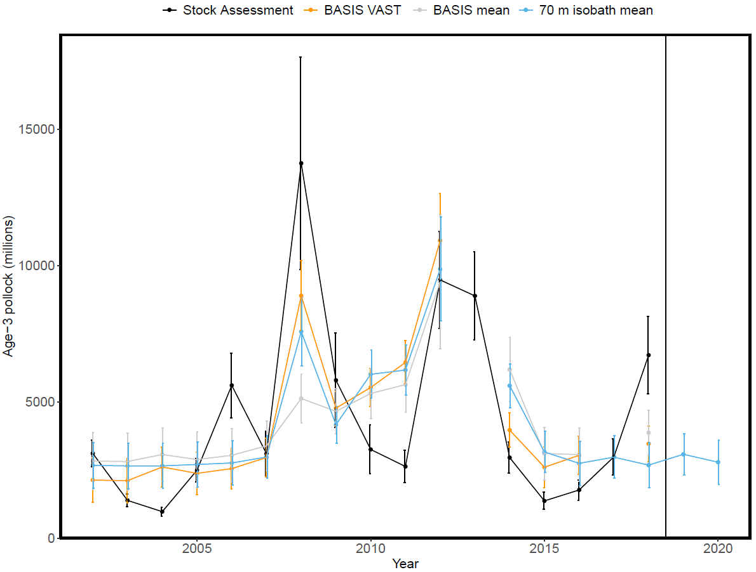
Figure 2. Fitted means and standard errors of the age-3 pollock abundance estimated from the linear regression models using VAST estimates of large copepods (orange), sample mean abundance of large copepods at the 70m isobaths stations (blue), and means from the pollock stock assessment estimates (black) from Ianelli et al. (2021). Predicted estimates of age-3 pollock (recruited into fishery as age 3’s in 2022 and 2023) are shown for the 2019 and 2020 year classes.
Literature Cited
Heintz, R.A., Siddon, E.C., Farley Jr., E.V., Napp, J.M., 2013. Climate-related changes in the nutritional condition of young-of-the-year walleye pollock (Theragra chalcogramma) from the eastern Bering Sea. Deep Sea Res. II 94,150–156.
For more information contact Ellen Yasumiishi (ellen.yasumiishi@noaa.gov).

Ontogenic Shifts in the Diet of Walleye Pollock – ABL

In 2022, we continued a pilot study to use cross sections of adult pollock eye lenses and stable isotope analysis to determine ontogenetic shifts in diet and movement between habitats on the Bering Sea shelf.
For more information contact Todd Miller, ABL, todd.miller@noaa.gov.

Condition and Diet of Juvenile Walleye Pollock – ABL

In 2022, we assessed the condition and diets of juvenile groundfish including walleye pollock, Pacific cod, and Atka mackerel during fall in the northern and southeastern Bering Sea. Annual changes in juvenile body condition can affect survival and recruitment, with particular attention on fall condition and over-winter survival effects.
For more information contact Rob Suryan, ABL, rob.suryan@noaa.gov.

RACE Recruitment Processes Program – RPP

The Recruitment Processes Program's (RPP) overall goal is to understand the mechanisms that influence the survival of young marine fish to recruitment. Recruitment for commercially fished species occurs when they grow to the size captured or retained by the nets or gear used in the fishery. For each species or ecosystem component studied, we attempt to learn what biotic and abiotic factors cause or contribute to the observed fishery population fluctuations. These population fluctuations occur on many different time scales (for example, between years, between decades). The mechanistic understanding that results from our research is used to better manage and conserve the living marine resources for which NOAA is the steward.

For more information contact Libby Logerwell at: Libby.Logerwell@noaa.gov

Gulf of Alaska

Changes in spawn timing and availability of walleye pollock to assessment surveys in the Gulf of Alaska

Lauren A Rogers, Martin Dorn, Darin Jones, Kresimir Williams, Cole Monnahan

Changes in phenology, or the seasonal timing of events, are a widely-documented response to changes in climate. Spawn timing, in particular, has been shown to be sensitive to temperature in many species, including walleye pollock. Beyond implications for recruitment and survival of offspring, climate-driven changes in the timing of spawning can affect the availability of fish to surveys designed to monitor their abundance, complicating efforts to assess stock status and sustainably manage fisheries.

In recent years, biomass estimates from four surveys used to monitor Gulf of Alaska (GOA) pollock have diverged, giving conflicting estimates of survey biomass and temporal trends. In particular, from 2017-2019, estimates of pollock biomass were record high in the winter pre-spawner survey in Shelikof Strait, while other GOA summertime surveys estimated near record low biomass. These conflicting trends increased uncertainty in the stock assessment and occurred during a time of rapid environmental change in the GOA. Following recent evidence of shifting spawn timing in GOA pollock, we hypothesized that changes in spawn timing relative to survey timing affected availability of pollock to the winter Shelikof survey. To test this, we reconstructed relative spawn timing from estimated hatch dates of larvae collected during spring larval surveys and from observations of spawning state in mature female pollock collected during the winter Shelikof survey. We then compared estimates of spawn timing/survey timing overlap with residual errors from an age-structured stock assessment model to evaluate whether model lack-of-fit to survey biomass estimates was related to the timing of spawning relative to the timing of the survey. Results suggest that changes in spawn timing relative to survey timing can explain a significant portion of recent and historical discrepancies in survey biomass estimates. Based on this, we developed a time series of covariates for survey catchability for the stock assessment model to account for changing availability of pollock to the winter Shelikof survey. As climate change accelerates, changes in phenology may complicate efforts to monitor and assess stock status. We show that knowledge of underlying processes can guide approaches to account for these changes in assessment frameworks, expanding our toolkit for climate-ready fisheries management.

For more information, contact Lauren Rogers (lauren.rogers@noaa.gov)

Bering Sea

Management strategies for the eastern Bering Sea pollock fishery with climate change – ESSR

Recent studies indicate that rising sea surface temperature (SST) may have negative impacts on eastern Bering Sea walleye pollock stock productivity. A previous study (Ianelli et al 2011 ICES J Mar Sci 68: 1297–1304) developed projections of the pollock stock and alternative harvest policies for the species, and examined how the alternative policies perform for the pollock stock with a changing environment. The study, however, failed to evaluate quantitative economic impacts. The present study showcases how quantitative evaluations of the regional economic impacts can be applied with results evaluating harvest policy trade-offs; an important component of management strategy evaluations. In this case, we couple alternative harvest policy simulations (with and without climate change) with a regional dynamic computable general equilibrium (CGE) model for Alaska. In this example we found (i) that the status quo policy performed less well than the alternatives (from the perspective of economic benefit), (ii) more conservative policies had smaller regional output and economic welfare impacts (with and without considering climate change), and (iii) a policy allowing harvests to be less constrained performed worse in terms of impacts on total regional output, economic welfare, and real gross regional product (RGRP), and in terms of variability of the pollock industry output. The results of this project are summarized in Seung and Ianelli (2017), which is currently under review / revision at a peer-reviewed journal. For further information, contact Chang.Seung@noaa.gov

An examination of size-targeting in the Bering Sea pollock catcher processor fishery – ESSR

Weight-based harvest quota regulations do not restrict the size of individual fish that fill that quota, although fish of different sizes may present varying fishery profit opportunities and have different impacts on the stock’s growth potential. This paper empirically links revenue per unit of quota and fish size by investigating the catcher-processor fleet of the U.S. Bering Sea pollock fishery, where larger fish can be made into higher-value fillets, instead of surimi that is lower value on average. We then use a dynamic age-structured model to illustrate how some harvesters target smaller fish to decrease their own harvesting costs, which imposes a stock externality on the fleet. This is a working paper that is being revised for submission to a peer-reviewed journal. We estimate the potential increase in profit if a manager hypothetically controls for the size of fish caught in the pollock fishery. Fishers benefit due to higher prices coming from higher-value products, and greater catches because of a larger biomass. For further information contact Alan.Haynie@noaa.gov.

Stock Assessment

Eastern Bering Sea – REFM

Walleye pollock (Gadus chalcogrammus; hereafter referred to as pollock) are broadly distributed throughout the North Pacific with the largest concentrations found in the Eastern Bering Sea. Also known as Alaska pollock, this species continues to play important roles ecologically and economically. This is a mature assessment done annually with new catch, survey, and composition information. For the 2022 assessment this included data from the NMFS bottom-trawl (BTS) and acoustic-trawl (ATS) surveys as well as total catch through 2022. In addition, opportunistic acoustic data from vessels (AVO) conducted by the BTS (2006-2019, 2021-2022) were used as an added index of pollock biomass in mid- water. Observer data for catch-at-age and average weight-at-age from the 2022 fishery were finalized and included.
Spawning biomass in 2008 was at the lowest level since 1980 but increased by a factor of 2.30 by 2017. Biomass trended downward after 2017 and increased rapidly between 2020 and 2022 The 2008 low was the result of extremely poor recruitments from the 2002-2005 year classes. Recent increases were fueled by recruitment from the very strong 2008, 2012, 2013, and 2018 year classes, along with spawning exploitation rates at or below 20% from 2008 through 2018.
The SSC has determined that EBS pollock qualifies for management under Tier 1 because there are reliable estimates of B_{MSY} and the probability density function for F_{MSY}. The updated estimate of B_{MSY} from the present assessment is 2.674 million t. Projected spawning biomass for 2023 is 4.171 million t. As has been the approach for many years, the maximum permissible ABC harvest rate was based on the ratio between MSY and the equilibrium biomass corresponding to MSY. The harmonic mean of this ratio from the present assessment, after adjusting according to the sloping portion of the harvest control rule, is 0.434. The harvest ratio of 0.434 is multiplied by the geometric mean of the projected fishable biomass for 2023 to obtain the maximum permissible ABC for 2023, which is 2.987 million t. However, as with other recent EBS pollock assessments, the authors recommend setting ABCs well below the maximum permissible levels. The authors were concerned about three assessment model related issues:
1. There was a substantial increase in biomass relative to the lower than expected survey observation from 2021 and this affected the retrospective analyses which last year indicated a tendency to over estimate the stock trend.
2. The model tracks the available data reasonably well except for the strong increase in the AVO index relative to the last two years.
3. The stock-recruitment relationship selected for this cannibalistic species requires a relatively informative prior distribution in order to have the residuals of the estimates relative to the curve to be less biased nearer the slope of the origin. This could be interpreted as being undesirable and having undue influence on the underlying stock productivity (noting that it has been demonstrated that the prior leads to increased conservativism).
The authors conclude that this warrants reducing the 2023 and 2024 ABCs by 43% and 56% from the corresponding maxABC. The values were derived by running the accepted model with the 2018 recruitment specified as the mean of the previous highest 2 years – which put the stock in Tier 3a – and then applying the Tier 3 maxABC harvest control rule. This reduction is necessary to account for uncertainties in the 2018 recruitment that are likely overestimated in the model, and to ensure stability in the fishery. The SSC agreed that a buffer was warranted and proposed a 36% reduction.
The OFL harvest ratio under Tier 1a is 0.491, corresponding to the arithmetic mean of the ratio between MSY and the equilibrium fishable biomass corresponding to MSY, after adjusting according to the sloping portion of the harvest control rule. The product of this ratio and the geometric mean of the projected fishable biomass for 2023 determines the OFL for 2023, which is 3.381 million t. Given a projected 2023 catch of 1.350 million t, the current projection for OFL in 2024 is 4.639 million t.
In addition to the ecosystem considerations listed in the SAFE chapter, an appendix to the SAFE chapter describes a multi-species model (“CEATTLE”) involving walleye pollock, Pacific cod, and arrowtooth flounder. The authors view this as a “strategic” model rather than a model that would be used for setting annual harvest specifications.
For more information contact Jim Ianelli (jim.ianelli@noaa.gov)

Aleutian Islands – REFM
The Aleutian Islands walleye pollock stock assessment has used the same modeling approach since 2015; implemented through the Assessment Model for Alaska (here referred to as AMAK). AMAK is an age-structured model implemented in AD Model Builder (ADMB). Catches for 1978 to 2022 were updated to latest estimates from the catch accounting system (CAS). The 2021 Aleutian Islands survey index and the 2019 and 2020 fishery age composition data were added. Survey age data from 2022 were not yet available. All survey age composition data prior to 1991 were removed from the model to be consistent with the use of Aleutian Islands bottom trawl survey data prior to 1991. There was no directed fishery catch of pollock in 2021, but there was a small, directed fishery in 2022 (217 t as of October 10, 2022). As of October 9, 2022, the total catch of pollock across the Aleutian Islands was 2,726 t.
The 2022 assessment estimates that spawning biomass reached a minimum level of about B_{27%} in 2010 but has generally increased since; the estimates from the authors’ preferred model showed a slight decline in female SSB from 2021 (82,121 t) to 2022 (79,828 t), with another slight decline projected for 2023. The status of AI pollock in 2021 and 2022 was assessed to be well above B20%. Mean recruitment was high in the late 1970s and mid-1980s, with the 1978 year-class having a strong influence on the model. Mean recruitment of age-1 pollock from 1978-1989 was almost eight times higher than that from 1998- 2008; no year class since the 1989 year class has exceeded the overall 1978-2018 overall mean recruitment of 131 million age-1 recruits. The most recent strong year classes were the 2011 and 2012 year classes, with 93 and 127 million age-1 recruits, respectively. Lower year class strength since 1990 has led to lower abundance of pollock in the Aleutian Islands, despite the fact that exploitation rates have remained low since 1999.
For more information contact Jim Ianelli (jim.ianelli@noaa.gov)

Bogoslof Pollock – REFM
Assessments for Bogoslof pollock are conducted in even years. Harvest recommendations for Bogoslof-area pollock calculated by multiplying the biomass estimate from the NMFS acoustic-trawl survey by an estimate of natural mortality. Biomass is estimated using a random effects model used widely in AFSC assessments. The 2020 acoustic-trawl survey biomass estimate was revised to correct how nearest-tow data were assigned to pollock backscatter, and the natural mortality estimate was increased from 0.3 to 0.313 based on updated age data in 2022.
NMFS acoustic-trawl survey biomass estimates are the primary data source used in this assessment. Between 1997 and 2020, the values varied between a low of 67,063 t in 2012 and a high of 663,070 t in 2018. The most recent acoustic-trawl survey of the Bogoslof spawning stock was conducted in February 2020 and resulted in a biomass estimate of 353,069 t. The random-effects method of survey averaging resulted in 367,880 t.
The maximum permissible ABC value for 2023 is 86,360 t (assuming M = 0.313 and FABC = 0.75 x M = 0.235 and the random effects survey estimate for biomass). The ABC for 2024 is the same. The OFL was calculated using the random effects estimate for the survey biomass. Following the Tier 5 formula with M = 0.313, OFL for 2023 is 115,146 t. The OFL for 2024 is the same.
For more information contact Steve Barbeaux (steve.barbeaux@noaa.gov)

Area | Year | Biomass | OFL | ABC | TAC* | Catch
Eastern Bering Sea | 2021 | 8,145,000 | 2,594,000 | 1,626,000 | 1,375,000 | 1,376,258
 | 2022 | 6,839,000 | 1,469,000 | 1,111,000 | 1,111,000 | 1,103,996
 | 2023 | 12,389,000 | 3,381,000 | 1,688,000 | n/a | n/a
 | 2024 | 11,445,000 | 4,639,000 | 1,815,000 | n/a | n/a
Aleutian Islands | 2021 | 292,967 | 61,856 | 51,241 | 19,000 | 1,840
 | 2022 | 308,525 | 61,264 | 50,752 | 19,000 | 2,895
 | 2023 | 264,173 | 52,383 | 43,413 | n/a | n/a
 | 2024 | 281,618 | 52,043 | 43,092 | n/a | n/a
Bogoslof | 2021 | 378,262 | 113,479 | 85,109 | 250 | 8
 | 2022 | 378,262 | 113,479 | 85,109 | 250 | 256
 | 2023 | 367,880 | 115,146 | 86,360 | n/a | n/a
 | 2024 | 367,880 | 115,146 | 86,360 | n/a | n/a

Gulf of Alaska – REFM
The Gulf of Alaska walleye pollock assessment is a mature age-structured assessment that underwent minor changes in 2022. Two minor changes to the model included adding a penalty to the recruitment deviations for all years and estimating selectivity of the summer acoustic survey. New data included in the model were: 1) 2021 total catch and catch-at-age from the fishery, 2) 2022 biomass and age composition from the Shelikof Strait acoustic survey, 3) 2021 NMFS Bottom Trawl survey age composition, 4) 2021 Summer GOA-wide acoustic survey age composition, and 5) 2022 biomass from the ADF&G crab/groundfish trawl survey.
While the model and data changes increased the scale of spawning biomass in comparison to last year’s assessment, the spawning stock is projected to decline in 2023 and 2024 as the 2012 year-class is further reduced in abundance. The presence of several incoming year classes should result in a stabilization in biomass. The 2017 year-class is still present in high numbers in both the fishery and surveys, and the 2018 year-class continues to be present in the Shelikof Strait survey. There is also emerging evidence of a larger than average 2020 year-class. The Shelikof Strait survey data in 2022 showed slight decrease in biomass compared to 2021. Overall, survey indices seem to be providing similar trends with closer agreement among the surveys.

Area | Year | Biomass (age3+) | OFL | ABC | TAC | Catch
W/C/WYAK | 2021 | 1,097,340 | 123,455 | 111,134 | 108,491 | 104,163
 | 2022 | 848,878 | 154,983 | 139,803 | 136,476 | 136,317
 | 2023 | 1,281,980 | 173,470 | 148,938
 | 2024 | 186,101 | 161,080
SEO | 2021 | 45,103 | 13,531 | 10,148 | 10,148 | 0
 | 2022 | 50,500 | 15,150 | 11,363 | 11,363 | 0
 | 2023 | 50,500 | 15,150 | 11,363
 | 2024 | 15,150 | 11,363
GOA-wide | 2021 | 1,142,443 | 136,986 | 115,870 | 113,227 | 99,019
 | 2022 | 899,378 | 170,133 | 144,444 | 141,117 | 129,876
 | 2023 | 1,332,480 | 188,620 | 160,301
 | 2024 | 201,251 | 172,443
For more information contact Cole Monnahan (cole.monnahan@noaa.gov)

Pacific Whiting (hake)

There are no hake fisheries in Alaska waters.

Rockfish

Research

Rockfish Condition and Reproductive Studies – RACE-GAP Kodiak

The development of accurate and logistically feasible methods to assess fish condition and reproductive success across the large spatial scales of the marine ecosystems of Alaska would be a valuable tool for assessing the importance of habitat for commercially important species. This research project is a collaborative effort with researchers from the EBS GAP group, the REFM Age and Growth Program (NOAA Strategic Initiative), and the Deep Sea Coral and Sponge Initiative.
Fish condition is generally thought to be a predictor of fish productivity and has been directly linked to reproductive success for some species (Kjesbu et al. 1991, Lambert and Dutil 2000). By measuring both condition indices and reproductive parameters (maturity, skipped spawning, and fecundity), it is possible to quantify the link between fish condition and reproductive status and success. Reproduction is energetically costly, and there is evidence that fish in better condition or that have higher energy reserves are more reproductively successful. The realization of maturity is related to greater body condition in some species (Henderson and Morgan 2002, Feiner et al. 2019). Improved fish condition is also linked to increased fecundity, earlier spawning, and eggs with larger energy reserves (Gagliano and McCormick 2007, Donelson et al. 2008, Feiner et al. 2019). Spawning omission has also been related to fish condition and low energy reserves (Rideout and Rose, 2006, Skjaeraasen et al. 2012, McBride et al. 2015). Several rockfish species in Alaska waters have been shown to exhibit some reproductive failure or skipped spawning (Conrath 2017, 2019), but it is unknown if body condition relates to this reduction in spawning effort.
Spatial differences in condition have been related to both water temperature and depth (Lloret and Ratz 2000, Chouinard and Swain 2002), but differences due to the presence of different substrate types are not as well documented. Rockfish species are frequently associated with coral and sponge habitat in both the Gulf of Alaska and the Aleutian Islands (Rooper et al. 2007, Rooper and Martin 2011, Conrath et al. 2019). It is often assumed structure-forming invertebrates provide a valuable habitat that results in higher productivity of these species. A previous study in the Gulf of Alaska examining rockfish abundance and community structure in different habitats found that rockfish densities were highest in complex habitat, but additional value of habitat containing structure-forming invertebrates was not shown (Conrath et al. 2019). Similarly, Rooper et al. (2019) found that rockfish in the eastern Bering Sea and the Aleutian Islands had an affinity for coral and sponge habitats, but that any structure is important for rockfish and both abiotic and biotic structure was associated with increased rockfish densities. A more comprehensive examination of fish condition and reproductive success across large spatial scales within the Gulf of Alaska and the Aleutian Islands will support the further examination of the value of coral and sponge habitats within these large marine ecosystems.

Northern Rockfishes and Pacific ocean perch – RACE-GAP

A project focused on developing an appropriate condition index for use during annual bottom trawl surveys, relating condition to reproductive success, and examining the relationship between these parameters and habitat was initiated in 2021. During 2021, the sampling for this project was focused on developing the best method to examine fish condition during standardized annual bottom trawl surveys. Pacific ocean perch (Sebastes alutus) and northern rockfish (S. polyspinis) were sampled for this project during the Alaska Fisheries Science Center (AFSC) 2021 Gulf of Alaska Bottom Trawl Survey. Fifty rockfish of each species were sampled throughout the survey area. Each sampled rockfish was measured for length, total weight, liver weight, and two types of fat meters were used to estimate lipid content. The condition indices developed form this data will be validated using energy density values measured with proximate composition and bomb calorimetry. The fish samples have been transported to the Auke Bay Laboratories in Juneau and these bioenergetics analyses will occur in 2023.

The focus of sampling in 2022 was collecting fish condition and reproductive samples for Pacific ocean perch and northern rockfish in or near areas of high concentrations of structure forming invertebrates and areas without structure forming invertebrates. During the 2022 Aleutian Bottom Trawl Survey, 390 Pacific ocean perch and 163 northern rockfish were sampled. In addition to the measurements listed above, ovaries were sampled from female fish and otoliths were collected from all fish. The maturity status and fecundity of these samples will be evaluated during 2023. The results from the data will be utilized to assess the efficiency and accuracy of fish condition indices and to develop further sampling plans for 2024 in the Aleutian Islands.
For further information, please contact Christina Conrath (907) 481-1732

Whole genome resequencing of rockfish – ABL

The genetics group at ABL is using whole genome resequencing to understand population structure in a number of groundfish and crab species including various rockfish, sablefish, king crab, and Pacific cod. The focus of this work will be understanding the population structure of these species. Sablefish were collected from Washington to the central Aleutian Islands. Analysis showed no structure, reinforcing results from Jasonowicz et al. 2017. Analysis of red king crab showed similar structure as previous microsatellite studies. Analysis of Pacific Ocean perch results revealed that there may be more than one species. This is being further investigated. A new high throughput GTseq panel has been developed for Pacific cod that will be used to understand stock-specific distributions.
For more information, contact Wes.Larson@noaa.gov.

Assessment

Pacific ocean perch (POP) – Bering Sea and Aleutian Islands – REFM
In 2005, BSAI rockfish were moved to a biennial assessment schedule with full assessments in even years to coincide with the occurrence of trawl surveys in the Aleutian Islands (AI) and the eastern Bering Sea (EBS) slope. A full assessment was conducted in 2022. The age-structured assessment implemented in AD Model Builder was unchanged from the 2020 stock assessment. Changes to the input data included updated catch data through 2021, projected 2022-2024 catch estimates, 2022 Aleutian Islands (AI) survey biomass estimate and length compositions, 2020 and 2021 fishery age composition, and reweighted age and length data using the iterative reweighting procedure (McAllister-Ianelli method).

The high survey biomass estimates over the past five years have contributed to a substantial increase in estimated stock size in recent years; however, there remains a poor residual pattern in the fit to the AI survey index. The 2022 AI survey biomass estimate is a 5% increase from the 2018 AI survey biomass estimate. Spawning biomass is projected to be 359,074 t in 2023 and decline to 352,616 t in 2024. The recent year classes of 2011-2012, 2014, and 2016 appear to be relatively strong, but the retrospective analysis suggests that recruitment estimates for these year classes may not have stabilized.

The updated point estimates of B_{40%}, F_{40%}, and F_{35%} are 261,050 t, 0.074, and 0.089, respectively. The maximum permissible value of F_{ABC} is 0.074, which results in a 2023 ABC of 42,038 t and 2024 ABC of 41,322 t. The OFL fishing mortality rate is 0.089 which results in a 2023 OFL of 50,133 t and 2024 OFL of 49,279 t.

The ABC is set regionally based on the proportions in combined survey biomass as follows (values are for 2023): EBS = 11,903 t, Eastern Aleutians (Area 541) = 8,152 t, Central Aleutians (Area 542) = 5,648 t, and Western Aleutians (Area 543) = 16,335 t. The recommended OFLs for 2023 and 2024 are not regionally apportioned.

Area | Year | Biomass (age 3+) | OFL | ABC | TAC | Catch
BSAI | 2021 | 756,011 | 44,376 | 37,173 | 35,899 | 35,479
 | 2022 | 738,710 | 42,605 | 35,688 | 35,385 | 32,294
 | 2023 | 888,722 | 50,133 | 42,038 | n/a | n/a
 | 2024 | 876,140 | 49,279 | 41,322 | n/a | n/a
Eastern Bering Sea | 2021 |  |  | 10,782 | 10,782 | 10,693
 | 2022 |  |  | 10,352 | 10,352 | 9,665
 | 2023 |  |  | 11,903 | n/a | n/a
 | 2024 |  |  | 11,700 | n/a | n/a
Eastern Aleutian Islands | 2021 |  |  | 8,419 | 8,419 | 8,288
 | 2022 |  |  | 8,083 | 8,083 | 5,924
 | 2023 |  |  | 8,152 | n/a | n/a
 | 2024 |  |  | 8,013 | n/a | n/a
Central Aleutian Islands | 2021 |  |  | 6,198 | 6,198 | 5,993
 | 2022 |  |  | 5,950 | 5,950 | 5,823
 | 2023 |  |  | 5,648 | n/a | n/a
 | 2024 |  |  | 5,551 | n/a | n/a
Western Aleutian Islands | 2021 |  |  | 11,774 | 10,500 | 10,505
 | 2022 |  |  | 11,303 | 11,000 | 10,882
 | 2023 |  |  | 16,335 | n/a | n/a
 | 2024 |  |  | 16,058 | n/a | n/a

For more information contact Paul Spencer (paul.spencer@noaa.gov)
.

Pacific ocean perch – Gulf of Alaska – ABL

In 2022, a partial assessment was conducted for Gulf of Alaska Pacific ocean perch. New data added to the projection model included updated catch data from 2021 and new estimated catches for 2022-2024.

Spawning biomass was above the B_{40%} reference point and projected to be 210,795 t in 2023 and to decrease to 205,713 t in 2024. The SSC has determined that reliable estimates of B_{40%}, F_{40%}, and F_{35%} exist for this stock, thereby qualifying Pacific ocean perch for management under Tier 3. The current estimates of B_{40%}, F_{40%}, and F_{35%} are 132,767 t, 0.10, and 0.12, respectively. Spawning biomass for 2023 is projected to exceed B_{40%}, thereby placing Pacific ocean perch in sub-tier “a” of Tier 3. The 2023 and 2024 catches associated with the F_{40%} level of 0.10 are 37,193 t and 36,196 t, respectively, and were the authors’ and Plan Team’s recommended ABCs. The 2023 and 2024 OFLs are 44,302 t and 43,117 t.

A random effects model was used to set regional ABCs based on the proportions of model-based estimates for 2023: Western GOA = 2,529 t, Central GOA = 29,940 t, and Eastern GOA = 4,724 t. The Eastern GOA is further subdivided into west (called the West Yakutat subarea) and east (called the East Yakutat/Southeast subarea, where trawling is prohibited) of 140° W longitude using a weighting method of the upper 95% confidence of the ratio in biomass between these two areas. For W. Yakutat the ABC in 2023 is 1,370 t and for E. Yakutat/Southeast the ABC in 2023 is 3,354 t. The recommended OFL for 2023 is apportioned between the Western/Central/W. Yakutat area (40,308 t) and the E. Yakutat/Southeast area (3,994 t). Pacific ocean perch is not being subjected to overfishing, is not overfished, and is not approaching an overfished condition.

For more information contact Pete Hulson, ABL, at (907) 789-6060 or pete.hulson@noaa.gov.

Dusky Rockfish-- Gulf of Alaska – ABL

In 2022, a full assessment was conducted for Gulf of Alaska dusky rockfish. The input data were updated to include final catch for 2020 and 2021, preliminary catch for 2022, fishery size composition for 2021, fishery age composition for 2020, trawl survey age composition for 2021, and trawl survey biomass for 2021. The survey biomass estimate is based upon the Groundfish Assessment Program’s Vector Autoregressive Spatio-temporal (VAST) model with a lognormal error distribution for the GOA. The length plus group was extended from 47 cm to 52cm and the age plus group was extended from 25 to 30 years.
Spawning biomass was above the B_{40%} reference point and projected to be 44,651 t in 2023. The SSC has determined that reliable estimates of B_{40%}, F_{40%}, and F_{35%} exist for this stock, thereby qualifying dusky rockfish for management under Tier 3. With B_{40%}, F_{40%}, and F_{35%} estimated at 26,226 t, 0.11, and 0.09, respectively. Spawning biomass in 2023 is projected to exceed B_{40%}, thereby placing northern rockfish in Tier 3a. The 2023 and 2024 catches associated with an F_{40%} are 7,917 t and 7,520 t, respectively. These catches were put forward as the authors’ and Plan Team’s recommended ABCs. The 2023 OFL is 9638 t.

A random effects model was used to establish regional ABCs based on the proportions of model-based estimates for 2023 with 149t allocated to the Western GOA, 7,647 t to the Central GOA, and 121t to the Eastern GOA. The recommended OFLs for 2022 and 2023 are not regionally apportioned. Dusky rockfish is not being subjected to overfishing, is not overfished, and is not approaching an overfished condition.

For more information contact Ben Williams, ABL, ben.william@noaa.gov.

Northern Rockfish – Bering Sea and Aleutian Islands – REFM

A partial assessment was carried out in 2022 because it was a scheduled off-year. THe AFSC projection model was run with updated catches. THe new data included updated 2021 catch and estimated 2022 catches. No changes were made to the assessment model. Exploitation rates (i.e., catch/biomass) well below the exploitation rate associated with fishing at F40%.

Spawning biomass is projected to be 118,251 t in 2023 and to decline to 115,215 t in 2024. The exploitation rates from the BSAI subareas are below F40%. The exploitation rate in the eastern Aleutian Islands peaked in 2015 and 2019, but was substantially lower in 2020 through 2022. The exploitation rates in the central Aleutian Islands have been increasing since 2014.

The current estimates of B40%, F40%, and F35% are 68,707 t, 0.069, and 0.085, respectively. The OFL fishing mortality rate is 0.085 which results in a 2023 OFL of 22,776 t and 2024 OFL of 22,105 t.

Area | Year | Biomass (age 3+) | OFL | ABC | TAC | Catch
BSAI | 2021 | 244,600 | 18,917 | 15,557 | 13,000 | 6,212
 | 2022 | 279,584 | 23,420 | 19,217 | 17,000 | 7,801
 | 2023 | 277,133 | 22,776 | 18,687 | n/a | n/a
 | 2024 | 273,414 | 22,105 | 18,135 | n/a | n/a

For further information, contact Paul Spencer (paul.spencer@noaa.gov)

Northern Rockfish – Gulf of Alaska – ABL

In 2022, a full assessment was conducted for Gulf of Alaska (GOA) northern rockfish. The input data were updated to include final catch for 2020 and 2021, preliminary catch for 2022, fishery age composition for 2020, trawl survey age composition for 2021, and trawl survey biomass for 2021. The survey biomass estimate is based upon the Groundfish Assessment Program’s Vector Autoregressive Spatio-temporal (VAST) model for the GOA. The length plus group was extended from 38 cm to 45 cm.
Spawning biomass was above the B_{40%} reference point and projected to be 39,445 t in 2023 decreasing to 37,470 t in 2024. The SSC has determined that reliable estimates of B_{40%}, F_{40%}, and F_{35%} exist for this stock, thereby qualifying northern rockfish for management under Tier 3. With B_{40%}, F_{40%}, and F_{35%} estimated at 32,940 t, 0.074, and 0.061, respectively. Spawning biomass in 2023 is projected to exceed B_{40%}, thereby placing northern rockfish in Tier 3a. The 2023 and 2024 catches associated with an F_{40%} are 4,965 t and 4,742 t, respectively. These catches were put forward as the authors’ and Plan Team’s recommended ABCs. The 2023 and 2024 OFLs are 5,927 t and 5,661 t.

A random effects model was used to establish regional ABCs based on the proportions of model-based estimates for 2023 with 2,614 t allocated to the Western GOA, 2,350 t to the Central GOA, and 1 t to the Eastern GOA. The Eastern GOA allocation is managed within the “Other Rockfish'' complex. The recommended OFLs for 2023 and 2024 are not regionally apportioned. Northern rockfish is not being subjected to overfishing, is not overfished, and is not approaching an overfished condition.

For more information contact Ben Williams, ABL, ben.william@noaa.gov.

Shortraker Rockfish – Bering Sea and Aleutian Islands – REFM

The Bering Sea and Aleutian Islands (BSAI) shortraker rockfish stock is classified as a Tier 5 stock for setting the acceptable biological catch (ABC) and overfishing level (OFL). In accordance with the new assessment schedule frequency, a full assessment for shortraker rockfish in 2022. The random effects model was fit in Template Model Builder (TMB; Kristensen et al. 2016) using the new rema R library. The model was fit to the Aleutian Islands BTS and the AFSC longline survey (LLS) relative population weights (RPWs) on the eastern Bering Sea (EBS) slope, 1997-2021. The EBS slope is sampled by the LLS in odd years.

Estimated shortraker rockfish biomass in the BSAI slowly decreased from 1998 to 2010 and remained relatively stable to 2022. Survey biomass estimates decreased in the western and eastern AI and increased in the central AI in 2022 compared to 2018. Relative population weights have been variable over time in the EBS slope portion of the longline survey (LLS) with an increase in 2019 followed by a decrease in 2021. Exploitation rates have generally been well below the ABC levels, and have been close to ABC in 2013 and 2021.

F_{ABC} is 75 percent of M, where the accepted value of M for this stock is 0.03 for shortraker rockfish. This results in a maxF_{ABC} value of 0.0225. The ABC is 530 t for 2023 and 2024 and the OFL is 706 t for 2023 and 2024. For more information, contact Katy.Echave@noaa.gov

Shortraker Rockfish – Gulf of Alaska – ABL

Rockfish in the Gulf of Alaska (GOA) have historically been assessed on a biennial stock assessment schedule to coincide with the availability of new trawl survey data (odd years). In 2017, the Alaska Fisheries Science Center participated in a stock assessment prioritization process. It was recommended that the GOA shortraker rockfish stock remain on a biennial stock assessment schedule with a full stock assessment produced in odd years and no stock assessment or document produced in even years. Because this is an “off year,” the 2022 values are rolled over for the 2023 fishery. Estimated shortraker rockfish biomass is 31,331 t. The NPFMC’s Tier 5 ABC definitions state that FABC ≤0.75M, where M is the natural mortality rate. Using an M of 0.03 and applying this definition to the exploitable biomass of shortraker rockfish results in a recommended ABC of 705 t for the 2023 fishery. Gulfwide catch of shortraker rockfish was 443 t in 2022. This is down from 528 t in 2021.
For more information contact Katy Echave at (907) 789-6006 or katy.echave@noaa.gov.

Other Rockfish – Bering Sea and Aleutian Islands – ABL

The Bering Sea and Aleutian Islands (BSAI) Other Rockfish complex is currently managed under Tier 5 harvest control rules, which define F_OFL and F_ABC as M and 0.75M, where M is the natural mortality rate. This complex is assessed fully in even years to coincide with the Aleutian Islands (AI) bottom trawl survey. The Other Rockfish complex includes all species of Sebastes and Sebastolobus, except Pacific ocean perch, northern rockfish, rougheye rockfish, and shortraker rockfish. Because of differences in the assumed M among species, the Other Rockfish complex is assessed in two parts: (1) shortspine thornyhead (SST; M=0.03), which comprise approximately 95% of the estimated total Other Rockfish exploitable biomass; and (2) the remaining “non-SST” species, which are dominated by dusky rockfish (M=0.09) but include at least eleven other rockfish species.

In recent years, concerns have been raised about the lack of abundance information for SST and other species in the Eastern Bering Sea (EBS) slope region following the cessation of the EBS slope bottom trawl survey in 2016 (Shotwell et al. 2020, Sullivan et al. 2020). In response, we recommended a new model that address these concerns by including the NMFS longline survey relative population weights in the eastern Bering Sea (EBS) slope region.
New data for the 2022 stock assessment included:

- Catch and fishery lengths updated through October 3, 2022.
- The 2022 AI bottom trawl survey for both SST and non-SST species.
- The 2021 and 2022 EBS shelf bottom trawl survey for non-SST species.
- New in 2022: NMFS longline survey relative population weights for SST on the EBS slope, 1997-2021 (Table 1).
- The EBS slope is sampled by the LLS in odd years.

Combined Other Rockfish biomass in 2023/2024 is estimated to be 52,733 t, a 1% decrease from the biomass estimated in the 2020 assessment. The recommended BSAI ABC and OFL for 2023/2024 are 1260 t and 1,680 t, respectively. The area-apportioned ABCs in the AI and EBS for 2023/2024 are 380 t and 880 t, respectively.
The 2022 stock assessment is available online at:
https://apps-afsc.fisheries.noaa.gov/Plan_Team/2022/BSAIorock.pdf
For more information contact Jane Sullivan, ABL, at 907 789-6000 or jane.sullivan@noaa.gov

Other Rockfish – Gulf of Alaska – ABL

The Other Rockfish complex in the Gulf of Alaska (GOA) is comprised of 27 species, but the composition of the complex varies by region. The species that are included across the entire GOA are the 17 rockfish species that were previously in the “Other Slope Rockfish” category together with yellowtail and widow rockfish, formerly of the “Pelagic Slope Rockfish” category. Northern rockfish are included in the Other Rockfish complex in the eastern GOA and the Demersal Shelf rockfish species are included west of the 140 line (i.e. all of the GOA except for NMFS area 650). The primary species of “Other Rockfish” in the GOA are sharpchin, harlequin, silvergray, redstripe and yelloweye rockfish; most of the others are at the northern end of their ranges in Alaska and have a relatively low abundance here. Rockfish in the GOA have been moved to a biennial stock assessment and the “Other Rockfish” stock complex is assessed in odd years as per prioritization. There was no assessment in 2022 and there will be a full assessment in 2023.
For more information contact Kristen.Omori@noaa.gov.

Blackspotted/rougheye Rockfish Complex – BSAI – REFM

Fish previously referred to as rougheye rockfish are now recognized as consisting of two species,
rougheye rockfish (Sebastes aleutianus) and blackspotted rockfish (Sebastes melanostictus). The current information on these two species is not sufficient to support separate assessments, so they are combined as a complex in one assessment. In 2005, BSAI rockfish were moved to a biennial assessment schedule with full assessments in even years to coincide with the occurrence of trawl surveys in the Aleutian Islands (AI) and the eastern Bering Sea (EBS) slope. A full assessment was conducted in 2022. The age-structured assessment model remained unchanged from the 2020 assessment. Changes to the input data included: 1) updated catch data through 2021 and total catch for 2022 was projected, 2) the 2022 AI survey biomass estimate and length composition were included in the assessment, 3) the 2013 and 2019 AI fishery length compositions were replaced by the age compositions, and the 2020 and 2021 AI fishery age compositions were included in the model, and 4) the input multinomial sample sizes for the age and length composition data were reweighted using the Francis iterative reweighting procedure.

Since 2014, spawning biomass has increased from 2,656 t to 3,335 t in 2022 and the total biomass has increased from 10, 141 t in 2002 to 23,221 t in 2022. Much of this increase in total biomass can be attributed to relatively recent year classes, especially the estimated large 2010-year class that is beginning to mature.

Area/subarea | Year | Total biomass (t) | OFL | ABC | TAC | Catch
BSAI | 2021 | 22,547 | 576 | 482 | 482 | 515
 | 2022 | 23,221 | 598 | 503 | 503 | 386
 | 2023 |  | 703 | 525 | n/a | n/a
 | 2024 |  | 763 | 570 | n/a | n/a
 | 2021 |  | 169 | 169 | 319
Western/Central | 2022 |  |  | 177 | 177 | 249
Aleutian Islands | 2023 |  |  | 166 | n/a | n/a
 | 2024 |  |  | 182 | n/a | n/a
 | 2021 |  |  | 313 | 313 | 196
Eastern AI/ | 2022 |  |  | 326 | 326 | 137
Eastern Bering Sea | 2023 |  |  | 359 | n/a | n/a
 | 2024 |  |  | 388 | n/a | n/a

For further information, contact Paul Spencer (paul.spencer@noaa.gov)

Blackspotted/rougheye Rockfish Complex – Gulf of Alaska – ABL

Rougheye (Sebastes aleutianus) and blackspotted rockfish (S. melanostictus) have been assessed as a stock complex since the formal verification of the two species in 2008. The rougheye and blackspotted rockfish (RE/BS) are caught primarily in trawl and longline fisheries and has been a bycatch only fishery since 1991. The GOA RE/BS complex is fully assessed as a Tier 3 stock in odd years to correspond with the GOA bottom trawl survey. This assessment consists of a population model, which uses survey and fishery data to generate a historical time series of biomass trajectories, and a projection model, which uses results from the population model to predict future population estimates and recommended harvest levels. For 2022, which was an off-cycle year, we updated the projection model with new catch information and based projections on the full assessment base model from 2021.

For the 2023 fishery, we recommend the maximum allowable ABC of 775 t from the updated projection model. This ABC is slightly less than the 2022 ABC of 788 t and nearly identical to last year’s projected 2023 ABC of 781 t. Female spawning biomass is estimated to be decreasing and is projected to be 8,554 t in 2023 and 8,514 in 2024. These estimates are above the B40% reference point of 5,911 t, thereby placing RE/BS in sub-tier “a” of Tier 3. Area apportionments for 2023 are based on the two-survey random effects results from 2021: Western GOA = 180 t, Central GOA = 232 t, and Eastern GOA = 363 t.

The 2022 stock assessment is available online at:
https://apps-afsc.fisheries.noaa.gov/Plan_Team/2022/GOArougheye.pdf
For more information contact Jane Sullivan, ABL, at 907 789-6000 or jane.sullivan@noaa.gov

Thornyheads

Research

Stock Assessment

Gulf of Alaska – ABL

The Gulf of Alaska (GOA) thornyhead stock complex are assessed on a biennial stock assessment schedule with a full stock assessment produced in even years and no stock assessment produced in odd years. For this on-cycle year, we incorporated the 2021 and 2022 Relative Population Weights (RPWs) from the AFSC longline surveys, the 2021 trawl survey biomass estimate, and updated catch.

The thornyhead complex has always been classified into “tier 5” in the North Pacific Fishery Management Council’s (NPFMC) definitions for ABC and overfishing level. Following the recommendation of the NPFMC for all Tier 5 stocks, we continue to use a random effects (RE) model fit to the AFSC longline survey RPW index (1992 – 2022) and the AFSC bottom trawl survey biomass index (1984 – 2021), to estimate the exploitable biomass that is used to calculate the recommended ABC and OFL values for the 2023 fishery. The methodology used to estimate exploitable biomass for the 2023 fishery changed slightly. This year, a coding error in the REMA model was corrected, and a new model with an additional observation error term estimated for both the AFSC longline survey and bottom trawl survey was used. Estimated thornyhead biomass is 72,349 mt. The NPFMC’s “tier 5” ABC definitions state that F_{ABC} ≤0.75M, where M is the natural mortality rate. Using an M of 0.03 and applying this definition to the exploitable biomass of thornyhead results in a recommended ABC of 1,628 t for the 2023 fishery, which is a decrease of 17% from the 2022 ABC of 1,953 t. Approximately two-thirds of this decrease can be attributed to changes in the model structure, with the remainder due to new abundance estimates from trawl and longline surveys. Gulfwide catch of thornyhead was 273 t in 2021 and estimated at 355 t in 2022, as of October. Thornyhead in the GOA are not being subjected to overfishing. It is not possible to determine whether this stock is overfished or whether it is approaching an overfished condition because it is managed under Tier 5.

For more information please contact Katy Echave at (907) 789-6006 or katy.echave@noaa.gov.

Sablefish

Research

Coastwide Research for Sablefish – REFM and ABL

The Pacific Sablefish Transboundary Assessment Team (PSTAT), which was established in 2017, is a research collaboration between the Alaska Fisheries Science Center, the Northwest Fisheries Science Center, the Alaska Department of Fish and Game, and the Department of Fisheries and Oceans Canada. The purpose of the PSTAT is to aid collaboration among scientists and managers across jurisdictions to enable wider understanding of Pacific-wide sablefish population dynamics. The group has nearly finalized a management strategy evaluation, base upon a spatially explicit coastwide operating model that incorporates movement rates from the tagging model along with spatially-varying demographics (i.e., as identified through earlier PSTAT research) to emulate sablefish dynamics.This MSE which aims to inform on the potential risks of current independent, regional assessment-management approaches and also identify whether regionwide management strategies might be more robust. Many of the performance measures identified during the April 2021 stakeholder workshop are incorporated into the project. The results suggest that valuable research directions for sablefish will include continued work on refining movement estimates, particularly within and between Alaska and BC, and evaluating drivers of recruitment dynamics coastwide. The next in-person meeting is in May in Juneau, AK.

For more information contact Maia Kapur (maia.kapur@noaa.gov)

2022 slinky pot and hook-and-line experiment on the NMFS sablefish longline survey – ABL
During July 2022, the Alaska Fisheries Science Center (AFSC) conducted a second year of slinky pot and hook-and-line experimentation during the annual sablefish longline survey. We fished three days, each day setting one hook set (90 skates with 45 hooks per skate) and one pot set (90 slinky pots) in similar habitat and along comparable depth profiles. We collected data on catch rates and length compositions of sablefish and other species. We closed all escape rings in the slinky pots.
In total we caught 5,217 sablefish on hook gear and 4,198 sablefish in pots. On average we caught 19 sablefish per hook skate and 11 sablefish per pot. Across all three comparison sets, catch rates were more variable in pots than in the hook-and-line gear. Interestingly, we found that catch rates between the gear types were highly correlated across depths (Pearson’s rho = 0.96, figure below).
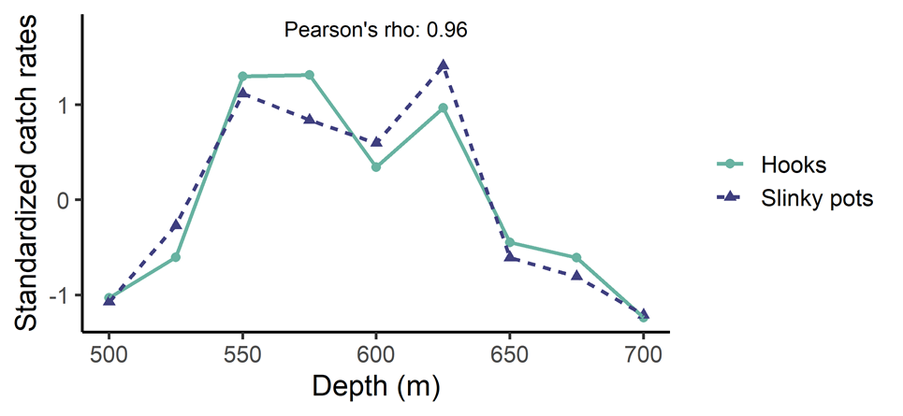
We found that pots caught smaller fish on average than hook-and-line gear, which we attributed to closing the escape rings. In particular, when small (<50 cm) sablefish were present, they were captured at a higher frequency in the pot gear compared to the hook-and-line gear (figure below). In contrast, when we fished four 3.5” escape rings in the pots during last year’s experiment, we found no difference between the average fish size caught between the two gear types.

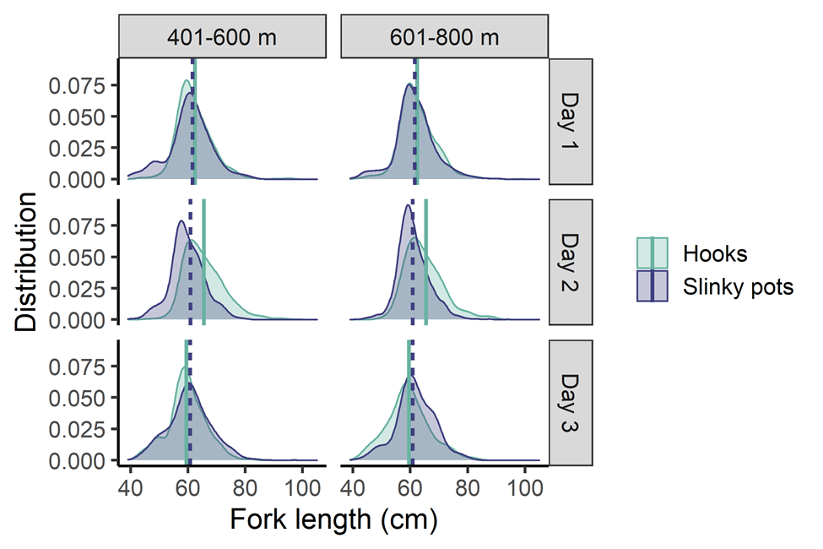
For more information about the 2021 slinky pot experiment, please check out our report online:
https://repository.library.noaa.gov/view/noaa/39401.
For questions about our slinky pot experiments, or to chat about your experience with slinky pot fishing, please contact Jane Sullivan, ABL, at 907 789-6000 or jane.sullivan@noaa.gov.

Groundfish Tag Program – ABL

ABL marine Ecology and Stock Assessment staff continued to process groundfish tag recoveries and administration of this longstanding tag reward program and the AFSC Groundfish Tag Database during 2022. While sablefish is the primary species tagged, tags from shortspine thornyheads (SST), Greenland turbot, Pacific sleeper sharks, lingcod, spiny dogfish, Pacific cod, Pacific ocean perch, and rougheye rockfish are also maintained in the database. Total tag recoveries for the year were ~450 sablefish and 14 SST. Of these recovered tags, approximately 2% were recovered by trawl gear, 35% by pot gear, and 63% by hook and line. Twenty one percent of the recovered sablefish tags in 2022 were at liberty for over 10 years. Approximately 40% of the total 2022 recoveries were recovered within 100 nautical miles from their release location, 29% within 100 – 500 nm, 21% within 500 – 1,000 nm, and 10% were recovered over 1,000 nm from their release location. The longest time a sablefish was at liberty was approximately 42 years (15,186 days), and the greatest distance traveled by a sablefish recaptured in 2022 was 1,873 nm. This fish was tagged in the Aleutian Islands on 6/8/2018 and recovered off the Washington coast on 4/3/2022. Two adult sablefish and one SST tagged with archival tags were recovered in 2022. Releases in 2022 on the AFSC groundfish longline survey totaled 5,422 adult sablefish, 433 shortspine thornyhead, and 3 Greenland turbot. An additional 193 juvenile (age-1) sablefish were tagged during one juvenile sablefish tagging cruise in inside waters in southeast Alaska in 2022.

The AFSC groundfish tag website is now available! On this site, you are able to view fish movement by species, area, year, or simply type in a specific tag number. There are also a number of tables and figures for viewing these data. All data displayed have been modified to meet confidentiality requirements. https://www.fisheries.noaa.gov/resource/map/alaska-groundfish-tagging-map
For more information, contact Katy Echave at (907) 789-6006 or katy.echave@noaa.gov.

Juvenile Sablefish Studies – ABL

Juvenile (age-1) sablefish tagging studies have been conducted by the Auke Bay Laboratories in Alaska since 1984 and were continued in 2022. One hundred and ninety three juvenile sablefish were tagged in St. John Baptist Bay near Sitka, AK during three days (August 29, 30, and 31) of sampling. The average length of fish was 360 mm.

For more information, contact Katy Echave at (907) 789-6006 or katy.echave@noaa.gov.

Ontogenetic Shifts in Sablefish Diet – ABL

In 2022, we continued to evaluate using a cross section of sablefish eye lenses to isotopically track ontogenetic shifts in diets and foraging habitats of sablefish through growth and development from pelagic juvenile life stages to benthic adults. Fish used in this study are collected during the AFSC longline surveys. In 2022, we initiated a laboratory study to experimentally test thresholds for detecting diet-derived isotopic shifts and trophic enrichment in cross sections of sablefish eye lenses. This study involves using live sablefish caught as juveniles in Southeast Alaska and rearing them in the ABL wet lab using experimentally controlled diets.
For more information contact Todd Miller, ABL, todd.miller@noaa.gov and Mariela Brooks, ABL, mariela.brooks@noaa.gov.

Young of the Year Sablefish Feeding Ecology and Growth – ABL
As part of a PhD project at the University of Alaska Fairbanks, young of the year sablefish from 1995-2019 are being analyzed for their growth, diet, trophic level, and hatch date. The primary objectives are to 1) develop a method to reconstruct the first year of growth from using daily growth rings in lapulus otoliths, 2) relate growth to temperature and rations, 3) describe a time series of trophic ecology in the Gulf of Alaska using diet and stable isotopes, 4) relate trophic ecology to environmental conditions, 5) evaluate growth as it relates to the switch to piscivory, and 6) utilize growth, hatch date, trophic ecology, environmental conditions, to predict age-2 recruitment for the sablefish assessment.
Contact wes.strasburger@noaa.gov with questions.

Sablefish Point of No Return Studies – RPP

The goal of our research funded by the North Pacific Research Board is to examine factors that may influence recruitment in Sablefish, particularly focusing on prey availability and temperature. During year 1, we focused on starvation resiliency of first feeding Sablefish larvae to low prey conditions at 6°C, an average springtime sea surface temperature in the western Gulf of Alaska. Our rearing work was initially delayed by the lack of spawning individuals at the Manchester Seawater Laboratory (NWFSC) and was, ultimately, unsuccessful due to low egg survivorship for the starvation resiliency experiments. However, we did have some success because our partners in the Fisheries Behavioral and Ecology Program also obtained Sablefish eggs and were able to test tank configurations to determine how best to proceed for year 2 temperature experiments.

For more information, contact Ali Deary at 518-366-6703 or alison.deary@noaa.gov

Stock Assessment

Sablefish in the Bering Sea, Aleutian Islands, and Gulf of Alaska – ABL

No changes to the assessment model were implemented for the 2022 Alaskan sablefish (Anoplopoma fimbria) Stock Assessment and Fishery Evaluation (SAFE) Report. New data included in the assessment model were relative abundance and length data from the 2022 longline survey, length data from the fixed gear fishery for 2021, length data from the trawl fisheries for 2021, age data from the longline survey and fixed gear fishery for 2021, updated catch for 2021, and projected 2022 – 2024 catches. A NMFS Gulf of Alaska bottom trawl survey did not occur in 2022, but associated relative abundance indices and length data for the Gulf of Alaska in waters less than 500m were included in the assessment for previous years, when a trawl survey occurred. Fixed gear fishery catch-per-unit effort (CPUE) data from logbooks for 2020 and 2021 were available for the first time during the 2022 assessment, which enabled developing and integrating a complete CPUE index of abundance. Models used to estimate fishery whale depredation were rerun with new data, providing updated estimates for the first time since 2017, and the updated estimates were used to project depredation for 2022–2024. Data weighting within the assessment was also updated using the Francis approach to ensure appropriate weights for all data sources given the updated data inputs.
The longline survey abundance index (relative population numbers, RPNs) increased 17% from 2021 to 2022 following a 9% increase from 2020 to 2021. Similarly, the trawl survey biomass index has increased nearly five-fold since 2013, including a 40% increase from 2019 to 2021. The age and length composition data continue to indicate strong recent year classes in 2014, 2016, 2017, 2018, and 2019. Based on the strength of these recent year classes, age-2+ biomass has almost tripled from a time series low of 228,000 t in 2015 to 665,000 t in 2022, sablefish population levels have not been estimated to be this large since the early 1970s. Although growth in SSB has lagged compared to total biomass, given that recent year classes are not fully mature, SSB has still increased by 60% from the time series low of 84,000 t in 2017 to 134,000 t in 2022. The updated point estimate of B_{40%}, is 122,238 t. Thus, the current SSB is at 44% of the unfished SSB (i.e., SSB₀) in 2022, while projected female spawning biomass (combined areas) for 2023 is 159,788 t (i.e., equivalent to B_{52%}). The maximum permissible 2023 ABC (combined areas) based on the NPFMC harvest control rule is 40,861 t. After accounting for whale depredation in the fishery, the whale adjusted ABC for 2023 is 40,502 t. The recommended 2023 ABC represents a 17% increase from the 2022 ABC, and a quadrupling of the quota since 2016, when the lowest ABC on record (11,795 t) was enacted.
It is necessary to apportion the total ABC to management regions because a single area stock assessment model is utilized. Based on biological rationale, the NPFMC SSC adopted a five-year average survey apportionment method in 2020, which uses a five-year moving average of the longline survey proportions of biomass in each region to apportion the Alaska-wide ABC to each management region. This method tracks biomass across management regions to the best of our current ability (i.e., by using estimates of regional biomass from the yearly longline survey that targets sablefish in prime adult habitat), while still buffering against variability caused by annual measurement error. The SSC also instituted a four-year stair step approach to move from the fixed apportionment used prior to 2020 towards the five-year average survey apportionment. In 2022, a 75% stair step from the 2020 fixed apportionment values towards the 2022 five-year average survey apportionment values was implemented.
Estimation uncertainty remains large for recent year classes, but continued high productivity over the last decade is evident. Yet, the lack of sablefish greater than 10 years of age (i.e., the age when sablefish are greater than 90% mature) remains concerning for such an extremely long-lived species and needs to be carefully monitored. As recent year classes grow towards full maturity, the population age structure is beginning to expand. It is important that each of these cohorts can survive in large numbers to fully mature ages to ensure long-term productivity.

For more information contact Dan Goethel (daniel.goethel@noaa.gov).

Sablefish Spatial Dynamics and Harvest Strategies – ABL

The projected maximum AK-wide sablefish ABC would represent the third largest catch on record, coinciding with the extreme catch levels of the early 1970s. Following the high catches during the 1970s and associated periods of poor recruitment, biomass and SSB declined rapidly. However, the ABC has not been fully harvested in recent years, which may provide an additional precautionary buffer for the sablefish population. Moreover, given concerns regarding the contracted age structure, alternate metrics of spawning potential, which better emphasize fully mature age classes (e.g., the biomass of ages > 10), could help maintain a stronger spawning portfolio as recent cohorts mature. Maintaining a diverse spawning portfolio would help improve the resilience of the sablefish resource. Similarly, given that sablefish are such a long-lived species along with the cyclic nature of sablefish dynamics, with historically rare, large recruitment events, exploration of a capped (i.e., implementing a maximum cap on the ABC) management procedure (or an ‘inventory’ management strategy) for sablefish may be worthwhile. Compared to using a maximum yearly catch strategy, capped HCRs could aid in stabilizing long-term sablefish dynamics (i.e., help to prevent long-term cyclical declines as the resource transitions between high and low recruitment regimes). Development has begun on a closed-loop simulation framework based on sablefish, which will explore alternate SSB metrics and harvest strategies. Similarly, better understanding spatial dynamics of sablefish and developing management region-specific estimates of exploitation could be beneficial for monitoring the potential for localized depletion across the Alaska region. A post-doctoral researcher (Craig Marsh) has begun work on a spatially-explicit assessment model for Alaskan sablefish, which estimates regional productivity, movement across the spatial domain, and estimates population status within each management unit. Results of the spatial model will be utilized as a companion to the single region assessment in coming years and demonstrates promise as a potential management tool in the future.

Lingcod

There are no federally-managed lingcod fisheries in Alaska waters. Recreational and small-scale commercial fisheries are managed by the Alaska Department of Fish & Game.

Atka Mackerel

Research

Condition and Diet – ABL

In 2022, we assessed the condition and diets of juvenile groundfish including walleye pollock, Pacific cod, and Atka mackerel during fall in the northern and southeastern Bering Sea. Annual changes in juvenile body condition can affect survival and recruitment, with particular attention on fall condition and over-winter survival effects.
For more information contact Rob Suryan, ABL, rob.suryan@noaa.gov.

Stock Assessment

Bering Sea and Aleutian Islands – REFM

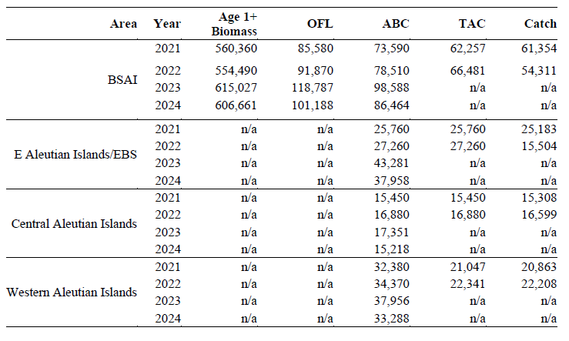The BSAI Atka mackerel assessment uses the Assessment Model for Alaska (AMAK), a statistical catch-at-age-model. No changes to the base model were made this year. The assessment methodology remained unchanged in 2022. Data updates included the final 2021 catch data were and an estimate of total catch for 2002 was assumed equal to the total allowable catch (TAC, 66,481 t). The 2021 fishery age composition data were also included in the assessment model. An important assumption made when setting the ABC and OFL values was that approximately 85% of the BSAI-wide ABC will be taken under the revised Steller Sea Lion Reasonable and Prudent Alternatives (SSL RPAs), which was implemented in 2015. This percentage was applied to the 2023 and 2024 maximum permissible ABCs, and those reduced amounts were assumed to be caught in order to estimate the 2023 and 2024 ABCs and OFL values.
For more information, contact Sandra.Lowe@noaa.gov.

Gulf of Alaska – REFM

Year | Biomass | OFL | ABC | TAC | Catch
2021 |  | 6,200 | 4,700 | 3,000 | 939
2022 |  | 6,200 | 4,700 | 3,000 | 880
2023 |  | 6,200 | 4,700
2024 |  | 6,200 | 4,700

In accordance with the approved schedule, no assessment was conducted for Atka mackerel this year. However, a full stock assessment will be conducted in 2023. Until then, the values generated from the previous stock assessment (https://apps-afsc.fisheries.noaa.gov/refm/docs/2021/GOAatka.pdf) will be rolled over for 2023 specifications.

For more information, contact Sandra.Lowe@noaa.gov.

Flatfish

Research

Assessment

Yellowfin sole – Bering Sea and Aleutian Islands – REFM

Area | Year | Age 6+ Biomass | OFL | ABC | TAC | Catch
BSAI | 2021 | 2,755,870 | 341,571 | 313,477 | 200,000 | 108,788
 | 2022 | 2,479,370 | 377,071 | 354,014 | 250,000 | 149,869
 | 2023 | 3,321,640 | 404,882 | 378,499 | n/a | n/a
 | 2024 | 4,062,230 | 495,155 | 462,890 | n/a | n/a

The EBS yellowfin sole fishery is the largest flatfish fishery in the world. This stock is assessed using an age-structured population dynamics model implemented in the software program AD Model Builder. Survey catchability (q) has been shown to be linked to bottom water temperatures, so in the model q is estimated as a function of an included bottom temperature index. Three models were presented in 2022. Model 18.2 was the accepted model in 2021 and retained natural mortality fixed at 0.12 while allowing the model to estimate male natural mortality. Model 22.0 is the same as Model 18.2 except a single-sex survey selectivity was used rather than a separate survey selectivity for males and females. Model 22.1 is the same as Model 22.0 except that the survey index data and age compositions (1982-2022) are based on model-based indices (VAST) for the combined Northern Bering Sea and eastern Bering Sea survey region. Model 22.1 was used for setting 2023 and 2024 harvest specifications.

For further information contact Ingrid Spies, Ingrid.spies@noaa.gov

Greenland turbot – Bering Sea and Aleutian Islands – REFM

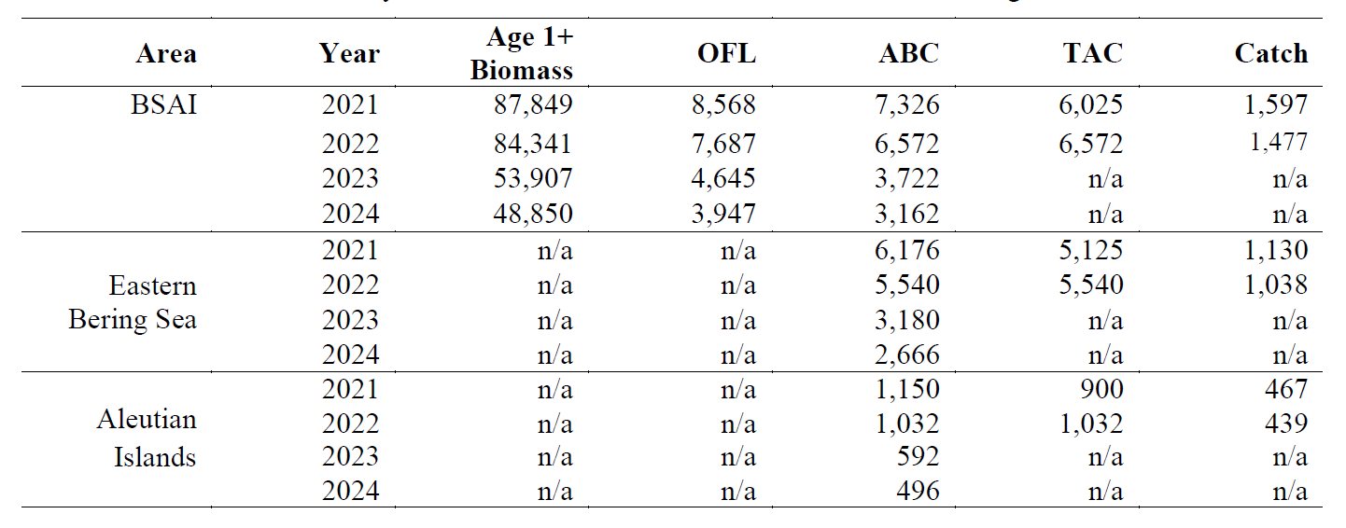
The Greenland turbot assessment model has been developed in Stock Synthesis 3 and uses fishery catch and length composition data, survey biomass and length composition from the EBS shelf (1991-2019, 2021-2022) and slope bottom trawl surveys. Mean size at age from the EBS shelf bottom trawl survey is also included in the model. Lastly, the relative population numbers and length data from the AFSC longline survey are included in the model.

The projected 2023 female spawning biomass is 33,554 t, which is a 29% decrease from last year’s 2023 projection of 47,376 t. This decrease is due to declining survey biomass in the EBS shelf and improved model fits to the AFSC longline survey relative population numbers in recent years. Exploitation rates are generally low (less than 5% since 2013), and catches are generally well below TACs. Between 2018-2021, an average of 40% of the TAC and 23% of ABC was caught in the fishery. Female spawning biomass is projected to decrease slightly to 30,484 t in 2024. The 2007-2009 recruitment classes appear to be fully integrated into the fishery, and overall, the stock is continuing its downward trend from the last several years. The 2022 EBS shelf survey showed a 26% reduction in survey biomass from the 2021 survey.

For further information contact Meaghan Bryan, Meaghan.bryan@noaa.gov

Arrowtooth flounder – Bering Sea and Aleutian Islands – REFM

Area | Year | Age 1+ Bio | OFL | ABC | TAC | Catch
BSAI | 2021 | 923,646 | 90,873 | 77,349 | 15,000 | 9,014
 | 2022 | 921,690 | 94,445 | 80,389 | 20,000 | 7,626
 | 2023 | 929,274 | 98,787 | 83,852 | n/a | n/a
 | 2024 | 919,797 | 103,070 | 87,511 | n/a | n/a

The Bering Sea and Aleutian Islands (BSAI) arrowtooth flounder stock is assessed using a statistical age-structured model. New data for this year included estimates of catch through
October 14, 2022, updated and new fishery size compositions, new survey biomass point estimates and associated standard errors, age and size data for the eastern Bering Sea shelf bottom trawl survey, and new age data from the eastern Bering Sea shelf bottom trawl survey.

There were no changes in the assessment methodology in 2022. Overall, this stock increased steadily from 1985 to 2009, dipped slightly until 2017 and then increased to current levels that are similar to the 2009 time series peak. The projected age 1+ total biomass for 2023 is 929,274 t, which is a slight decrease from the 914,915 t projected for 2023 in last year’s assessment. The projected female spawning biomass for 2023 is 514,577 t, which is a slight decrease from last year’s 2023 estimate of 528,725 t. The authors recommend setting FABC at the F40% level, which is the maximum permissible level under Tier 3a, resulting in 2023 and 2024 ABCs of 83,852 t and 87,511 t, respectively. Projected harvesting at F35% (0.174) gives 2023 and 2024 OFLs of 98,787 t and 103,070 t respectively. Arrowtooth flounder is a lightly exploited stock in the BSAI. Arrowtooth flounder is not being subjected to overfishing, is not overfished, and is not approaching an overfished condition.

For more information, contact Kalei Shotwell, kalei.shotwell@noaa.gov.

Arrowtooth flounder – Gulf of Alaska – REFM

Year | age-1+ Biomass | OFL | ABC | TAC | Catch
2021 | 1,321,700 | 151,723 | 126,970 | 97,372 | 9,984
2022 | 1,268,140 | 143,100 | 119,779 | 96,501 | 11,456
2023 | 1,265,950 | 142,749 | 119,485
2024 | 141,008 | 118,015

Arrowtooth flounder are assessed on a biennial schedule to coincide with the timing of survey data. The last assessment was presented in 2021. This off-cycle (even) year partial assessment consisted of an executive summary with recent fishery catch and survey trends as well as recommend harvest levels for the next two years. There were no changes to the assessment methodology.

The SSB projection for age 1+ for this stock is expected to be between 1.268 and 1.269M t during 2022-2024. There has been a 16% decrease in the longline survey, which is below the long-term average. Catch / biomass has increased 22% from last year but the resulting value is still among the lowest in the time series.

For more information, contact Kalei Shotwell, kalei.shotwell@noaa.gov.

Kamchatka flounder – Bering Sea and Aleutian Islands – REFM

Area | Year | Age 2+ Biomass | OFL | ABC | TAC | Catch
BSAI | 2021 | 144,671 | 10,630 | 8,982 | 8,982 | 6,561
 | 2022 | 143,983 | 10,903 | 9,214 | 9,214
 | 2023 | 121,977 | 8,946 | 7,579 | n/a | n/a
 | 2024 | 118,713 | 8,776 | 7,435 | n/a | n/a

Before 2011, Kamchatka flounder and arrowtooth flounder were managed in aggregate as a single stock. Due to the emergence of a directed Kamchatka flounder fishery and concerns about overharvesting, the stocks were separated in 2011. The BSAI Kamchatka flounder assessment is conducted in even years using a statistical age-structured model. Data inputs include fishery catch data and length composition, EBS shelf and Aleutian Islands bottom trawl survey biomass estimates and standard error and length composition, and an age-length transition matrix using the length and age specimen data from the EBS shelf and Aleutian Islands bottom trawl surveys.

The projected 2023 female spawning biomass is 47,877 t, above the B40% level of 37,748 t, and spawning biomass is projected to remain above B40% for the foreseeable future. The decreasing biomass and biomass trend scaling lower than the 2020 assessment correspond to fitting a lower survey biomass. The addition of the new survey data does result in an overall decrease in the spawning stock biomass, total biomass, numbers, and age-2 recruits trends through time, particularly after 2010.

Kamchatka flounder is not being subjected to overfishing, is not overfished, and is not approaching an overfished condition.

Northern rock sole – Bering Sea and Aleutian Islands – REFM

Area | Year | Age 6+ Biomass | OFL | ABC | TAC | Catch
BSAI | 2021 | 923,197 | 145,180 | 140,306 | 54,500 | 14,393
 | 2022 | 1,361,360 | 214,084 | 206,896 | 66,000 | 18,242
 | 2023 | 941,359 | 166,034 | 121,719 | n/a | n/a
 | 2024 | 1,111,320 | 196,011 | 119,969 | n/a | n/a

The vast majority of rock sole in the BSAI region is northern rock sole, and it is managed as a single stock. The stock is assessed biennially using an age-structured population dynamics model implemented in the software program AD Model Builder. No changes were made to the assessment methodology in the accepted model. However, two alternative models were used, but only as a method for deriving the reductions from maxABC. Changes to the input data include 2022 catch biomass through October 10, 2022, and 2021 catches, 2020 catch biomass was updated to reflect October – December 2020 catches, 2020-2021 fishery age composition data were added to the model, 2020-2021 survey age composition data were added to the model, and 2021-2022 Eastern Bering Sea (EBS) shelf survey biomass was added to the model

Spawning biomass was at a low in 2008, increased through the early 2010s, steadily decreased from 2015-2020, and models indicate steady decline. Recruitment was maintained at near historic lows for several years straight in the mid-2010s. More recently a pulse of recruits has begun to show up in the surveys including a strong 2020-year class; however, there was uncertainty regarding the true strength of this year class. The stock assessment model projects a 2023 female spawning biomass of 260,887 t, an 18.6% decrease from the previous 2023 female spawning biomass estimate of 320,399 t. The projected spawning biomass for 2024 is 291,774 t. Exploitation rates are relatively low and recent catches have typically been well below TAC’s.

For further information contact Carey McGilliard, carey.mcgilliard@noaa.gov

Northern and southern rock sole – Gulf of Alaska – REFM

Northern and southern rock sole in the GOA are managed as part of the shallow-water flatfish complex and assessments are conducted every four years. This year was a partial assessment for this stock. More details are given in the shallow-water flatfish description.

For further information contact Meaghan Bryan, meaghan.bryan@noaa.gov

Flathead sole – Bering Sea and Aleutian Islands – REFM

Area | Year | Age 3+Biomass | OFL | ABC | TAC | Catch
BSAI | 2021 | 602,497 | 75,863 | 62,567 | 25,000 | 10,259
 | 2022 | 608,631 | 77,967 | 64,288 | 35,500 | 14,559
 | 2023 | 606,522 | 79,256 | 65,344 | n/a | n/a
 | 2024 | 606,080 | 81,167 | 66,927 | n/a | n/a

In 2018, the BSAI flathead sole assessment was transitioned to the Stock Synthesis modeling platform. This assessment was changed to a biennial cycle beginning with the 2014 assessment. This was supposed to be a full assessment year, but due to limited staff resources, a partial assessment was presented this year. Changes to the input data in this analysis include updated catch information for 2021 and estimated catches for 2022 and 2023-2024. There were no changes to the assessment methodology.

Spawning biomass is projected to increase slightly in 202 and in 2024. Age 3+ biomass is also projected to have small decreases in 2023 and 2024.

For further information contact Maia Kapur, maia.kapur@noaa.gov

Flathead sole – Gulf of Alaska – REFM

This assessment is conducted using Stock Synthesis on a four-year schedule. The flathead sole stock is assessed on a four-year schedule. Due to limited staff resources, the full stock assessment planned for last year was postponed until this year.

For further information contact Maia Kapur, maia.kapur@noaa.gov

Alaska plaice – Bering Sea and Aleutian Islands – REFM

Area | Year | Age 3 + Biomass | OFL | ABC | TAC | Catch
BSAI | 2020 | 428,800 | 37,600 | 31,600 | 17,000 | 20,078
 | 2021 | 427,587 | 37,924 | 31,657 | 24,500 | 15,653
 | 2022 | 442,946 | 40,823 | 33,946 | n/a | n/a
 | 2023 | 454,030 | 43,328 | 36,021 | n/a | n/a

Alaska plaice are assessed biennially using an age-structured population dynamics model implemented in the software program AD Model Builder. Changes to the assessment model were not made in 2022. Changes to the input data included updated catch data through 2020, estimated catch for 2021, projected catches for 2022-2023, 2021 eastern Bering Sea (EBS) trawl survey biomass estimates and standard errors (no survey in 2020 due to COVID-19), 2019 survey ages (no otoliths collected in 2020 due to no survey), and 2019 and 2020 fishery length compositions.

The survey biomass estimate for 2021 (333,830 t) was 9% lower than the 2019 estimate and is the lowest value in the survey time series. Similarly, model estimates of female spawning biomass (158,090 t in 2021) continued their decline since 2013. In contrast, model estimates of total biomass (455,187 t in 2021) show an increasing trend since 2019. These results are likely due to estimates of relatively strong recruitment since 2017, a pattern which began to emerge in the 2019 assessment. The Alaska plaice stock is projected to remain above the B35% level of female spawning biomass while declining over the next several years. Alaska plaice continue to be found in high abundance in the northern Bering Sea (NBS) and the 2021 NBS estimate (344,578 t) exceeded the EBS estimate for the first time.

Alaska plaice is not being subjected to overfishing, is not overfished, and is not approaching an overfished condition.

For further information contact Sandra Lowe, sandra.lowe@noaa.gov

Rex sole – Gulf of Alaska – REFM

Year | age-3+ Biomass | OFL | ABC | TAC | Catch
2021 | 101,244 | 18,779 | 15,416 | 15,416 | 301
2022 | 124,543 | 23,302 | 19,141 | 19,141 | 694
2023 | 127,297 | 25,135 | 20,664
2024 |  | 25,652 | 21,097

This stock is on a four-year cycle and a full assessment was conducted in 2021. This year a partial assessment was presented. The projection model was run using updated catches. The 2022 spawning biomass estimate increased slightly from 2021 and projected to slightly increase through 2023.

Gulf of Alaska rex sole is not being subjected to overfishing and is neither overfished nor approaching an overfished condition. Catches are below TACs and below levels where overfishing would be a concern.

For further information contact Carey McGilliard (206) 526-4696

“Other flatfish” complex – Bering Sea and Aleutian Islands – REFM

Area | Year | Total Biomass | OFL | ABC | TAC | Catch
BSAI | 2021 | 146,679 | 22,919 | 17,189 | 6,500 | 2,638
 | 2022 | 146,679 | 22,919 | 17,189 | 10,000 | 2,550
 | 2023 | 146,679 | 22,919 | 17,189 | n/a | n/a
 | 2024 | 22,919 | 17,189 | n/a | n/a

The BSAI “Other flatfish” complex includes all flatfishes not managed individually, but the primary species by abundance are starry flounder, rex sole, longhead dab, Dover sole, and butter sole. Harvest recommendations are made using Tier 5 methods (OFL = F * biomass, where F=M; ABC = 0.75 * OFL) and are not revised during off years. The ABC and OFL are calculated separately for rex sole, Dover sole, and a single group of all remaining species; these are then aggregated to produce a single set of recommendations for the complex.

This stock is managed on a four-year cycle and 2022 was an off year. Therefore there was no update to this assessment. The last full assessment was in 2020 and the next full assessment is scheduled for 2024.

For further information contact Carey McGilliard, carey.mcgilliard@noaa.gov

Shallow-water flatfish complex – Gulf of Alaska – REFM

Year | Biomass | OFL | ABC | TAC | Catch
2021 | 342,226 | 68,841 | 56,164 | 45,263 | 1,857
2022 | 442,424 | 62,273 | 50,610 | 42,604 | 1,294
2023 | 449,607 | 65,736 | 53,537
2024 |  | 68,015 | 55,474

The GOA shallow-water flatfish complex includes northern and southern rock sole, yellowfin sole, butter sole, starry flounder, English sole, sand sole, and Alaska plaice. The complex has is on a 4-year assessment cycle.

Northern and southern rock sole are Tier 3a species and assessed separately from the other shallow water flatfish, which are Tier 5. The shallow water flatfish stock complex is on a 4-year assessment cycle; the last full assessment was completed in 2021. Separate assessment models were developed for northern and southern rock sole, and two-area models were developed for each species due to growth differences between the central and western Gulf of Alaska. The rock sole models included recent fishery catch and survey results. This year, the authors presented a partial assessment consisting of an executive summary including recent fishery catch, survey results, and recommend harvest levels for 2023 and 2024.

Harvest recommendations for the remaining species are made using Tier 5 methods (OFL = F * biomass, where F=M; ABC = 0.75 * OFL). The ABCs and OFLs for all groups are aggregated to produce recommendations for the complex.

The shallow-water flatfish complex 2023 biomass estimate is a (2%) increase from the 2022 biomass estimate. Overall, biomass for shallow water flatfish is stable. Both northern and southern rock sole biomass and spawning biomass estimates show increasing trends.

For further information contact Meaghan Bryan, meaghan.bryan@noaa.gov

Deep-water flatfish complex – Gulf of Alaska – REFM

Year | Biomass | OFL | ABC | TAC | Catch
2021 | 84,771 | 7,040 | 5,926 | 5,926 | 95
2022 | 83,131 | 7,026 | 5,908 | 5,908 | 122
2023 | 81,328 | 6,918 | 5,816
2024 |  | 6,802 | 5,719

The deepwater flatfish complex is comprised of Dover sole, Greenland turbot, Kamchatka flounder, and deepsea sole. Dover sole is the dominant species. Dover sole is assessed using Stock Synthesis, while Greenland turbot and deepsea sole recommendations are based on historical catch. The OFLs and ABCs for the individual species in the deepwater flatfish complex are determined and then summed for calculating a complex-level OFL and ABC.

A full assessment for the Gulf of Alaska deepwater flatfish complex was conducted in 2019. Projections were run in 2022 and updated numbers were used for 2023 specifications.

The model estimate of 2023 spawning stock biomass for Dover sole is 25,717 t, which is well above B40% (7,613 t). Spawning stock biomass and total biomass are expected to remain stable through 2024. Stock trends for Greenland turbot, Kamchatka flounder, and deepsea sole are unknown. The Gulf of Alaska Dover sole stock is not being subjected to overfishing and is neither overfished nor approaching an overfished condition. Information is insufficient to determine stock status relative to overfished criteria for Greenland turbot, Kamchatka flounder, and deepsea sole. Since Dover sole comprises approximately 96% of the deepwater flatfish complex they are considered the main component for determining the status of this stock complex. Catch levels for this complex remain well below the TAC and below levels where overfishing would be a concern.

Pacific halibut

Research

Abundance-based management of halibut bycatch in Alaska’s federal fisheries

The NPFMC has been actively working for several years to improve management of halibut bycatch. Following is the purpose and need statement for the Council’s current actions:

Halibut is an important resource in the Bering Sea and Aleutian Islands (BSAI), supporting commercial halibut fisheries, recreational fisheries, subsistence fisheries, and groundfish fisheries. The International Pacific Halibut Commission (IPHC) is responsible for assessing the Pacific halibut stock and establishing total annual catch limits for directed fisheries and the North Pacific Fishery Management Council (Council) is responsible for managing prohibited species catch (PSC) in U.S. commercial groundfish fisheries managed by the Council. The Amendment 80 sector is accountable for the majority of the annual halibut PSC mortality in the BSAI groundfish fisheries.

While the Amendment 80 fleet has reduced halibut mortality in recent years, continued decline in the halibut stock requires consideration of additional measures for management of halibut PSC in the Amendment 80 fisheries. When BSAI halibut abundance declines, PSC in Amendment 80 fisheries can become a larger proportion of total halibut removals in the BSAI, particularly in Area 4CDE, and can reduce the proportion of halibut available for harvest in directed halibut fisheries. The Council intends to establish an abundance-based halibut PSC management program in the BSAI for the Amendment 80 sector that meets the requirements of the Magnuson-Stevens Act, particularly to minimize halibut PSC to the extent practicable under National Standard 9 and to achieve optimum yield in the BSAI groundfish fisheries on a continuing basis under National Standard 1. The Council is considering a program that links the Amendment 80 sector PSC
limit to halibut abundance and provides incentives for the fleet to minimize halibut mortality at all times. This action could also promote conservation of the halibut stock and may provide additional
opportunities for the directed halibut fishery.

For more information please consult the NPFMC website (https://www.npfmc.org/); you may also contact Jim Ianelli at jim.ianelli@noaa.gov or Carey McGilliard at carey.mcgilliard@noaa.gov.

Other Groundfish Species

Other groundfish stocks assessed by the AFSC – REFM

In addition to the assessments described above, the AFSC assesses and provides harvest recommendations for an octopus complex in both the BSAI and GOA. These are non-target species and exploitation rates are low. In addition, the AFSC produces status reports for several species groups included in the FMPs as “Ecosystem Components”. These are stocks for which there are not active conservation concerns, but which have ecosystem roles that warrant some level of monitoring. These groups currently include grenadiers, squids, and a diverse forage fish group (the osmerids capelin and eulachon, as well as Pacific sand lance, are the main species of interest). Sculpins are also included in the FMP as Ecosystem Components but receive no reports.

Understanding transboundary stocks availability by combining multiple fisheries-independent surveys and oceanographic conditions in spatiotemporal models – RACE-GAP/HEPR/REFM
In this study, we illustrate the necessity for novel partnerships in the North Pacific when responding to climate-driven distribution shifts. We specifically develop the first-ever biomass estimate for groundfishes across the North Pacific, combining scientific fishery-independent bottom trawl data from the United States and Russia. We use three groundfish species across the Bering Sea as case studies, estimating biomass across the Bering Sea in a spatio-temporal model using the Vector Autoregressive Spatio-Temporal (VAST) model. We estimated a fishing-power correction as a catchability ratio to calibrate the disparate data sets and also estimated the impact of an annual oceanographic index, the cold pool extent index (CPI), as a covariate to explain variation in groundfish spatiotemporal density. We found that for major groundfish species included in this analysis, ‘hot spots’ or areas of high density span across the international border, particularly in warmer years when the cold pool extent is lower than the long-term average. We also found that groundfish densities increase throughout the entire Bering Sea region relative to historical densities, and all three groundfish species are shifting northward to varying degrees. The proportion of groundfish biomass found in the eastern and western sides of the Bering Sea is highly variable, but the majority of biomass was consistently found in the eastern Bering Sea until the final few years in this study. In the final year of comprehensive survey data (2017), 49%, 65%, 47% of biomass was in the western and northern Bering Sea for pollock, cod, and plaice, respectively, suggesting that availability of groundfish to the more regular eastern Bering Sea survey is declining. We conclude that International partnerships are key to tracking fish across international boundaries as they shift beyond historical survey areas. Research effort should be directed towards international collaborations to combine and calibrate past data, and to coordinate efforts in future data collection in order to fully understand biomass changes and manage shifting distribution of fish species as ocean conditions change. This work was accepted into ICES Journal of Marine Science and will be available online soon.
For further information, contact Cecilia O’Leary (cecilia.oleary@noaa.gov).

Gulf of Alaska
Establishing groundfish densities estimates in GOA untrawlable habitat with paired lowered stereo-camera system and bottom trawl data – RACE-GAP/RACE MACE/REFM/MESA
This newly funded project will collect data from untrawlable (UT) habitats using a lowered stereo-camera system (LSC) and integrate those data with existing bottom-trawl data and bathymetry maps to develop a model-based index of abundance for groundfish that includes UT habitat-specific information. Many groundfish stock assessments in the Gulf of Alaska depend on fishery-independent surveys conducted by the Groundfish Assessment Program (GAP) to provide reliable indices of abundance over time. This work will help to provide more accurate and precise indices to GOA stock assessments for select rockfish species, particularly for those species that rely on rocky habitat, tend to be longer-lived with low fecundity, and thus are particularly vulnerable to overfishing and unfavorable environmental conditions.
For further information, contact Cecilia O’Leary (cecilia.oleary@noaa.gov) or Kresimir Williams (kresimir.williams@noaa.gov).

Nearshore bathymetric changes along the Alaska Beaufort Sea coast and possible physical drivers – RACE-GAP

Erosion rates along Alaska’s Beaufort Sea coast, among the highest in the world, are negatively impacting communities, industrial and military infrastructure, and wildlife habitat. Decreasing maximal winter ice extent and increasing summer open water duration and extent in the Beaufort Sea may be making the coast more vulnerable to destructive storm waves than during recent, colder, icier decades. Previous studies of Beaufort Sea coastal change have been limited to subaerial analyses of the shoreline. Here we describe nearshore seafloor change by comparing post-World War II (WWII) (1945-53) bathymetry data to recently acquired (1985–2018) bathymetry data and relate the observed seafloor change to adjacent shoreline change near Utqiagvik, within Stefansson Sound, and immediately west of Barter Island and Kaktovik. Within the Utqiagvik region, seabed erosion was generally highest (>1.0 m of loss) offshore of Point Barrow and along the eastern end of the Tapkaluk Islands, while there were lesser amounts of deposition (<0.5 m of gain) within the protected waters of Elson Lagoon. Sedimentation was generally highest offshore of Point Barrow, in a region of converging currents, and on the landward side of the barrier islands and spits fronting Elson Lagoon, which is likely related to a regional trend of westerly sediment transport and landward migration of the barrier islands. Within Stefansson Sound, perhaps the most notable changes from post-WWII bathymetry data compared to recent data are a switch from mixed, low erosion and deposition in 1997 to low deposition (<0.5 m) in 2018 east of the Boulder Patch, a switch from low erosion in 1997 to neutral depth change in 2018 in the channel between the north and south Boulder Patch areas, and higher deposition from 1997 to 2018 landward of the rapidly retreating barrier islands along the Sound’s northern border. At Barter Island, high erosion near north-facing shorelines and high deposition near west-facing shorelines generally matched shoreline changes. One of our goals is to identify possible processes responsible for the depth changes we quantified. Using simple metrics that relate sediment characteristics with modeled waves and non-wave induced currents, we show that sediment resuspension and transport by both wave and non-wave driven currents likely contribute to the overall patterns of change within the ~13 m isobath along the open coast, and that the influence of wave action affecting sediment transport is expanding seaward.
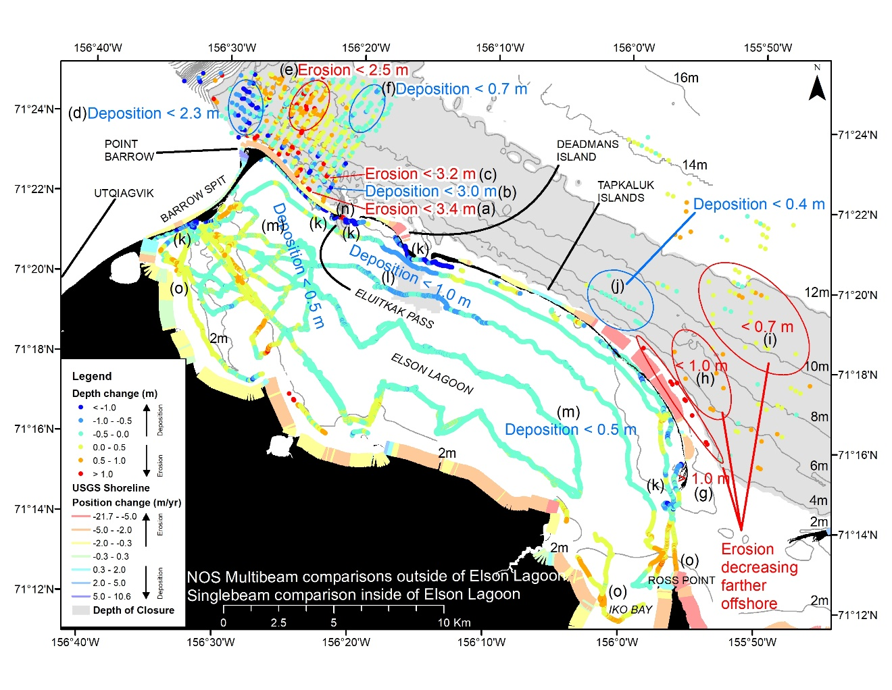

Figure 2 (example figure). Depth differences between post-World War II (1945-53) and recent (2012-15) hydrographic surveys in the Utqiagvik region. Warm colors (yellow to red) indicate erosion, whereas cool colors (teal to blue) indicate deposition. Bathymetric contours were generated from post-World War II era NOS smooth sheet bathymetry raster, shoreline change is from Gibbs and Richmond (2017), and the land is from IFSAR (Interferometric Synthetic Aperture Radar: https://elevation.alaska.gov/).

Zimmermann, M., Erikson, L.H., Gibbs, A.E., Prescott, M.M., Escarzaga, S.M., Tweedie, C.E., Kasper, J.L., and Duvoy, P.X. 2022. Nearshore bathymetric changes along the Alaska Beaufort Sea coast and possible physical drivers. Cont. Shelf Res., 242, p.104745. https://doi.org/10.1016/j.csr.2022.104745

For further information, contact Mark.Zimmermann@noaa.gov

Accounting for trophic relationships in Essential Fish Habitat designations – RACE/CICOES/ABL/EMA/EcoFOCI/AKRO
This project will seek to characterize the relationship between satellite chlorophyll a (chl-a), zooplankton, and forage fish density. We will accomplish this objective by answering 1) Do dynamic environmental conditions, such as temperature, phytoplankton concentrations, and zooplankton abundances influence the abundance and distribution of forage fish? 2) Is there spatial overlap between chl-a hotspots and forage fish hotspots? The proposed project directly addresses the Alaska Essential Fish Habitat (EFH) Research Plan’s Core EFH Research Priority 1: to characterize habitat utilization and productivity, increase the level of information available to describe and identify EFH; and Research Priority 2: apply information from EFH studies at regional scales. The outcomes from this study are intended to advance EFH for forage fish and invertebrate prey species including capelin [Mallotus villosus], herring [Clupea pallasii], age-0 walleye pollock [Gadus chalcogrammus], and large copepods. If possible based on model performance, more spatially and temporally explicit zooplankton biomass estimates from ROMS-NPZ may be incorporated into EFH models. This project has developed SDMs for three species of prey fish from BASIS survey data; next steps will include an analysis of overlap between hot spots of chlorophyll, zooplankton, and prey fish, to identify months where chlorophyll concentrations most strongly influence the late summer distributions of higher trophic levels. Our work will develop methodology for describing prey habitat and incorporating dynamic environmental covariates in species distribution models. This project involves co-PIs from CICOES, ABL, and EMA and collaborators from EcoFOCI and AKRO.
For more about this project, contact Margaret Siple (margaret.siple@noaa.gov ; RACE) or Jens Nielsen (jens.nielsen@noaa.gov ; CICOES).

Advancing Essential Fish Habitat (EFH) Species Distribution Modeling (SDM) Descriptions and Methods for North Pacific Fishery Management Plan (FMP) Species – RACE-GAP/AKR
Councils and NMFS are required to review the essential fish habitat (EFH) components of Fishery Management Plans (FMPs) and revise or amend these components based on available information at least every five years (50 CFR 600.815(a)(10)) in an EFH 5-year Review. This study demonstrates advances in EFH component 1 descriptions and identification (maps) based on refinements to the habitat-based species distribution modeling (SDM) approach to mapping EFH that was established in the 2017 EFH 5-year Review. All of the SDM ensembles constructed for FMP species in three regions in Alaska (GOA, AI, and the Bering Sea) in this present work describe and map EFH Level 2 (habitat related abundance), meeting a key objective of the EFH Research Plan for Alaska. For early juvenile life stages in the GOA, SDMs describe and map EFH Level 1 (distribution) for the first time. Another objective of the Research Plan was met by introducing maps for a subset of species with EFH Level 3 information (habitat related vital rates) for the first time. In this study, 229 new or revised EFH descriptions and maps were generated for 211 species’ life stages and 10 stock complexes available across all regions. For the majority of stocks and life stages, 2022 ensemble performance demonstrated clear improvements over the 2017 SDMs. The maps and descriptions here present the best available science to form a basis for assessing anthropogenic impacts to habitats in Alaska and are extensible to other fishery and ecosystem management information needs. This process revealed some recommendations for the next EFH review cycle, including a goal to develop methods for combining disparate data sources to expand spatial and seasonal coverage; and the goal of increasing the scope of EFH research to address rapidly changing environmental conditions in the region. These tech memos contain methodological advancements in species distribution modeling, leading to better species coverage and more robust habitat maps in the 2022 Five Year-Review. In order to make these transparent and available to other scientists and to ensure continuity in the methodology used for EFH, members of the analytical team produced a publicly available R package.
For more about this project, contact Margaret Siple (margaret.siple@noaa.gov) or Jodi Pirtle (Jodi.pirtle@noaa.gov).

Groundfish Assessment Program Systematics Lab – RACE-GAP

Several projects on the systematics of fishes of the North Pacific have been completed or were underway during 2023. Friedman recently published work in collaboration with other AFSC scientists on using phylogenetic trait imputation and spatially-varying parameters to improve modeling performance. In collaboration with researchers at the University of Texas at Austin, Friedman and Buser are finishing up work on a long-standing project examining the morphological diversity of cryptobenthic fishes across biogeographic regions. As part of another collaboration, Friedman is also continuing to advise UC Irvine graduate student Ayomikun Akinrinade, who is studying the evolution of viviparity with latitude across scorpaeniform fishes. Buser published a description of the function and evolutionary history of preopercular spines in intertidal sculpins of the North-East Pacific with collaborators at the University of Washington (UW) and Oregon State University (OSU). Buser has an ongoing collaboration on the systematics of poachers with researchers at UW and University of Kentucky, as well as a large study of the morphology and evolutionary history of the skull in sculpins and their allies with collaborators at UW, OSU, Rice University, University of Alabama, and CSU Los Angeles.

As part of an international collaboration, Friedman recently received a grant to build a global database of fish functional traits to examine the ecological, physiological, and evolutionary consequences of morphological variation. This research will be crucial in our ability to quantify, predict, and preserve marine ecosystems both in Alaska and globally. In the future, Friedman will also be examining morphological variation related to recently revealed genetic heterogeneity in Pacific Ocean Perch (Sebastes alutus) in collaboration with AFSC geneticists. Lastly, Friedman is working with GAP scientists on a trawl confidence tech memo, which will incorporate systematic and functional information on Alaskan fishes to assess the reliability of species-specific survey metrics

In 2023, Friedman and Buser thoroughly revised and automated the taxonomic database at AFSC to align with international standards set by ITIS and WORMS databases, which are already used by other NOAA centers around the country. Friedman and Buser have also begun efforts to completely revamp the field guides for fishes and invertebrates. Major updates will include taxonomy, distribution, and identification. The layout of the guides is also being revised in collaboration with AFSC Visualization Specialist Rebecca White.

Publications

Friedman, S. T., & Muñoz, M. M. (2023). A latitudinal gradient of deep-sea invasions for marine fishes. Nature Communications, 14(1), 773.

Thorson, J.,... Friedman, S.T.,...Wainwright, P.C. (2023). Identifying direct and indirect associations among traits by merging phylogenetic trait imputation and structural equation models. Methods in Ecology and Evolution.

Thorson, J., Barnes, C., Friedman, S.T., Morano, J, Siple, M. (2023). Spatially varying coefficient models can improve ecological inferences from species distribution models. Ecography.

Buser, T.J., Kee, V.E., Terry, R.C., Summers, A.P. and Sidlauskas, B.L., 2023. Taurus of the Tidepool? Inferring the Function of Cranial Weapons in Intertidal Sculpins (Pisces: Cottoidea: Oligocottinae). Ichthyology & Herpetology, 111(1), pp.98-108.

For more information about this program contact Sarah Friedman (sarah.friedman@noaa.gov) or Thaddaeus Buser (thaddaeus.buser@noaa.gov)

Sponge Identification and Genetics in the Gulf of Alaska and Aleutian Islands – RACE-GAP/NWFSC

Definitive species identification is necessary to support sustainable management of deep-sea sponge ecosystems and establish species distribution models. Previous research in the Gulf of Alaska has identified 52 taxa of sponges with an additional 38 taxa suspected of occurring in the region. In the Aleutian Islands (AI), over 125 species (or subspecies) of deep-water sponges have been identified to date, though it is estimated that several hundred additional sponge species have yet to be described in the region. The objectives of this fieldwork were to collect voucher specimens and accompanying genetic sequences for use as a reference collection, to assist in the development of a species identification guide, and to support future eDNA work proposed for the region.

Specimens were opportunistically collected during the Alaska Fisheries Science Center (AFSC) Resource Assessment and Conservation Engineering Division’s Groundfish Assessment Program’s (RACE) biennial bottom trawl survey in the AI aboard the F/V Alaska Provider (6/11-8/17/2022). The survey area extended over 1,670 km from east to west, and is composed of the continental shelf and upper slope from Islands of Four Mountains (170°W long.) to Stalemate Bank (170°E long.), including Petrel Bank (180° long.), and the northern side of the archipelago between Unimak Pass (165°W long.) and the Islands of Four Mountains (Fig. 1). During the 2022 survey, trawls were successfully conducted from the Alaska Provider at 200 stations (Figure 1).

The AI bottom trawl survey is a index survey and utilizes a stratified random design of assigning previously successful stations to vessels while occasionally adding new stations. The survey area is divided into 45 strata based on depth, major bathymetric features, and former International North Pacific Fisheries Commission (INPFC) statistical areas. Each stratum is subdivided by 5×5 km grid cells (25 km² stations) superimposed onto the stratum boundaries. Sampled depths range from nearshore areas (>15 m) to 500 m depths on the continental slope. Effort allocation among strata is determined using a Neyman optimal sampling allocation strategy based on previous survey catches, stratum variances, and ex-vessel prices for a select set of commercially landed groundfishes. The survey design and estimation methods are described in detail in the most recent AI Bottom Trawl Survey Report

The survey vessel was equipped with RACE Division Poly Nor'Eastern high-opening bottom trawl nets with rubber bobbin roller gear. Vessel position was provided by a global positioning system (GPS), and measures of water depth were provided via a recording depth profiler. Water temperature profiles were recorded every 1 to 4 seconds during most tows using a Seabird® SBE-39 bathythermograph placed on the headrope of the net.

The protocols used by the AFSC’s RACE Division for conducting bottom trawl surveys have been standardized (Stauffer 2004). Criteria for a successful tow include maintaining a continuous vessel speed of 3 knots (5.56 m/sec) while keeping the net in contact with the bottom and in fishing configuration for 15 minutes. Occasionally, tows of shorter duration were necessary to avoid obstacles or when net configuration (e.g., reduced wing spread) indicated that an exceptionally large catch was affecting the performance of the trawl.

All sponges collected for this project were assigned an AFSC/RACE voucher identification number. Specimens were photographed (Figure 2), and placed in individual plastic bags with a voucher label and preserved in 95% ethanol. In cases where only larger specimens (> 20 cm) were available, then the whole specimen was photographed and a 4” subsample containing both the ectosome and choanosome layers was retained.

After the survey, the samples will be cataloged and a subset will be selected for further analyses. Voucher specimens will be identified using morphological methods including a combination of light and scanning electron microscopy methods in consultation with Helmut Lehnert, a morphological taxonomist at GeoBio-Center LMU München. Identified specimens will be archived at the Smithsonian Institution.

DNA will be extracted from the sponges using a Qiagen DNEasy kit, following manufacturer's protocols. Extracted DNA will be sequenced for the 28s DNA barcode using standard Sanger sequencing methods. The resulting sequences will be used to create a genetic voucher collection for future use, pairing the sequences to morphological species identification whenever possible. Unique sequences that lack a clear morphological identification will be clustered into individual Operational Taxonomic Units (OTU) for future analysis. All sequences will be deposited in GenBank (https://www.ncbi.nlm.nih.gov/genbank/). These vouchers and OTUs will serve as a reference collection of sponge identifications for future eDNA work proposed in the region.

A total of 77 samples were collected during the 2022 field work. Initial screening of these samples is underway to determine which samples to send on for further analysis.

Of the samples collected in 2021, 71 have undergone morphological identification. Voucher specimens were identified using a combination of light microscopy and scanning electron microscopy methods in consultation with morphological taxonomists (Helmut Lehnert, GeoBio-Center LMU München). The 71 samples comprised 54 different species, five of which were newly described.

The 72 sub-samples were also forwarded to Meredith Everett (NWFSC-Molecular-genetics) for DNA extraction and sequencing. To date, 40 of the 72 samples have been successfully amplified and sequences have been obtained for 20 of these. An additional 20 failed to sequence due to a now solved instrument error and sequencing is underway. Troubleshooting the remaining samples which failed to amplify in the first round is ongoing.

Additional collaborators on this project are Meredith Everett, NWFSC-Molecular-genetics division (meredith.everett@noaa.gov) and Helmut Lehnert, GeoBio-Center LMU München (Lehnert@spongetaxonomics.de)

There is a feature story on NOAA Fisheries Website about the 2021 field work, which can be found here: https://www.fisheries.noaa.gov/feature-story/discovering-deep-sea-sponges-alaska

For more information contact Sean Rooney, AFSC-RACE Division (sean.rooney@noaa.gov)

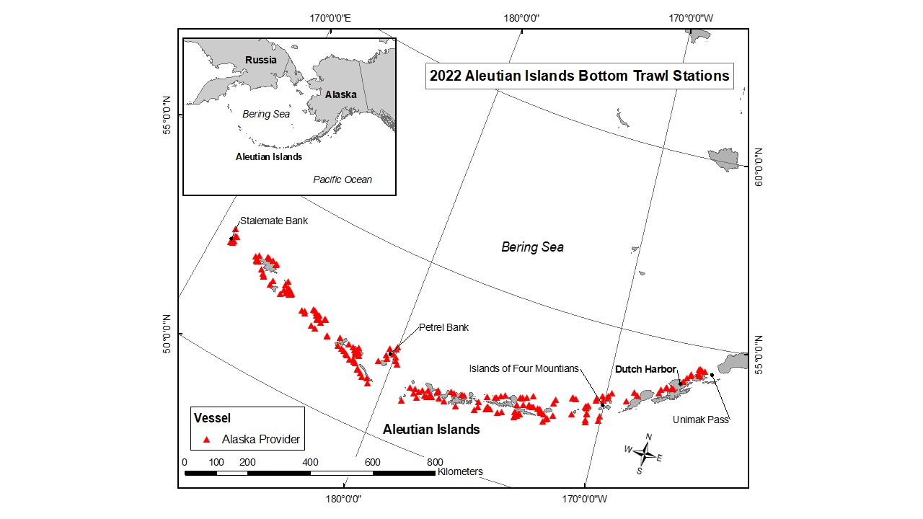
Figure 1. 2022 Aleutian Islands bottom trawl survey occupied stations.

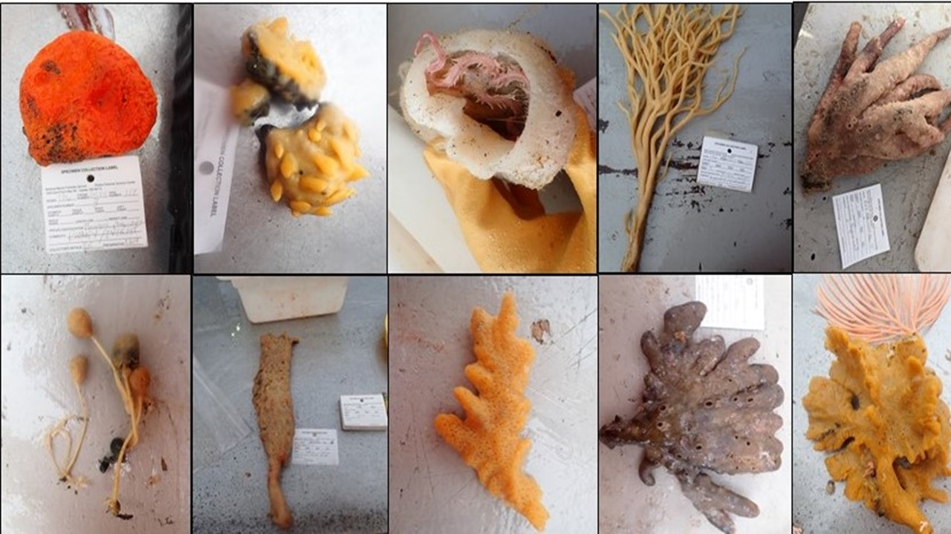

Figure 2. Example images of sponges collected in the Aleutian Islands.

Science-Industry Rockfish Research Collaboration in Alaska (SIRRCA) – RACE-GAP/APU FAST
Over time, the Alaska Fisheries Science Center (AFSC) Gulf of Alaska (GOA) bottom trawl survey has systematically identified certain habitats as untrawlable and subsequently eliminated these habitats from survey sampling (Figure 1). The label of “untrawlable” is a functional definition describing habitats that are unavailable to sample using survey gear while maintaining constant bottom contact. Rockfish can be found in both trawlable and untrawlable habitats (Zimmermann 2003), but Jones et al. (2021) found increased densities for several rockfish species (Sebastes spp.) in untrawlable habitats. There has been speculation that estimates of abundance for rockfish species in the GOA are both imprecise and inaccurate because the trawl survey is generally unable to sample in areas where many of these species are more abundant, and habitats are thus not being sampled in proportion to their importance (Rooper and Martin 2012). One potential solution to this problem is to cooperatively collect data in untrawlable habitats with partners in the fishing industry, as industry boats successfully fish many areas that are unavailable to the bottom trawl survey.
Beginning in 2020, AFSC began pursuing cooperative work with the GOA fishing industry via the Science-Industry Rockfish Research Collaboration in Alaska (SIRRCA). SIRRCA aims to develop a solution for quantifying commercial fishery catch and effort data for several rockfish species focused on adding information from untrawlable habitats through cooperative sampling of these habitats by fishery vessels, supplying valuable data to the stock assessment from areas not sampled by the survey. These cooperatively collected data will serve as a supplemental source of population abundance information and aid in understanding differences between survey and commercial gear catchability between different habitat types. Additionally, this work can inform how estimates of abundance (including the magnitude and variability) are impacted by gear deployment in trawlable versus untrawlable habitats.
SIRRCA began fieldwork aboard 2 catcher-processor vessels (F/V America’s Finest, F/V Seafisher) in 2021 concurrent with the biennial Gulf of Alaska bottom trawl survey (GOA BTS), sampling 29 calibration stations (cells defined as “trawlable” in the GOA BTS grid) and 2 experimental stations (cells defined as “untrawlable”). We had a willing third participant in the F/V Araho, but weather prevented a critical transfer and we missed our ability to collaborate. In 2022, an off-year for the GOA BTS, we conducted 6 test-tows in experimental cells aboard the Kodiak catcher vessel F/V Evie Grace. The locations of the SIRCCA pilot tows conducted in 2021 are shown in Figure 2.
SIRRCA is preparing for a third consecutive year of data collection after receiving funding support from the National Cooperative Research Program in 2021 and 2022. While previous sampling efforts were completed by Madison Hall, either alone or with an assistant, 2023 sampling will be coordinated and supervised by Madison Hall, but conducted by teams of government contracted sea samplers. These teams will be deployed as our participating vessels are ready to receive them and will likely be operating in the GOA simultaneously to the GOA BTS.
Once the 2023 SIRRCA survey commences, participating vessels can request that a team of samplers meet the vessel in Dutch Harbor, AK or Kodiak, AK. In the interest of facilitating cooperation with multiple willing partner vessels, government contracted sea samplers will accompany each vessel for one trip and then will be available to rotate to a new participating vessel. Barring other issues, SIRRCA will continue sampling until we have reached our total station goal, or until we have consumed the 100 funded at-sea sampling days.
Objectives of the 2023 SIRRCA survey include:

1. Measure the abundance (numbers), biomass (weight), and species composition of the catch, and size composition of Pacific ocean perch, northern rockfish, and dusky rockfish.

2. Calibrate SIRRCA vessel CPUE to GOA BTS CPUE by performing tows at 15 scheduled 2023 GOA BTS stations defined as “trawlable”

3. Conduct tows at 45 randomly selected GOA BTS stations currently defined as “untrawlable”

4. Record echosounder data streams from vessels during SIRRCA survey tows and record to external hard drives

Experimental Design

SIRRCA tows will be conducted at stations defined by the AFSC GOA BTS grid (5 × 5 km grid cells) and the sampling burden will be distributed among the participating 2023 vessels. Approximately 2.7% of all possible NMFS survey stations are selected for sampling in a given two-boat GOA BTS year. If SIRRCA sampled untrawlable cells at this same rate during our 2023 data collection season, we would aim to sample 45 untrawlable GOA bottom trawl survey stations (1719 [number of untrawlable stations] * 0.027 = 46.4 stations). We will also aim to sample 15 calibration stations where the GOA BTS will survey. We will complete two tows per calibration cell and one tow per experimental cell, equaling a total of 75 SIRRCA hauls for the 2023 survey. This plan is subject to changes due to individual vessel’s fishing plans or willingness to participate.

Three primary sources of information will be collected for each haul: 1) total catch weight and number, 2) species composition of catch (to then estimate species-specific catch weight and numbers), and 3) length frequencies of our target species (Pacific ocean perch, northern rockfish, and dusky rockfish). Each sea sampler team will conduct SIRRCA sampling concurrently with, but downstream from observer sampling and will not interfere with standard observer protocols. The team will collect data only on 15-minute, standard cooperative research tows, no data will be collected by our scientists during normal fishing operations. All rockfish species of interest will be sorted into baskets by species and subsampled for weights, counts and lengths. Sorting of species is performed by vessel crew, all other on deck/ factory/ wheelhouse data collection tasks are performed by SIRRCA scientists. We will subsample at least 200 lengths per species in order to match the requirements for rockfish lengths on the AFSC bottom trawl survey. We will not collect any otoliths in 2023.

For calibration tows, cells are ranked according to the number of times that cell has been successfully sampled by the survey in previous years and the historical proportion of catches from survey data for our species of interest; final calibration station selection is opportunistic but informed by this information (Figure 3). During the survey, SIRRCA scientists and the captain will collectively decide which calibration station to sample based on 1) the information in the provided maps and 2) the proximity of the station to the vessel’s normal fishing operations. For experimental tows, the industry’s normal summer fishing grounds across the Gulf of Alaska were plotted, and we eliminated (1) BTS survey strata where the industry does not regularly fish, and (2) BTS survey strata where the proportion of biomass for our target rockfish species was less than 10% (as estimated by recent BTS surveys). Finally, 45 experimental cells were selected using a stratified random design from the remaining BTS strata (Figure 4). The number of experimental stations allocated to each of these strata was directly proportional to the number of untrawlable stations in each stratum divided by the total number of untrawlable stations in all considered strata.

Lastly, SIRRCA has focused on using simulations to quantify the impact of additional information on the bias and precision of rockfish biomass estimates. Preliminary results from this study (Figure 5) indicated that a trawlable-only survey (representing current GOA BTS methods) of N=550 stations produced biomass estimates about 1/3 below the simulated population total (bias = -0.303, cv=0.219), whereas the all-habitats survey of the same size in the same seascape overestimated by less than 5% (bias = 0.035, cv=0.254). Comparing trawlable only and all habitat surveys, average CV was slightly lower in trawlable-only surveys but average bias was lower in “all-habitat” surveys. Across survey sizes, average bias for trawlable-only surveys was consistently low by around 1/3, ranging from from -0.350 to -0.283. The range in average bias for “all habitat” surveys in this seascape included 0 and was more narrow, ranging from -0.061 to 0.036. These preliminary results indicate that adding SIRRCA data from untrawlable habitats to the assessment process could make meaningful improvements for some rockfish estimates.

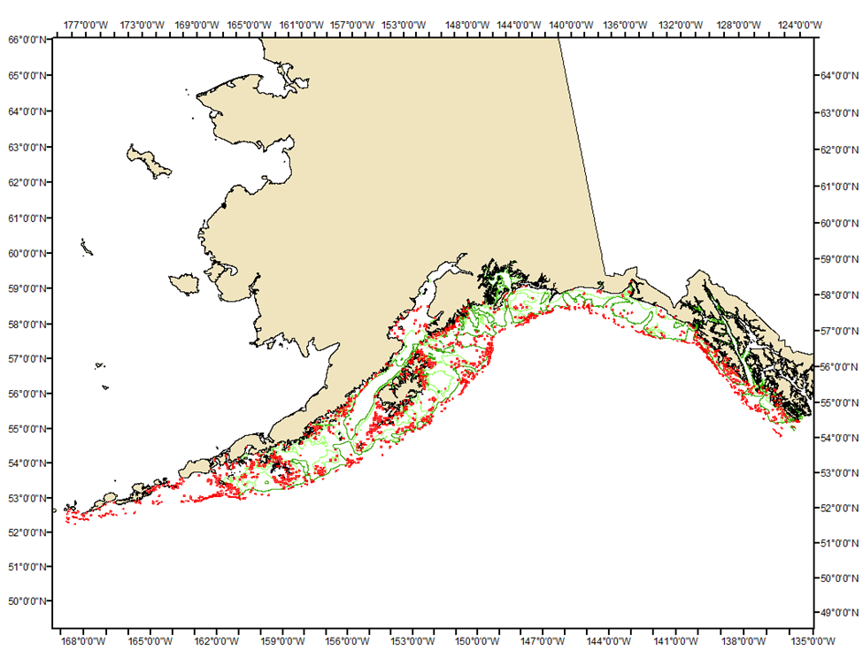
Figure 1. Locations of all potential untrawlable habitat sampling locations in the Gulf of Alaska bottom trawl survey grid (n=1788; red cells).

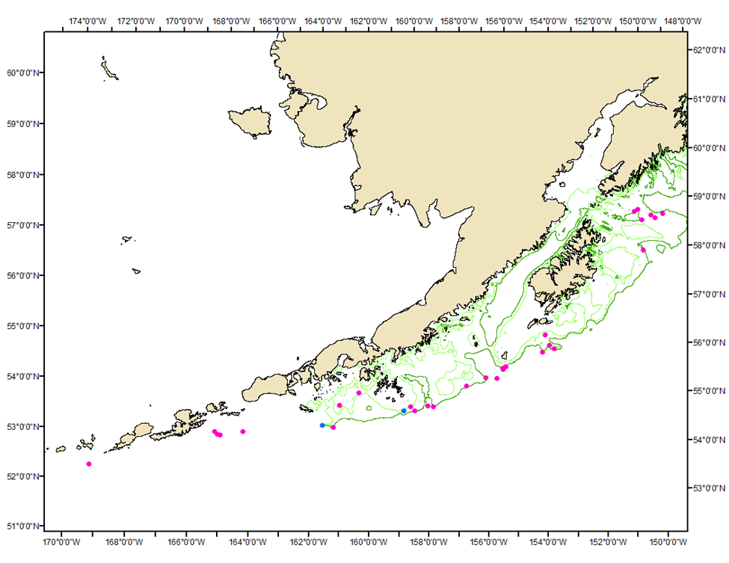
Figure 2. Locations of 30 GOA BTS stations sampled during 2021 cooperative sampling. Stations where calibration tows were conducted are shown in pink; n = 29); untrawlable stations are shown in blue (n = 2).
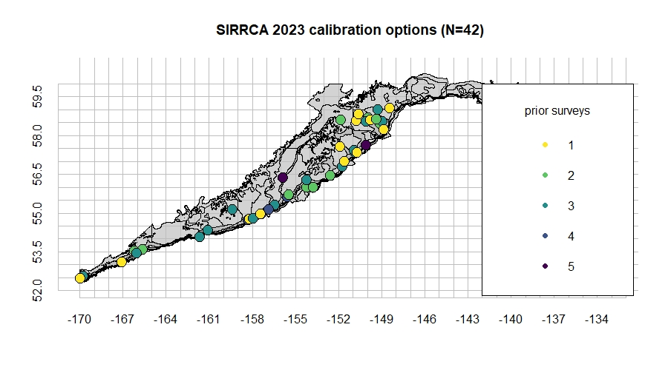
Figure 3: Top calibration station options for 2023 (n = 42) based on previous successful survey sampling efforts and high previous rockfish catches by weight. Legend displays number of previous successful survey samples.

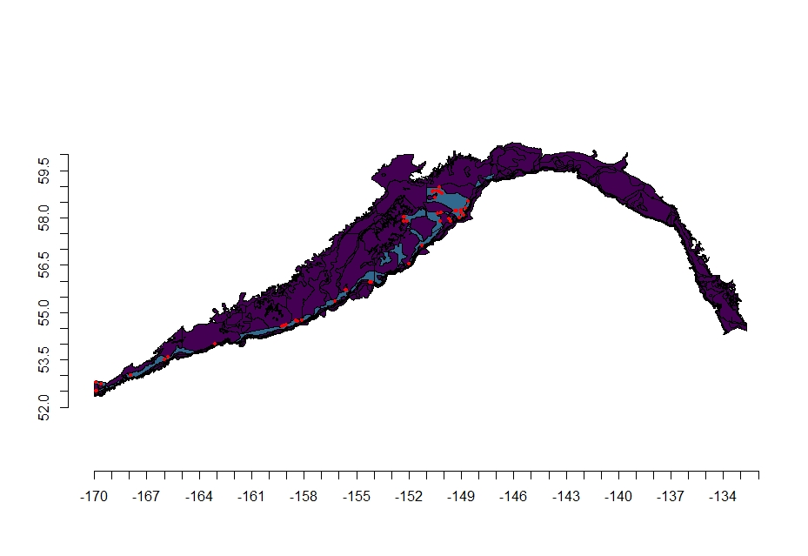
Figure 4. Locations of 2023 SIRRCA experimental survey stations. Stations within each stratum were selected by stratified random sampling and are depicted in red (n=45); the strata considered in this process are depicted in blue (n=5), whereas all other strata not considered for our 2023 untrawlable habitat survey are depicted in purple (n=54).

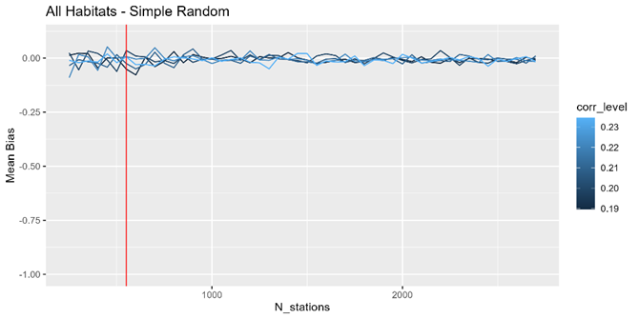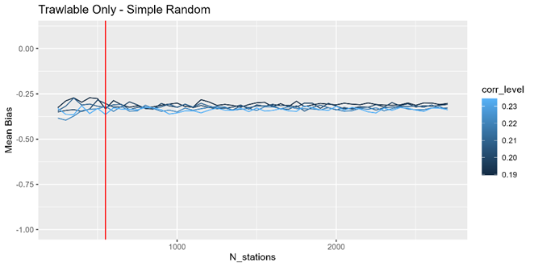
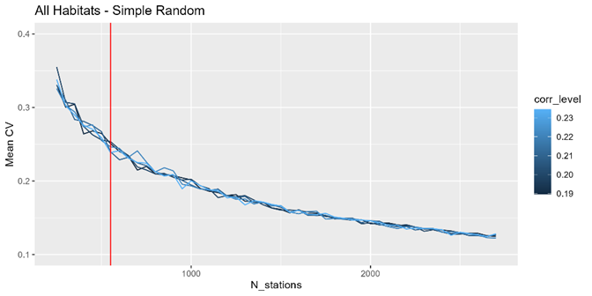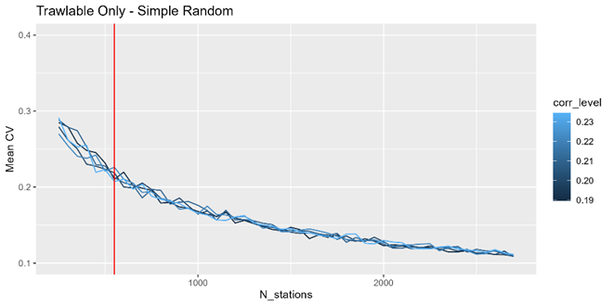
Figure 5: Mean Bias (MB) and Mean CV (MCV) in the Targeted Simulation Run. Mean bias and Mean CV were calculated across replicate surveys at each survey size (N_stations). The red line indicates n=550 stations, the standard survey effort in the biennial GOA BTS. The two left panels depict results for surveys sampling all habitats (trawlable + untrawlable), while the two right panels depict results from surveys sampling trawlable habitats only. The top right panel indicates that current methods could be underestimating northern rockfish biomass by about ⅓ (-0.350 to -0.283).
Literature Cited
Jones, D. T., C. Rooper, C. Wilson, P. Spencer, D. Hanselman, and R. Willborn (2021). "Estimates of availability and catchability for select rockfish species based on acoustic-optic surveys in the Gulf of Alaska." Fisheries Research 236: 105848.
Rooper, C. N. and M. H. Martin (2012). "Comparison of habitat-based indices of abundance with fishery-independent biomass estimates from bottom trawl surveys." Fishery Bulletin 110(1): 21-35.
Zimmermann, M. (2003). Calculation of untrawlable areas within the boundaries of a bottom trawl survey. Canadian Journal of Fisheries and Aquatic Sciences. 60: 657-669.
For more information, contact Madison Hall (madison.hall@noaa.gov) or Mark Zimmermann (mark.zimmermann@noaa.gov)

V. Ecosystem Studies

Ecosystem and Socioeconomic Profiles (ESP) – REFM

Ecosystem-based science is an important component of effective marine conservation and resource management; however, the proverbial gap remains between conducting ecosystem research and integrating with stock assessments. A main issue involves the general lack of a consistent approach to deciding when to incorporate ecosystem and socioeconomic information into a stock assessment and how to test the reliability of this information for identifying future change. Our current national system needs an efficient testing ground and communication tool in order to effectively merge the ecosystem and stock assessment disciplines.

Over the past several years, we have developed a new standardized framework termed the Ecosystem and Socioeconomic Profile or ESP that facilitates the integration of ecosystem and socioeconomic factors within the stock assessment process and acts as a proving ground for use in management advice (Shotwell et al., 2020). The ESPs are a commitment to a process that allows for creating a proactive strategy in response to change. Here we are building on the rich history of identifying ecosystem pressures on stocks in the Alaska region and designing a research template that tests these linkages for providing advice. The ESPs serve as a corollary stock-specific process to the large-scale ecosystem status reports, effectively creating a two-pronged system for ecosystem based fisheries management at the AFSC.

There are four steps to the ESP process. In the first step, we start with a focused effort to review information from national initiatives on prioritization, vulnerability, and classification and combine that with regional priorities to develop a list of priority stocks for producing ESPs. Once an ESP has been prioritized for a stock, we then move to grading a standard set of descriptive stock metrics and then evaluate ecosystem and socioeconomic processes driving stock dynamics to develop a mechanistic understanding of the drivers for the stock. This leads to defining a suite of indicators to monitoring and analyzing trends of these indicators using tests appropriate to the data availability for the stock. The process is completed with a standardized reporting template that is concise and conveys the status of the leading indicators to fisheries managers within the stock assessment cycle (Shotwell et al., In Review).

Three annual workshops planned to fine-tune the ESP framework to the needs of the AFSC have recently been completed. The first data workshop summarized the available data for use in an ESP from a large variety of programs both within and external to the AFSC. This workshop was conducted in May 2019 and results were presented at the Preview of Ecosystem and Economic Considerations (PEEC) meeting in June 2019 and at the Joint Crab and Groundfish September Plan Team 2019. The second model workshop was conducted in March 2020 through two small in-person host sites and large remote participation due to current events regarding COVID-19. The workshop presentations reviewed current progress on the ESPs as well as modeling applications to create value-added metrics or indicators for the ESPs and models to evaluate indicators for use in the ESPs and the operational stock assessments. A one-day follow-up discussion session was conducted in September 2020 to provide a short review of the presentations and engage in-group discussions that were truncated due to the largely remote participation of the workshop.

The third ESP advice workshop was conducted entirely remotely in March 2021 due to the persistence of COVID-19; however, attendance was higher than the previous two workshops. Progress on new ESPs and ESP teams were reviewed as well as presentations on data accessibility and reproducibility and a series of program updates that reviewed avenues for interfacing with the ESPs. Two evaluation gates have now been established for including indicators within an ESP (gate 1) and within a stock assessment model (gate 2). A series of presentations reviewed the types of indicators currently in ESPs and forecasting with climate enhanced single and multispecies models. Two discussion sessions included creating guideline criteria for entering the two ESP gates. The final workshop day included presentations on how the ESPs are currently used for management advice and a discussion session on interfacing more with stakeholders and the public. A one-day ESP session is now scheduled to coincide with the PEEC workshop to review new and upcoming ESPs and have discussions on further developing the ESP process both regionally and nationally.

A methods manuscript detailing the four-step ESP framework, along with technical memorandums of the workshops are planned for 2021. Additional web applications and data repository are also in development to provide access to the data and model output for use in the ESPs. These products will improve communication of the ESP framework and allow timely and consistent access to regional or stock-specific ecosystem and socioeconomic indicators for use in the ESPs. Altogether, the workshops and reports will pave a clear path toward building next generation stock assessments and increase communication and collaboration across the ecosystem, economic, and stock assessment communities at the AFSC. We plan to expand the ESPs to other regions to form a more coordinated national effort of integrating ecosystem information within our next generation stock assessments.

For more information, contact Kalei Shotwell at (907) 789-6056 or kalei.shotwell@noaa.gov.

References:

Shotwell, S.K. 2020. Update on the Ecosystem and Socioeconomic Profile (ESP) in the Alaska groundfish and crab fishery management plans. NPFMC Report. 18 p. Available online at: https://meetings.npfmc.org/CommentReview/DownloadFile?p=8f5233fb-3b62-4571-9b49-8bb7ce675916.pdf&fileName=ESP_Shotwell.pdf

Shotwell, S.K., K., Blackhart, C. Cunningham, B. Fissel, D., Hanselman, P., Lynch, and S., Zador. In Review. Introducing the Ecosystem and Socioeconomic Profile, a national framework for including stock-specific ecosystem and socioeconomic considerations within next generation stock assessments. Frontiers in Marine Science or Marine Policy (Anticipated submission 2021)

2020 Groundfish ESPs:
Shotwell, S.K., S. Barbeaux, B. Ferriss, B. Fissel, B. Laurel, and L. Rogers. 2020. Ecosystem and socioeconomic profile of the Pacific cod stock in the Gulf of Alaska. Appendix 2.1 In Barbeaux, S., B. Ferriss, W. Palsson, S.K. Shotwell, I. Spies, M. Wang, and S. Zador. 2020. Assessment of the Pacific cod stock in the Gulf of Alaska. In Stock assessment and fishery evaluation report for the groundfish resources of the Gulf of Alaska. North Pacific Fishery Mngt. Council, 605 W 4th Ave, Suite 306 Anchorage, AK 99501. Pp. 144-183. Available online: https://archive.fisheries.noaa.gov/afsc/refm/stocks/plan_team/2020/GOApcod.pdf

Shotwell, S.K., M. Dorn, A. Deary, B. Fissel, L. Rogers, and S. Zador. 2020. Ecosystem and socioeconomic profile of the walleye pollock stock in the Gulf of Alaska. Appendix 1A In Dorn, M.W., A.L. Deary, B.E. Fissel, D.T. Jones, M. Levine, A.L. McCarthy, W.A. Palsson, L.A. Rogers, S.K. Shotwell, K.A. Spalinger, K. Williams, and S.G. Zador. 2020. Assessment of the walleye pollock stock in the Gulf of Alaska. In Stock assessment and fishery evaluation report for the groundfish resources of the Gulf of Alaska. North Pacific Fishery Mngt. Council, 605 W 4th Ave, Suite 306 Anchorage, AK 99501. Pp. 104-135. Available online: https://archive.fisheries.noaa.gov/afsc/refm/stocks/plan_team/2020/GOApollock.pdf

Shotwell, S.K., D. Goethel, A. Deary, K. Echave, K. Fenske, B. Fissel, D. Hanselman, C. Lunsford, K. Siwicke, and J. Sullivan. 2020. Ecosystem and socioeconomic profile of the Sablefish stock in Alaska. Appendix 3C In D.R. Goethel, D.H., Hanselman, C.J. Rodgveller, K.H. Fenske, S.K. Shotwell, K.B. Echave, P.W. Malecha, K.A. Siwicke, and C.R. Lunsford. 2020. Assessment of the Sablefish stock in Alaska. Stock assessment and fishery evaluation report for the groundfish resources of the Bering Sea Aleutian Islands and Gulf of Alaska. North Pacific Fishery Management Council, 1007 W 3rd Ave, Suite 400 Anchorage, AK 99501. Pp. 190-218. Available online: https://archive.fisheries.noaa.gov/afsc/refm/stocks/plan_team/2020/sablefish.pdf

Shotwell, S.K., G.G. Thompson, B. Fissel, T. Hurst, B. Laurel, L. Rogers, E. Siddon. 2020. Ecosystem and socioeconomic profile of the Pacific cod stock in the Eastern Bering Sea. Appendix 2.2. In Thompson, G.G., J. Conner, S.K. Shotwell, B. Fissel, T. Hurst, B. Laurel, L. Rogers, and E. Siddon. 2020. Assessment of the Pacific cod stock in the Eastern Bering Sea. In Stock assessment and fishery evaluation report for the groundfish resources of the Bering Sea and Aleutian Islands. North Pacific Fishery Mngt. Council, 605 W 4th Ave, Suite 306 Anchorage, AK 99501. 266-310. Available online: https://archive.fisheries.noaa.gov/afsc/refm/stocks/plan_team/2020/EBSpcod.pdf

2020 Crab ESPs:
Fedewa, E., B. Garber-Yonts, K. Shotwell. 2020. Ecosystem and Socioeconomic Profile of the Bristol Bay Red King Crab stock. Appendix E. In J. Zheng and M.S.M. Siddeek. 2020. Bristol Bay Red King Crab Stock Assessment in Fall 2020. Stock assessment and fishery evaluation report for the Bering Sea/Aleutian Islands king and Tanner crabs. North Pacific Fishery Management Council, 1007 W 3rd Ave, Suite 400 Anchorage, AK 99501. 31 p. Available online: https://meetings.npfmc.org/CommentReview/DownloadFile?p=ea0403bc-6544-4241-bf8c-b9c7a8ebf17d.pdf&fileName=SAFE_2020_App_E_BBRKC_ESP_2020.pdf

Fedewa, E., B. Garber-Yonts, K. Shotwell. 2020. Ecosystem and Socioeconomic Profile of the Saint Matthew Blue King Crab stock. Appendix F. In K. Palof, J. Zheng, and J. Ianelli. 2020. Saint Matthew Island Blue King Crab Stock Assessment 2020. Stock assessment and fishery evaluation report for the Bering Sea/Aleutian Islands king and Tanner crabs. North Pacific Fishery Management Council, 1007 W 3rd Ave, Suite 400 Anchorage, AK 99501. 14 p. Available online: https://meetings.npfmc.org/CommentReview/DownloadFile?p=f82852c5-2b1f-44a3-90c8-159b269077d6.pdf&fileName=SAFE_2020_App_F_SMBKC_ESP_2020_Exec_Summ.pdf

Gulf of Alaska Climate Integrated Modeling Project – REFM and other divisions

The Gulf of Alaska ecosystem supports valuable and diverse marine fisheries and most of the human population of Alaska resides in the Gulf of Alaska region. Large changes in climate are expected in the Gulf of Alaska in the coming decades. Scientists are using an integrated modeling approach to identify factors affecting present and future ecosystem-level productivity and to assess the economic and social impacts on Gulf of Alaska fishing and subsistence communities of Climate Change. This is an interdisciplinary collaboration and a complement to a successful project developed for the eastern Bering Sea.

This multidisciplinary modeling effort applies a regional lens to global climate models. Scientists are combining regional socio-economic, oceanographic data and biological models including single-species, multispecies and ecosystem models to develop a regional multi-model (an ensemble model) to provide quantitative advice to support resource management given climate variability and long-term change. One important management application of this research is to evaluate the Optimum Yield (OY) range (160,000–800,000 t) in the Groundfish Fishery Management Plan for the Gulf of Alaska in a changing climate.

Scientists will begin to address the critical need to anticipate those changes and evaluate their impact on the ecosystem and its inhabitants. By providing near-term and long-term projections, scientists hope to help resource managers and local communities anticipate and better plan for environmental and ecological changes due to Climate Change in the Gulf of Alaska. This effort represents a substantial step towards meeting the objectives of Gulf of Alaska Climate Science Regional Action Plan and the NOAA Fisheries Climate Science Strategy. This project will examine how individuals, families, and communities adapt to climate variability and associated changes in fisheries and marine ecosystems. We will also identify the factors underlying adaptation choices, and tradeoffs associated with those adaptations.

Project activities
- Develop and apply the Atlantis model as an element of a multi-model ensemble to evaluate fisheries management strategies in a changing climate.
- Combine oceanographic modeling driven by climate projections of earth system models (ESM) with biological models including single species, multi-species, and ecosystem models. This includes the Atlantis end-to-end ecosystem model, food web models for the Gulf of Alaska (Ecopath and Ecosim) and a Gulf of Alaska multi-species (CEATTLE).
- Explore recent climate change impacts on the Gulf of Alaska social-ecological system (e.g., use the 2013-2016 marine heat wave, PDO variation, and climate projections as natural experiments to explore ecosystem-level and species-specific responses to physical forcing).
- Apply the coupled climate-biological-social multi-model ensemble to explore the implications of long-term changes in physical forcing on various management questions (e.g., current OY range in the Gulf of Alaska; implementation of catch share programs, etc.), taking into account model uncertainty.
- Evaluate performance of management strategies under climate change (e.g., estimate system-level OY for Gulf of Alaska using the multi-model ensemble)
- Evaluate and predict the impacts of major environmental anomalies to an endangered population of Steller sea lions using the 2013-2016 marine heatwave as a natural experiment.
- Model fleet dynamics and fishery landings responses to ecosystem and management change

Greater detail can be found at https://www.fisheries.noaa.gov/alaska/socioeconomics/gulf-alaska-climate-integrated-modeling-socioeconomics-climate-communities. Also , for more information please contact Martin Dorn at Martin.Dorn@noaa.gov.

Resource Ecology and Ecosystem Modeling Program – REFM/REEM

The REEM Program creates various types of statistical models that incorporate ecosystem information such as predator-prey relationships, food web relationships, diet analysis and socio-economic data that is used to inform fishery management decisions for Alaska groundfish species.

Ecosystem Status Reports 2022: the Status of Alaska’s Marine Ecosystems completed and posted online

The status of Alaska’s marine ecosystems is presented annually to the North Pacific Fishery Management Council as part of the Stock Assessment and Fishery Evaluation (SAFE) report. There are separate reports for each of four ecosystems: the eastern Bering Sea, Aleutian Islands, Gulf of Alaska, and the Arctic. In 2022, new information became available to update the reports for the eastern Bering Sea, the Aleutian Islands, and the Gulf of Alaska. The goal of these Ecosystem Status Reports (ESRs) is to provide the Council and other readers with an overview of marine ecosystems in Alaska through ecosystem assessments and by tracking time series of ecosystem indicators. This information provides ecosystem context to the fisheries managers’ deliberations. The reports are now available online at the Ecosystem Considerations website at: https://apps-afsc.fisheries.noaa.gov/refm/reem/ecoweb/index.php.

Groundfish Stomach Sample Collection and Analysis – REFM/REEM

The Resource Ecology and Ecosystem Modeling (REEM) Program continued regular collection of food habits information on key fish predators in Alaska’s marine environment. During 2022, AFSC personnel analyzed the stomach contents of 8 species sampled from the eastern Bering Sea, Gulf of Alaska and Aleutian Islands regions. The contents of 9,480 stomach samples were analyzed in the laboratory in addition to 1,726 stomach samples analyzed at sea during the Aleutian Islands groundfish survey.

Predator-Prey Interactions and Fish Ecology

The predator fish species for which we have available stomach contents data can be found at
https://apps-afsc.fisheries.noaa.gov/refm/reem/webdietdata/dietdataintro.php

Diet composition tables have been compiled for many predators and can be accessed, along with sampling location maps at https://apps-afsc.fisheries.noaa.gov/refm/reem/webdietdata/diettableintro.php.

REEM also compiles life history information for many species of fish in Alaskan waters, and this information can be located at https://apps-afsc.fisheries.noaa.gov/refm/reem/lhweb/index.php.

These data are annually updated and time series of diets are produced for use in groundfish stock assessments presented to the North Pacific Fishery Management Council, as part of either the Ecological and Socioeconomic Profile for that stock, or as a contribution to the annual Ecosystem Status Reports.

Economics and Social Sciences Research – REFM/ESSR

The Economic and Social Science Program staff provide economic and community information to resource managers, industry leaders, and other agencies. Each year, socio-economic indicators are produced as part of ecosystem status reports for the Gulf of Alaska, Aleutian Islands, Bering Sea and Arctic. These data are used to inform resource management decisions.

Summary of the 2022 Groundfish Economic SAFE Report
The Economic SAFE report contains detailed information about economic aspects of the groundfish fisheries through 2021, including figures and tables, economic performance indices, year-to-date information on volume and value, an Amendment 80 fishery economic data report (EDR) summary, an Amendment 91 fishery EDR summary, a Gulf Trawl fishery EDR summary, market profiles for the most commercially valuable species, and product price and ex-vessel price nowcast projections for 2022. Data tables are organized into four sections: (1) All Alaska, (2) BSAI, (3) GOA, and (4) Pacific halibut. The figures and tables in the report provide estimates of total groundfish catch, groundfish discards and discard rates, prohibited species catch (PSC) and PSC rates, the ex-vessel value of the groundfish catch, the ex-vessel value of the catch in other Alaska fisheries, the gross product value of the resulting groundfish seafood products, the number and sizes of vessels that participated in the groundfish fisheries off Alaska, vessel activity, and employment on at-sea processors. Generally, the data presented in this report cover 2017-2021, but limited catch and ex-vessel value data are reported for earlier years to illustrate the rapid development of the domestic groundfish fishery since the 1980s and to provide a more complete historical perspective on catch. The data behind the tables from this and past Economic SAFE reports will be available online at: https://reports. psmfc.org/akfin.
The commercial FMP groundfish fisheries off Alaska had a total catch of 2.01 million metric tons (mt) in 2021 (including catch in federal and state waters), a decrease of 4% from 2020. Groundfish accounted for 81.84 % of Alaska’s 2021 total catch. Total catches of Alaska’s FMP groundfish fisheries increased in 2021 for pollock, sablefish, and Atka mackerel, and decreased for Pacific cod, and the flatfish and rockfish species complexes.
The aggregate ex-vessel value of the FMP groundfish fisheries off Alaska was $759.57 million, which was 37.7% of the ex-vessel value of all commercial fisheries off Alaska in 2021.[1] After adjustment for inflation, the real ex-vessel value of FMP groundfish decreased $40.09 million in 2021 and the aggregate real ex-vessel price decreased 1.2% to $0.18 per pound. Nominal pollock ex-vessel prices increased 6.9% to $0.14 per pound in the Bering Sea and Aleutian Islands (BSAI), and 5.1% to $0.12 per pound in the Gulf of Alaska (GOA). Pacific cod nominal ex-vessel prices decreased 13.4% to $0.34 per pound in the BSAI, and decreased 0.5% to $0.39 per pound in the GOA. Among the other species that are the focus of the shoreside ex-vessel fisheries: The GOA flatfish ex-vessel price fell 19.8%, GOA rockfish prices were stable, and GOA sablefish prices increased 20.3% (in nominal terms). For BSAI FMP groundfish in aggregate, the change in price was larger than the change in catch, while in the GOA, prices and catch were both increasing with the change in catch the more dominant of the two. For other fisheries in Alaska, halibut, salmon, herring, and shellfish ex-vessel revenues increased.
The gross value of the 2021 groundfish catch after primary processing (first-wholesale) was $2.14 billion, a decrease of 2.5% in real terms from 2021. This change was the combined effect of a 6.5% increase in the real aggregate 2021 first-wholesale price to $1.27 per pound which was offset by aggregate production volumes decreasing 8.4% to 765.3 to thousand mt. In the BSAI, aggregate first-wholesale value decreased 3.4% and value was increasing for pollock, and sablefish but was decreasing or stable for nearly all other species including Pacific cod, rockfish, and flatfish. The average first-wholesale price for all products was increasing for most species with the exception of Atka mackerel and some flatfish species. In the GOA, aggregate first-wholesale value increased (26.1%) with increases in value for all species except for flatfish. Prices were increasing for most species with the exception of some flatfish species.
Starting in 2020, COVID-19 has had an unprecedented impact on fisheries in Alaska. Undoubtedly, one of the significant economic impacts experienced by the industry were the mitigation costs experienced by the fishing and processing industries to continue to supply national and global markets for seafood. This report does not provide a comprehensive accounting of these costs, as they are not part of our existing EDR data collections. The core economic data tables in this report focus on catch, revenues, and effort and changes occurring during the most recent year.
The first-wholesale value of Alaska’s FMP groundfish fisheries accounted for Inf% of Alaska’s total first-wholesale value from commercial fisheries. First-wholesale value of Alaska’s fisheries products other than FMP groundfish fisheries totaled $2.6 billion, most of which ($1.92 billion) came from Pacific salmon. Pacific salmon value increased 34.43%, in part, because of the typical cycle in salmon returns and production, though year-over-year prices were down. Pacific halibut fisheries, which are concentrated in the Gulf of Alaska, saw an increase of 75.2% in value in 2021 to $152.8 million as a result of substantial increases in prices and volume.
The groundfish fisheries off Alaska are an important segment of the U.S. fishing industry. In 2020, it accounted for 53.99% of the weight of total U.S. domestic landings and 17.21% of the ex-vessel value of total U.S. domestic landings (Fisheries of the United States, 2020). Alaska fisheries as a whole (including salmon, halibut, herring, and shellfish) accounted for 60.96% of the weight of total U.S. domestic landings and 33.02% of the ex-vessel value of total U.S. domestic landings.
NOAA Fisheries collects only limited data on employment in the fisheries off Alaska. The most direct measure available is the number of ‘crew weeks’ on at-sea processing vessels and catcher vessels of FMP groundfish. These data indicate that in 2021 crew weeks for both sectors totaled 107,559 with the majority of them (92,697.5) occurring in the BSAI groundfish fishery. In the BSAI, the months with the highest employment correspond with the peak of the pollock seasons in February-March and July-September. In the Gulf of Alaska, crew weeks peak February-May with the catcher vessel hook and line fisheries targeting sablefish and Pacific cod. Relative to 2020, annual crew weeks in Alaska decreased in 2021 by 10.4 %.

[1] The data required to estimate net benefits to either the participants in fisheries or the Nation, such as cost or quota value (where applicable) data, are not available. Unless otherwise noted ‘value’ should be interpreted as gross revenue.

VI – AFSC GROUNDFISH-RELATED PUBLICATIONS: PUBLICATIONS DATABASE
Published in Fiscal Year 2022

BARRY, P. D., C. M. KONDZELA, J. A. WHITTLE, J. T. WATSON, K. KARPAN, K. D’AMELIO, and W. A. LARSON. 2022. Genetic stock composition analysis of chum salmon from the prohibited species catch of the 2020 Bering Sea walleye pollock trawl fishery. U.S. Dep. Commer., NOAA Tech. Memo. NMFS-AFSC-453, 50 p. View Online.
BARRY, P. D., C. M. KONDZELA, J. A. WHITTLE, J. T. WATSON, K. KARPAN, K. D’AMELIO, and W. A. LARSON. 2022. Genetic stock composition analysis of chum salmon from the prohibited species catch of the 2021 Bering Sea walleye pollock trawl fishery. U.S. Dep. Commer., NOAA Tech. Memo. NMFS-AFSC-454, 50 p. View Online.
CAHALAN, J., and J. GASPER. 2022. The commercial size limit for the Pacific halibut fishery off Alaska and its relationship to observer-derived estimates of at-sea discard. U.S. Dep. Commer., NOAA Tech. Memo. NMFS-AFSC-432, 42 p. View Online.
DAWSON, L., A. DE ROBERTIS, K. WILLIAMS, S. KOTWICKI, L. BRITT, T. COSGROVE, S. RUSSELL, S. FURNISH, R. TOWLER, and N. YOCHUM. 2022. Construction of a remotely operated catamaran with acoustic system for observations of fish response to bottom trawls. U.S. Dep. Commer., NOAA Tech. Memo. NMFS-AFSC-435, 21 p. View Online.
FAUNCE, C., M. MOON, P. PACKER, G. CAMPBELL, M. PARK, G. LOCKHART, and N. BUTTERWORTH. 2021. The Observer Declare and Deploy System of the Alaska Fisheries Science Center. U.S. Dep. Commer., NOAA Tech. Memo. NMFS-AFSC-426, 86 p. View Online.
GANZ, P., C. FAUNCE, G. MAYHEW, S. BARBEAUX, J. GASPER, S. LOWE, and R. WEBSTER. 2022. Deployment Performance Review of the 2020 North Pacific Observer Program. U.S. Dep. Commer., NOAA Tech. Memo. NMFS-AFSC-431, 47 p. View Online.
GUTHRIE III, C. M., Hv. T. NGUYEN, K. KARPAN, and W. A. LARSON. 2021. Genetic stock composition analysis of Chinook salmon (Oncorhynchus tshawytscha) bycatch samples from the 2019 Bering Sea trawl pollock trawl fishery. U.S. Dep. Commer., NOAA Tech. Memo. NMFS-AFSC-418, 33 p. View Online.
GUTHRIE III, C. M., Hv. T. NGUYEN, K. KARPAN, and W. A. LARSON. 2021. Genetic stock composition analysis of Chinook salmon (Oncorhynchus tshawytscha) bycatch samples from the 2019 Gulf of Alaska trawl fisheries. U.S. Dep. Commer., NOAA Tech. Memo. NMFS-AFSC-417, 35 p. View Online.
GUTHRIE, C. M. III, Hv. T. NGUYEN, C. L. D’AMELIO, K. KARPAN, P. D. BARRY, and W. A. LARSON. 2022. Genetic stock composition analysis of Chinook salmon (Oncorhynchus tshawytscha) bycatch samples from the 2020 Bering Sea pollock trawl fisheries. U.S. Dep. Commer., NOAA Tech. Memo. NMFS-AFSC-446, 35 p. View Online.
GUTHRIE, C. M. III, Hv. T. NGUYEN, C. L. D’AMELIO, K. KARPAN, P. D. BARRY, and W. A. LARSON. 2022. Genetic stock composition analysis of Chinook salmon (Oncorhynchus tshawytscha) bycatch samples from the 2020 Gulf of Alaska trawl fisheries. U.S. Dep. Commer., NOAA Tech. Memo. NMFS-AFSC-445, 36 p. View Online.
HARRIS, J., E. A. LAMAN, J. L. PIRTLE, M. C. SIPLE, C. N. ROOPER, T. P. HURST, and C. L. CONRATH. 2022. Advancing model-based essential fish habitat descriptions for North Pacific species in the Aleutian Islands. U.S. Dep. Commer., NOAA Tech. Memo. NMFS-AFSC-458, 406 p. View Online.
HULSON, P.-J. F., K. B. ECHAVE, P. D. SPENCER, and J. N. IANELLI. 2021. Using multiple Indices for biomass and apportionment estimation of Alaska groundfish stocks. U.S. Dep. Commer., NOAA Tech. Memo. NMFS-AFSC-414, 28 p. View Online.
KEARNEY, K. 2021. Temperature data from the eastern Bering Sea continental shelf bottom trawl survey as used for hydrodynamic model validation and comparison. U.S. Dep. Commer., NOAA Tech. Memo. NMFS-AFSC-415, 40 p. View Online.
KONDZELA, C. M., J. A. WHITTLE, P. D. BARRY, Hv. T. NGUYEN, E. M. YASUMIISHI, D. W. NICOLLS, J. T. WATSON, and W. A. LARSON. 2021. Genetic stock composition analysis of chum salmon from the prohibited species catch of the 2019 Bering Sea walleye pollock trawl fishery. U.S. Dep. Commer.,NOAA Tech. Memo. NMFS-AFSC-422, 69 p. View Online.
LAMAN, E. A., J. L. PIRTLE, J. HARRIS, M. C. SIPLE, C. N. ROOPER, T. P. HURST, and C. L. CONRATH. 2022. Advancing model-based essential fish habitat descriptions for North Pacific species in the Bering Sea. U.S. Dep. Commer., NOAA Tech. Memo. NMFS-AFSC-459, 538 p. View Online.
MARKOWITZ, E. H., E. J. DAWSON, N. E. CHARRIERE, and B. K. PROHASKA, S. K. ROHAN, D. E. STEVENSON, and L. L. BRITT. 2022. Results of the 2021 eastern Bering Sea continental shelf bottom trawl survey of groundfish and invertebrate fauna. U.S. Dep. Commer., NOAA Tech. Memo.NMFS-AFSC-452, 227 p. View Online.
MARKOWITZ, E. H., E. J. DAWSON, N. E. CHARRIERE, and B. K. PROHASKA, S. K. ROHAN, D. E. STEVENSON, and L. L. BRITT. 2022. Results of the 2019 eastern Bering Sea continental shelf bottom trawl survey of groundfish and invertebrate fauna. U.S. Dep. Commer., NOAA Tech. Memo.NMFS-AFSC-451, 225 p. View Online.
MARKOWITZ, E. H., E. J. DAWSON, N. E. CHARRIERE, and B. K. PROHASKA, S. K. ROHAN, R. A. HAEHN, D. E. STEVENSON, and L. L. BRITT. 2022. Results of the 2018 eastern Bering Sea continental shelf bottom trawl survey of groundfish and invertebrate fauna. U.S. Dep. Commer., NOAA Tech. Memo.NMFS-AFSC-450, 183 p. View Online.
MURPHY, J., S. GARCIA, J. DIMOND, J. MOSS, F. SEWALL, W. STRASBURGER, E. LEE, T. DANN, E. LABUNSKI, T. ZELLER, A. GRAY, C. WATERS, D. JALLEN, D. NICOLLS, R. CONLON, K. CIECIEL, K. HOWARD, B. HARRIS, N. WOLF, and E. FARLEY JR. 2021. Northern Bering Sea surface trawl and ecosystem survey cruise report, 2019. U.S. Dep. Commer., NOAA Tech. Memo. NMFS-AFSC-423, 124 p. View Online.
OYAFUSO, Z.S., L.A.K. BARNETT, M.C. SIPLE, and S. KOTWICKI. 2022. A flexible approach to optimizing the Gulf of Alaska groundfish bottom trawl survey design for abundance estimation. U.S. Dep. Commer., NOAA Tech. Memo. NMFS-AFSC-434, 142 p. View Online.
RAND, K.M., MCDERMOTT, S.F., BRYAN, D.R., NIELSEN, J.K., SPIES, I.B., BARBEAUX, S.J., LOOMIS, T., and GAUVIN, J. 2022. Non-random fishery data can validate research survey observations of Pacific cod (Gadus macrocephelus) size in the Bering Sea. Polar Biology https://doi.org/10.1007/s00300-022-03088-3
ROHAN, S. K., L. A. K. BARNETT, and N. CHARRIERE. 2022. Evaluating approaches to estimating mean temperatures and cold pool area from Alaska Fisheries Science Center bottom trawl surveys of the eastern Bering Sea. U.S. Dep. Commer., NOAA Tech. Memo. NMFS-AFSC-456, 42 p. View Online.
SEUNG, C. K., and S. MILLER. 2022. Regional economic analysis for fishery-dependent communities in Southwest Alaska. U.S. Dep. Commer., NOAA Tech. Memo. NMFS-AFSC-444, 51 p. View Online.
SIWICKE, K. 2022. Summary of temperature and depth recorder data from the Alaska Fisheries Science Center’s longline survey (2005–2021). U.S. Dep. Commer., NOAA Tech. Memo. NMFS-AFSC-437, 74 p. View Online.
STEPHENS, J. D., and R. A. MCCONNAUGHEY. (editors). 2022. Bibliography: Northern Bering Sea. U.S. Dep. Commer., NOAA Tech. Memo. NMFS-AFSC-433, 156 p. View Online.
SULLIVAN, J. Y., C. A. TRIBUZIO, and K. B. ECHAVE. 2022. A review of available life history data and updated estimates of natural mortality for several rockfish species in Alaska. U.S. Dep. Commer., NOAA Tech. Memo. NMFS-AFSC-443, 45 p. View Online.
WHITTLE, J. A., C. M. KONDZELA, J. T. WATSON, P. D. BARRY, Hv. T. NGUYEN, E. M. YASUMIISHI, D. NICOLLS, and W. A. LARSON. 2021. Genetic stock composition analysis of chum salmon from the prohibited species catch of the 2018 Bering Sea walleye pollock trawl fishery and Gulf of Alaska groundfish fisheries. U.S. Dep. Commer., NOAA Tech. Memo. NMFS-AFSC-420, 81 p. View Online.
WHITTLE, J. A., C. M. KONDZELA, J. T. WATSON, P. D. BARRY, Hv. T. NGUYEN, E. M. YASUMIISHI, D. NICOLLS, and W. A. LARSON. 2021. Genetic stock composition analysis of chum salmon from the prohibited species catch of the 2017 Bering Sea walleye pollock trawl fishery and Gulf of Alaska groundfish fisheries. U.S. Dep. Commer., NOAA Tech. Memo. NMFS-AFSC-419, 73 p. View Online.

APPENDIX I. RACE ORGANIZATION CHART
Science and Research Director, Bob Foy; Deputy Science and Research Director, Jeremy Rusin

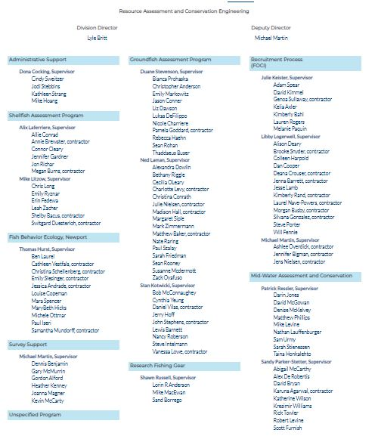

APPENDIX II. REFM ORGANIZATION CHART
Science and Research Director, Bob Foy; Deputy Science and Research Director, Jeremy Rusin

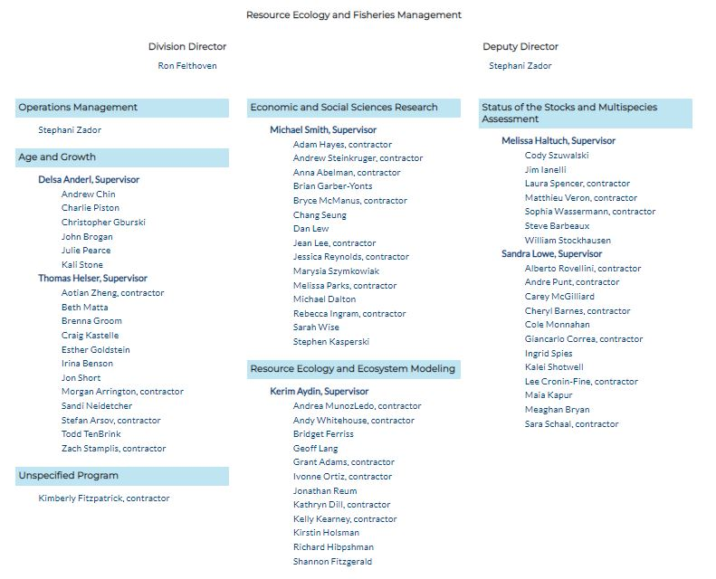

APPENDIX III. AUKE BAY LABORATORY ORGANIZATIONAL CHART
Science and Research Director, Bob Foy; Deputy Science and Research Director, Jeremy Rusin

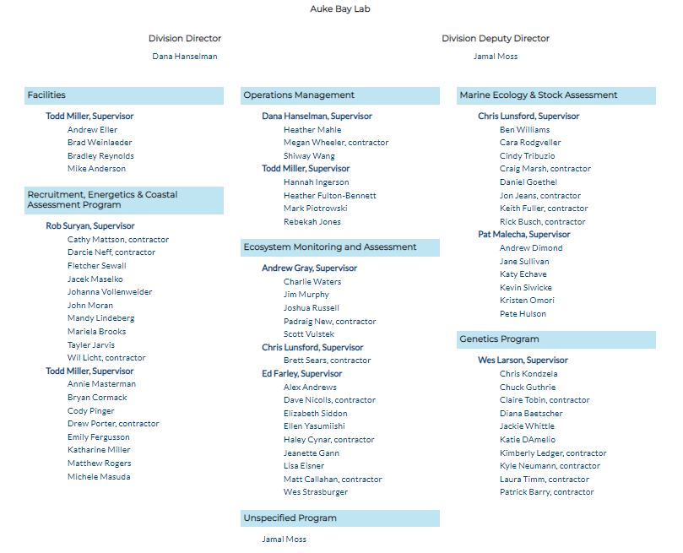

APPENDIX IV. FMA ORGANIZATIONAL CHART
Science and Research Director, Bob Foy; Deputy Science and Research Director, Jeremy Rusin

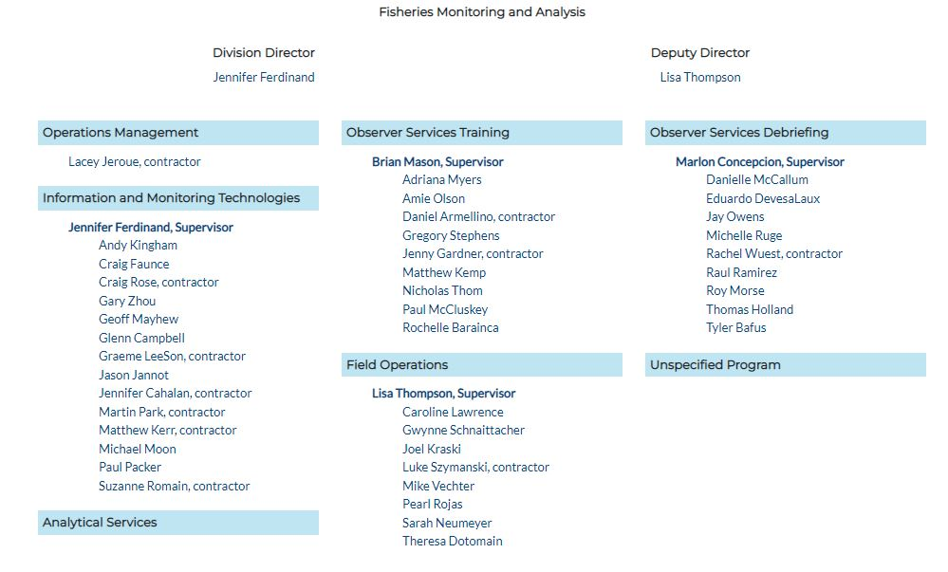

https://www.fisheries.noaa.gov/insight/understanding-ecosystem-based-fisheries-management
ICES (2023): Workshop on Unavoidable Survey Effort Reduction 2 (WKUSER2). ICES Scientific Reports. Report. https://doi.org/10.17895/ices.pub.22086845.v1
PSMFC Alaska Fisheries Information Network: https://akfin.psmfc.org/
NMFS Fisheries One-Stop Shop: https://www.fisheries.noaa.gov/foss/f?p=215:28
Von Szalay, P.G. and N. Raring. 2020. Data Report: 2018 Aleutian Islands Bottom Trawl Survey. NOAA Technical Memorandum NMFS-AFSC-409, 175 p.

