**Courter, Ian – Mt. Hood Environmental**

**Presentation Title: Factors that affect steelhead (and salmon) catch and release survival in freshwater sport fisheries throughout Washington state**

Abstract for the 2018 Pacific Coast Steelhead Management Meeting

Ian Courter1, Thomas Buehrens 2, Forrest Carpenter1, Ben Briscoe1, Joshua Richards1, and Scott Gibson1

1Mount Hood Environmental, PO Box 744, Boring, Oregon 97009

2Washington Department of Fish and Wildlife, 2108 Grand Boulevard, Vancouver, Washington 98661

Salmon and steelhead hooking mortality rates affect both the quantity and duration of sport fisheries in the Columbia Basin where Endangered Species Act (ESA) listed stocks are impacted by angling. In most cases, ESA-listed wild stocks are hooked and released by anglers targeting hatchery salmon and steelhead. Angling impacts associated with these fisheries are typically calculated using an estimate of the number of wild salmon or steelhead captured combined with simple assumptions about hooking mortality. Limited empirical data exists to inform these assumptions and current mortality estimates do not account for specific aspects of the fisheries that may significantly alter hooking mortality rates (i.e. water temperature, angling gear/methods, species, or run type). To improve the accuracy and regional specificity of hooking mortality estimates used to manage salmon and steelhead sport fisheries in the Columbia Basin, we initiated a three-year angling evaluation on the Lower Cowlitz River in southwest Washington in May 2017. Between May and November 2017, 315 hatchery salmon and steelhead have been angled and tagged. Angled fish are reported when recaptured by recreational anglers, creel surveyors, or by operators at the Cowlitz Salmon Hatchery adult fish separator. Due to well below average returns of summer steelhead and fall Chinook to the Lower Cowlitz River in 2017, coho salmon make up the majority of tagged treatment (angled) fish thus far (Figure 1). Twenty-nine control fish releases of non-angled summer steelhead and coho salmon occurred in 2017 and enabled us to directly compare treatment fish recapture rates to control groups. Preliminary results from data summaries in 2017 indicate that recapture rates of treatment fish were influenced by hooking location, but not by terminal tackle type (Figure 2). Two additional years of data collection are planned, followed by development of a model to estimate hooking mortality in a wide variety of fisheries.

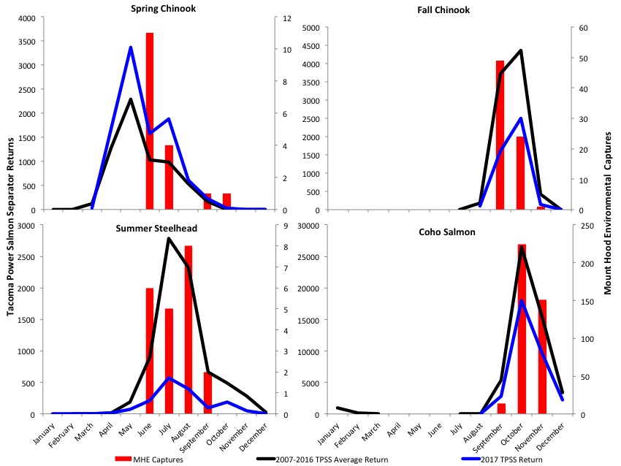

**Figure 1.** Cowlitz River salmon and steelhead angling catch rates and hatchery returns, June-November 2017. Angling captures include both natural and hatchery-origin fish. 2017 spring Chinook captures were incidental.

**Figure 2.** Recapture rates of Cowlitz River coho salmon angled using three different terminal tackle types during 2017.