Poster Presentation

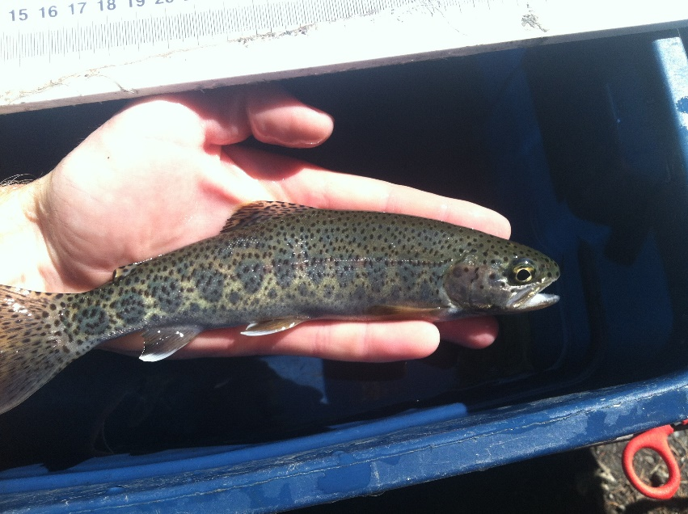

Photo: An *O. mykiss* parr caught in the Duckabush River, WA.

**Abstract: Growth performance of juvenile steelhead *Oncorhynchus mykiss* in the Duckabush River and Hamma Hamma Rivers, Washington.**

Gary Marston

Washington Department of Fish and Wildlife - Hatchery Evaluation and Assessment Team, 600 Capitol Way N., Olympia, WA, 98501. (253) 225-9968. Gary.Marston@dfw.wa.gov.

**Abstract**

This study evaluated the growth performance of juvenile *Oncorhynchus mykiss* at various life stages (age 0-1 and age 1-2) in the Duckabush and Hamma Hamma Rivers, Washington. The objectives of the study were to determine whether growth is limited by environmental conditions within the watershed, and if so, whether the available food resources or thermal experience had the greatest influence over growth. Bioenergetic modeling was used to estimate the feeding rate, growth trajectory and the amount of food required to attain the growth observed between life stages in the Duckabush River. Model outputs indicated that *O. mykiss* were feeding at 22.0% and 24.2% of their maximum consumption rate (%Cmax) annually at ages 0-1 and 1-2 respectively. During the summer low flow period of July 15 to September 15, *O. mykiss* fed at 26.9% of Cmax at age 0, 23.8% at age 1, and 24.4% at age 2. Based on analyzing growth sensitivity from temperature-dependent growth curves for juvenile *O. mykiss,* prey quality and consumption rate exerted the strongest influence over growth rates. Increasing the prey energy density from the observed 3614 J/g to 5000 J/g resulted in a 92% to 192% increase in the growth rate, highlighting the importance of high energy seasonal food resources to *O. mykiss* growth in the watersheds. Based on the findings of this study, food availability and quality appear to be limiting the growth of juvenile *O. mykiss* throughout their early life stages. With steelhead facing declines across their range, this study highlights the importance of preserving high quality rearing habitat for these fish.