Request For Quotes
Vessel Needed for White Sturgeon Setline Survey Operations


Actual issue date: January 23, 2026
Schedule/Instruction/Provision/Clauses
DEADLINE FOR QUOTES: Feb 11, 2026

Table of Contents
Section 1: Contact Information and Timeline 4
Section 2: Statement of Work 4
2.1 General 4
2.2 Project Objective 5
2.3 Project Description 5
2.4 Vessel Requirements 8
2.5 Vessel Crew Requirements 9
2.6. Scientific Crew 10
2.7. Operating Procedures 10
2.8. Contractor Responsibilities 11
2.9. Covid-19 & Vessel Safety Protocol 12
2.10 Compensable Time 13
2.11 Post-Award and Post-Project Meetings 15
2.12 Execution of Contract 15
Section 3: Instructions, Conditions, and Notices to Offerors 15
3.1. Definitions 15
3.2 Questions 16
3.3 Amendments to Solicitations 16
3.4 Submission, Modification, Revisions, and Withdrawal of Quotes 16
3.5 Offer Expiration Date 18
3.6 Restrictions on Disclosure and Use of Information 18
3.7 Contract Award 18
3.8. Quote Evaluation Criteria 19
Section 4: Supplies or Services and Price/Costs 20
Section 5. Attachments 21
5.1 Bid Quote Worksheet: Vessel Characteristics 21
5.2 Captain/Crew Members Fishing Experience 22
5.3. Safety Equipment and Training 23
5.4 Vessel Availability 24
5.5 Indemnity and Insurance 24
5.6 Subrogation Waiver Provision 25

Section 1: Contact Information and Timeline
Vessel needed for White Sturgeon Setline Survey
11 February 2026  @ 11:59 pm PST
  Deadline for quotes
  One (1) original to:
  Vanessa Lo
  Pacific States Marine Fisheries Commission
  Email: vlo@psmfc.org
  Phone: (858) 717-5667
6 April – 29 May 2026  AND  3 August – 25 Sept 2026 | Timeline of work

Section 2: Statement of Work
Pacific States Marine Fisheries Commission (PSMFC) is seeking up to three (3) Contractors (hereafter “Contractor” or “Offeror”) to furnish approved vessels, the necessary crew, materials, operating equipment, and services to perform the following Statement of Work/Specifications. For a description of the terms used within this Statement of Work, please consult the Definitions (Section 3.1).

2.1 General
2.1.1 The PSMFC intends to charter up to three (3) vessels for up to 64 sample days (‘sample day’ defined in section 3.1) to assist in a White Sturgeon mark-recapture study in the San Francisco Estuary (SFE). The timeline to complete this work is between 6 April – 25 September of the current year. PSMFC will be responsible for implementing the project and providing all required scientific equipment. PSMFC will supply an electric line hauler, mainlines (groundline), gangions (snap gear design), hooks, floats, float lines, anchors, and bait. The Captain (or ‘vessel operator’) and crew must be available during all scientific operations. To ensure full use of each sample day, the Captain and crew should make any necessary transit arrangements to begin fishing operations at the start of each sample day. Sampling will only occur when scientific staff are on board the vessel. All gear deployment and retrieval will occur during daylight hours.
2.1.2 The length of working days is expected to be 6 – 12 hours. Human safety, fish safety, and data integrity are the highest priorities. The survey will be conducted at the speed of the person collecting data. Rushing the science crew may result in contract termination.
2.1.3 The PSMFC expects the contracted captain(s) and crew(s) to uphold the highest standards of integrity, professionalism, and ethical conduct in accordance with the expectations set forth in this document. Failure to adhere to these provisions may result in corrective action, up to and including termination of the PSMFC contract.

2.2 Project Objective
2.2.1 The objective of this study is to mark White Sturgeon captured in setline gear (i.e., anchored longlines) with Passive Integrated Transponder (PIT), external tags, and internal acoustic tags during the April-May sampling period and recapture marked and unmarked White Sturgeon during the August-September sampling period. Sufficient recapture data will enable the estimation of abundance metrics (age-class abundance and relative abundance index) of White Sturgeon in the SFE.

2.3 Project Description
2.3.1 The PSMFC intends to charter three (3) vessels for up to 64 sample days (per year) to assist in a White Sturgeon mark-recapture study. This project will occur in the San Francisco Estuary (SFE), from San Pablo Bay east to the Sacramento River near Rio Vista (Fig. 1). The success of this project will depend, in part, on the Contractor’s knowledge of areas within this region where White Sturgeon aggregate, as well as longlining techniques. The terms of this contract are anticipated to start at date of last signature and run through September 25, 2026.
2.3.2 The study period (April-September 2026) will contain two 8-week stages, a “marking period” from April – May and a “recapture period” from August – September, with two months in between to allow tagged sturgeon to redistribute in the environment. In the marking period, the goal is to maximize the number of sturgeon tagged while maintaining broad and balanced spatial coverage. All zones within the study area will be sampled to achieve spatial coverage (Fig. 1); however, the locations within zones and the frequency of visits to each sampling location will be adjusted to maximize the number of White Sturgeon tagged. For the recapture period (August-September), each survey zone is divided into 9 km² survey units (Fig. 2) and units within zones are drawn randomly. The main purpose of creating a spatially balanced recapture sampling scheme is to reduce spatial bias in population abundance estimates and relative abundance indices.
Up to 10 setlines (i.e., anchored longlines) will be deployed in the study area per Contractor vessel per day. Each setline will consist of a 600-ft mainline with ¼ inch nylon rope with 40 circle-hook gangions (hooked line attached perpendicular to mainline via stainless steel longline snap) attached every 15 ft (Fig. 3). Circle hooks will consist of 3 different sizes (12/0, 14/0, and 16/0). All hooks will be baited by hand with bait provided by PSMFC. The goal is to fish 9 setlines per Contractor vessel per day for 24-hour soaking periods. All setline gear deployment and retrieval will occur between sunrise and sunset hours. Prior to (or immediately after) setline deployment, environmental (water quality) data will be collected by the on-board scientific staff. All species caught will be recorded, measured, and scanned for PIT tags (if appropriate), while only White Sturgeon will be tagged. Tagging will be conducted exclusively by scientific staff. All species caught will be released after recovery. In brief, sample protocols are as follows:
- A float line of appropriate length for a given depth is attached to mainline at starting end of setline.
- When directly over a sampling site, the float is tossed overboard and the anchor is lowered as one person pays out the mainline and the other attaches pre-baited gangion to the mainline at 15 ft. intervals.
- When nearly all the line is deployed, the second anchor and float line are attached to the opposite end of the mainline and lowered to the bottom. The start time and GPS coordinate is recorded when the second buoy is tossed overboard.
- After a 24-hour soaking period, the setline is retrieved starting from the downstream float. The buoy and float line are brought aboard, the float line is routed through a hydraulic or electric line puller, and the stop time is recorded.
- Fish are removed from the hooks as they are retrieved. Bycatch and small sturgeon are gently placed in a live well until the entire set is pulled.
- In the order they are encountered, larger sturgeon are examined for tags, tag scars, fin marks, and surgery scars and then scanned for PIT tags.
- Weight is recorded to the nearest kg, fork length and girth is recorded to the nearest cm, and a pit tag is injected behind and beneath the bony plates of the head on the fish’s left side. PIT tag code is then read and recorded.
- After tagging is completed, the condition (good, fair, poor) of the sturgeon is recorded and the fish is released.
- Smaller sturgeon are pulled from the livewell (in the order they were encountered) and steps 6-9 are repeated.
- Up to 8 White Sturgeon per day per vessel will additionally receive a Vemco acoustic tag. Each fish will receive a 3 cm incision into which an otoscope will be inserted to identify the sex of the specimen. After a biopsy of gonadal tissue taken the acoustic tag will be inserted and the incision closed up with several sutures.
- All incidental catch (i.e., bycatch) is recorded (including species, length, condition, and sex if possible) and returned to the water.
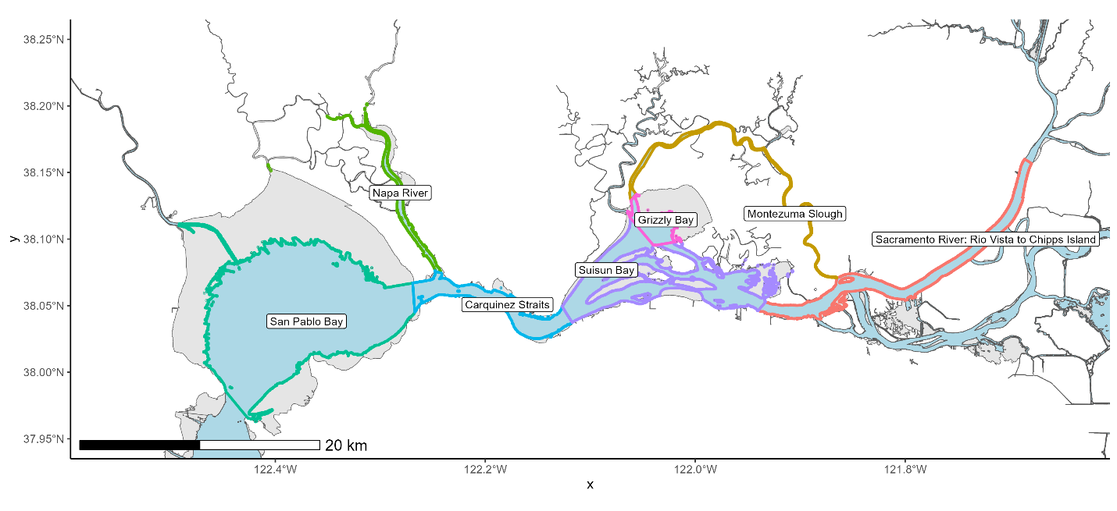
Figure 1. Regions (i.e., zones) for setline survey sampling. Colors differentiate location codes as established on the Sturgeon Report Card. Sampleable survey area (depths >4 ft at MLLW, NAVD 1983) is denoted by light blue shading.
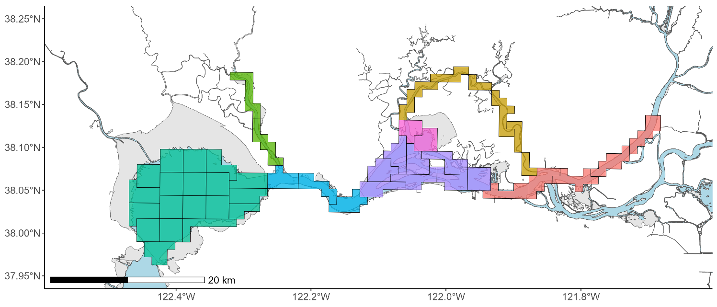
Figure 2. Survey units (9 km²) for each survey zone.

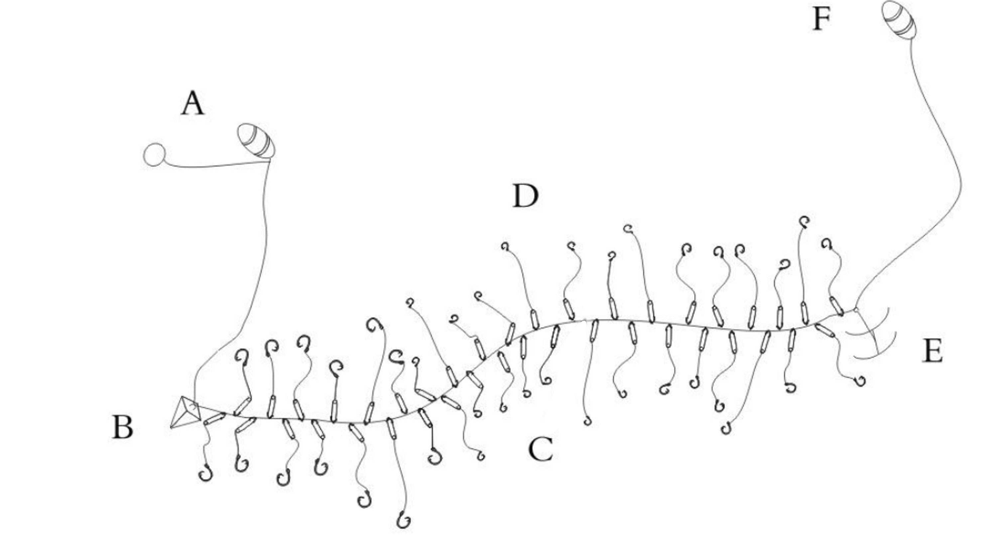
Figure 3. Example of one complete setline rig, including (A) main buoy and trailer buoy, (B) pyramid anchor (downstream end), (C) mainline, (D) baited hooks, (E) rocker anchor (upstream end), and (F) float lines (from Hannevig 2020).
2.3.3 It is anticipated that PSMFC will need three (3) Contractors for up to 64 sample days (depending on charter rate) per Contractor during the April – May and August – September sampling periods. The field schedule will consist of four 10-hour days (Monday – Thursday) to complete sampling in 3 survey units (Fig. 2) per Contractor vessel per week. Precise sampling dates will be somewhat flexible given weather, vessel sampling logistics, and personnel constraints, and therefore may include weekends (see Section 2.7.2 for more details on Contractor scheduling obligations).
2.3.4 For the ‘marking stage’, surveys will discontinue when, as determined jointly by the vessel Captain and Lead Scientist, either: (1) scientific objectives of releasing 1300 marked (i.e., PIT tagged) White Sturgeon are met, (2) available funds have been exhausted or compensable sampling days have been reached, (3) due to equipment failure, inclement weather, or other causes that prevent scientific objectives from being met within a reasonable time frame. The Lead Scientist, in consultation with the Project Manager and Contractor, will determine the vessel’s sampling schedule.

2.4 Vessel Requirements
2.4.1 The vessel must be current on all USCG requirements and in accordance with Title U.S.C. 46 C.F.R. Subchapter C, Subparts 24, 25, 26, and 28 (as applicable) and capable of setlining for White Sturgeon in depths upwards to 30 meters bottom depth (~ 100 ft). The vessel must be at least 26 feet in registered length and have the capacity to operate commercial longline gear. Additionally, the vessel is required to have a depth sounder, radar and GPS navigational system.
2.4.2 The vessel must have sufficient open deck area to allow space for fish sampling equipment (e.g., livewell, sturgeon sling, baskets, scales, sampling table, measuring boards, etc.) and processing the landed catches. All White Sturgeon caught must be released with minimal injury after processing. No intentional harvest of White Sturgeon or bycatch will occur during this study.
2.4.3 All hooks must be hand baited. Auto-baiting machines are prohibited.
2.4.5 The vessel must have clean and sanitary conditions, adequate space for up to 3 scientific crew members, a private head and 110-volt power that can be used for charging data collection equipment (such as phones and tablets).
2.4.6 The vessel must have a motor sufficient to power the vessel throughout the fishing area specified in the contract and wash-down hose suitable for pumping water on the sturgeon awaiting tags and livewell/holding tank for sturgeon and bycatch.
2.4.7 PSMFC reserves the right to check the background of any fishing vessel and may reject any bid if unfavorable information is detected.
2.4.8 Additional or Substitute Vessel or Operator: If for any reason an additional or substitute vessel or operator is required to complete the work required under a Contract, it will be the responsibility of the Contractor to supply or subcontract the same, within 48 hours, and with PSMFC approval, at the Contractor’s expense. The Contractor must specify names of operators/deckhands provided for this Contract and may not provide substitute operators/deckhands without prior approval by PSMFC. Substitute or back-up fishing vessels must meet the same standards as the original vessel requirements as specified. No more than one subcontractor shall act as the Captain in a given week.

2.5 Vessel Crew Requirements
2.5.1 The Captain (or subcontracted boat operator) must have a minimum of five years of fishing experience in the San Francisco Estuary (1) as master of a comparable-sized vessel (see Vessel Requirements Section 2.4) and (2) specifically targeting White Sturgeon. Preference will be given to Contractors possessing previous longlining experience. Vessel operators are required to hold, at minimum, a US Coast Guard OUPV license.
2.5.2 Preference will be given to Contractors (including Captains and crew) possessing previous experience with hand baiting longline gear.
2.5.3 The Captain shall be competent in the use of modern navigational and fisheries sonar equipment. Captain(s) must be familiar with navigation markers and navigation hazards in the specified fishing area.
2.5.4 The vessel crew shall consist of a Captain and at least one deckhand. In addition to the normal duties reserved for the deckhand, one or more of the deckhands or the Captain will also undertake the responsibilities of engineer to ensure safety of vessel, crew, and scientific staff. If desired, the crew may include an additional deckhand capable of operating the vessel to provide additional flexibility/support.
2.5.5 The deckhand(s) will be responsible for assisting the scientific staff with baiting, fish handling, and processing under the direction and guidance of the Lead Scientist on board.
2.5.6 Vessel crew with previous experience supporting scientific research/data collection are highly desired.

2.6. Scientific Crew
2.6.1 One scientist per vessel will be designated the Lead Scientist each sampling day. This person will be responsible for implementing the cruise plan (under the direction of the Project Manager), compliance with charter terms, and disposition of catches. The Lead Scientist (1) ensures that research is conducted according to established protocols, (2) follows good scientific practices to ensure data quality, (3) serves as the supervisor of the scientific staff, (4) ensures that the entire team adheres to safety regulations and rules of conduct, (5) has the necessary contact information for all scientific personnel, and (6) confirms all permits, emergency contact information, cruise plans, and protocols are read, understood and aboard prior to departure.
2.6.2 The scientific crew shall consist of up to 3 individuals.

2.7. Operating Procedures
2.7.1 With each change in on-board personnel (vessel and scientific crew) or as often as deemed necessary by Lead Scientist and/or Captain, the Lead Scientist will provide a joint orientation meeting with the Captain, crew members, and scientific staff prior to departure from the dock. This orientation will cover the objectives and methods for accomplishing the project goals for that day and establish roles amongst staff and crew. The Lead Scientist will facilitate the safety briefing, which will include a review of vessel safety procedures and equipment by the Captain.
2.7.2 Workday length and hours will be determined by the Lead Scientist in consultation with the Captain. The length of working days will range from 10 to 12 hours. Work schedule decisions will be based on the type of activity expected (pre-departure preparations, transit, sampling, etc.) and prevailing weather conditions. The Lead Scientist has the final authority except in matters relating to safety of the vessel and crew. Best efforts by PSMFC will be made to ensure that work falls within a Monday-Thursday schedule. Under this agreement, the Contractor agrees to prioritize availability for project activities in the event sampling must temporarily occur during Friday-Sunday due to weather, tides, or other developments out of the control of PSMFC.
2.7.3 The Lead Scientist and Captain will work together to resolve all problems which may occur regarding the project. In the event the Lead Scientist and Captain are unable to resolve a problem which has the potential for invalidating the project or threatens the safety or welfare of the scientific crew, the Lead Scientist will direct the vessel to return to port where an acceptable solution will be arranged between the PSMFC and the Contractor and sampling may cease for the remainder of the day. In such situations, the vessel will go off charter (and therefore, non-compensable) if required to return to port and will remain off charter until the problem has been resolved and the vessel has returned to the project area. Note: grounds for such actions include the requirement that scientific crew not be harassed, assaulted, opposed, impeded, intimidated, threatened, interfered with, or subject to unwelcome advances.

2.8. Contractor Responsibilities
2.8.1 PSMFC will provide all scientific sampling equipment needed for the project, including the gangions (including the snaps and hooks), bait, anchors, lines, and buoys. Vessel crew is responsible for carrying out the safe deployment and retrieval of setlines, including but not limited to (1) deploying the mainline while attaching pre-baited gangions 15 feet apart, (2) operating the line hauler upon line deployment and retrieval, (3) safely removing catch from gangions.
2.8.2 The Contractor will be responsible for all vessel-related gear needs (other than that supplied by PSMFC), including supplies normally needed for routine maintenance and any vessel-related gear lost or damaged during the charter. Contractor agrees to provide labor to repair the vessel as needed. Any contractor-owned setline gear elements that may be lost during sampling will not be reimbursed or replaced by PSMFC.
2.8.3 The Contractor (including Captain and crew) shall exercise due caution and follow safety procedures as directed by the Lead Scientist to help prevent damage or loss of scientific gear and equipment. The Lead Scientist may present specific safety procedures in writing to the Contractor/Captain. If loss of or damage to scientific equipment is the result of negligent disregard of such instructions and procedures, repair or replacement costs may be deducted from charter payments.
2.8.4 During all project activity, the Contractor hereby assumes full responsibility for moorage, operation, maintenance and repair of the boat, line hauler, and all equipment furnished by the Contractor. PSMFC will reimburse the Contractor for any additional mooring fees accrued during the work. Receipts must be provided for reimbursement.
2.8.5 PSMFC reserves the right to ground any vessel operator who, in its sole opinion, violates any Contract requirements, is unsafe, or otherwise performs unsatisfactorily. Successful Contractor may be required, within 48 hours, to replace the grounded operator. All replacements shall be approved in advance of use under the Contract by the PSMFC. Failure to furnish a replacement operator within the specified time will authorize PSMFC to terminate the contract if no resolution is made within a reasonable timeframe (i.e., less than 96 hours).

2.9. Covid-19 & Vessel Safety Protocol
2.9.1 Due to the dynamic nature of COVID-19, this contract may need to be modified if new CDC guidelines or state mandates prevent or alter survey operations as outlined. Current recommendations regarding health and safety shall be followed. Any scientific staff or vessel crew member that tests positive for Covid-19 shall forgo field work for the time period recommended by the CDC or state. If the impacted crew member is part of the vessel crew, a replacement shall be scheduled by the Captain/Contractor. If the impacted crew member is part of the scientific staff, the Lead Scientist or Project Manager will schedule a replacement. Replacements shall be scheduled as soon as possible to maintain sampling operations. Any crew (scientific and vessel) that are exposed to Covid-19 but do not have symptoms and do not test positive shall act with caution while on board, including wearing a mask and maintaining 6 ft distance from other crew when possible.
2.9.2 The vessel Captain is responsible for all matters related to the safety of all crew, the vessel, and equipment operation. The Captain will adhere to Navigational Rules of the Road whether sampling, running, drifting, or at anchor. The Captain shall review safety procedures and equipment with the scientific crew at the beginning of each sampling day. At all times while sampling, the Captain shall post a wheel/anchor watch (as required by the USCG Navigational Rules of the Road).
2.9.3 The Contractor shall provide USCG approved life jackets for all vessel crew members. The scientific crew members will provide their own life vests.
2.9.4 While not required, it is desired that Contractors possess a Category I EPIRB (Emergency Position Indicating Radio Beacon) affixed to the exterior of the vessel in a manner approved by the USCG. At a minimum, the Contractor must maintain at least two operational VHF radios and monitor VHF channels 13 and 16 for communications and to receive U.S. Coast Guard notices to mariners.
2.9.5 Before leaving the dock to commence sampling operations or when any crew change occurs, the Captain will conduct a safety drill detailing locations of all safety equipment, description of vessel station bill, and instructions on operating appropriate safety and communications equipment.
2.9.6 Conduct while on-board shall be professional and respectful. Personal attacks, yelling, threats, or disrespect towards any crew (vessel and scientific) will not be tolerated. Crew shall not engage in unlawful discrimination/harassment of any sort, including discrimination against any person on the basis of race, sex (including pregnancy and gender identity), religion, color, national origin, disability, age, marital status, sexual orientation, or veteran status. Alcohol/drug use while onboard will not be tolerated. Violations of conduct outlined in Section 2.9.6 may result in the termination of the contract or immediate removal of the crew member in violation.
2.9.7 The vessel must have a valid USCG Safety Decal. The decal must remain valid during the entire contract period and all requirements of the decal must remain valid for the entire contract period (including EPIRB batteries, if applicable). The vessel must also be current on all USCG requirements and in accordance with Title U.S.C. 46 C.F.R. Parts 24,25,26, and 28 (as applicable).

2.10 Compensable Time
2.10.1 For terms of this agreement, only days meeting the definition of “sample days” as defined in Section 3.1 are eligible for compensation at the daily charter rate, with the following exceptions outlined in 2.10.2-2.10.4 below.
2.10.2 Termination of sampling due to weather or forces out of the control of PSMFC and Contractor: If, during a survey, inclement weather or other developments makes it impossible or unlikely to ensure the safe and effective completion of sampling operations, the Contractor and PSMFC may elect to terminate the survey and return to port.
2.10.2 (a) If, at the point of sampling termination due to reasons specified in 2.10.2, criteria for a sample day (as defined in section 3.1) is met, the Contractor will be paid the full charter rate for that day.
2.10.2 (b) If, at the point of sampling termination due to reasons specified in 2.10.2, criteria for a sample day (as defined in section 3.1) is not met and the Contractor has spent 5 or less hours on the water in pursuit of project activities, the Contractor shall be paid half of the daily charter rate.
2.10.2 (c) If, at the point of sampling termination due to reasons specified in 2.10.2, criteria for a sample day (as defined in section 3.1) is not met and the Contractor has spent more than 5 hours on the water in pursuit of project activities, the Contractor shall be paid for the full charter rate.
2.10.3 In the event that the Lead Scientist and the Contractor/vessel operator jointly elect to suspend sampling operations and wait for conditions to improve, this time will be compensable according to criteria outlined in 2.10.2 a-c. Delays to sampling caused by scientific crew or scientific operations will be considered compensable time. However, time loss due to vessel equipment breakdown or time spent at the dock waiting for vessel supplies/crew is not compensable under this agreement.
2.10.4 Termination of sampling due to vessel equipment/engine malfunctions: If, during a survey, the vessel or other essential equipment (maintained by Contractor) breaks down or poses a safety risk to vessel and scientific crew and results in the termination of sampling operations, the Contractor will be compensated according to the following:
2.10.4 (a) If, at the point of sampling termination due to reasons specified in 2.10.4, criteria for a sample day (as defined in section 3.1) is met, the Contractor shall be paid the full charter rate for that day.
2.10.4 (b) If, at the point of sampling termination due to reasons specified in 2.10.4, criteria for a sample day (as defined in section 3.1) is not met and the Contractor has spent greater than 2 but less than 5 hours on the water in pursuit of project activities, the Contractor shall be paid half of the daily charter rate.
2.10.4 (c) If, at the point of sampling termination due to reasons specified in 2.10.4, criteria for a sample day (as defined in section 3.1) is not met and the Contractor has spent more than 5 hours on the water in pursuit of project activities, the Contractor shall be paid the full charter rate for that day.
2.10.4 (d) If, at the point of sampling termination due to reasons specified in 2.10.4, criteria for a sample day (as defined in section 3.1) is not met and the Contractor did not reach the sample location (i.e., issues were detected at the dock, or on the way to the sampling location) the Contractor will not be compensated for that day.
2.10.5 Should the Vessel or other essential equipment break down and cause delay or termination of the operation, the equipment shall be repaired or replaced within 72 hours to allow continuance of the project.
2.10.5 (a) In the event that repairs are projected to take more than 72 hours, the Contractor will be responsible for providing a substitute vessel for the period of time that the primary vessel is unavailable. See Vessel Requirements Section 2.4.9 for additional details on substitute vessel requirements and restrictions.
2.10.5 (b) In the event that repairs are projected to take more than 72 hours and the Contractor fails to provide a substitute vessel, resulting in a maximum of two weeks (8 cumulative days) of project delay, PSMFC reserves the right to terminate the contract.

2.11 Post-Award and Post-Project Meetings
2.11.1 Upon award of contract and prior to the start of the charter, a post-award meeting or conference call will be held to discuss details relating to the charter and project. All vessel personnel participating in the charter work are required to participate in the meeting. PSMFC, upon award of the contract, will schedule the date and time for the meeting.
2.11.2 After completion of the project, a post-project debriefing will be held at an agreed upon location. The purpose of the debriefing is to provide the Contractor with an evaluation of the performance of the vessel and crew during the charter and for the crew to voice any suggestions or concerns they may have. All vessel personnel participating in the charter work are required to attend the meeting. PSMFC, upon completion of the project will schedule the date and time for the meeting.

2.12 Execution of Contract
2.12.1 The Contractor hereby agrees to execute the project design as described, or a modification of said plan or design based upon agreement between the Contractor and PSMFC.

Section 3: Instructions, Conditions, and Notices to Offerors

3.1. Definitions
As used in this provision –
3.1.1 “Contractor” is defined as the owner of a vessel selected to take part of the project.
3.1.2 “Captain” is defined as the master or primary vessel operator who will have final say on matters on the behalf of the safety of vessel crew. This definition includes any subcontractors hired to operate the boat.
3.1.3 “Lead Scientist” is defined as the member of the scientific team who oversees the research operations on board the vessel.
3.1.4 “Sample day” is defined as a day when the vessel completes six or more line sets.
3.1.5 “Mobilization Day” is defined as a day preceding scientific operations required for loading or installing of scientific equipment.
3.1.6 “Demobilization Day” is defined as a day succeeding scientific operations required for unloading or removal of the scientific equipment.
3.1.7 “Cruise Plan” is defined as the logistical methodologies employed to implement the project design.

3.2 Questions
3.2.1 Questions shall be submitted via email no later than 4 February 2026 to:

Vanessa Lo
Pacific States Marine Fisheries Commission
Email: vlo@psmfc.org

3.3 Amendments to Solicitations
3.3.1. If this solicitation is amended, all terms and conditions that are not amended remain unchanged. Offerors shall acknowledge receipt of any amendment to this solicitation on offeror’s quote.

3.4 Submission, Modification, Revisions, and Withdrawal of Quotes
3.4.1. Deadline for quotes is 11 February 2026.
3.4.2. Quotes must be submitted to:
Vanessa Lo
Pacific States Marine Fisheries Commission
Email: vlo@psmfc.org
3.4.3. Quotes and modifications to quotes must be submitted by email.
3.4.4. Quotes must include the completed forms found in Sections 4 and 5 of this RFP.
3.4.5. In addition to requested information (Section 4 and 5), the quote must show:
The name of the solicitation;
The name, address, and telephone and facsimile numbers of the offeror (and email address if available);
Name, title, and signature of person authorized to sign the quote. Quotes signed by the agent shall be accompanied by evidence of that agent’s authority, unless that evidence has been previously furnished to the issuing office;
3.4.6. The PSMFC reserves the right to consult with and to consider information from its own sources, including information from state and federal agencies regarding the offeror’s prior performance or the status of outstanding investigations or warrants involving the offeror.
3.4.7. Offerors are responsible for submitting quotes, and any modification or revisions, to Vanessa Lo (vlo@psmfc.org) at PSMFC by 11:59 p.m. PST, on 11 February 2026.
3.4.8. Late quotes
3.4.8.1. Any quote, modification, or revision received at the PSMFC office designated in the solicitation after the exact time specified for receipt to offers is “late” and will not be considered unless it is received before award is made, the Program Manager determines that accepting the late offer would not unduly delay the acquisition; and
3.4.8.2. There is acceptable evidence to establish that it was received at the PSMFC installation designation for receipt of offers and was under the PSMFC’s control prior to the time set for receipt to offers; or
3.4.8.3. It is the only quote received.
3.4.8.4. However, a late modification of an otherwise successful quote that makes its terms more favorable to the PSMFC will be considered at any time it is received and may be accepted.
3.4.8.5. Offerors may submit revised quotes only if requested or allowed by the Program Manager.

3.5 Offer Expiration Date
3.5.1. Quotes in response to this solicitation will be valid for 30 days following the time specified for solicitation of offers (unless a different period is proposed by the offeror).

3.6 Restrictions on Disclosure and Use of Information
3.6.1. Offerors that include in their quotes data that they do not want disclosed to the public for any purposes, or used by the PSMFC except for evaluation purposes, shall mark the title page with the following legend: “This quote includes data that shall not be disclosed outside the PSMFC and shall not be duplicated, used, or disclosed—in whole or in part—for any purpose other than to evaluate this quote. If, however, a contract is awarded to this offeror as a result of – or in connection with – the submission of this data, the PSMFC shall have the right to duplicate, use, or disclose the data to the extent provided in the resulting contract. This restriction does not limit the PSMFC’s right to use information contained in this data if it is obtained from another source without restriction. The data subject to this restriction are contained in sheets [insert numbers or other identification of sheets]”; and mark each sheet of data it wishes to restrict with the following legend: “Use of disclosure of data contained on this sheet is subject to the restriction on the title page of this quote”.

3.7 Contract Award
3.7.1. The PSMFC intends to award a contract or contracts resulting from this solicitation to the responsible offeror(s) whose quote(s) represent the best value after evaluating in accordance with the factors and subfactors in the solicitation.
3.7.2. The PSMFC may reject any or all the quotes if such action is in the PSMFC’s interest.
3.7.3. The PSMFC may waive informalities and minor irregularities in quotes received.
3.7.4. The PSMFC intends to evaluate quotes and award a contract without discussions with offerors (except clarifications as described in FAR 15.306(a)). Therefore, the offeror’s initial quote should contain the offeror’s best terms from a cost or price and technical standpoint. The PSMFC reserves the right to conduct discussions if the Program Manager later determines them to be necessary. If the Program Manager determines that the number of quotes that would otherwise be in the competitive range exceeds the number at which an efficient competition can be conducted, the Program Manager may limit the number of quotes in the competitive range to the greatest number that will permit an efficient competition among the most highly rated quotes.
3.7.5. The PSMFC reserves the right to make an award on any item for a quantity less than a quantity offered, at the unit cost or price offered, unless the offer specifies otherwise in the quote.
3.7.6. The PSMFC reserves the right to make multiple awards if, after considering the additional administrative cost, it is in the PSMFC’s best interest to do so.
3.7.7. Exchanges with offerors after receipt of a quote do not constitute a rejection or counteroffer by the PSMFC.
3.7.8. The PSMFC may determine that a quote is unacceptable if the prices proposed are materially unbalanced between line items or subline items. Unbalanced prices exist when, despite an acceptable total evaluated price, the price of one or more contract line items is significantly overstated or understated as indicated by the application of cost or price analysis techniques. A quote may be rejected if the Program Manager determines that the lack of balances poses an unacceptable risk to the PSMFC.
3.7.9. If a cost realism analysis is performed, cost realism may be considered by the source selection authority in evaluating performance or schedule risk.
3.7.10. A written award or acceptance of quote emailed or otherwise furnished to the successful offeror within the time specified in the quote shall result in a binding contract without further action by either party.
3.7.11. The PSMFC may disclose the following information in post award debriefings to other offerors:
3.7.11.1. The overall evaluated cost of price and technical rating of the successful offeror;
3.7.11.2. The overall ranking of all offerors, when any ranking was developed by the agency during source selection; and
3.7.11.3. A summary of the rationale for award.

3.8. Quote Evaluation Criteria
3.8.1 The following criteria and evaluation weighting will be used for evaluating both solicited and unsolicited quotes.
Vessel Characteristics (25 points)
- Vessel size, horsepower, available deck space and lighting
- Vessel electronics, space, and layout
- Communication equipment
Charter Rate (25 points)
- Daily rate (gas included)
Captain/Crew (35 points)
- Current US Coast Guard OUPV license
- Current First Aid certification
- Captain/crew members with fishing experience, particularly with longline gear
- Captain/crew members experience with fisheries research and collecting scientific data
Other desirable characteristics (15 points)
- Safety equipment
- Crewmember with certified first aid

Section 4: Supplies or Services and Price/Costs
Provide vessel, captain, crew, fuel, and all gear necessary to conduct the work described in sections 2-3 of the RFQ titled “Vessel Needed for White Sturgeon Setline Survey Operations” (See section 5). PSMFC will reimburse the contractor for any additional moorage fees accrued during this project (receipts must be provided for reimbursement). There will be no reimbursements for gear elements that may be lost (i.e., buoys, anchors, etc.). The desired timeline to complete this work is between 6 April and 25 September 2026. Invoices for any costs shall be submitted at the end of each month and PSMFC shall provide payment within 30 days of receipt of approved invoices.
Note: ‘Quantity’ refers to the maximum days anticipated for the project, actual days may be fewer than the value specified.

 | Quantity | Daily Charter Rate | Vessel Bid Amount
Sampling Days | 64 | $______________ | $ ______________
Mobilization Day | 2 | $*_____________ | $ ______________
Demobilization Day | 2 | $*_____________ | $ ______________
 |  | Total: $ ______________
Name of Vessel: _______________________________________________________
Authorized signature: ___________________________________________________
Printed Name: _________________________________________________________
*= amount paid to the contractor by PSMFC for Mobilization and Demobilization days.

Section 5. Attachments

5.1 Bid Quote Worksheet: Vessel Characteristics
General Vessel Characteristics
Owner Name: _______________________________________________________________
Registration No.: ____________________________________________________________
Vessel Name: _______________________________________________________________
Address: ___________________________________________________________________
___________________________________________________________________________
___________________________________________________________________________
Phone: ( )__________________________
Registered Vessel Length (LOA): _______________________
Vessel Back Deck Width _____________________________
Equipped for setlining up to depths of ____________ meters
Main Engines:
Number ________________ | Mfg. ______________ | Model __________________ | Total HP ____________ | Hours* _____________
Auxiliary Engines:
Mfg. ________________ | Model ______________ | Total HP __________________ | kVA ____________ | Hours* _____________
Mfg. ________________ | Model ______________ | Total HP __________________ | kVA ____________ | Hours* _____________
* Please specify total engine hours or number of hours since any rebuild
Wheelhouse Electronics, Space, and Layout
Is there an available electrical power supply (110 V.A.C.) in the wheelhouse? Yes / No
Is there available space within the vessel for the scientific crew to store and protect laptop computers from inclement weather, as well as charge sampling equipment? Yes / No
Does the vessel possess a functional head with a lock/latch? Yes / No
Available Deck Space and lighting
Appropriate clear working deck area available ________________ square feet.
Comments: ___________________________________________________________________
Is lighting available from several angles on the deck? Yes / No
Comments: ____________________________________________________________________
Communication and Navigational Electronic Equipment
Satellite Telephone available: Yes / No
GPS: Mfg_____________________________ Model__________________________________
Equipment
Does the vessel possess a wash-down hose? Yes / No
Is there anything additional you would like us to know about your vessel?
______________________________________________________________________________
______________________________________________________________________________
______________________________________________________________________________

5.2 Captain/Crew Members Fishing Experience
(One sheet each for Captain and each crew member)
Name____________________________________ Position___________________________
Vessel name | Dates | Target gear/Location | Responsibilities/specialized experience

5.3. Safety Equipment and Training
Life Raft Yes / No
If yes, capacity:_________
# of VHF Radios: ____________________
EPIRB present? Yes / No
If yes:
EPIRB: No._____________________ Class_________________________
EPIRB Battery Expiration___________________________________________
USCG Certification of Inspection Expiration Date________________________
Have all crew members had a certified first aid and/or Emergency Medical Training (EMT) course? Yes / No
Comments: ____________________________________________________________________
______________________________________________________________________________
______________________________________________________________________________
______________________________________________________________________________
______________________________________________________________________________

5.4 Vessel Availability
The desired timeline to complete this work between 6 April – 29 May and 3 August – 25 September 2026. Do you have any prior engagements during the desired timeline to complete this project that would potentially conflict with conducting this research (i.e. other charter work commitments, commercial fishing activities, boat yard work, vacations, etc.)? Please specify if you are able to commit to both survey periods (April – May AND August – September).
______________________________________________________________________________
______________________________________________________________________________
______________________________________________________________________________

5.5 Indemnity and Insurance
Contractor agrees to indemnify PSMFC, its officers, agents, and employees, boards and commissions, against all loss, damage, expense and liability resulting from injury to or death of person, including, but not limited to, employees of PSMFC or Contractor, or injury to property, including, but not limited to, property of PSMFC, Contractor, and third parties, arising out of or in any way connected with the performance of this contract, however caused, regardless of any negligence of PSMFC, whether active or passive, excepting only such injury or death or property damage as may be caused by the sole negligence or willful misconduct of PSMFC.

________________________Yes ________________________No

INSURANCE COVERAGE
1) Minimum Coverage. Please indicate if able to present evidence to show, as a minimum, the amounts of insurance coverage indicated below:
a. Protection and Indemnity in the amount of $1,000,000
______________________Yes ______________________No
b. Jones Act coverage for vessel crew in the amount of $1,000,000
______________________Yes ______________________No
c. Vessel Hull and Machinery Coverage
______________________Yes ______________________No

5.6 Subrogation Waiver Provision
Contractor agrees that in the event of loss due to any of the perils for which Contractor is required to provide or perils insured under the Maritime Employer’s Liability, and Vessel Liability or equivalent Policy coverage, Contractor shall look solely to its insurance for recovery. Contractor shall herby grant PSMFC, its officers, agents, employees, boards, commissions, and cooperative agency participants on behalf of any insurer providing, Maritime Employer’s Liability, and Vessel Liability or equivalent Policy coverage to either Contractor of PSMFC with respects to the service of Contractor herein, a waiver of any right to subrogate which any such insurer of said Contractor may acquire against PSMFC its officers, agents, employees, boards, commissions by virtue of the payment of any loss under such insurances.
________________________Yes ________________________No
1) Evidence of Insurance provision. Before the final execution of this contract, Contractor shall produce a standard Accord from Certificates of Insurance with Insurance Carriers acceptable to the PSMFC/NMFS, evidencing all required insurances. The Certificate shall also comply with the Subrogation Waiver Provision and forward actual endorsements from the contractor’s insurance carriers evidencing required coverage amendments.
2) Renewal/Cancellation. The respective Insurance Carriers and the Certificate of Insurance shall allow for a minimum of 30 days written notice of cancellation, non-renewal or reduction or required coverage’s before the expiration date thereof and the Certificate shall delete the word(s) “endeavor” and the last two lines of a standard Accord Certificate (“But failure to mail such notice shall impose no obligation or liability of any kind upon the company, its agents or representatives”). Renewal Certificates evidencing the same shall be received 10 days prior to the expiration of the coverage’s so evidenced. The Certified evidencing all requirements herein and any reduction of required coverage’s or cancellation shall be sent to: Matt Robertson, PSMFC, 6720 S. Macadam Ave., Ste. 200 Portland, OR 97219 Phone: (503) 595-3100 Fax: (503) 595-3232.
3) Sufficiency of Insurance. The insurance limits or coverages required by PSMFC are not represented as being sufficient to fully protect the Contractor. Contractor is advised and responsible to determine his own adequate coverage sot limits.
4) Qualifications. Insurance companies shall be legally authorized to engage in the business of furnishing insurance in the State of the exposure

