Request for Proposals
RFP 26-007
2020 Prince William Sound Pink and Coho Salmon Fishery Disaster Research 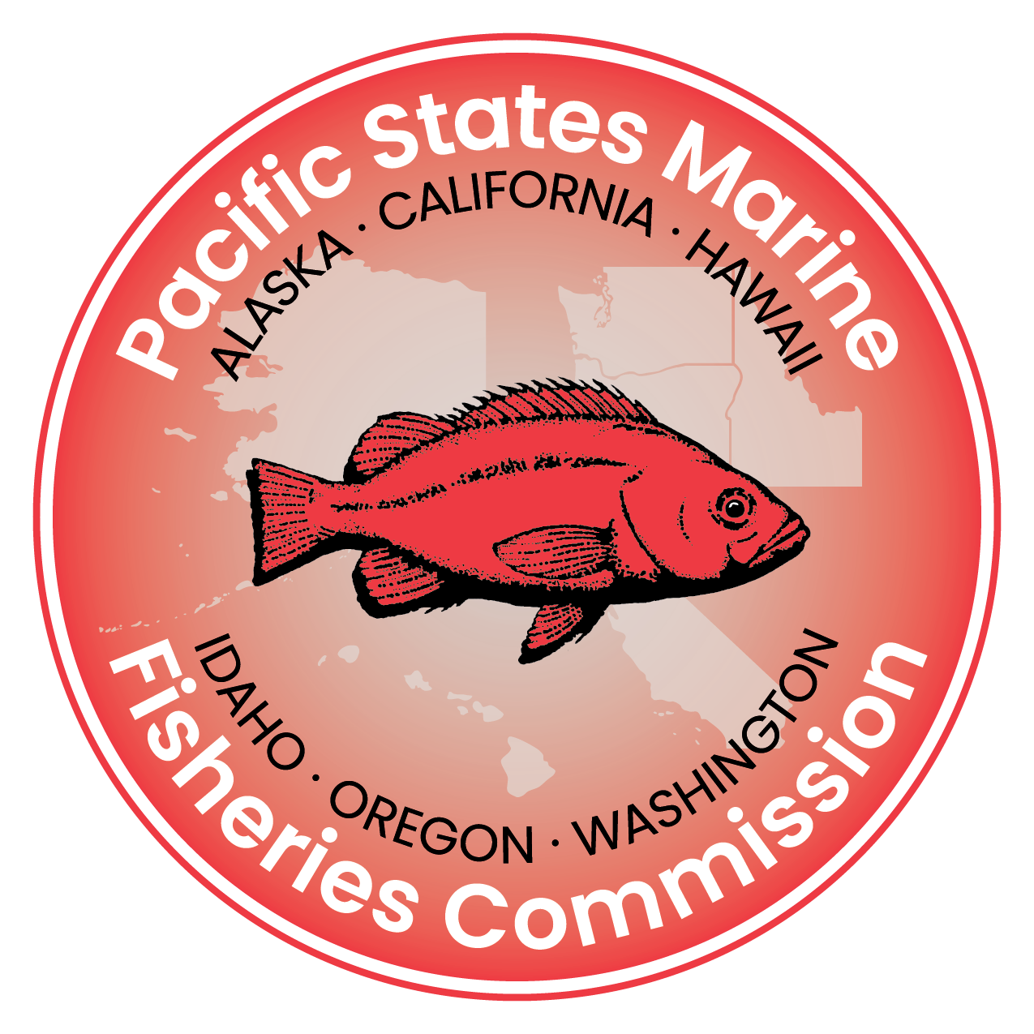
Issue Date:
December 24, 2025
Deadline for Proposal Submissions:
January 30, 2026 | 5:00 PM (PST)
- PSMFC Program Manager: Brian Bissell
- PSMFC Project Manager: Allan Martin
- Prime Award: NA24NMFX477G0008
Proposal Schedule
ACTIVITY | DATE | NOTES
Request for Proposal (RFP) issued and distributed | December 24, 2025
Deadline for Written Questions | January 9, 2026 | 5:00 PM (PST) | Email questions, with the subject line:  “RFP 26-007: 2020 PWS Salmon” to the following:  - Contracting@psmfc.org  - AKFishDisaster@psmfc.org  Hard copy or faxed questions will not be accepted.
Q&A Document with Responses Posted | January 14, 2026 | Q&A document with responses posted at https://www.psmfc.org/procurements
Deadline for Proposals | January 30, 2026 | 5:00 PM (PST) | Email proposals, with the subject line:  “RFP 26-007: 2020 PWS Salmon” to the following:  - Contracting@psmfc.org  - AKFishDisaster@psmfc.org  Hard copy or faxed proposals will not be accepted.
Proposal Review | February 2-13, 2026
Applicants Notified of Recommendations | February 27, 2026
Anticipated Project Period | April 1, 2026 – August 31, 2028

Funding Opportunity Description
Summary
In 2020, the Prince William Sound salmon fishery experienced a significant disaster, caused in part by warmer-than-average ocean conditions and other environmental factors that were beyond the control of fishery managers. These challenging conditions led to a decline in biomass and reduced access to the fishery, creating serious impacts for those who depend on it.
In response, the Alaska Department of Fish and Game (ADF&G) is directing research funds toward projects that aim to improve the quality of fishery information and help mitigate the long-term effects of the disaster. This effort is being supported through a funding opportunity offered by the Pacific States Marine Fisheries Commission (PSMFC), in collaboration with the National Oceanic and Atmospheric Administration (NOAA Fisheries).
Approximately $1,540,000 in grant funding is available to support research focused on Prince William Sound Pink and Coho Salmon. All projects funded through this Request for Proposals must be completed by August 31, 2028. Final approval of proposals submitted under this RFP is subject to review and authorization by NOAA’s federal program officer and must satisfy all special award conditions associated with the Commission’s primary funding award.
Research Priority Areas
- Research projects designed to investigate the potential effect of hatchery Pink Salmon releases on the size and number of returning salmon.
- Investigate the potential causes of sporadic Coho Salmon returns.
- Research the impact of salmon release timing.
- Radio-telemetry projects to improve upriver timing and distribution forecasting for Coho Salmon to determine distribution and spawning locations in the Copper River.

Eligible Applicants
Eligible applicants include researchers affiliated with U.S. academic institutions, research laboratories, for-profit entities, nonprofit organizations, and state or local government agencies. Foreign entities and U.S. federal government agencies, including Regional Fishery Management Councils, are not eligible to apply.
Collaborative proposals involving multiple investigators are encouraged. Proposals submitted by industry entities or private individuals must include a formal partnership with qualified government or academic researchers to be considered.
The research team must include a minimum of two primary investigators (PIs) holding a Master of Science degree or at least one individual holding a doctoral degree. This requirement may be waived at the discretion of NOAA’s federal program officer for applications submitted by well-established organizations with a demonstrated record of peer reviewed research.
Federal employees, such as NOAA Alaska Science Center personnel may not serve as PIs but may serve as unfunded collaborators.
Proposal Requirements
- Submit proposals by 5:00 PM (PST) on January 30, 2026
  - Submission must be emailed to both Contracting@psmfc.org and AKFishDisaster@psmfc.org
  - Subject line must be “RFP 26-007: 2020 PWS Salmon”
  - Hard copy or faxed proposals will not be accepted.
Proposals must be clear, concise, and prepared in a minimum 12-point font. Tables and visuals (e.g., charts, maps, graphs, and photographs) are included in the five-page limit for the project description. Sections such as the project summary, budget and justification, data management plans/access agreements, and information on prior, current, or pending support do not count toward this limit. Appendices may include résumés or letters of endorsement. Any additional material beyond what is requested will be disregarded.
A. Project Summary (1-page limit)
Include the following:
- Names and Contact (email address, phone number, and mailing address)
  - Primary Investigator(s) | PIs
  - Co-Principal Investigator(s) | CO-PIs
  - Unfunded Collaborators | UC
- PIs Organization
- Project title
- Project objectives
- Summary of proposed work
- Project proposals must address how the research will mitigate the effects of the disaster on the fishery.

- Budget details:
  - Total funds requested from PSMFC
  - Current and pending support (if applicable)
  - Cost sharing (optional; specify cash or in-kind)
  - Total project cost
B. Project Description (5-page limit)
Provide a complete and accurate description of the proposed research. Include:
- Specific objectives and performance measures
- Key issues and significance
- Relationship to project goals
- Relation to other planned or ongoing work
- Methodology
- Literature Review
- Milestone & Deliverables Table
C. Project Budget
Submit a detailed narrative for each budget category. Justify how funds will be used for each participating organization or agency.
- Salaries and Wages
Include name, job title, role, responsibilities, effort (percent/time), base salary, and total compensation. Salaries must:
- Follow organizational policy and 2 CFR § 200.430
- Be reasonable, allocable, and well documented
- Reflect actual time on the project
- Include incentive pay only when documented, reasonable, and allowable
2. Fringe Benefits:
- Type of benefits (e.g., health, retirement, FICA, unemployment, workers’ comp, life insurance, paid leave)
- Calculation method (e.g., percent of salary or flat rate) Fringe costs must comply with 2 CFR § 200.431, be allocable to project effort, and be supported by documentation.
3. Travel
Travel must directly support project goals. Include:
- Traveler name and role
- Dates and purpose
- Destination(s)
- Itemized costs: lodging, airfare, per-dem, ground transport, other related expenses
Travel must:
- Follow federal and organizational travel policies
- Be booked at lowest reasonable cost
- Be justified with clear links to project outcomes
- Use federal per diem rates unless a higher rate is justified
- Exclude international travel
4. Contractual
For each contract:
- List contractor name, if known
- Justify contractual need
- State method of selection
- Summarize scope of work and deliverables
- Provide cost breakdown
Contracts must:
- Follow procurement rules under 2 CFR § 200.318
- Be competitively awarded unless justified
- Avoid conflicts of interest
- Include payment and performance terms
- Be distinguished from subawards if applicable

- Supplies
Describe tangible items under $10,000/unit. For each category (e.g., lab supplies, safety gear):
- Group and itemize
- Justify relevance to project objectives
- Equipment
For items $10,000 or more:
- List each item with description, quantity, cost, and justification
- Equipment must be essential, special purpose (if applicable), and comply with 2 CFR §§ 200.313 and 200.439
- Maintain proper records and disposition procedures
- Indirect Costs
Include:
- A copy of the current federally approved NICRA, or
- If no NICRA exists, a de minimis rate of up to 15% may be applied.
Indirect costs must be:
- Consistent, allowable under 2 CFR § 200.414, and applied to the MTDC base
- Limited to necessary admin and facility expenses (e.g., utilities, HR, compliance)

Instructions, Conditions & Notices
- Submit questions by 5:00 PM (PST) on January 9, 2026
  - Questions must be emailed to both Contracting@psmfc.org and AKFishDisaster@psmfc.org
    - Subject line must be: “RFP 26-007: 2020 PWS Salmon”
    - Hard copy or faxed questions will not be accepted.
- Answers posted by January 14, 2026 at psmfc.org/procurements
Proposal Revisions/Withdrawals:
- Proposals may be revised/withdrawn any time before award.
- Must be submitted in English and U.S. dollars.
- All proposals must be valid for 120 days from submission.
Late Submissions: Will not be considered.

Evaluation Criteria (100-point scale)
- Qualifications, experience, relevance to priorities: 30 pts
- Technical approach and work plan: 40 pts
- Cost and budget: 30 pts

Conflict of Interest
Reviewers must avoid actual or perceived conflicts of interest, disclose any conflicts, and recuse themselves from discussion when a conflict exists.

