Request for Proposals (RFP)
RFP 26-006

Electronic Monitoring (EM) systems for

Pacific Island region longline vessels



Issue Date: 12/10/25

Deadline for Proposals: 2/2/26

PSMFC Project Manager: Joshua Tucker

Prime Awards:
NA25NMFX437C0013
NA25NMFX472C01
NA25NMFX437C0014
Open to additional funding

RFP Process Schedule

12/10/25 Requests for proposals (RFP) issued and distributed

1/5/26 Deadline for written questions regarding this RFP

Please email questions to Jacob Allen at contracting@psmfc.org and Caren Braby at cbraby@psmfc.org

1/14/26 Q&A document, including the answer to the written questions posted on the PSMFC website at: http://www.psmfc.org/procurements/blog

2/2/26 Deadline for submission of proposals- 4:00 PM PDT

Proposals need to be submitted by email to: contracting@psmfc.org and cbraby@psmfc.org

Subject line for submissions:
RFP 26-006: Pacific Island region EMS

Faxed and hard copy proposals will not be accepted.

2/3/26 Proposal review starts

3/27/26 Project finalist selected

Issue Notice of Intent to Award

SECTION 1: Background

The Pacific States Marine Fisheries Commission (PSMFC) seeks proposals from electronic monitoring (EM) system providers to assist with electronic monitoring of vessels participating in the pelagic longline fishery around the Pacific Islands region, including American Samoa. We are seeking a contractor(s) to supply, install and maintain onboard EM system hardware, provide remote and on-site technical support, conduct data transmission and processing, and develop Vessel Monitoring Plans (VMPs) to document vessel specific EM deployment details. PSMFC will design and build this EM program to serve the information needs of the federal fisheries managers in the region. Regulatory authorization of EM to meet monitoring requirements for the fishery are expected to be put in place by the National Marine Fisheries Service (NMFS) in 2026; ultimately, NMFS is expected to move to full implementation and requirement of EM for monitoring by 2029.

Program Goals

The primary goal of implementing electronic monitoring (EM) in the Pacific Islands region is to meet the requirements of the Marine Mammal Protection Act (MMPA), Endangered Species Act (ESA), Magnuson-Stevens Fishery Conservation and Management Act (MSA), and international obligations implemented under the Western and Central Pacific Fisheries Convention Implementation Act, the Tuna Convention Act and other applicable laws. Specific monitoring objectives include:

- Collecting accurate data on interactions with protected species that allow for robust post-release mortality rates, to inform population impact assessments.
- Producing statistically robust estimates of protected species interactions
- Monitoring bycatch/discards per MSA Requirements:
  - National Standards 9 and Federal Ecosystem Plan
  - Standardized Bycatch Reporting Mechanism (SBRM)
- Meeting international obligations, including catch, bycatch, and discard monitoring standards established by regional fisheries management organizations (RFMOs), including the Western and Central Pacific Fisheries Commission (WCPFC) and the Inter-American Tropical Tuna Commission (IATTC).

The National Marine Fisheries Service (NMFS) is required to monitor and estimate the amount of incidental take of species listed under the ESA and MMPA and minimize bycatch in federally managed Pacific pelagic longline fisheries. These data are critical for evaluating fishery impacts on vulnerable and protected species.

Monitoring requirements apply to vessels operating under Federal deep-set and shallow-set longline fishing permits in fisheries managed under the Fishery Ecosystem Plan for the Pelagic Fisheries of the Western Pacific (50 CFR 665.801) in the Pacific Island region, including vessels based in Hawaii and American Samoa.

Beginning in 2004, NMFS maintained observer coverage targets of 100 percent for Hawaii shallow-set longline fishing trips and 20 percent for deep-set longline trips operating out of both American Samoa and Hawaii. Human observers served as the primary collectors of bycatch and protected species interaction data. In recent years, increasing costs associated with human observer programs, reduced funding availability, and growing fishing effort have led to decreased coverage relative to historical levels. EM systems deployed under this proposal support a viable, cost-effective alternative for collecting comparable catch and effort data.

Pelagic Longline Fishery Characteristics
This project will support the implementation of electronic monitoring (EM) in three federally managed pelagic longline fisheries in the Pacific Islands region that target tunas and other large highly migratory species.

- Sectors:
  - Hawaii-based deep-set longline fishery (approximately 150 vessels)
  - Hawaii-based shallow-set longline fishery (approximately 20 of the 150 deep-set vessels also participate in shallow-set), and
  - American Samoa-based deep-set longline fishery (approximately 10 vessels).
- Fishing areas:
  - EEZ and International waters, north of Hawaiian Archipelago and south to American Samoa
  - Ports of landing include Honolulu Hawaii (Pier 38 as well as Pier 17), Pago Pago American Samoa, and less frequently in California.
- Seasonality and hours of operation:
  - Year-round (peak effort October-June in Hawaii, January-June in American Samoa),
  - Day and night operations
- Pre- departure notification:
  - Vessels are required to provide 72 hours notice prior to leaving port on a fishing trip. (50 CFR 665.803). 72 hour notice can be given before a vessel returns to port, thereby reducing time in port.
- Trip Length:
  - 21-84 days and 12-40 sets per trip
- Transmission capabilities of vessels
  - Some vessels have Starlink installed, but not all. Others are on a combination of satellite, cellular, and in-port wifi.

For more information on the fisheries, please see appendix B.

SECTION 2: Contractor Services and Tasks

To support the implementation of Electronic Monitoring in the Pacific Islands region, PSMFC is soliciting the services of a Contractor to provide the following services and accomplish the following tasks:

- Supply and Install Onboard Equipment
  - Provide EM systems (specifications below) for designated fishing vessels, per direction from PSMFC (vessels, install deadlines, etc.)
  - Schedule the install with the vessels (contact information provided by PSMFC).
  - Install systems on vessels with consideration for the privacy and dignity of the crew, as well as the operation needs of the vessel’s owners and operators; install will include (but is not limited to):
    - Strategically placed high-definition, low-light, weather-resistant cameras to record fishing activity and protected species interactions (including hook location and characteristics).
    - Install pressure and hall sensors to log hydraulic and drum system information necessary to identify fishing events, equipment usage, and to trigger the system to start and end recording.
    - Install an integrated GPS antenna to track the vessel location and speed.
    - Install an on-board control center to process video and sensor data, and store trip data;
    - data storage must include redundant systems and data transfer options (which should include a removable, encrypted hard drive functionality).
  - Provide successful system test results to PSMFC from install that the system is functioning, as required.
  - Define the terms of any equipment failure warranty that will be provided beyond initial installation.
- Ensure Full Functionality of EM Systems during the contract period
  - Provide on-site support strategy: Sustain fully-functioning EM equipment including system repair, maintenance, and component replacement. Support must be available on a daily basis (7 days a week) throughout the year and provide in-person technical assistance to designated vessels in Honolulu, HI that minimizes disruption to normal fishing operations.
  - Establish procedures for communication with the vessel operator to coordinate field service repairs or replacement of faulty EM systems or components.
  - Provide timely service for EM system issues, ensuring the replacement or repair of faulty components is complete within 72 hours of notice or vessel becoming available to maintenance personnel (e.g. after returning to port or getting out of dry dock).
  - A pre-departure function test is required during the pre-departure notification. This check can be carried out by the vessel operator, who must be trained on the procedure or performed remotely via established protocols and system tools. Any issues identified during this check must be resolved within 72 hours to ensure the vessel departs with a fully operational system.
  - During fishing: Provide continuous remote and on-site technical support to the vessels for installed equipment, data collection, and data delivery.
    - Within 24 hours of notification, the Contractor shall have trained technicians available by telephone or remote communication to resolve the equipment performance issues.

  - Specify standard operating procedure outlining vessel responsibilities for when and how the vessel owner and operators must be involved in the required maintenance and/or modifications.
- Data Confidentiality, Processing, Provision, Ownership and Review
  - Confidentiality Agreement: Due to the sensitivity of the commercial fishing industry data, a confidentiality agreement must be signed by the Contractor and their designees to ensure complete confidentiality of the project details during the entire period of performance (to be determined by contractual agreement). All outreach and information specific to this project will be approved by PSMFC prior to release by the Contractor.
  - PSMFC personnel will collect and maintain data from the onboard EM system, and protect all data as confidential PII.
    - To ensure the security of confidential data, the deliverables will be encrypted at the point of data collection (specifications described in Section 3), and the Contractor will supply PSMFC with a decryption key to allow for video review.
    - Interpretation and reporting of video data will be the responsibility of PSMFC, not the Contractor.
  - The system must be capable of providing an integrated dataset to PSMFC with complete monitoring records from all vessels and vessel trips (continuously integrated video imagery, sensor data, etc.).
  - Data provision to PSMFC may be achieved by transmission or removable hard drives. Proposals should specify the method, equipment, and line item costs for any and all methods proposed.
  - Data ownership:
    - Data will be permanently owned by PSMFC.
    - No copies of digital video recordings, sensor information, location data or other confidential vessel data collected during the execution of these tasks will be retained by the Contractor without the written consent of PSMFC.
  - The dataset provided must have the ability to be ingested into another external review system.
- Create and submit a Vessel Monitoring Plan for each vessel
  - The Contractor will utilize a Vessel Monitoring Plan (VMP) template and create a VMP unique to each participating vessel. The template will include prompts to capture vessel-specific information on:
    - catch handling procedures,
    - EM system hardware,
    - EM system operations, and the
    - operator’s responsibilities for operation, maintenance, and reporting malfunctions.
  - The Contractor will provide the unique VMP to the NMFS for approval and to PSMFC for use during video review.
    - Approval of VMP by NMFS is required prior to vessel fishing.
    - Any changes needed on the submitted VMP will require a new signature from the vessel owner.
    - The contractor will retain a copy of each VMP and hold confidentially for their own use during the contract period.
  - Each VMP will document vessel-specific install specifications including:
    - Camera views and vessel layout diagrams
    - System settings and designated discard control points
    - Action plan for at-sea maintenance, health checks, and troubleshooting procedures.
    - Technical support contact information and protocol for the captain/crew to use in reporting malfunctions and technical issues.
  - The Contractor will provide initial and ongoing training to vessels operators on VMP responsibilities, including EM system operation, troubleshooting, malfunction reporting, and catch handling defined in the VMP.
- Provide Training Support
  - Train vessel owners and operators including: on the VMP contents, VMP requirements for owner/operators, onboard system operation, maintenance (cleaning), and troubleshooting.
  - Train PSMFC staff (and designees) including: on protocols and procedures of the EM system related to data collection, disk replacement, vessel-specific VMP and other relevant elements to the system and data de-encryption.
- Inventory EM equipment installs & report on install costs (by vessel).
  - Contractor will build and share an inventory list/database of EM equipment that has been installed on each vessel (including serial numbers, date of install, and anticipated lifespan of each component). The contractor will update and maintain to ensure effective operation of EM systems in the fleet during phase 1-3.
- Equipment removal from vessels, as directed by PSMFC, and disposition of PSMFC-owned materials
  - As directed, remove equipment from vessels and return equipment to PSMFC. This is anticipated for any vessels that have EM installs and then leave the fishery or for vessels that need EM equipment replaced with different configurations.
  - Repair vessels to original condition prior to EM system install, within 2 weeks of equipment removal or replacement.
  - All equipment acquired by the Contractor in the performance of this contract shall become the property of PSMFC. Upon completion or termination of the contract, all property, equipment, data, and supplies procured or generated under this contract shall be inventoried by the Contractor, verified by both parties, and provided to PSMFC.

SECTION 3. PSMFC EM System Specification Requirements and Standards

3.1 General EM System Requirements and Standards (overview)
The specifications (e.g., image resolution, frame rate, user interface) and configuration of an EM system and associated equipment (e.g., number and placement of cameras, lighting) used to meet the requirements of this section must be sufficient to meet the management monitoring goals for protected species interactions and other reporting requirements. In summary, these requirements include:

- Camera system (Table 3.2.a., below)
  - Allow complete viewing, identification, and quantification of all pelagic longline gear retrieval/catch events in all types of marine weather and lighting conditions, especially during low light conditions.
  - Video footage that shows hook placement, entanglement with longline gear, and the amount of gear remaining is critical as this is information needed for assessing serious injury determinations and mortality estimates for protected species.
  - Cameras should support continuous recording at 30 fps and a minimum resolution of 1080p. Cameras are required to have at least a 4MP sensor to ensure sufficient clarity for detailed digital zooming during review.
- Computer and Hardware Requirements (Table 3.2.b., below)
  - All system components must be ruggedized and designed for continuous marine operation, with a control unit installed in the vessels' wheelhouse.
  - The system requires secure (encrypted), scalable storage (e.g. 3TB total), must include sufficient PoE (4-6 port) capability for cameras and incorporate onboard or external DAQ device for sensor power and data acquisition.
- Display & User Interface (Table 3.2.c., below)
  - Continuously integrate non-video data: drum rotation, hydraulic pressure, gear deployment and retrieval, time, date, and vessel position.
  - Be secure, using end-to-end encryption of data files and restricting access to system settings (i.e., prohibiting administrative access to vessel crew).
  - Have system component test functionality, ensuring operational integrity of core EM system components. Results of function test must be logged for later review.
- Power supply and features (Table 3.2.d, below)
  - Have an internal uninterruptible power supply to power the system through short power interruptions and provide for a controlled shutdown.
  - A feature to automatically restart the system based upon restoration of sufficient power.
  - Have a single means of distributing power to all system components with the ability to log any interruption to system power.
- Sensor Package and requirements (Table 3.2.e, below)
  - All wiring and external components must be marine-grade and weatherproofed for open deck operations. The GPS antenna must be mounted externally, independent of the vessel’s primary navigation systems recording location, speed, and direction.
  - The system requires a hydraulic sensor and a drum Hall sensor with a neodymium magnet setup to detect the speed and direction of gear deployment/hauling. These sensors can be used to trigger video recording.
  - All sensor data must be logged at a frequency of 1 to 5 seconds.

3.2 Detailed EM System Requirements and Standards

EM System Specification Requirements and Standards must be explicitly addressed in the proposal for work including, but not limited to:
    - Manufacturer & brand name,
    - model name & model number,
    - software version and date,
    - firmware version number and date,
    - hardware version number and date,
    - monitor/terminal number and date,
    - pressure sensor model number and date,
    - drum rotation sensor model number and date, and
    - GPS model number and date.

Performance Standards must be explicitly addressed in the proposal for work, including description of specifications in tables below and must also describe how the EM system meets the following performance standards:

- The marine camera must be weatherproof and resistant to condensation and corrosion.
- Record and store image data to allow complete viewing, identification, and quantification of all pelagic longline gear retrieval/catch events in all types of marine weather and lighting conditions, especially during low light conditions. Video footage showing hook placement, entanglement with longline gear, and the amount of gear remaining is critical for assessing serious injury determinations and mortality estimates for protected species.
- Continuously integrate non-video data: drum rotation; hydraulic pressure; gear deployment and retrieval; time; date; and vessel position.
- Provide image and sensor data in a format that enables their integration for analysis.
- Prevent tampering of equipment and of data collected; or, if tampering does occur, show evidence of tampering, and,
- Prevent interference with the GPS,VMS and other equipment on board the vessel.

The following tables provide specifications which must be met by the EM system components being proposed in response to the RFP.

Table 3.2.a. Marine Camera System Requirements
Category | Requirement
Environmental Durability | The camera should be rated for ingress protection of at least IP67, ensuring it is weatherproof and resistant to condensation and corrosion.
Resolution | Cameras must support continuous recording at 30 fps and utilize a 4MP sensor, recording at a minimum of 1080p.
Field of View (FOV) | Camera must have a horizontal angle between 90°- 110° degrees
Visual Capabilities | Must allow: Counting individual fish, identification of species to the lowest taxonomic level practicable, assessment of fish disposition; assessment of hooks, location of hooking on catch/bycatch species; assessment of entanglement with longline gear for serious injury and mortality evaluation of protected species interactions.
Video Format | Open-source digital formats such as: MPEG, AVI, MOV. Must not require third-party plug-ins.
Camera Quantity | Minimum of 2 cameras per EM system.
Camera Functions | Wide-angle view: Capture location/retrieval of gear and fish counts.  Close-up view (via digital zoom during review): Enable identification of fish and protected species.  Low light view: High-quality data capture during low and night time conditions.

Table 3.2.b. Computer & Hardware Requirements
Component | Requirement
General Design | All components must be ruggedized and capable of continuous operation in a marine environment.
Installation Location | A secure (login) EM computer/control unit must be installed in the vessel’s wheelhouse.
Cooling System | Fanless design required to prevent dust/debris ingress and reduce component failure risk.
Boot Drive | Internally mounted NVMe or SSD required for OS.
Data Storage | Must accommodate the data volume for a single trip, plus sufficient backup/redundancy space (1TB primary and 2TB backup). Drives must be secure (encrypted), readily accessible (hot-swappable, internal/USB) and scalable
PoE Capability | Must include or be supplied with a PoE or PoE+ switch (4–6 ports) to power cameras and allow redundancy.
USB Ports | Sufficient quantity and power output to operate all EM components.
DAQ Device | Onboard or external DAQ must be included to power and read sensors.

Table 3.2.c. Display & User Interface
Component | Requirement
Monitor | Must be connected to an EM computer for vessel operator interface.
Display Functions | Must show: Camera feeds, Recording status, GPS location, and Sensor data
System Function Test | System component check capability, ensuring all core EM system components are operational. It is mandatory that the results of the system function test are to be logged for later review.
Night Mode | Required – reduces display brightness and uses dark backgrounds to reduce light pollution.

Table 3.2.d. Power & Redundancy
Component | Requirement
Power Supply | Must have uninterruptible power via: Direct connection to vessel's DC system (with inverters), or 110V AC supply with dedicated UPS. This is to ensure continuous operation during brief power outages or generator swaps.
Auto-reboot | System must include a mechanism to reboot automatically when power is sufficient, in the event that power is interrupted.
Log power interruptions | System must be able to catalog any interruptions to equipment power

Table 3.2.e. Sensors & Environmental Requirements
Component | Requirement
Sensor Cabling | All wiring must be marine-grade and weatherproofed for open-deck sea conditions.
Hydraulic Sensor | Must be high-pressure, installed in line with the hydraulic system. Used to detect gear deployment/hauling and changes in gear use. Triggers video recording. Log frequency: every 1-5 seconds
Drum Rotation Sensor | Hall sensor in conjunction with neodymium magnet setup. Mounted with an air gap. Detects speed and direction of drum rotation to differentiate hauling vs setting. Triggers video recording. Log frequency: every 1-5 seconds
GPS Sensor | Mandatory. GPS must record the location, speed, and direction of the vessel. Antenna must be mounted externally, independent of, and must not interfere with, the vessel’s primary GPS, VMS and navigational systems.

SECTION 4: Proposal Specifications and Evaluation Factors

PSMFC reserves the right to make an award without discussion based solely upon initial proposals. Therefore, Contractors should ensure that their initial proposal constitutes their best offer in terms of both technical factors and price factors; both technical and price factors are used in combination to determine best value. Proposals must include an EM Support Plan (EMSP) that describes in detail how the applicant will provide all services and accomplish all tasks (Section 2) and meet all system specifications (Section 3). PSMFC intends to award to a qualified offeror whose proposal conforms to the solicitation’s requirements, with the final selection based on a 70% technical evaluation and 30% price evaluation weighting.

4.1 Technical Proposal and Evaluation Factors

The technical, non-price factors for this requirement are described below and are of equal value:

- EM Support Plan
  - EM System Specification Requirements and Standards (address all of the general and detailed specifications as described above in Section 3)
  - Installation, technical, and field support services (address all of the components of Section 2 for Services and Tasks)
  - Optional: Remote health monitoring of EM system (without a prompt from the vessel), if this is part of the services the offeror provides. The proposal must include a detailed description of the product and services and outline any associated costs.
- Past Performance – Description of previous EM installations and fleets (see description, below)
- Experience (see description, below)
- Past Legal Performance (If applicable)
  - Description of any legal challenges of the core technologies included in this proposal.
  - If the technologies have previously been subject to scrutiny in a court of law, provide a brief summary of the litigation and any court findings on the reliability of the technology.

Past Performance
Proposals must include a detailed summary of relevant past performance of the offeror/company, particularly in projects of similar scope, size, and complexity. This section should demonstrate the offeror’s experience and technical capabilities in delivering EM system installations, maintenance and field support services.

For each project that the offeror refers to or wants to be considered by PSMFC as qualifying experience, the proposal should include a full description including:
- Project title and client/agency name
- Project duration and completion date
- Fleet/vessel characteristics (geography, vessel size, trip duration, and other relevant factors)
- Scope of work performed, including any EM system installations, maintenance, etc.
- Key personnel involved and their roles
- Challenges encountered and how they were addressed
- Description of how the data from this project are/were an operational element in fishery management, and how those data were used
- Contact information for references, including name, title, phone, and email

For evaluation of past performance, preference will be given to
- Offerors with experience in commercial fisheries where data collected through EM systems represents an operational component in the management of the fishery.
- Offerors with installation and operations successful for fleets that exceed a total of 50 vessels.
- Offerors who successfully performed contract requirements, quality and timeliness of delivery of goods and services, effective management of subcontractors, cost management, level of communication between the contracting parties, proactive management, and customer satisfaction.
- Offerors who have worked with vessels that have similar operational requirements, relative to the Hawaii and American Samoa longline fleets.

Personnel Experience in EM Programs

Provide a list of proposed personnel (template below) and include attachments separate from the technical proposal (so as to not count towards the page limit) that describe education, background, work experience, and their expected duties on this project. For each person in your proposed team:

Person 1
Name:
Title/Role:
Residence (City, State):
Contact information:
Employer (primary offeror or proposed subcontractor):

Add Persons as appropriate for the size of your proposed team.

4.2 Price Proposal

For the purposes of evaluating this RFP, please provide a detailed price estimate for providing all costs associated with your proposed EM program (including hardware, software, and field services and tasks) based on the following assumptions:

Year 1:
- 50 NEW vessels based in Honolulu, Hawaii (all equipment purchase included)
  - 50 installations (in accordance with Section 2 and Section 3 requirements)
  - 2 cameras per vessel
- Service training, maintenance support for these 50 vessels.
- Data transfer:
  - If offeror is proposing remote transmission, offeror should include estimate of transmission cost per vessel per month based on average
  - If offeror is proposing removable hard drives, offeror should include estimate of number of drives per vessel and cost.

Year 2 (optional year 1)
- 50 NEW vessels based in Honolulu, Hawaii; up to 6 vessels based in American Samoa
  - Up to 56 installations (in accordance with Section 2 and Section 3 requirements)
  - 2 cameras per vessel
- Service training, maintenance support for up to 106 vessels (cumulative for program years 1 and 2).
- Data transfer:
  - If offeror is proposing remote transmission, offeror should include estimate of transmission cost per vessel per month based on average
  - If offeror is proposing removable hard drives, offeror should include estimate of number of drives per vessel and cost.

Year 3 (option year 2)
- Up to 50 NEW vessels based in Honolulu, Hawaii; up to 6 vessels based in American Samoa
  - Up to 56 installations (in accordance with Section 2 and Section 3 requirements)
  - 2 cameras per vessel
- Service training, maintenance support for up to 156 vessels (cumulative for program years 1, 2 and 3).
- Data transfer:
  - If offeror is proposing remote transmission, offeror should include estimate of transmission cost per vessel per month based on average
  - If offeror is proposing removable hard drives, offeror should include estimate of number of drives per vessel and cost.

Prices will be evaluated for all technically qualified offerors. The price evaluation will determine whether the proposed prices are realistic, complete, and reasonable in relation to the solicitation requirements. Proposed prices must be entirely compatible with the technical proposal. Detail must be sufficient to evaluate hourly rates of each staff person, overhead rate, total price for equipment, total price for services (install, training, maintenance, 1st year service, etc.).

4.3 Selection Criteria

Proposal selection will be based on combination of the technical and cost proposals, weighted according to the following criteria:
- 70% Technical Evaluation
- 30% Price Proposal

4.4 General Instructions

Only proposals that address and meet all tasks, requirements and services set forth in this solicitation will be considered acceptable. Non-response of any item will lead to that element receiving a score of zero of the total percentage points. In addition, the following instructions establish the acceptable minimum requirements for the format and content of proposals.

The proposal must be prepared in two parts: A technical proposal and a separate price proposal. Each of the parts shall be separate and complete in itself so that evaluation of one may be accomplished independently from evaluation of the other. The technical proposal must not contain reference to price; however, resource information (such as data concerning labor hours and categories, materials, subcontracts, etc.), must be contained in the technical proposal so that the offeror’s technical approach is sufficiently detailed to provide a clear and concise presentation that addresses all contract requirements and demonstrates a clear understanding of the requirements.

The Price Proposal Template is directly embedded following the submission instructions within this document. A separate Price Quote Proposal Template (Excel) is also provided as an accompanying attachment to the RFP document for reference and use.

The entire proposal inclusive of both parts, if printed, should be double-spaced, with one inch margins, using size 12-font or equivalent, and printed, unreduced in size, on 8-1/2" by 11" paper, not exceeding 36 pages if single-sided (18 pages if double-sided), exclusive of resumes, diagrams and attachments. Any pages in excess of 36 pages will be disregarded at the discretion of PSMFC and will not be included in the proposal evaluation.

The offeror shall electronically submit:
  - Technical Proposal
  - Price Proposal
Please designate each part clearly by title.

Offerors shall not merely offer to perform work in accordance with the Statement of Work, but shall outline the actual work proposed as specifically as practical.

Offerors shall identify and explain any exceptions or deviations taken to any part of the solicitation, or conditional assumptions made, with respect to the technical requirements of the solicitation.

Submission deadline. The deadline for submitting proposals to PSMFC is 4:00 PM PDT on February 02, 2026. It is anticipated that selection results will be announced by February 27, 2026.

Proposals should be submitted by e-mail to Jacob Allen (contracting@psmfc.org) and Caren Braby (cbraby@psmfc.org). Proposal submissions should include the subject line:
RFP 26-006: Pacific Island region EMS

Information requests or questions. Questions should be directed to Jacob Allen at contracting@psmfc.org and Caren Braby at cbraby@psmfc.org. Written questions can be submitted via e-mail by January 05, 2026. Responses to all written questions will be posted on the PSMFC website http://www.psmfc.org/procurements/blog by January 14, 2026.

Price Proposal Template

PRICE/COST PROPOSAL FORM |  |  |  |  | Page No. 1 of N
Contractor Name: | Project
Contractor Name: | RFP ID #
Point of Contact:  Telephone:  Email: | Period of Performance: |  |  | Year 1
Point of Contact:  Telephone:  Email: | Proposal Summary Total: |  |  | $0
COST EMELEMENTS
1. DIRECT LABOR | Task # | Quantity | Unit | Unit Price | Total Estimated Cost
Project Manager | 1 | 2,080 | hour | $ - | $ -
Software Developer | 2 | 520 | hour |  | $ -
 | 3 | 87 | hour |  | $ -
TOTAL LABOR |  |  |  |  | $ -
2. MATERIALS & SUPPLIES
 | 1 | 12 | each |  | $ -
 | 2 | 12 | month |  | $ -
 | 3 | 3 | unit |  | $ -
 |  |  |  |  | $ -
 |  |  |  |  | $ -
 |  |  |  |  | $ -
 |  |  |  |  | $ -
TOTAL MATERIALS & SUPPLIES |  |  |  |  | $ -
3. TRAVEL
Airfare PDX to STS | 1 | 1 | unit |  | $ -
Airfare PDX to SFO | 2 | 2 | unit |  | $ -
Airfare SBP to PDX | 3 | 1 | Unit |  | $ -
 |  |  |  |  | $ -
 |  |  |  |  | $ -
 |  |  |  |  | $ -
 |  |  |  |  | $ -
TOTAL TRAVEL |  |  |  |  | $ -
4. OTHER (Specify)
 | 1 |  | hours |  | $ -
 | 2 |  | hours |  | $ -
 | 3 |  | hours |  | $ -
 |  |  |  |  | $ -
TOTAL OTHER |  |  |  |  | $ -
5. TOTAL PRICE PROPOSED |  |  |  |  | $ -

Appendix A. Table of EM Vendor and Vessel Operator responsibilities.

Stakeholder | Task
 | EM system installation
 | EM system maintenance
 | Vessel specific VMP creation
EM Vendor | Vessel training on EM equipment/function
 | VMP management
 | EM system error reporting and documentation
 | Pre-departure system check
 | Pre-departure call in
 | Pre-departure system check
Vessel Operator | At-sea system check/cleaning
 | Catch is brought into camera view
 | Reporting at-sea system failures
 | Following troubleshooting guide

Appendix B. Description of Fishery Sectors

Section 2. Fishery and Fleet Characteristics
This project will support the implementation of electronic monitoring (EM) in three federally managed pelagic longline fisheries in the Pacific Islands Region:
- the Hawaii-based deep-set longline fishery,
- the Hawaii-based shallow-set longline fishery, and
- the American Samoa-based deep-set longline fishery.
These fisheries operate under the Western Pacific Fishery Management Council’s Pelagic Fishery Ecosystem Plan and are managed through a limited entry permit system. While a maximum of 164 transferable permits are authorized, only approximately 150 vessels are currently active.

Hawaii-based pelagic deep-set longline fishery
  - Number of vessel permits participating in the fishery: 150
  - Target species: Primarily bigeye tuna and yellowfin tuna.
  - Gear deployment: Sets are deployed in the early morning, with haulback at night. During haulback operations, sodium or LED deck lights are used.
  - Gear configuration: On average, 20 hooks are deployed between floats.
  - Trip Length: average 21 days. Usually, crew members make one set per day, with an average of 15 sets per trip.
  - Seasonality: Deep-set operations occur year-round, with peak effort between October and June (Table 1).
  - Fishing area: Predominantly outside the U.S. Exclusive Economic Zone (EEZ), to the southwest and northeast of the main Hawaiian Islands in international waters (Figure 1).
The range for Hawaii's deep-set fishery is primarily due to the need to keep their catch fresh for the local market. Because they supply a fresh-fish market, rather than a frozen one, they must return to port in time to deliver high-quality seafood.
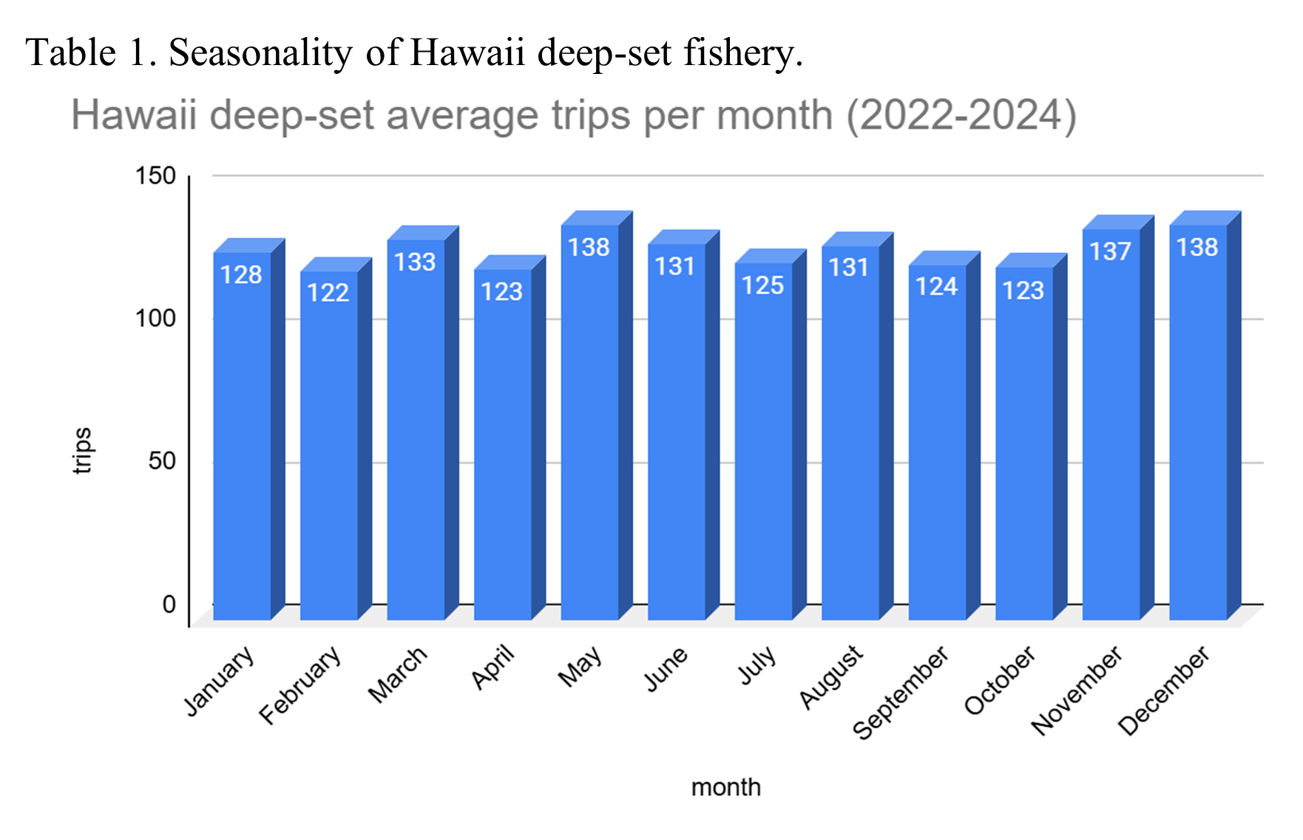
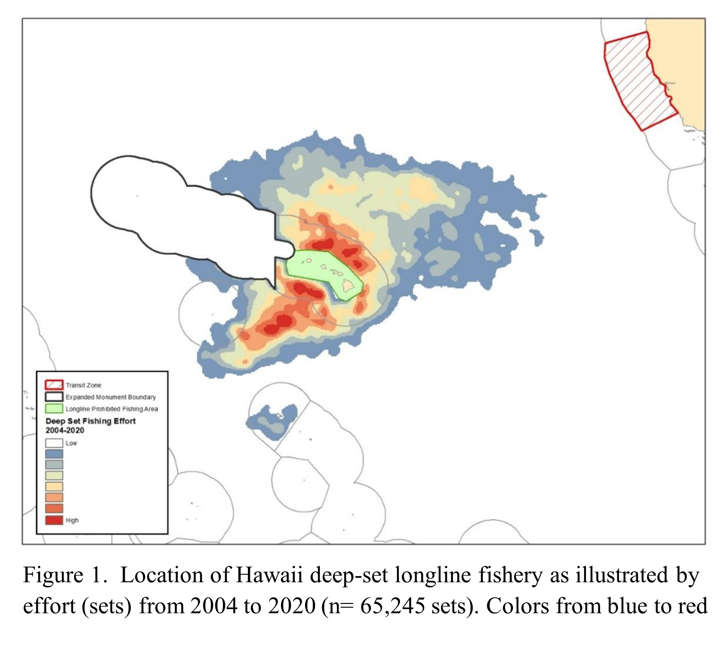
Hawaii-based pelagic shallow-set longline fishery
  - Number of vessel permits participating in the fishery: 20
  - Target species: Swordfish.
  - Gear deployment: Sets are deployed at night, with haulback in the early morning and throughout the day.
  - Gear configuration: Typically, 5 hooks are deployed between floats.
  - Trip Length: average 27 days. Usually, crewmembers make one set per day, with an average of 17 sets per trip.
  - Seasonality: Shallow-set operations occur predominantly from November through June (Table 2).
  - Fishing area: Predominantly north of Hawaii outside the EEZ on the high seas (Figure 2).
A portion of the Hawaii deep-set tuna longline fishery also participates in the Hawaii shallow-set swordfish longline fishery. While their fishing grounds vary, they often target waters north of approximately 20° N, and in some years, much further north than 30° N, following ocean temperatures. The Hawaii-based shallow-set fleet supplies a premium, fresh product for both the local and mainland U.S. markets, where it commands a higher price than imported frozen swordfish.
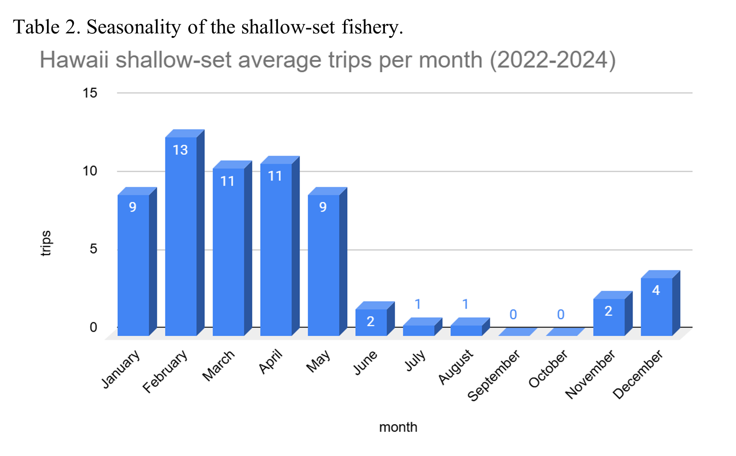
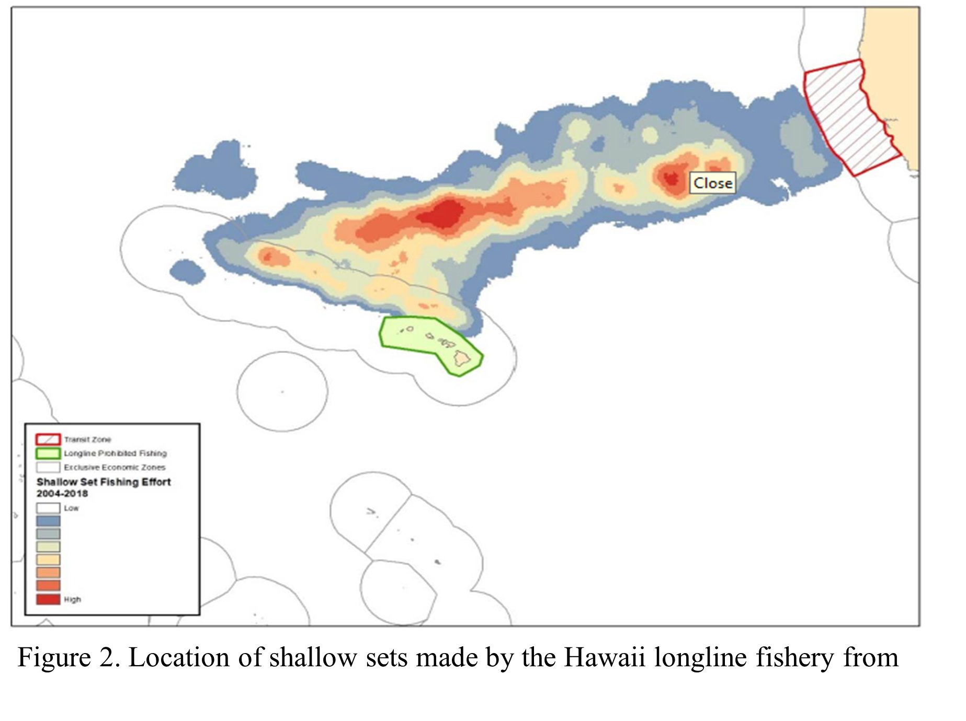

American Samoa-based pelagic longline fishery
- Target species: Five primary tuna species – albacore, yellowfin, skipjack, mackerel tuna, and bigeye tuna.
- Gear deployment: Sets are deployed in the early morning, with haulback at night. During haulback operations, Sodium or LED deck lights are used.
- Gear configuration: On average, 20 hooks are deployed between floats.
- Trip Length: Average trip length is 46 days, with a typical range of 10 to 84 days.
- Seasonality: Deep-set operations occur year-round, and tend to drop in the 3rd and 4th quarters (Table 3).
Fishing area: Beyond 12 nautical miles from shore within the U.S. EEZ around American Samoa (Figure 3).
The fishing effort in the American Samoa-based longline fishery tends to limit their range to the EEZ. As depicted in figure 3, American Samoa is in close proximity to the EEZ’s of other Pacific Island nations. Unless the vessel has an agreement with the neighboring Pacific Island nations, they must transit many miles to international waters. Although these vessels are equipped with blast freezer systems to preserve catch, the cost of fuel is a limiting factor. The American Samoa longline fishery is a limited-entry program with a maximum of 60 permits. However, currently only six vessels are actively fishing.
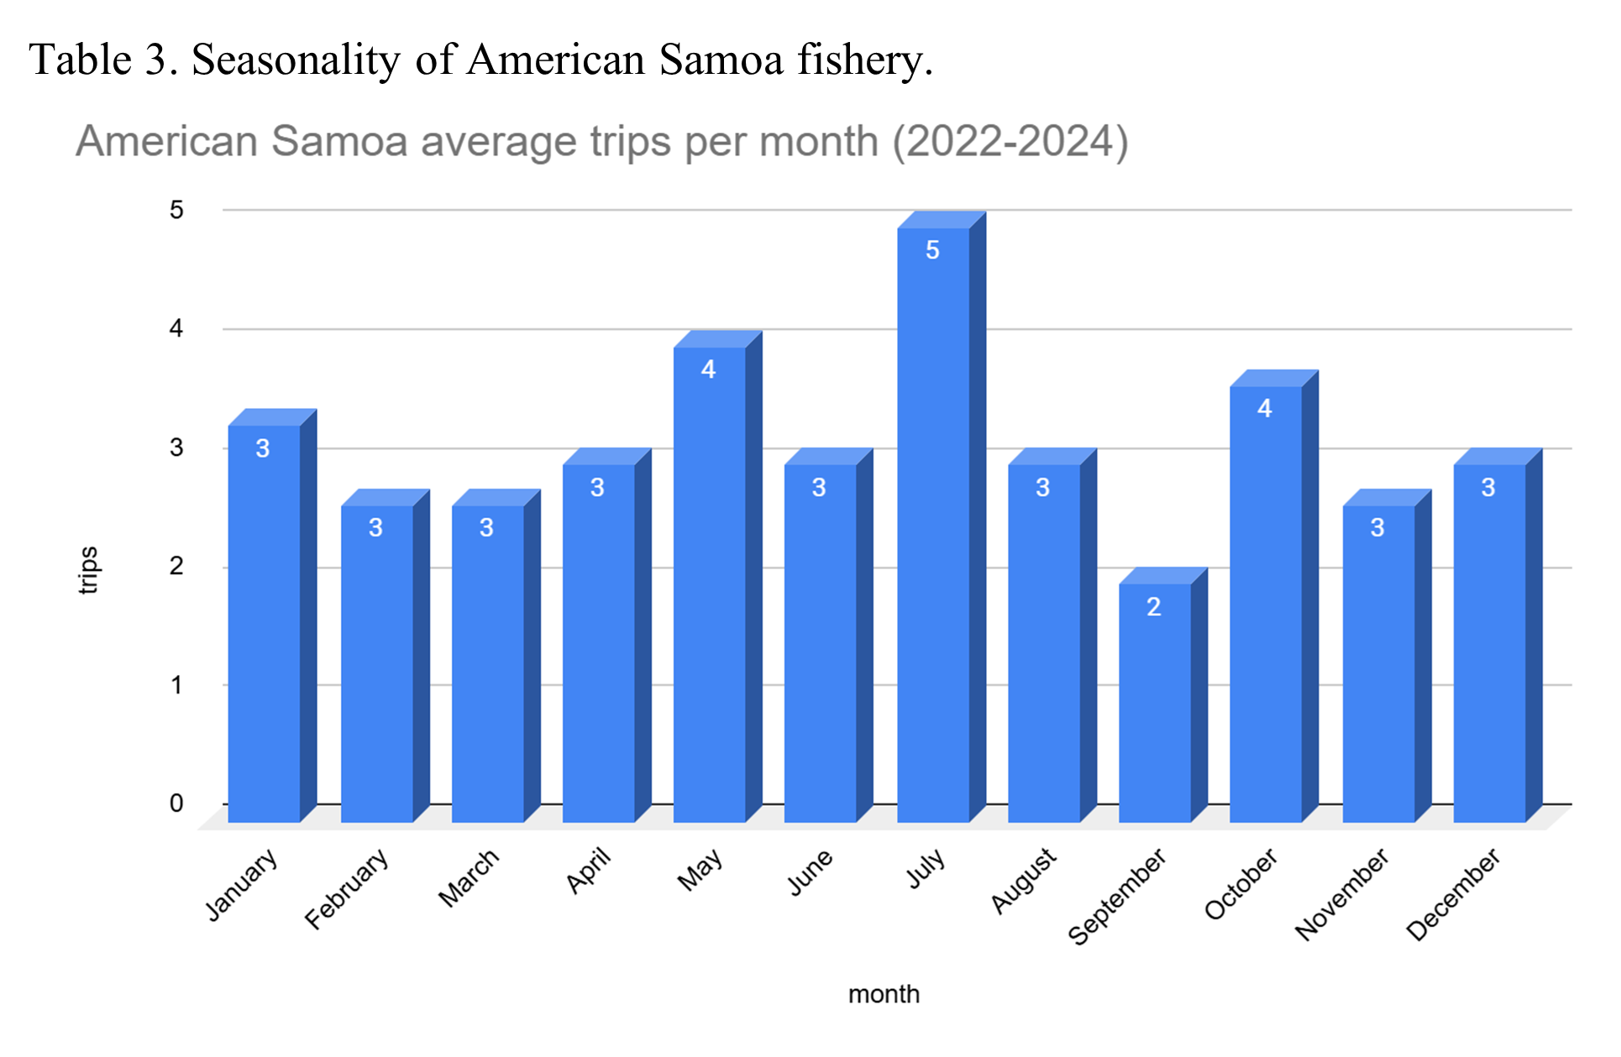
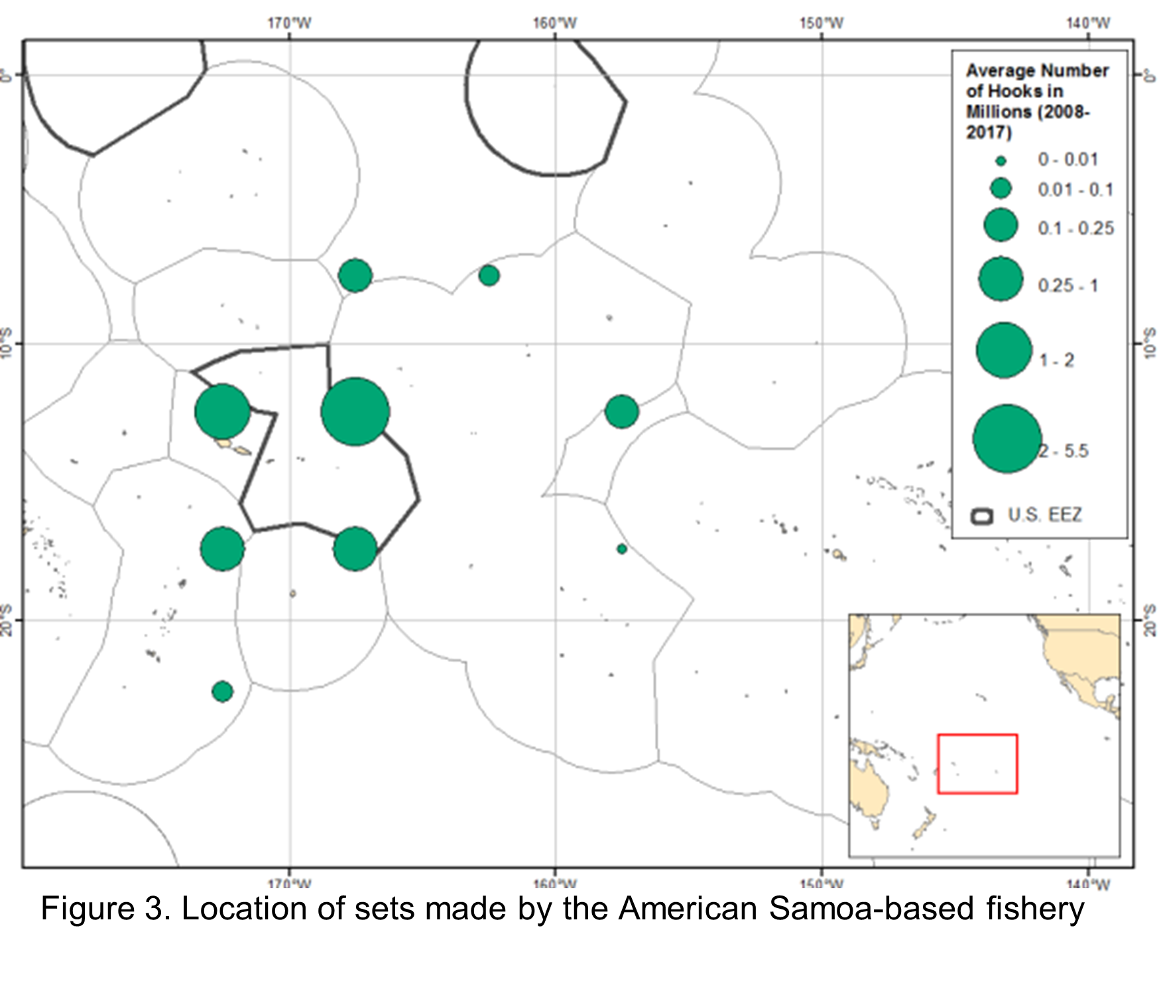
2.A. Fleet Characteristics
Commercial longline vessels in the Hawaii-based fisheries and in American Samoa are typically steel-hulled, measuring between 65 feet and over 100 feet in length. These full-displacement vessels are equipped with large hydraulic reels for monofilament mainline, radio buoys, and line shooters—especially important in the Hawaii deep-set fishery, where gear is deployed at depth. These vessels usually cruise at modest speeds of 7 to 8 knots.

Additional Operational Considerations

EM system installation and maintenance must consider the following:
- Crew privacy and dignity: All work must be executed with respect for the crew, given that the vessel is considered their home. Many are non-US citizens and may not disembark from the vessel, and many crew members are non-native English speakers.
- Safety and Access: Due to vessels often being moored 2-3 vessels deep, maintenance personnel should exercise caution to safely cross to the intended vessel.

Internet Connectivity
While over half of the fleet utilizes Starlink for internet access, we do not intend to rely on the vessel’s onboard service or a separate Starlink connection for real-time monitoring or system checks while the vessel is underway.
Fleet Ownership and Crew Demographics
The Hawaii-based longline fleet is ethnically diverse in both ownership and crew composition. Three main ethnic groups dominate vessel ownership and captaining roles:
- Vietnamese-Americans: A significant portion of vessels are owned by Vietnamese-American families, many of whom are first-generation immigrants.

- Korean-Americans: Korean-American families also own a notable share of the fleet. Like the Vietnamese-American owners, many are first-generation immigrants with limited English proficiency.

- Euro-Americans: Owners and captains from the U.S. mainland comprise another major segment of the fleet.

- Samoan-Americans: A significant portion of vessels in American Samoa are owned by Samoan-American families

Crew Composition
The crew aboard Hawaii-based longline vessels primarily consists of foreign labor, with a distinct ethnic composition differing from that of vessel owners:
- Filipino Workers: Filipino crew members represent one of the largest foreign labor groups in the fleet. A 2004 study found that they made up approximately 75% of longline crew members at the time.
- Indonesians and Pacific Islanders: Additional crew members often come from Indonesia and Pacific Island nations such as Kiribati and Samoa, contributing to the workforce's international character.

Ports of landing
The majority of commercial fish landings in Honolulu occur at Pier 38 and Pier 17, although some landings occur in California (Table 4, 5).
Pier 38 serves as the center of Honolulu's commercial fishing industry. It is home to the Honolulu Fish Auction and a cluster of seafood-related businesses. NMFS operates a satellite office at this pier featuring five offices and a conference room. The office also hosts the protected species workshops, which are mandatory for vessel operators.
Pier 17, located less than two miles from Pier 38, is a semi-industrial section of the port that supports cargo vessels, commercial longline vessels, and other shipping operations. Unlike Pier 38, it lacks amenities such as restaurants or services.
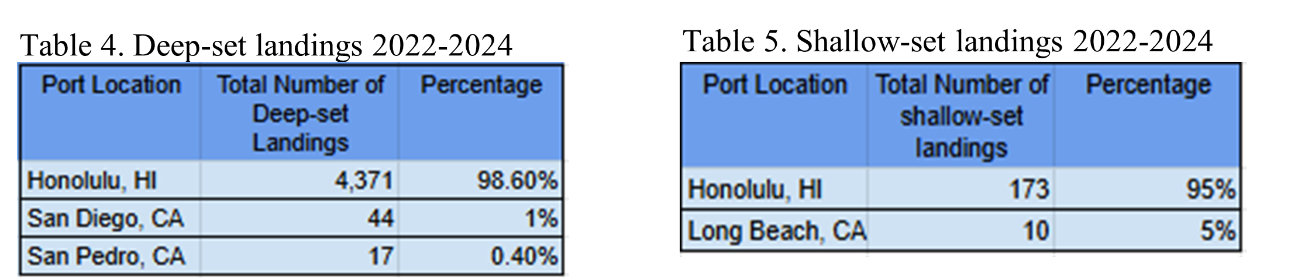
Pago Pago Harbor is the home of StarKist Samoa, the local cannery in Pago Pago on the island of Tutuila, and is where American Samoan-based longline vessels offload.
Unlike the Hawaii-based longline fishery, crew members—primarily from the Philippines, Samoa, Indonesia, and other Pacific Island nations—are allowed to disembark while in port, as American Samoa controls its own borders.

