Request for Proposals (RFP)
RFP 26-005

Electronic Fish Ticket Mobile Application

for West Coast Commercial Fisheries



Issue Date: 11/14/25
DEADLINE FOR PROPOSALS: 12/15/25

PSMFC Project Manager: Aileen Smith
Prime Awards:
NA21NMF4370550
1305M325C0041
Open to additional funding

RFP Process Schedule

11/14/25 Request for Proposal (RFP) issued and distributed

11/26/25 Deadline for written questions regarding this RFP

Please email questions to Jacob Allen at contracting@psmfc.org

12/3/25 Q&A document, including the answer to the written questions posted on the PSMFC website at: https://www.psmfc.org/procurements/

12/15/25 Deadline for submission of proposals

Proposals need to be submitted by e-mail to: contracting@psmfc.org

Subject line for submissions:
RFP 26-005: Electronic Fish Ticket Mobile Application

Faxed and hard copy proposals will not be accepted.

12/22/25 Project finalist selected
Issue Notice of Intent to Award

12/29/25 Deadline for Protest

Overview
Pacific States Marine Fisheries Commission (PSMFC) is seeking to contract a vendor to redevelop an application to collect fish ticket data on the West Coast. The new application will serve both mobile and desktop users, and allow for entry of fish tickets for California, Oregon and Washington. In addition to data entry, the application will include a variety of reporting features for users.

Currently fish ticket data is collected via the “ETix” electronic fish ticket web application. This application has been successfully used for data collection and reporting for users for the past 10 years but is only functional on PCs and has components that are becoming outdated. The vendor selected will design a new front-end application that integrates with the existing ETix back-end system. The new application will meet the following goals:

- System Modernization (a system that can be supported for the next 10 years)
- Mobile compatible with the ability to record data offline
- Improved reliability
- Streamline and improve the user experience
- Address agency requests for improvement in validations
The vendor selected through this RFP will initially be contracted to develop a pilot mobile application for a limited group of users, with completion required by June 30, 2026. Subject to available funding, the contract may be extended for up to five years to support subsequent development phases (with the goal of fully replacing the existing ETix web application) as well as ongoing maintenance.

Background
PSMFC supports a variety of data collection, management, and user tools for West Coast, Alaska, and Hawaii commercial fisheries. This work is done in support of and with funding from NOAA fisheries as well as state fisheries and wildlife agencies.

Fish tickets document the sale of fish from a fisher to a fish dealer. These landing receipts are required in most fisheries and are used to track total commercial landings and to inform management decisions. In most West Coast fisheries, an electronic fish ticket is required.

PSMFC hosts the ETix system which includes a web application for entry of fish tickets by dealers, as well as back-end databases, APIs for exchange of data with partners, and other data infrastructure. ETix was developed in 2014 and has regularly been updated to meet changing regulations, expanding user base, and to improve user experience.

The current ETix web application is a .NET Framework web application. The current web application covers entry of a variety of fish ticket types and includes reporting tools and help guides for users (Appendix A).

The vendor selected in this RFP will help build a replacement for this application that supports mobile users and meets the above stated redevelopment goals. The new application built by the selected vendor will interface with the current ETix database, hosted by PSMFC on SQL Server. The selected vendor will work with PSMFC staff and database contractors to integrate the new mobile application into the existing ETix system.

The new application is expected to ultimately fully replace the existing web application, however PSMFC expects to develop through a phased approach. The first phase of work will be to develop a mobile application for data entry that serves a limited scope of fishers (based on the type of fish ticket). Subsequent phases will add data entry for other ticket types and add reporting features and other user and administrative tools.

Scope of Work
The scope of work for the full project is designing a front-end application for mobile devices to collect electronic fish ticket data. The application will integrate with the existing SQL Server database back-end and use API layers for data retrieval and submission. The end goal of the project is an application meeting the standards described below. In addition, the vendor may be used on an ongoing basis to continue to modify and adapt the application in response to changes in data requirements or user feedback.

Platforms
  - Android and iOS compatible.
  - Must work with mobile devices and PCs. Some reporting features may only be necessary for PC users.

Features of the ETix Application
  - User Roles and Management
    - Require user authentication through the existing user management system
    - Roles exist for organizations and for users within each organization as well as administrators
  - Fish Ticket Creation
    - Ranges of tickets are assigned in advance either by state or by dealer. New tickets must pull from these preassigned ranges
  - Fish Ticket Data Collection
    - Provide forms for entry of fish tickets including header data (permit, fisher, vessel, dealer information) and catch landing data (fish species, value, quantity, etc).
    - Ability to populate lookup fields through an API layer. Lookup values may be dependent on the ticket type or other criteria
    - Ability to make certain fields required dependent on state of landing, fishery, or other criteria.
    - Ability to validate specific entries for business rules specific to fishery type
    - Ability to save drafts and final versions of a fish ticket.
    - Ability to find an existing fish ticket, edit and finalize it.
    - Ability to void a fish ticket.
  - Reports
    - Tax and regulatory reports can be generated by dealers that summarize catch and value based on entered fish tickets
  - Help Information
    - User guides are provided for each state
  - Administration
    - Ability for site administrators to see and manage lists of organizations and users and send out broadcast messages
  - More extensive details on the ETix application are outlined in Appendix A.

Data Transmission
  - Data must be recorded and stored locally until the user has network access.
  - Data must be transmitted either via cell network or Wi-Fi.
  - The vendor will work with PSMFC and database subcontractors to integrate the application with the existing SQL Server database for both data retrieval (look-up lists, past submissions, etc.) and data submission (new draft and final fish tickets).

- Confidentiality and Security
  - Data requirements include fishing trip information (species caught, total weights and counts, dealer information, fisher information, vessel information, permits, etc). Data collected includes PII as well as data deemed confidential under federal regulations.
  - The vendor will ensure that all data access is provided only to authorized users.
  - User roles will need to be developed to cover authorization for individuals, organizations, and regulatory agencies.
  - Per federal fisheries requirements, a confidentiality agreement must be signed by the contractor to ensure complete confidentiality of all data collected as well as all data provided for look-up values, etc. No copies of confidential data will be retained by the contractor without the written consent of PSMFC.

Ownership
  - The final version of the application will be owned by PSMFC. The vendor may adapt the product for use in other projects or products, but PSMFC will have the right to the application and all associated code such that they may adapt and further develop the product independently.
  - All data collected will be owned by PSMFC or the agencies PSMFC represents.

User Interface
  - Intuitive, simple navigations
  - Drop-down menus
  - Auto-fill fields including locations and date/times
  - Ability to easily see related data
- Testing and Improvements
  - PSMFC will lead field testing of the application, in coordination with state agencies and fish dealers.
  - The vendor will update the application based on initial testing, as well as in response to ongoing user feedback or changes in requirements.
  - The vendor will update the application at regular intervals to keep software up to date and compatible with a range of user platforms.

- Client Relationship and Support
  - PSMFC expects to work with the contractors in a close and dynamic relationship; open and frequent communication is expected to review the application specifications, design, and back-end integration.
  - Meet typically once every 2 weeks with PSMFC staff during active development phases to coordinate and prioritize development and to review work timelines and budget.
  - Participate in meetings with other agency staff or stakeholders as needed.
  - Development process to include screen mock-ups for feedback.
  - Educate PSMFC staff about the application as requested.

Phases of Work
The Scope of Work provided above defines the complete project scope. Implementation will occur in multiple phases to accommodate funding constraints and to facilitate progressive testing and refinement.

- Phase 1 (This work must be completed by 6/30/2026): The first year of contract will be to complete an initial phase of development that creates a mobile application for data entry of one type of ticket. The new mobile application will operate in parallel with the existing ETix web application, allowing users to enter ticket data through the mobile interface while continuing to access ticket history, reporting, and other existing features through the web platform. This mobile application is intended to fully replace the current web application in subsequent project phases. Accordingly, the design should be scalable and extensible to support additional ticket types, reporting functionality, and user tools in the future.
  - Database Interaction
    - An API endpoint will be used to provide user information and lookups and receive fish ticket submissions
  - User Accounts
    - Existing Users: share the username and password with the ETix web application, accessed from the ETix database
    - New Users can fill out a form to request an account; the request is submitted to the ETix system. The site administrator will view and approve the request in the existing web application. The user would receive a link back to the mobile app to create a password.
  - Fish Ticket Data Entry
    - A single type of fish ticket will be selected.
    - The application must access the ETix SQL Server database to find the next sequential number when creating a ticket.
    - The form will include header and catch detail fields (see Appendix A for more detail).
  - Submission
    - Users will have options to Save, Submit, Edit and Resubmit, and Void tickets
PSMFC may continue to work with the vendor for up to four additional years on continuing development of the new application. Below are anticipated phases of future work. PSMFC and the vendor will work together to finalize the specific development tasks for each year of contract.
- Phase 2: Expand the mobile data entry application to other states and fisheries (add remaining fish ticket types and a wider user base). This expansion will include adding the ability to print a PDF of tickets.
- Phase 3: Expand user tools to include searchable ticket lists; adding customizable reports (tax and regulatory reports) for dealers; and adding comprehensive help features and user guides.
- Phase 4: Add administrative roles and features. This includes adding site administrators with the ability to view and manage lists of organizations and users, view all fish ticket data, and send out broadcast messages to all users, as well as read-only administrators who can see all fish ticket data but have no other administrative roles.

Proposal Requirements and Scoring

Proposal Requirements
Proposals should detail each of the three areas described below:

- Qualification & Experience
  - Business experience: Explain the qualifications of the company and its specialized experience and technical competence that qualify it to perform the tasks described in the scope of work. Include experience and knowledge of West Coast fisheries. Priority will be given to vendors that have worked with commercial fisheries data in the past two years.
  - Personnel: Include the qualifications and experience of the primary personnel who will be involved in supporting the contract.
  - References: Provide a list of three clients and contact information for whom similar services have been provided. If you have references from work with fisheries data, please include these.
  - Subcontractors: A list of all, if any, third parties and/or subcontractors that vendor intends to use or may use in connection with meeting the scope of work.

- Technical Approach. Describe your approach to meeting the scope of work. Include descriptions of:
  - Design and development approach, interaction with PSMFC
  - Initial development platform and level of version compatibility
  - Testing, deployment and documentation plans
  - Expected timelines

- Cost Proposal
  - ETix Mobile Application:
    - Cost proposal should cover the entire Scope of Work
    - Please organize the cost proposal to match the phases described in the “Phases of Work” section
    - Submit a cost proposal using the provided template.
  - 5-year Rate Proposal:
    - For all job titles included, give rate proposals for 5 years (either specific rate or intended measure of inflation).

Scoring
- Qualification & Experience (30 percent)
- Technical Approach (40 percent)
- Cost (30 percent)

Appendix A. Detailed Features of the ETix Application

- Database Interaction
  - An API endpoint will be used to provide user information and lookups and receive fish ticket submissions.
- User Accounts and Roles
  - The system will support multiple organizations (dealers), each with its own set of user accounts. User management within each organization will be handled by a designated organizational administrator.
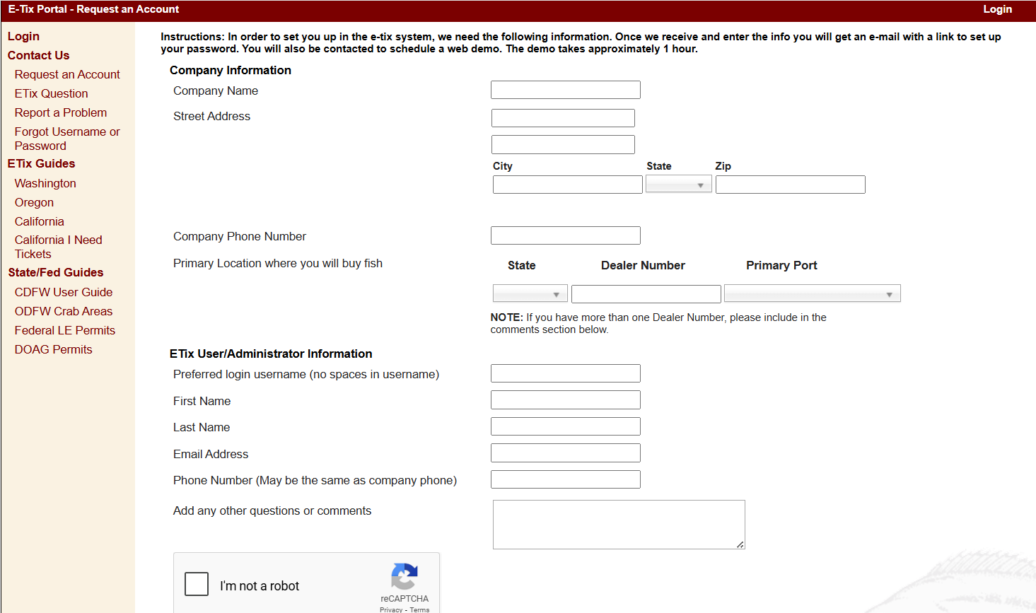
  - A dealer can request an organizational account via a form on the ETix application:
  - Accounts are verified by an ETix site administrator
    - The site administrator can view and modify applications
    - The ETix application gives warnings about dealer numbers that are already in use, expired, or incorrect, among other warnings.
    - Once verified by the site administrator, an organizational account is created. The email and person associated with the application becomes the organization administrator.
    - An email is sent to the user asking them to create a password.
  - The organizational administrator manages user accounts within the organization.
    - A user interface allows the organizational administrator to add new users, including input of similar information to the user form above.
  - Site administrators can also add new locations to the dealer organization.

- Creating Fish Tickets
  - California and Washington tickets are numbered in advance and a range of tickets (“ticket book”) is assigned to each organization.
    - A user creates a new ticket and enters the ticket date
    - A ticket number from their existing ticket book can be selected
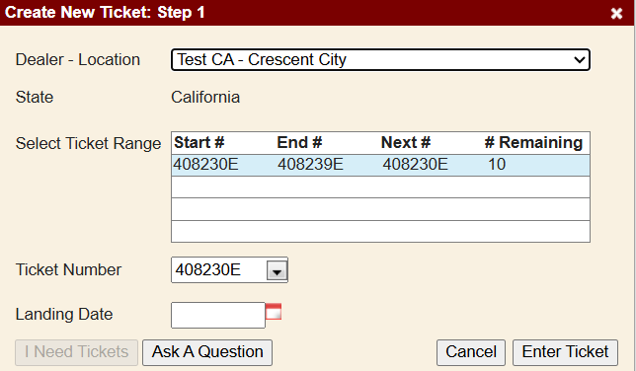
    - The user can request new tickets when they are near the end of their book. Book sizes by organization are stored in the SQL database.

- Data entry of fish tickets
  - The Header section contains data with one value per ticket. The field list below is an example for one ticket type:
    - Date of Landing (date)
    - Dealer # (default based on user)
    - Commercial License # (lookup/dropdown)
      - License, vessel name, vessel number and owner must be displayed and stored based on the selected License #
    - Operator (text stored for future selection by user)
    - Port Code (lookup/dropdown with default based on location)
    - Gear Used (lookup/dropdown)
    - Inside/Outside (lookup/dropdown)
    - Primary Catch Area (lookup/dropdown)
    - Trip Type (lookup/dropdown with default value)
    - Unloading Station (text stored for future selection by user)
    - Hold Inspection # (text)
    - IFQ Landing? (Boolean)
    - IFQ Vessel Account # (text)
    - IFQ Management Area (lookup/dropdown)
    - Sablefish Tier? (Boolean)
    - Fed LE Permit (lookup/dropdown)
    - DOAG Permit (lookup/dropdown)
  - The Detail Rows include multiple rows per ticket showing sale information by species; note that while the full table of details may not always be visible, summary info or a running total should be easily visible.
      - Fish species (lookup/dropdown)
      - Gross Lbs (decimal)
      - Price per lb (decimal)
      - Dollar amount (decimal – calculated from Price per Lb x Gross Lbs)
      - Number of fish (integer)
      - Condition (lookup/dropdown)
      - Grade (lookup/dropdown)
      - Gear (lookup/dropdown with default based on header)
      - Type (lookup/dropdown with default based on header)
      - Use (lookup/dropdown with default)
      - GF# (default based on permit)
      - IFQ Area (default based on permit)
  - Additional costs can be entered (e.g. ice or fuel costs; multiple per ticket)
    - Cost type (lookup/dropdown)
    - Dollar amount (decimal)
- Managed User Lists
  - Users create and save custom drop-down lists for multiple entity fields, including licenses, vessels, operators, cost types, and unloading stations. New list entries may be populated dynamically from database lookup tables or entered manually as free-text values.
- Submission and Related Actions
  - Data should be stored locally on the device as it is entered
  - Option to “Save” ticket which sends a submission to the API endpoint with all data flagged as “Draft”
  - Option to “Submit” ticket which sends a submission to the API endpoint with all data flagged as “Final”
  - Option to edit or resubmit data which send an updated version to the API endpoint with unique identifier that matches original and updates the version number.
- Viewable and Printable Summary
  - The user must be able to easily see a summary screen that shows all sales and costs for a fish ticket.
  - The user must be able to generate a printable PDF that shows all data entered on the fish ticket and includes totals of gross pounds, dollar amount, and number of fish, and shows total costs.
- Ticket Types
  - California: One ticket type at present; possible addition of a second ticket type in the future.
  - Oregon: Multiple ticket types, however most are nearly identical forms with differences only in the drop down lists provided or validations.
    - Columbia River
    - Columbia River Tribal
    - Columbia River Washington Boat
    - Nearshore Groundfish
    - Shellfish and Bait
    - Shellfish and Bait Tribal
    - Troll
  - Washington
    - Marine Fish
    - Puget Sound Fish
    - Shellfish
    - Treaty Indian Fish
    - Troll Fish
    - Utility Fish
  - Examples of one ticket for each state:

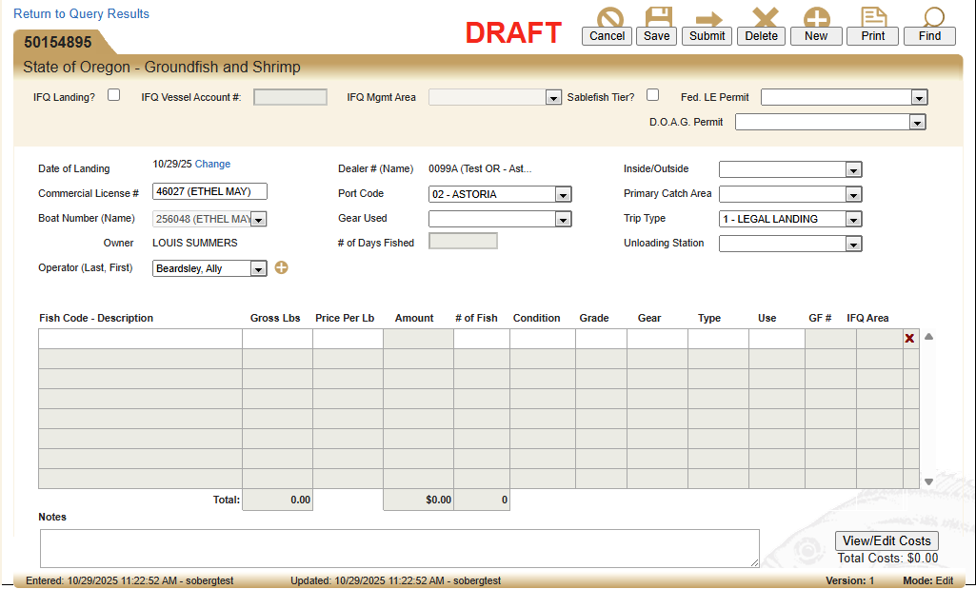
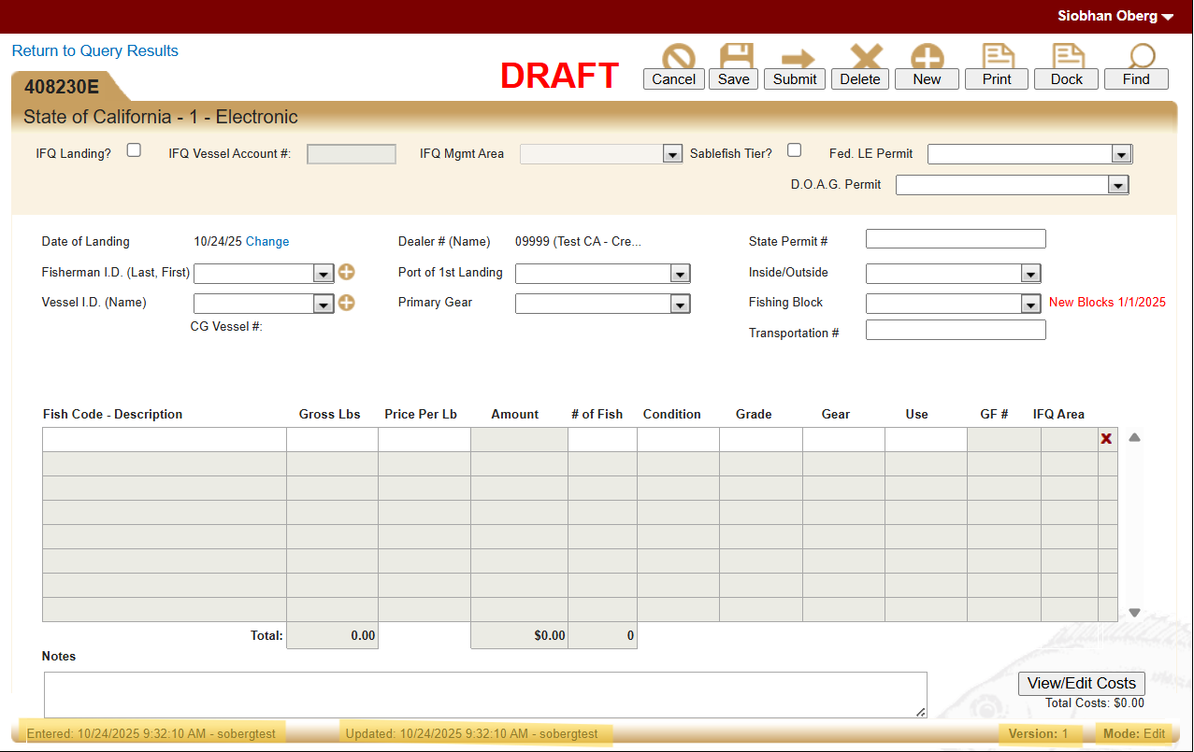

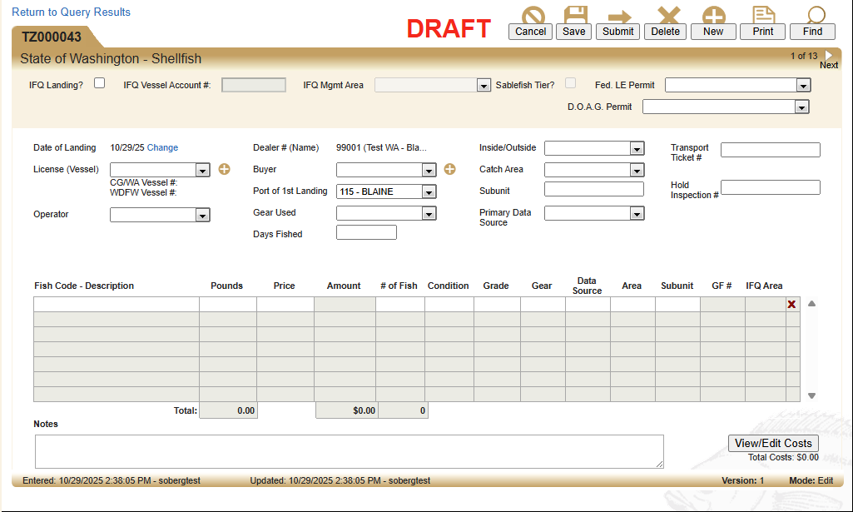

- Reporting
  - Ten tax and assessment reports are provided to users that use fish ticket data from the dealer to calculate fees and taxes the dealer may owe to either federal or state agencies.
  - Reports are based on database queries and include user filters by date range, dealer location, etc. Users also enter some values such as interest value, penalty value, etc. that may need to be included in the reports’ calculations.
  - Report designs are based off government agency forms.
  - Reports are generated as PDFs
  - One example report is shown below:
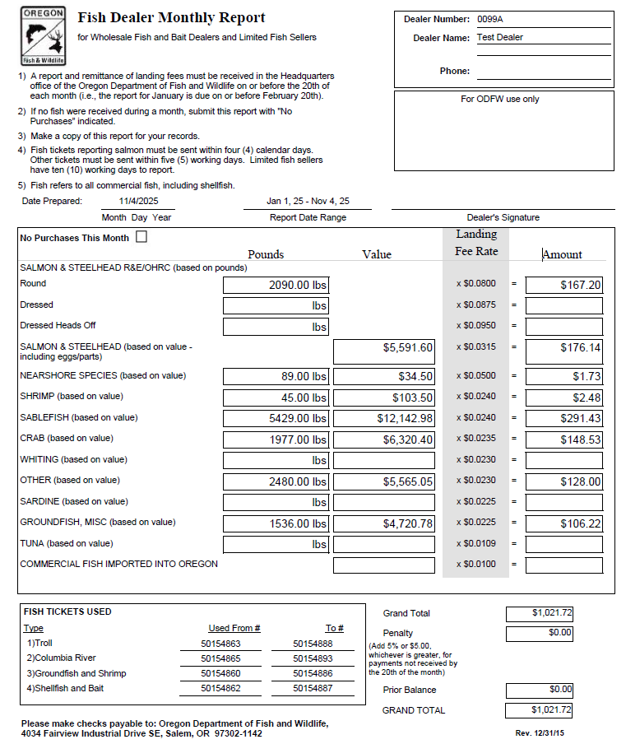
- Administration
  - Site administrator role:
    - See all fish ticket data in list with options to sort and filter
    - View sortable lists of organizations and users and manage these (add, edit, deactivate)
    - Site administrators can send out broadcast emails to users from within the application.
  - Read-only administrator role:
    - See all fish ticket data in list with options to sort and filter
- Help Information
  - User guides are provided for using the ETix application
  - Users can submit a help request form for additional help
  - Other regulatory guidance from management agencies is posted in a PDF library

